IHO S-121
Product Specification for
Maritime Limits and Boundaries

Submission to S-100 WG
Version 1.0
5 April 2018

Overview
S121 is a product specification for Maritime Limits and Boundaries for the administration of the marine domain. Its data model allows the description of marine areas and their associated rights restrictions and responsibilities in compliance with the UN Convention of the Law of the Sea (UNCLOS) while also allowing States to represent generic objects as necessary. Its exchange formats would assist States Parties to meet their depository obligations under UNCLOS, as well as other legal declarations and would support integration with other S-100 based products. The standard is based on S-100 and also on the ISO standard 19152 Land Administrative Domain Model.

IHO S-121
Product Specification for
Maritime Limits and Boundaries
Revision History

Version Number | Date | Author | Purpose
Draft 1 | April 14 | GA Australia | Initial Draft.
Draft 2 | 7 Nov 16 | CHS Canada | Revise BAUnit relationship.
Draft 2.2 | 23 Nov 16 | CHS Canada | Revise spatial relationships.
Draft 2.3.7 | 27 Nov 16 | CHS Canada | Overall review.
Draft 3 | 8 Mar 17 | CHS Canada | Restructuring as recommended by S-121 Project Team meeting Dec 16.
Draft 4 | 21 Nov 17 | CHS Canada | Restructuring as recommended by S-121 Project Team meetings.
Draft 5 | 17 Mar 18 | CHS Canada | Restructuring as recommended by S-121 Project Team meeting Dec 17 and editorial meetings.
Submission to S-100WG Version 1.0 | 5 April 18 | S121 PT | Revision after review by S-121 Project Team and by UN DOALOS

IHO S-121
Product Specification for
Maritime Limits and Boundaries
TABLE OF CONTENTS

Overview i
1 Scope 1
2 Conformance Clause 1
3 Normative References 1
4 Terms, Definitions and Abbreviations 1
5 General Data Product Description 3
6 Specification Scope 6
7 Dataset Identification 6
8 Data Content and Structure 8
9 Coordinate Reference System (CRS) 9
10 Data Quality 11
11 Data Capture and Classification 13
12 Maintenance 13
13 Portrayal 14
14 Data Format (encoding) 14
15 Data Delivery 14
16 Metadata 15
Appendix A. Abstract Test Suite and Conformance Classes 16
A.1 Test case for attribute assignation to feature classes 16
A.2 Test case for attribute domains 16
A.3 Test case for UUID 16
A.4 Test case for data completeness 16
A.5 Test case for feature commission 17
A.6 Test case for omission 17
A.7 Test case for domain consistency 17
A.8 Test case for format consistency 17
A.9 Test case for topological consistency 18
A.10 Test case for data accuracy 18
Appendix B. Use Case Description 19
B.1 Overview 19
B.2 Use Cases 20
Appendix C. Application Schema 22
C.1 Overview 22
C.2 Feature and Attribute Structure from S-100 22
C.2.1 Application Schema General Model 23
C.2.2 Basic Administrative Unit Package 24
C.2.3 Feature Unit 26
C.2.4 Spatial Attribute 27
C.2.5 Party Unit Package 36
C.2.6 RRR Administrative Package 37
C.2.7 Governance Object 38
C.2.8 Versioned Object 40
C.3 Implementation Model 41
Appendix D. Bibliography 44

IHO S-121
Product Specification for
Maritime Limits and Boundaries

Scope
This document describes a product specification for the administration of maritime limits and boundaries in support of the deposit by States Parties of the geographical coordinates of points identifying their baselines and outer limits of maritime zones in accordance with UNCLOS, and other technical and legal requirements. This Product Specification complies with the IHO S-100 Universal Hydrographic Data Model. Maritime Limit and Boundary features may also be used in charting and other contexts.

Conformance Clause
Any data set claiming conformance with this Product Specification shall pass the requirements described in the abstract test suites in ‎Appendix A.

Normative References
The following referenced documents are indispensable for the application of this document.
IHO S-100:2017 Universal Hydrographic Data Model, edition 3.0
ISO 3166-1:2013 Codes for the representation of names of countries and their subdivisions – Part 1: Country codes
ISO 19107: 2003 Geographic Information – Spatial Schema
ISO 19108: 2002 Geographic Information – Temporal Schema
ISO 19115: 2003 Geographic Information - Metadata
ISO 19152: 2012 Geographic Information - Land Administration Domain Model (LADM)

Terms, Definitions and Abbreviations

Use of Language
Within this document:
- “Must” indicates a mandatory requirement.
- “Should” indicates an optional requirement, that is the recommended process to be followed, but is not mandatory.
- “May” means “allowed to” or “could possibly”, and is not mandatory.

Terms and Definitions
For the purposes of this document, the following terms and definitions apply.

Attribute
Named property of an entity. For example, number of lanes or pavement status. [ISO 19115-2:2009 from ISO/IEC 2382-17:1999]
In UML “a classifier that describes a range of values that instances of the classifier may hold.” [ISO/TS 19103:2005 – adapted from ISO/IEC 19501]

Class
Description of a set of objects that share the same attributes, operations, methods, relationships, and semantics.
Note: A class does not always have an associated geometry (e.g., address range class).
[ISO/TS 19103:2005 – adapted from ISO/IEC 19501]

Dataset
Identifiable collection of data. [ISO 19101:2002 from ISO 19115-1:2014, 4.3]

Feature
Abstraction of real-world phenomena.
[ISO 19101-1:2014 from ISO 19101:2002]

Object
An object is an instance of a class.
In UML “entity with a well-defined boundary and identity, which encapsulates state and behaviour.” [ISO/TS 19103:2005 – adapted from ISO/IEC 19501]

Abbreviations
CEDA Category of Estimated Data Accuracy
CMAS Circular Map Accuracy Standard:
CRS Coordinate Reference System
DOALOS Division of Ocean Affairs Law of the Sea, Office of Legal Affairs, United Nations
EEZ Exclusive Economic Zone
EPSG European Petroleum Survey Group
GIS Geographic Information System
GML Geography Markup Language (ISO standard 19136:2007)
ID Identifier
IHO International Hydrographic Organisation
ISO International Organization for Standardization
KML Keyhole Markup Language
LADM Land Administration Domain Model
MLB Maritime Limits and Boundaries
MSDI Marine Spatial Data Infrastructure
UNCLOS United Nations Convention on the Law of the Sea
UML Unified Modeling Language
UUID Universal Unique Identifier
WMS Web Mapping Service

General Data Product Description

Title
IHO S-121 - Product Specification for Maritime Limits and Boundaries

Abstract
This document describes a product specification for Maritime Limits and Boundaries (MLB) data as part of the suite of IHO S-100 standards. The purpose is to establish a framework of sourced and versioned objects for communicating in a digital form the geographic extents of marine areas and the associated rights and restrictions that apply to them as well as to provide a flexible and expandable framework able to support other maritime delimitation requirements such as defining areas of overlapping jurisdiction and Joint Development Areas, or any other maritime management areas. This product specification is also compatible with the ISO 19152 Land Administration Domain Model (LADM) structure. This integration bridges both the land and maritime domain structurally and provides to the S-100 series a product specification which effectively supports the description of objects defined in national legislation.
Datasets that conform to this product specification comply with one of the conformance classes defined in ‎Appendix A.

Spatial Extent
This product specification applies to the maritime area, the boundaries of which are described as an instance of the ISO Metadata element EX_Extent as an EX_GeographicBoundingBox in clause ‎5.3.1. The area of applicability is the entire world.

Description
The IHO S-121 - Product Specification for Maritime Limits and Boundaries contains a set of MLBs expressed as set of objects compliant with the IHO S-100 Universal Hydrographic Data Model. A number of new feature types and attributes have been defined with their definitions taken from UNCLOS. The objects and attributes used in this product specification are described in a separate document and are registerable in the IHO Feature Object register.
The product specification also includes metadata derived from both S-100 and from ISO 19115:2003 Geographic Information – Metadata¹. In addition to general discovery metadata and descriptive metadata, there are metadata elements used to describe the quality of the data.

West Bound Longitude
-180

East Bound Longitude
+180

South Bound Latitude
-90

North Bound Latitude
+90

Purpose
The purpose of this product specification is the establishment of a data model presented that supports the description in a digital form the geographic extents of marine areas and the associated rights and restrictions that apply to them and to provide a flexible and expandable framework able to support other maritime delimitation requirements such as defining areas of overlapping jurisdiction and Joint Development Areas, or any other management areas. Built on top of the data model structuring the information, there is a need for several encodings (exchange format) to support key usages: (1) MLB objects may be used as a source for some elements of navigation products such as ENC and in that context would follow an S-101 encoding. (2) A separate encoding would be needed for a stand-alone MLB product or the use of MLB objects in a Marine Cadaster. (3) This standard also establishes a structured text record oriented exchange format that is \readable and comprehensive by both the human eye and a computer. This exchange format is designed to support the description of legal aspects of the MLB objects in a manner so that they can easily be presented in a court or other legal venue. This data needs to look similar to the current text in treaties and laws. This human readable format is the encoding required to facilitate the States Parties’ deposit obligations under UNCLOS.
In this products specification, Locations, Limits and Zones are considered objects. Zones may be defined by several limit objects and limit objects may be shared between different adjacent zones.

Data Product Specification Metadata
The following metadata shall be included in each instance of a Maritime Boundary data product.

 | Item Name | Description | Multiplicity | Type | Content
1 | title | Title of the data product specification | 1 | CharacterString | IHO S-121 - Product Specification for Maritime Limits and Boundaries
2 | S-100 version | The version of S-100 upon which the product is based | 1 | CharacterString | Version 3.0.0
3 | version | Version of the data product specification | 1 | CharacterString | Version 1.0
4 | date | Date the product specification was created / last updated | 1 | Date | 31 March 2018
5 | language | Language(s) of the data product specification, e.g. translations | 1..* | CharacterString | Eng  This does not exclude instances of data being in multiple languages.
6 | classification | Security classification code on the data product specification | 0..1 | MD_Classification  Code (ISO 19115) | The default value is “unclassified” however any value from the code list MD_ClassificationCode may be used, see clause 5.9.
7 | contact | Party responsible for the data product specification | 1 | CI_Responsible  Party (ISO 19115) | International Hydrographic Bureau  4b quai Antoine 1er  B.P. 445  MC 98011 MONACO CEDEX  Telephone: +377 93 10 81 00  Telefax: + 377 93 10 81 40  Email: info@iho.int
8 | URL | Online-address where the resource is downloadable | 0..1 | URL | <https://www.iho.int/srv1/index.php?option=com_content&view=article&id=448&Itemid=345&lang=en >
9 | identifier | Persistent unique identifier for a published version of the product specification. | 1 | CharacterString | S-121
10 | maintenance | Description of the maintenance regime for the product specification. | 1 | MD_Maintenance  Information  (ISO 19115) | IHO S-121 project team, part of the IHO S-100 Working Group
Table ‎5-1 – Data Product Metadata

Product Specification Maintenance
This data product specification is managed by the S-121 Project Team of the IHO S-100 Working Group. The maintenance of the S-121 compliant data is done by the various nations that have implemented this standard or have developed their own national profiles of this standard.

Specification Scope

Scope General
This product specification describes the S-121 data model for Maritime Limits and Boundaries which contains a set of feature objects which can be attributed to specific party, rights, restrictions, responsibilities and sources as defined in applicable legislation..

Scope ID
Global
Note: "Global" means that this scope refers to all parts of this data product specifications.

Level
This scope refers to the following level according to the ISO 19115 standard:
006 - series

Level name
S-121

Dataset Identification

Title
IHO S-121 - Product Specification for Maritime Limits and Boundaries

Alternate title
S-121

Abstract
This document describes a product specification for Maritime Limits and Boundaries (MLB). The data model can be expressed based on several profiles defined in this product specification, which are established as conformance classes as described in Appendix A.

Topic category
Main topics for the product, as defined by the ISO 19115:
003 - boundaries
012 - inland waters
013 - location
014 - oceans

Geographic description
The extent element of MD_DataIdentification is conditional; either the EX_GeographicBoundingBox or the EX_GeographicDescription subclass of extent’s geographicElement Role shall be included if the dataset is spatially referenced. If necessary both may be used. If a code is used then the following applies.

Code
Code of the geographical region covered by the product according to the ISO 3166-1:1997
Any code from ISO 3166-1 may be used to identify different national areas of interest. This IHO standard is suitable for addressing Maritime Limits and Boundaries for the whole world.

Spatial resolution
Spatial resolution of the data:
Maritime limits and boundaries are normally calculated to a high accuracy based on control points that themselves are normally determined to a high accuracy. The product specification does not require high precision, but allows for it.
Data elements represent either locations or limits or derived elements as defined in national legislation and/or bilateral and multilateral treaties. Positions defined in such a manner have an absolute accuracy. Derived elements, such as a transformed point, or a densified line or a calculated limit based on a rule, such as 12 nautical miles seaward from a straight baseline, bear the accuracy or the calculation. An accuracy and precision statement shall accompany a derived element or group.

Purpose
The S-121 MLB data model provides authoritative, accurate, and accessible data model to describe a specific set of maritime locations, limits and/or zones as described in related legislation . MLB objects may be considered as an independent data set, or the data may serve as a foundation for the production of other S-100 data products. The conformance class used by the dataset is indicative of its intended usage and purpose.

Language
Data sets for exchange internationally will be in English. Nations may also maintain data sets in any other language. Other language information will be included as required as "locale" information (See ISO 19115:2003 Annex J).

Classification
The default value of the Maritime Boundaries and Limits data is “forOfficialUseOnly”; however, any value from the code list MD_ClassificationCode may be used. Certain types of data may be “Unclassified’, “sensitiveButUnclassified”, “protected” or of “limitedDistribution”. The full list of classification codes from ISO 19115 are:
- unclassified,
- restricted,
- confidential,
- secret,
- topSecret,
- sensitiveButUnclassified,
- forOfficialUseOnly,
- protected,
- limitedDistribution.

Spatial representation type
Type of spatial representation for the product, as defined by the ISO 19115
001 - vector

Point of contact
International Hydrographic Bureau
4b quai Antoine 1er
B.P. 445
MC 98011 MONACO CEDEX
Telephone: +377 93 10 81 00
Telefax: + 377 93 10 81 40
Email: info@iho.int

Use Limitation
The allowed uses of the data are defined in clause ‎8.1 in accordance with conformance clauses as defined in ‎Appendix A.

Data Content and Structure

Introduction
The S-121 suite of data products consists of the following sub-products. Each is defined in a conformance class in ‎Appendix A.

 | Dataset Type | Description | Limitations | Example
1 | Production | An approved set of MLB data for use in production of other data products. | Available to other groups for inclusion in the production of charts or maps. | - Support Electronic Nautical Chart creation.  - Support Raster Nautical Chart creation.  - Support the creation of an overlay layer such as Additional Military Layers (AMLs).
2 | Legal Declaration | MLB object(s) as defined explicitly by location in national legislation and or bilateral and multilateral treaties and MLBs that have been included in such legislation by reference to a process that may require additional administrative or technical intervention. | Usage may be limited depending on the implementation policies associated with the State’s governance procedures. | - Provide human and computer readable file to support the creation of legal declarations.  - Support deposit to the UN Secretary General in accordance with UNCLOS.
3 | General Public Release | An approved set of MLB data that may be distributed to the general public for use. | Released publically - MLBs could include a limiting legal usage statement. | - Provide GML, KML, Text, and manufacturer specific data formats (such as Shapefiles)
Table ‎8-1 – Data Content and Structure

Application schema
The conceptual model of the S-121 Product Specification is provided in Appendix C.
Every feature instance shall be assigned a UUID.

Feature catalogue
The feature catalogue to support Maritime Limits and Boundaries is described in a separate document “S-121 Feature Model”.

Dataset Types
The S-121 Product Specification contains a specific set of features related specifically to MLBs. This is a scale independent set of data. It is not necessarily a complete set of data and it may be combined with other data.

Geometry
The S-121 Product Specification consists of a set of point, curve and surface primitives in accordance with S-100 Level of Geometry level 3a. That is, zones may overlap.
Each feature type is independent and Maritime Boundaries may cross other Maritime Boundaries or zones (areas). Different features may be a zone represented by a geometric surface, a limit represented as curves (polylines) or a location represented by a point.
The relationship to the geometric primitives used to represent an object are described in Appendix C.2.4.
The geometry of each feature type and the feature types referenced by it shall form a consistent geometric complex; however, other independent features or complexes of features may also exist in the same data set.

Coordinate Reference System (CRS)

Horizontal reference system
Spatial data are expressed in latitude (φ) and longitude (λ) geographic coordinates in reference to a horizontal reference systems.
The longitude is stored as a negative number to represent a position west of the prime meridian (0°). Latitude is stored as a negative number to represent a position south of the equator.
Latitude and Longitude may also be stored as textual strings. This is required so that positions may be described in the exact format that they are described in the legal document (treaty or national legislation) they were extracted from. If a position is described in legal document in degrees, minutes and seconds then this description must be retained in the textual string as degrees, minutes and seconds because a conversion to decimal degrees would imply a transformation that would change the data from its legally defined value. The same latitude and longitude position may also be stored as a transformed point as a set of real numbers within a GIS system so that it can be used. That is, the values used in legal documents must be preserved, but points and other geometric primitives may have multiple representations.
Different reference systems are used by various nations. Since data may come from different legal sources such as different treaties, multiple coordinate reference systems may be used in the same dataset. Because the coastline and baseline are linked to the land, the reference systems used to define national sets of MLBs tend to be the land based reference systems that are associated with various continents and other land masses. International data may be referenced to a world reference system such as WGS 84, but in such cases the transformations parameters to local land based reference systems may also be required.
MLB data is geographic data and therefore is not projected.

Vertical coordinate reference system
Vertical position is expressed in meters above or below a vertical reference.
The IHO S-100 object catalogue includes vertical datums as registered attributes, although IHO also indicates that S-100 is not an exhaustive or authoritative definition.

Temporal reference system
Time is measured by reference to Calendar dates and Clock time in accordance with ISO 19108:2002 Temporal Schema clause 5.4.4.

Coordinate reference system registry
The International Association of Oil and Gas Producers (formally the EPSG) has established a register of Coordinate Reference Systems that has been recognized by the International Organization for Standardization (ISO) Technical Committee TC211. This register is not the authoritative definition of the CRS but it establishes a code that may be used to identify a CRS. The registry containing the register is available at <http://www.epsg-registry.org/>.
The IHO S-100 object catalogue also included horizontal datums as registered attributes, although IHO also indicates that S-100 is not an exhaustive or authoritative list.

Data Quality

Completeness
An S-121 product contains a quality geometric and attributive description (current, accurate, consistent), homogeneous and standardised of the entire set of MLB managed by the organization which issued the data set.

Commission
MLB data is legal data and therefore redundant and oversampled data elements are not permitted.
Evaluation methods used for the detection of data in excess of the required data consist of two cases:
- Redundant data will be identified and considered an error;
- Oversampled source data will be reduced to sample accuracies by the data producer.
Duplicate instances of features that are valid at the same time are not permitted. Multiple instances of feature classes shall be differentiated by means of attributes or metadata. Different versions of a feature instance are permitted using the versioning attributes to distinguish which is valid and any particular time.

Omission
The description of jurisdictions zones through the definition of MLBs is often done through conceptual descriptions which can either be complete or incomplete. For the sake of clarity the feature object defined in the Feature Catalogue have very strict geometric primitive to ensure that when an object is defined its geometries match the objects definition as included in related legislation. In order to also support conceptual description, these features also may be described textually or by reference to other objects. This standard is extremely permissive, but quite clear and exhaustive at the feature level. Certain objects types; such as geodetic lines or loxodromes, shall meet densification requirements.

Logical consistency

Conceptual consistency
The physical implementation of the S-121 product specification aligns with the conceptual model according to the conformance classes defined in ‎Appendix A. The conceptual model remains the same for all conformance classes except that different objects and attributes are included in the data set under each conformance class, and the accuracy of the attributes may be reduced for different products.

Domain consistency
The attribute values are validated to ensure they are within defined range. The allowed ranges are defined in the feature catalogue.

Format consistency
S-121 data formats for the various conformance classes conform to the S-100 standard, or are explicitly defined in the encoding document associated with this product specification and are generated by GIS software that complies with this standard.

Topological consistency
The spatial relations of the entities of S-121 datasets are systematically validated by means of commercial GIS software implementing ISO 19107-Geographic Information-Spatial Schema.
The validation performed consists in detecting and correcting within reasonable measures: adjacency and connectivity calculations to avoid any inadvertent misconnections, slivers, or crosses. The data must align with the original treaties and legal documents upon which the data is based and any errors topological resultant in the integration of data from different sources (different treaties or other legal sources) must be identified and accommodated but the original legal data must not be changed.

Positional accuracy

Absolute external positional accuracy
Legally authoritative data has by definition absolute accuracy because it represents a legally defined position without legal qualification. Legally authoritative data may be described in treaties, national legislation and/or deposits in compliance with UNCLOS. These absolute accuracy positions may be included in a data set along with derived data.
Official data has by definition absolute accuracy because it depicts a determination of a state’s maritime limits and boundaries where no legal process exists to make it authoritative or where a technical process has been required to realize the data; although, errors may exist in the data no disadvantage will apply to a user that acts in good faith. Official data may be described in treaties, national legislation and/or deposits in compliance with UNCLOS and become legally authoritative data. These absolute accuracy positions may be included in a data set along with derived data. Official data may be normalized to a single spatial reference system.
Cartographic only data - Data derived from legally authoritative or official data has the accuracy of the transformation or other process used to generate the data. Cartographic data may be used to inform decision makers but are inadequate where legal certainty is required. A location may be represented by a point that has an absolute (legal) accuracy in one Coordinate Reference System, but has a different transformed value in another CRS. Since multiple treaties may have been agreed at different times there may be multiple locations with absolute accuracy in a MLB data set that use different CRS. If all of these points are transformed to a common CRS, so that they can be managed in a GIS and used, then each point may have an error resultant from the transformation process. The transformation source and the resultant error may be referenced in a source reference within the structure for each transformed point.
The accuracy of derived lines, such as transformed or densified lines shall also carry an accuracy statement in a referenced source for the transformation process.

Temporal accuracy
Constituent of data objects may be established at different dates. A validity attribute is mandatory for all objects. A single creation date may be assigned to a component object derived from different sources. The source description shall be used to describe the difference between the actual establishment (collection or legal) date of an object and any date assigned to a group.

Thematic accuracy

Thematic classification correctness
Each of the standardized objects will have an IHO code to serve as a linkage to proper depiction based on the IHO S-100 Feature Concept Dictionary. When a feature type will be realised into a specific object the corresponding IHO code shall be linked to the object to ensure that the proper thematic classification is used. Through such automation, no further verification is needed.

Non-quantitative attribute accuracy
The method used for evaluating the accuracy of the non-quantitative attribute values with respect to reality is determined by the type of data and its method of acquisition, and thus rely on the metadata information, and data description provided at the time of the dataset integration.

Quantitative attribute accuracy
The method used for evaluating the accuracy of the quantitative attribute values with respect to reality is determined by the type of data and its method of acquisition, and may be calculated in accordance with clause ‎10.3.1 or may rely on the metadata information.

Data Capture and Classification

Description
The MLB data is primarily acquired form multiple external and internal sources. Critical points may be defined in treaties and other agreements. The S-121 source object is design to support references to legal sources.

Maintenance

Maintenance and Update Frequency
Maintenance of the S-121 compliant database is done by the nation issuing the data set based on input received from either internal or external data sources. The frequency of maintenance updates of the database is driven by the availability of new or better data.
In order to help S-121 compliant database users in their management of the various update releases, updates shall be packaged and distributed by change effects (addition, retirement, modification, confirmation).
Versioning capacities are established for all objects within the model, both information and feature objects.

Data Source
Data source are multiple and diverse. Each nation that implements S-121 will be responsible for its own data sources, which can be described and put in relation with the associated objects using the S121_source object.

Production Process
One important production aspect of the S-121 Product Specification is that it shall serve through an exchange format only the datasets that are in compliance with S-100 with properly defined metadata.

Portrayal
Portrayal will be in compliance with the S-100 standards where they apply. Some of the uses do not require a portrayal specification because the data is internal or defined according to client requirements. The Publicly Released Dataset will use S-100 portrayal or Web based portrayal such as in a Web Based Service. Some new symbology may be required for the portrayal of specific objects unique to MLBs. The data deposited with the UN Secretary General to address the deposit obligations in compliance with UNCLOS are textual and the textual data shall be formatted to resemble legal documents that can be read without the need for special tools or software.

Data Format (encoding)
The data format for the data provided is dependent upon its use.
- Production– An approved dated set of MLB data for use in production of other data products. Data is formatted in S-100 format (or in some cases in S-57 format) in a manner supported by the production GIS system or it may be formatted in GLM as a layer that may be used as an overlay or as a source to be read into a production system.
- Legal Declaration – Data is provided as official legal declaration of MLB objects including supporting information that can be used to verify the correctness of the data. It is important that legal support data be simple to interpret. Since only sections of the data will be extracted and examined the efficiency of the data format is not important. The data may be verbose, but it must be easy to read by humans examining the data without the need for special tools or software.
- General Public Release – An approved dated set of MLB data that may be distributed to the general public for use. Data is provided as an S-100 dataset encoded as a GML or KML file, in a GIS vendor specific file format or through an MSDI service.

Data Delivery
Multiple encodings and product delivery mechanisms for the data are permitted. The GML (ISO 19136) encoding is identified as a neutral encoding.

Metadata
The S-121 Product Specification makes use of the IHO S-100 and ISO 19115:2003 metadata. The Metadata in this dataset complies with the S-100. The metadata for an entire data product data set is defined in Table ‎5-1, clause ‎5.5 in this document. Additional metadata may be defined to be associated with any feature instance in a dataset.

- Abstract Test Suite and Conformance Classes
(Normative)
  - Test case for attribute assignment to feature classes
- Test purpose: Verify that all attributes associated with feature classes are provided.
- Test method: Check that all attributes that are defined for each feature class in the feature catalogue are provided.
- Reference: Error! Reference source not found.Appendix C 2.3
- Test type: Basic.
  - Test case for attribute domains
a) Test purpose: Verify that attribute domains respect feature catalogue definition.
b) Test method: Check that all attribute domains defined in the feature catalogue are respected.
c) Reference: Error! Reference source not found.Appendix C 2.3
d) Test type: Basic.
  - Test case for UUID
- Test purpose: Verify that a UUID attribute is defined for all feature instances.
- Test method: Check that UUID exists for all feature instances and check that no duplication exists. This may be done by database tools used to implement a database containing the data.
- Reference: Clause ‎8.2
- Test type: Basic.
  - Test case for data completeness
- Test purpose: Verify that all features include all the feature types required for the specific conformance class. Three conformance classes have been defined. Each described in a sub-test case in table A-1.
- Test method: Check that each feature required by the use case is available.
- Reference: Section ‎10.1
- Test type: Basic.
Sub test cases establishing the conformance classes are defined in the following table.

 | Dataset Type | Conformance Class | List of allowed Features and Attributes.
1 | Production | Production Conformance Class | Features and Attributes with official status required for publication of charts or support of other S-100 based products. See C.2.1
2 | Legal Declaration | Legal Conformance Class | All available Features and Attributes required to support legal proceedings. See C.2.2
3 | General Public Release | General Conformance Class | Limited selection of Features and Attributes allowed for release to the general public. See C.2.3
Table A- 1 – Conformance Class Elements

  - Test case for feature commission
- Test purpose: Verify that a feature is not duplicated with another feature from the same class.
- Test method: Check that each feature is not duplicated with itself. Multiple feature instances from the same class shall not be duplicated. If two instances of a feature class exist they must be differentiated by means of attributes such as the versioning attribute or metadata.
- Reference: Clause ‎10.1.1
- Test type: Basic.
  - Test case for omission
- Test purpose: Verify that data is not missing.
- Test method: Check that geometrically defined linear features are logically continuous using software and that geometrically defined area features are bounded by as set of boundary objects.
- Reference: Clause ‎10.1.2 and ‎10.2.1
- Test type: Basic.
  - Test case for domain consistency
- Test purpose: Verify that attribute values are within specified ranges.
- Test method: Check that attribute values are within range by means of test software. Authorized combinations of attribute values are validated by means of test software.
- Reference: Clause 10.2.2
- Test type: Basic.
  - Test case for format consistency
- Test purpose: Verify that format is compliant with the formats allowed under S-100. The formats allowed depend upon the use.
- Test method: The format consistency test is done by the GIS software producing the data.
- Reference: Clause ‎10.2.3
- Test type: Basic.
  - Test case for topological consistency
- Test purpose: Verify that object topology is consistent and in alignment with the data model.
- Test method: The object topology consistency test is done by the GIS software.
- Reference: Clause ‎10.2.4
- Test type: Basic.
  - Test case for data accuracy
- Test purpose: Verify that objects and attributes are represented to the accuracies specified in the metadata or associated source objects associated with the data types within the data set.
- Test method: Verify that all data elements are either of absolute accuracy (legally declared) or associated with metadata elements or source objects that describe the accuracy.
- Reference: Section ‎10.3
- Test type: Basic.

- Use Case Description
  - Overview
This product specification for MLBs addresses several different diverse use cases. The basic underlying model remains the same however there are some variations in the extent of the data distributed under different use cases. This is addressed in this document by the establishment of separate conformance classes in ‎Appendix A for each use case. These conformance classes align with the use cases defined in this Appendix.
Each of the use cases described below address the need for different output datasets that form a subset of the information found in the administration environment. It is expected that these released dataset be associated with respective and distinct stages of testing and approval defined by the State.
The output data sets are:
1) Production Dataset – An approved dated set of MLB data for use in production of other data products, such as Electronic Nautical Chart, Raster Nautical Chart, or Additional Military Layers. Approved objects may be included in other products. For example a Territorial Sea Outer Limit object may be extracted from a MLB data set and included as an object in another S-100 based data set, such as an S-101 ENC. The S-121 defined MLB data would serve as the source for the object as used in the other S-100 based data set.
A production data set may also consist of a set of S-121 defined MLB objects that form an overlay layer. Such a layer would be a consistent description of a set of Maritime Limits and Boundaries. The layer could be displayed on its own or as an overlay over an S-101 defined ENC or a base chart in a similar manner as is done with Additional Military Layers (AMLs)..
2) Legal Declaration Dataset –Legal declaration of legally authoritative or official MLB object(s) extracted directly from the administration environment at a specific date and time. Its usage may be limited depending on the implementation policies associated with the State’s governance procedures. This dataset is a human and computer readable file formatted to contain all elements to be considered a valid legal declaration. Such dataset can be used to support a State’s activities aiming to create, manage and update official legal declaration defining MLB objects and can be used to deposit data to the UN/DOALOS in compliance with UNCLOS related obligations.
3) General Public Release Dataset – Approved dated set of MLBs that may be distributed to the general public for use. This dataset may include a special limiting legal usage statement in its metadata. If this data is distributed as part of a Marine Spatial Data Infrastructure (MSDI) it may be transformed to a different CRS so that it can be displayed with other data on the MSDI.
  - Use Cases
Use Case #1
Items | Description
Name | Production
Number | 1
Description | Allow access to officially released Maritime Limits and Boundary data for use in the production of other data products.
Output | The output of this use case is an approved and time stamped set or layer of Maritime Limits and Boundary data for use in production of other data products.
Primary Actors | The national authority responsible for the S-121 MLB data together with the organizations responsible for dependent products (such as the use of some MLB data in an S-101 nautical chart).
Precondition | Initial data loading, and input of external data sources
Access rights | Read access only to the official set of MLB data for use in production of other data products.
Required Products | All
Activity and usage description | The relevant parts of the legally authoritative and official data and their associated official metadata.
Note | In many countries production data is not allowed to represent the baselines, or the contiguous zone on the charts.

Use Case #2
Items | Description
Name | Legal Support Data
Number | 2
Description | Allow the gathering of information that pertains to specific legal purposes, involving legally authoritative and official data and metadata release, linkages between release editions or computation dependencies between the different products.
Output | The output of this use case is an extract from the Administration Dataset at a specific date and time as well as all the supporting information that can be used to verify the correctness for use in legal proceedings. The data must be easy to read by legal practitioners and may consist of structured text with a possible associated illustrative map. Since the main objective of this output is human readability, where conflict exists between computational efficiency and ease of parsing and legal drafting norms, clarity for a human audience will be a priority.
Primary Actors | Legal proceedings, deposit in compliance with the depositary obligations of UNCLOS
Precondition | Specific request needs to be made to define the criteria to be used in the data extraction from the database.
Access rights | Read access only.
Required Products | The entire official legal support data and all associated official metadata plus additional legal references, documentation and computational relationship between the data elements.
Activity and usage description | Legal consultation purposes, deposit in compliance with the depositary obligations of UNCLOS.
Note | Some material may be covered by national release policies, legal protection orders or other legal restrictions and related security needs to be maintained.

Use Case #3
Items | Description
Name | General Public Release
Number | 3
Description | Allow for the distribution of data approved for releases to the general public. The data and metadata will be subject to approval by designated authority for distribution for general use only.
Output | The output of this use case is an approved dated set of MLBs that may be distributed for the General Public Release. Some additional data elements may also be required to complement the data to close areas and zone along the coastline or other feature elements that come from other sources than the MLBs.
Primary Actors | General Public
Precondition | The data must be approved for open distribution.
Access rights | The general public would have no direct access rights to the entire MLBs dataset, however select data for general release may be made available through other distribution channels.
Required Products | A version of the officially released MLBs dataset that have been approved for general distribution, possibly downgraded with lower resolution. This product is not intended for production.
Activity and usage description | The general public release MLBs dataset would be distributed through separate channels than the other output products, to facilitate public access, while isolating the database from public access. For example the data may be made available through an MSDI.
Note | The General Public Release MLBs dataset may be made available as WMS layers.

- Application Schema
(Normative)
  - Overview
The S-100 Universal Hydrographic Model allows for the representation of many aspects of the marine environment. Marine resources maps, fisheries maps, a marine cadaster, political and jurisdictional maps and marine limits and boundaries include concepts of rights, ownership, and legal aspects. The theme behind some of these additional types of marine data is legal rights, restrictions and responsibilities. These types of marine data need to incorporate and accurately depict the concepts of rights, restrictions and responsibilities. Experience in this area does not derive from marine navigation which is focused on safety but it largely is based on the methods by which these legal rights, restrictions and responsibilities are addressed.
This appendix describes the Application Schema model for managing legal rights, restrictions and responsibilities within the context of S-100. The high level conceptual model is based on the General Feature Model defined in ISO 19109 and on the conceptual model defined in IHO S-100. The model is similar to that defined for any S-100 compliant feature based data model. The major distinguishing characteristic is the introduction of the Rights, Restrictions, Responsibilities and Parties structure derived from the ISO 19152 Land Domain Administrative Model. Although the title of the ISO standard says “Land” the scope of the ISO 19152 standard clearly address the marine domain.
The conceptual model for managing legal rights, restrictions and responsibilities is described in this appendix to S-121. To distinguish the classes from those defined in S-100, class names begin with "S121" followed by the name of the class.
  - Feature and Attribute Structure from S-100
The S-121 Application Schema uses the same Feature and Attribute model as defined in IHO S-100. Feature types, attribute types and listed values for code lists have their definitions recorded in the S-100 Feature Concept Dictionary. A separate domain “MLB” is defined for the Feature Concept Dictionary to distinguish features defined in the MLB context from those defined in the Hydro or other context.
Attributes provide detail that establish context for a feature. S-100 defines two types of attributes that may be associated with a feature. These are spatial attributes and thematic attributes. The spatial attribute references GM_Object from ISO 19107 for the geometry, but the types of geometry are limited by the Spatial Primitive Types defined in S-100. Thematic attributes have their definitions recorded in the Feature Concept Dictionary and Feature Catalogue.
The S-121 elements recorded in the Feature Catalogue are shown in Figure C1.
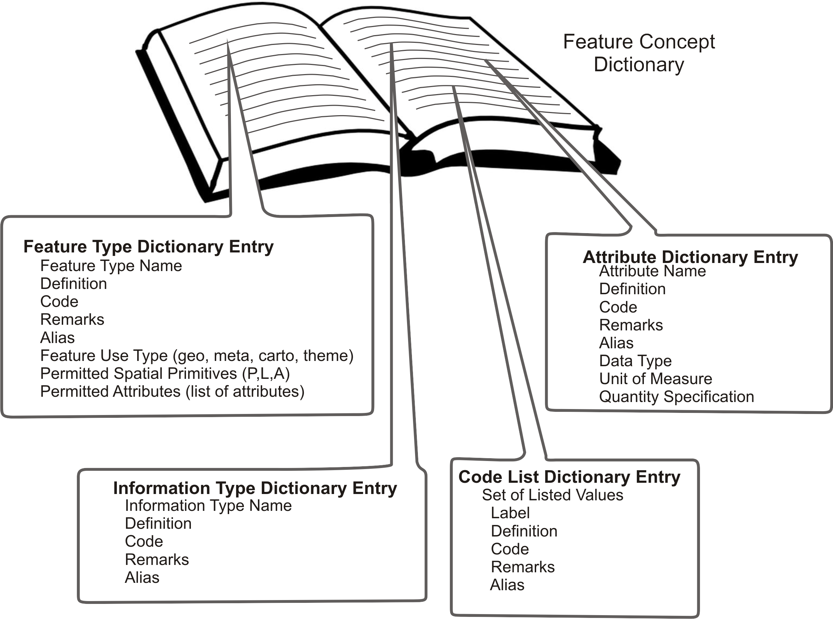
Figure C1 – Objects Recorded in the Feature Catalogue
The ISO 19152 standard defines a structure to represent Rights, Restrictions and Responsibilities, Parties and Sources. This structure also acts as a set of attributes by reference. These attributes may be shared. For example, several of the features in a MLB data set may describe sovereign rights, or have common sources. The structure inherited from ISO 19152 is implemented using the Information Objects defined in S-100. These Information Objects and their attributes and code lists of listed values are also recorded in the Feature Concept Dictionary and the Feature Catalogue.
Another attribute structure inherited from ISO 19152 is the capability to version objects. Versioning allows for individual objects to be revised using a start and end date. The alternative approach is to version entire data sets using metadata. The versioned data sets approach is used by some S-100 based products. Both versioned objects and versioned data sets can be used together.
    - Application Schema General Model
Figure C2 shows the overall S-121 Application Schema model. The S-121 Feature Unit derives directly from S-100 and takes on attributes defined in the Feature Catalogue. The S-121 Spatial Attribute Type takes on the spatial attribute types of S121_Point, S121_Curve, S121_Surface or S121_Volume. These spatial attributes take their geometry from S-100 Part 7.
This Feature and Attribute structure has a relationship to S121_Source so that source information can be provided on any feature or spatial attribute. Zone (or Space) features may also have a relationship to a Basic Administrative Unit type object, which is an Information Object. This allows Rights, Restrictions and Responsibilities to be described and associated to Parties or Group Parties. These may also be sourced.
All of the Information objects are defined in the S-121 Feature Catalogue. Each Right, Responsibility, and Restriction is described in the Feature Catalogue as a separate simple or complex attribute.
The S121_Party and S121_GroupParty are non-spatial objects. Individual parties are identified by the attribute values of the party classes.

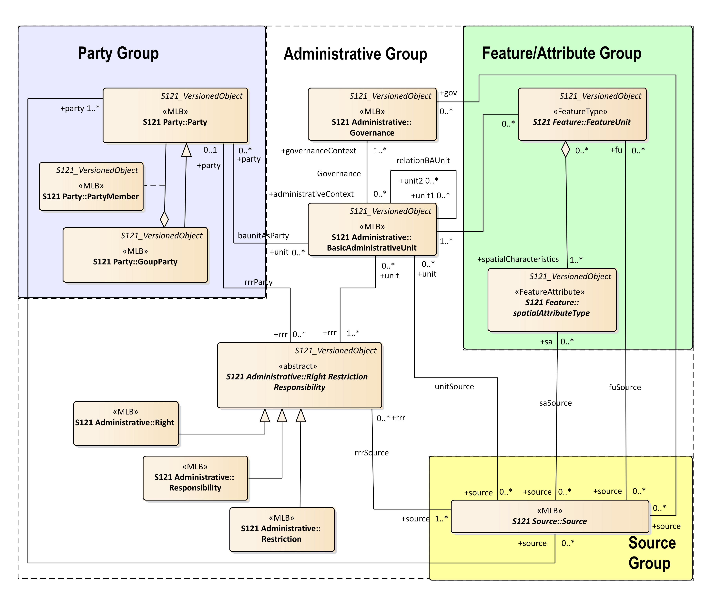
Figure C2 – Application Schema Model
    - Basic Administrative Unit Package
The Basic Administrative Unit is a collection object to “which (one or more) unique and homogeneous rights, responsibilities or restrictions are associated”. This class does not take on spatial attributes itself, but is related to the FeatureUnit, which corresponds to a feature and may take on spatial attributes. The rights, restrictions and/or responsibilities and parties structure is shared through the BasicAdministrativeUnit collection object. That is, a Basic Administrative Unit is an attribute by reference for a Feature Unit. The BasicAdministrativeBAUnit object is also a Versioned Object which allows the duration of validity for an object to be described. The BasicAdministrativeUnit is illustrated in Figure C3.
The attribute basicAdministrativeUnitType is taken from the code list basicAdministrativeUnitType and describes the types of the administrative unit.
BasicAdministrativeUnit realizes attributes from the metaclass S121_GF_ThematicAttributeType The memberName attribute is inherited and is renamed as basicAdministrativeUnitName. It establishes name for an instance of a BasicAdministrativeUnit.
The feature component of the Application Schema model is derived from IHO S-100allowing direct compatibility with other IHO product specifications. Features defined in S-121 can be imported into other S-100 based products.
The attribute uID is used in relationships between instances of the BasicAdministrativeUnit and Rights, Restrictions and/or Responsibilities and parties (Party) information objects.
The attribute basicAdministrativeUnitContext allows the context for an instance of a BasicAdministrativeUnit to be described. This would include other information that would be included with a logical administrative unit in a legal document.
Both the attribute basicAdministrativeUnitName and basicAdministrativeUnitContext support multilingual character strings in accordance with the ISO TC211 PT_Locale structure.

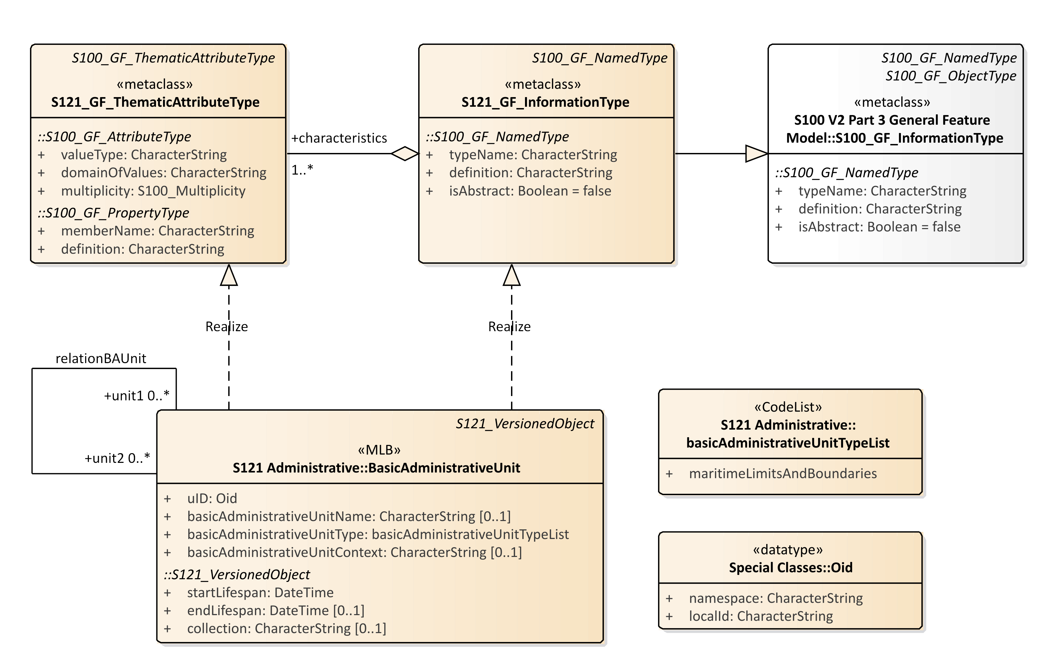
Figure C3 – S121 Basic Administrative Unit

    - Feature Unit
The class Feature Unit realizes S121_GF_FeatureType. The definition, code and other aspects are recorded in the Feature Concept Dictionary. A Feature Unit such as Exclusive Economic Zone would relate to a BasicAdministrativeUnit to take on rights, responsibilities and restrictions and party administrative attributes.
The name of the feature is optionally defined in the attribute name. The attribute name is realized from the attribute typeName from the metaclass S121_GF_FeatureType. The definition, and isAbstract of the feature are recorded in the Feature Concept Dictionary so do not need to be included in attributes.
The attribute fuID is the feature unit identifier that is referenced by the other elements of the administrative attribute structure.

The attribute label provides an optional short textual identifier of the feature unit such as the six character AlphaCode or the camelCaseCode. One of name or label is required although both a type name and a label (code) may be included.
The attribute legalStatusType optionally is used to differentiate between the legal status of particular features. It makes use of the codelist legalStatusCodeList.
The attribute context optionally describes the legal or administrative aspects of the feature object.
The attribute releasability is optionally used to differentiate between releasability status for particular features. It makes use of the codelist releasabilityTypeList.
The attributes context is of type CharacterString and may support PT_Locale from ISO 19139 (or ISO 19115-3) in order to support multi-language data description.
The Feature Unit may be associated with one or more spatialAttributeType component objects to allow shared geometry as allowed in IHO S-100.
Figure C4 shows FeatureUnit. Note that FeatureUnit is also a versioned object.
There are two constraints on the relation from FeatureUnit to SpatialAttributeType. The multiplicity constraint states that only one Spatial AttributeType version may be associated with one FeatureUnit instance at one time. The type constraint states that all Spatial Attribute Types associated with a FeatureUnit shall be of the same geometric type Point, Curve or Surface. Versioning allows the Spatial Attribute instance to be changed, but not its type.
Another constraint requires that there be either a name or a label identifying the feature.

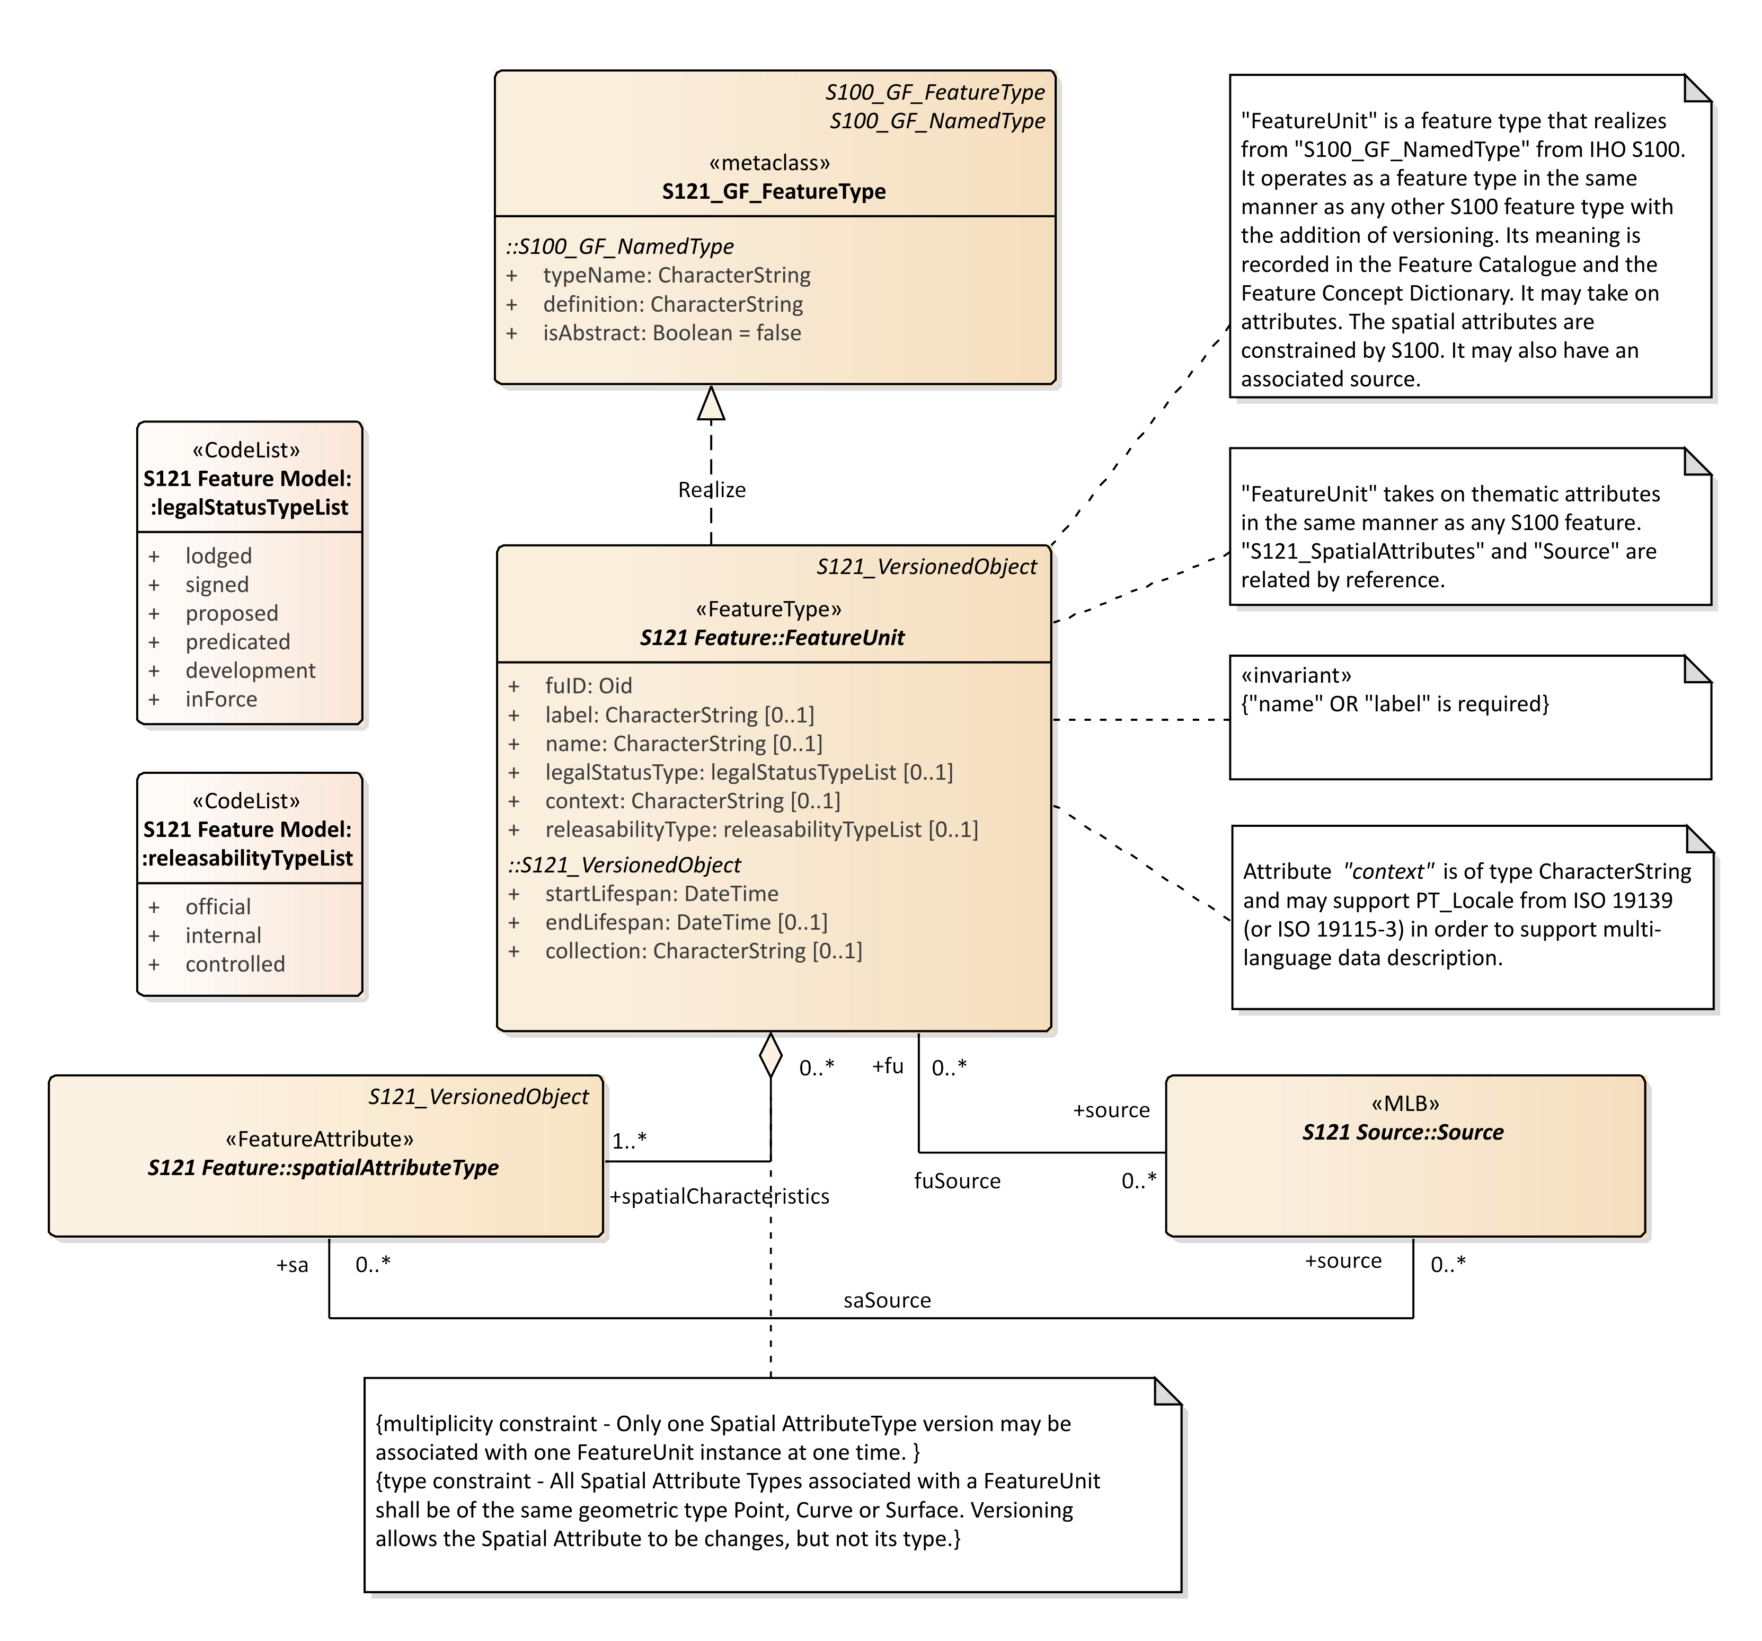
Figure C4 – S121 Feature Unit
    - Spatial Attribute
The spatial properties of the S--121 Application Schema make use of the class spatialAttributeType which derives from the S100 geometry model. This class has a component relationship with FeatureUnit and is in effect an attribute class carrying spatial characteristics. Only the geometry types GM_Point, GM_MultiPoint, GM_Curve, GM_Surface, CV_Coverage, GM_Curve (arcByCentrePoint and circleByCentrePoint) may be used.
The approach to geometry in S-121 is different from that used in ISO 19152 which is based on a surveying model. S-100 allows only one geometry per feature. Composition is handled at the feature level through complex feature objects. It is straight forward to convert from the ISO 19152 to and from the S-100 geometry model because both are based on the ISO 19107 spatial schema. They differ only in how composition is done. S-121 uses the IHO S-100 approach.
The attributes and relationships of spatialAttributeType are shown in Figure C5
The attribute saID is the spatial attribute identifier that is referenced by the FeatureUnit.
The attribute locationByText allows a spatial attribute to be a textual description. This allows locations, limits, zones or spaces that are not fully described geometrically to be included. This is important in some legal cases where only some of the boundaries of a zone may be rigorously described.
A CoordinateReferencingSystem (CRS) may optionally be described using the attribute referenceSystem. Some treaties points or lines may come from different sources and it is possible in one data set to make use of more than one CRS.

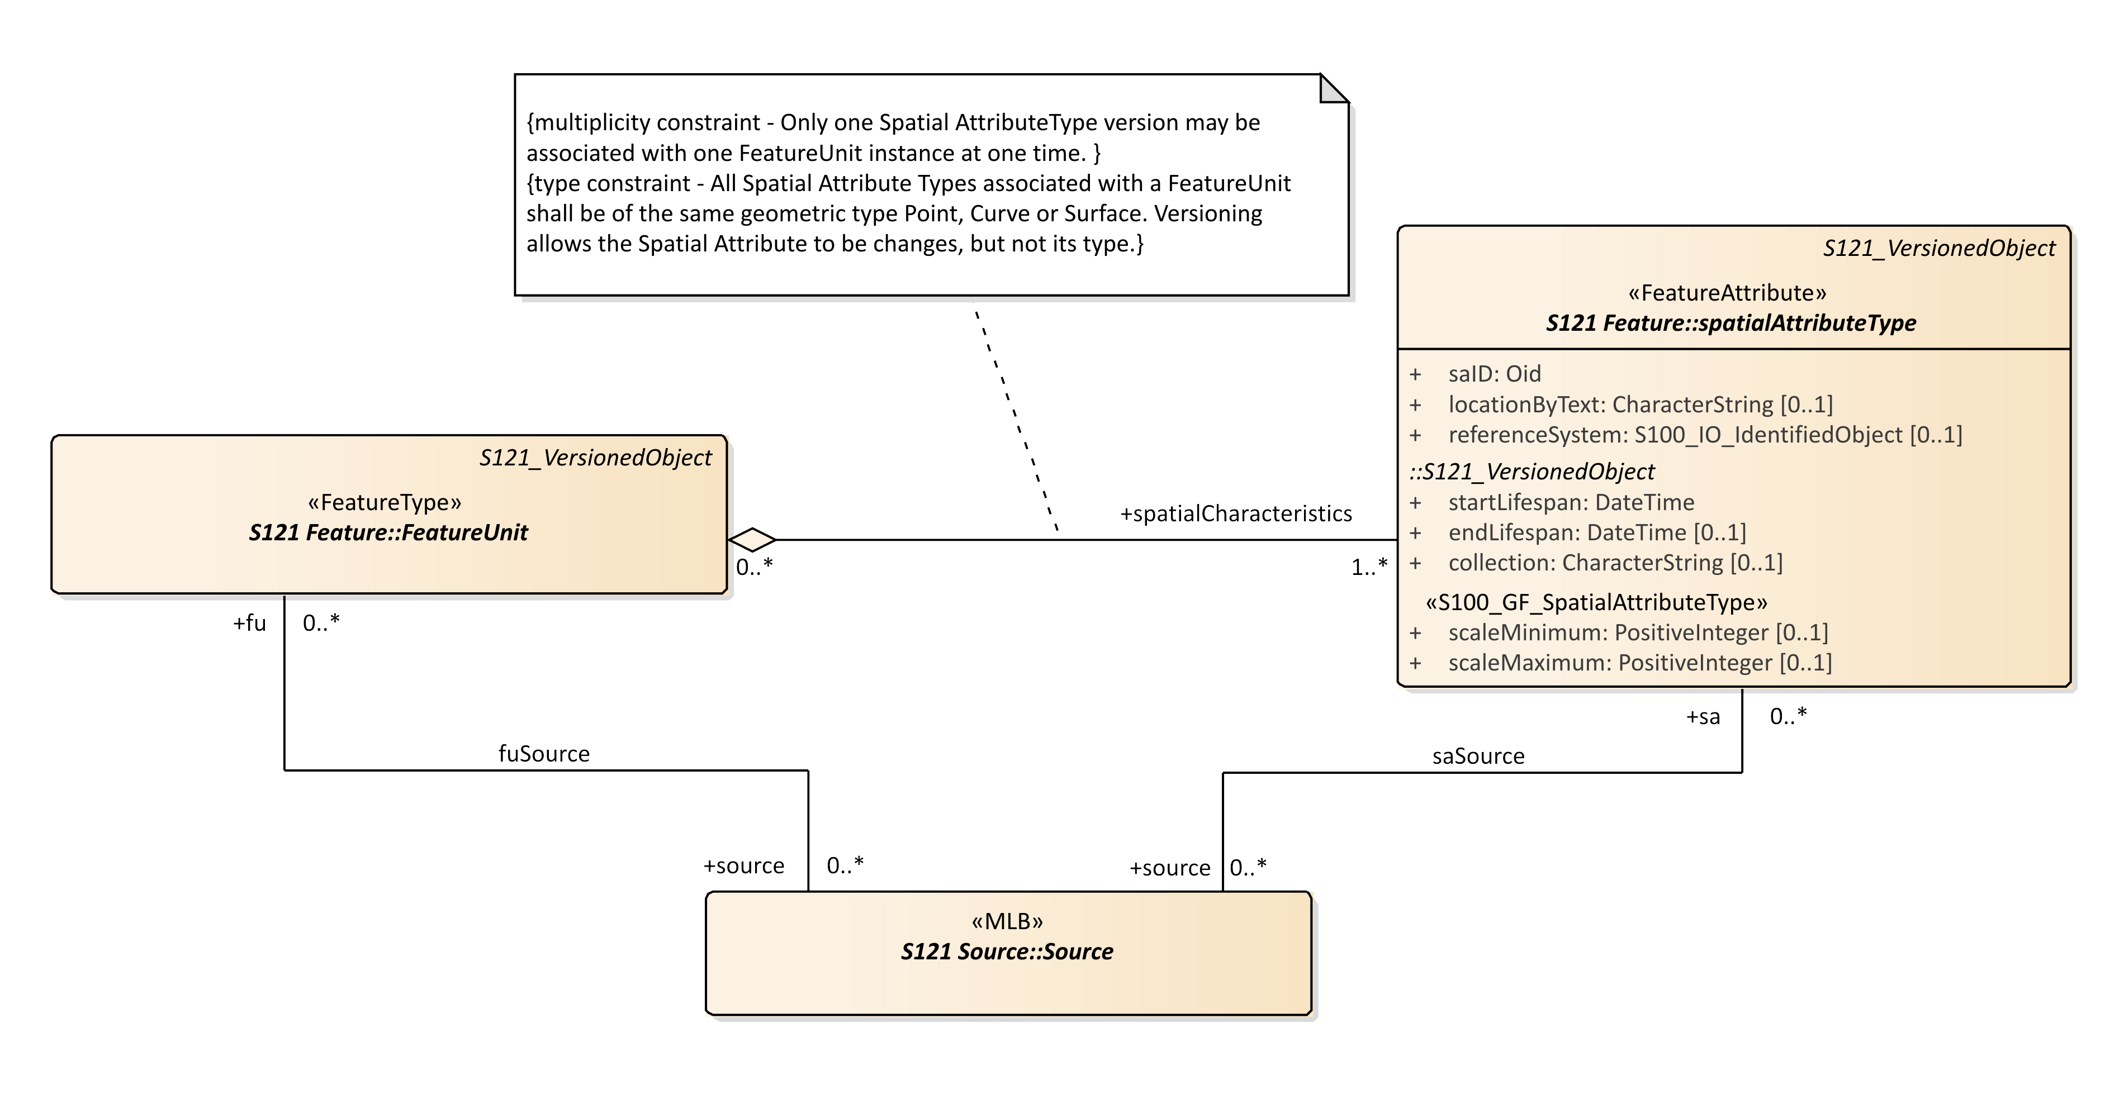
Figure C5 – S121 Spatial Attribute Type
The attribute referenceSystem references the class S100_IO_IdentifiedObject. This in turn references a series of other classes shown in Figure C6 that identify the CRS. This includes an optional reference to an authority that makes use of the metadata class CI_Citation. This is complex way of duplicating the role of S121_Source, so a constraint is applied to make use of the S121_Source approach.

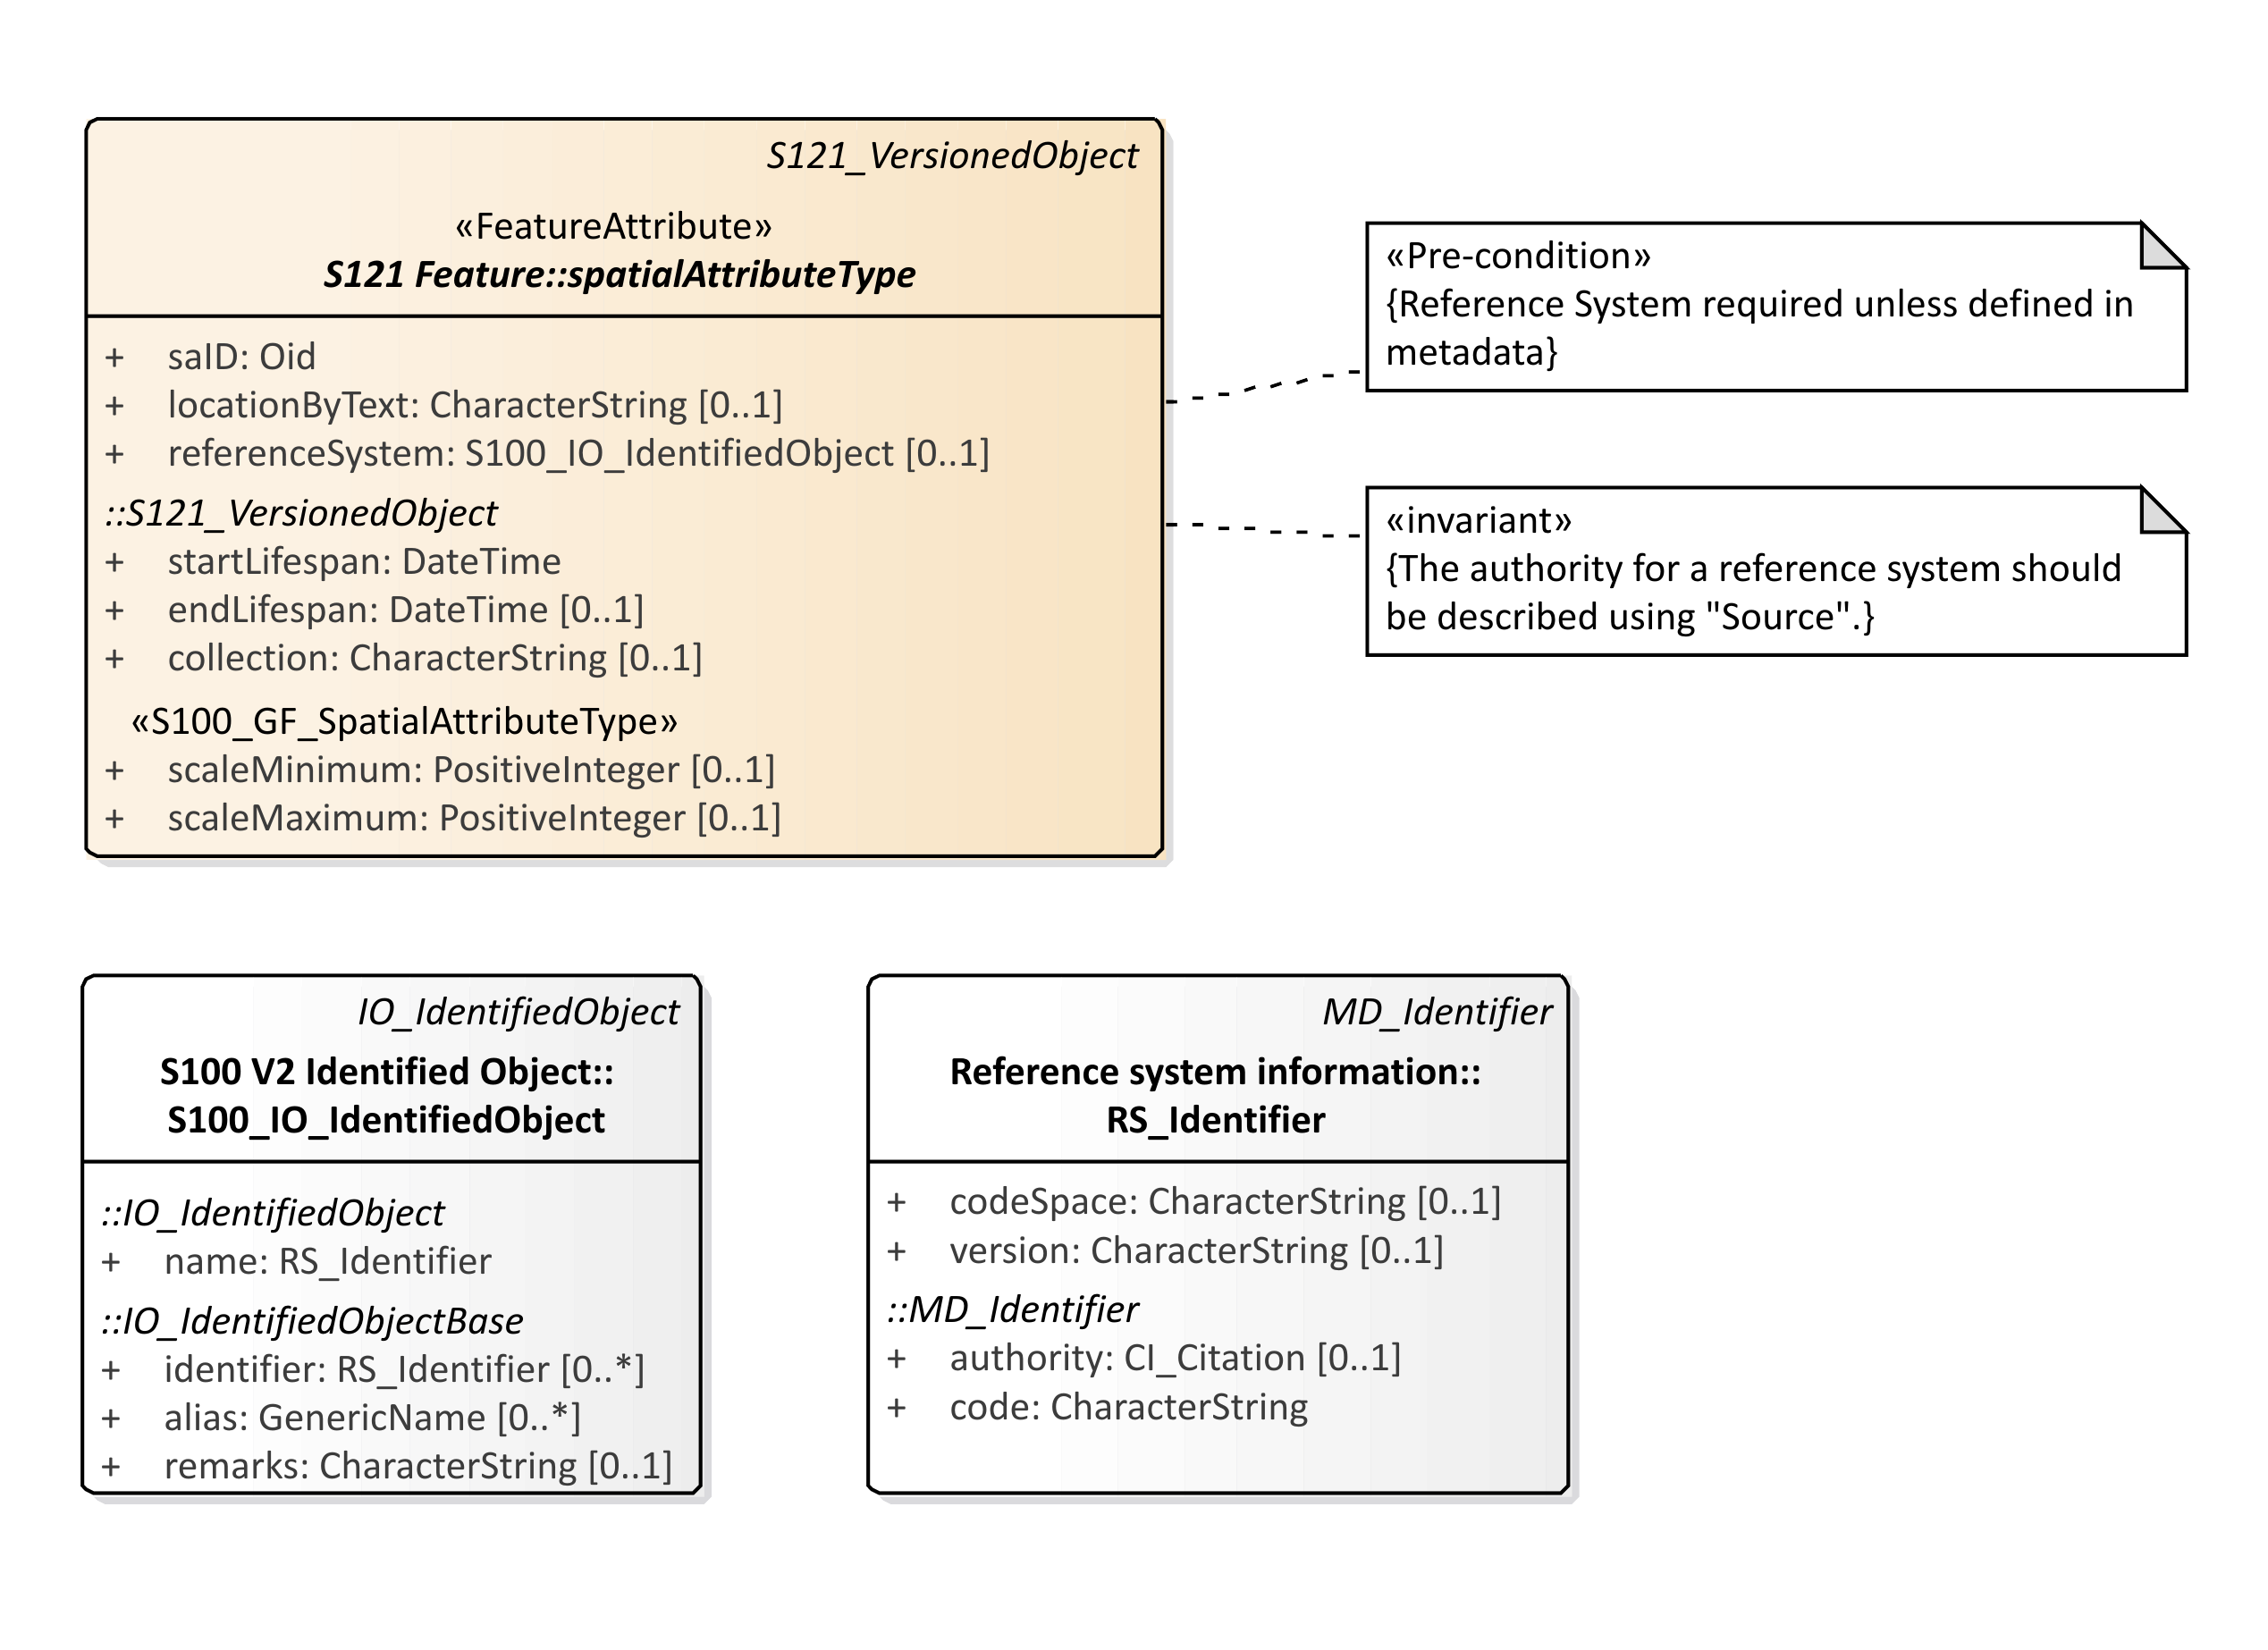
Figure C6 – S121 Reference System Attribute

Since the domain of rights for some of the UNCLOS feature objects have different vertical extents it is necessary to address the third dimension. This is done by using a height description attribute on 2D features to establish a volume. 3D space type features that support volume have the same feature types as 2D zone type features.
Figure C7 shows spatial geometry for each of the four feature types Location, Limit, Zone and Space. S-100 separates features types and spatial attribute types.
The locationByText attribute is a spatial attribute that allows a textual description. There are some situations where MLB authoritative documents do not geometrically describe all boundaries of a zone. This may be for political or legal reasons so that the data set is not prejudicial. If both spatial geometry and text are both provided then the geometry may be considered as an approximation and the text as the authoritative description.
Feature to feature relations are allowed between the Location, Limit, Zone and Space objects. This will allow one to associate particular treaty or control points to delimit curves and particular curves to bound zones. Since administrative attributes such as Rights only apply to Zones and Spaces it is necessary to have a mechanism to relate a Zone or a Space to Limits and Location points when the geometric elements are not described.

Figure C7 – Spatial Geometry

The Basic Administrative Unit (BasicAdministrativeUnit) acts as an attribute by reference to provide administrative attributes of Rights, Restrictions or Responsibilities to the Zone and Space feature units. This is shown in Figure C8.

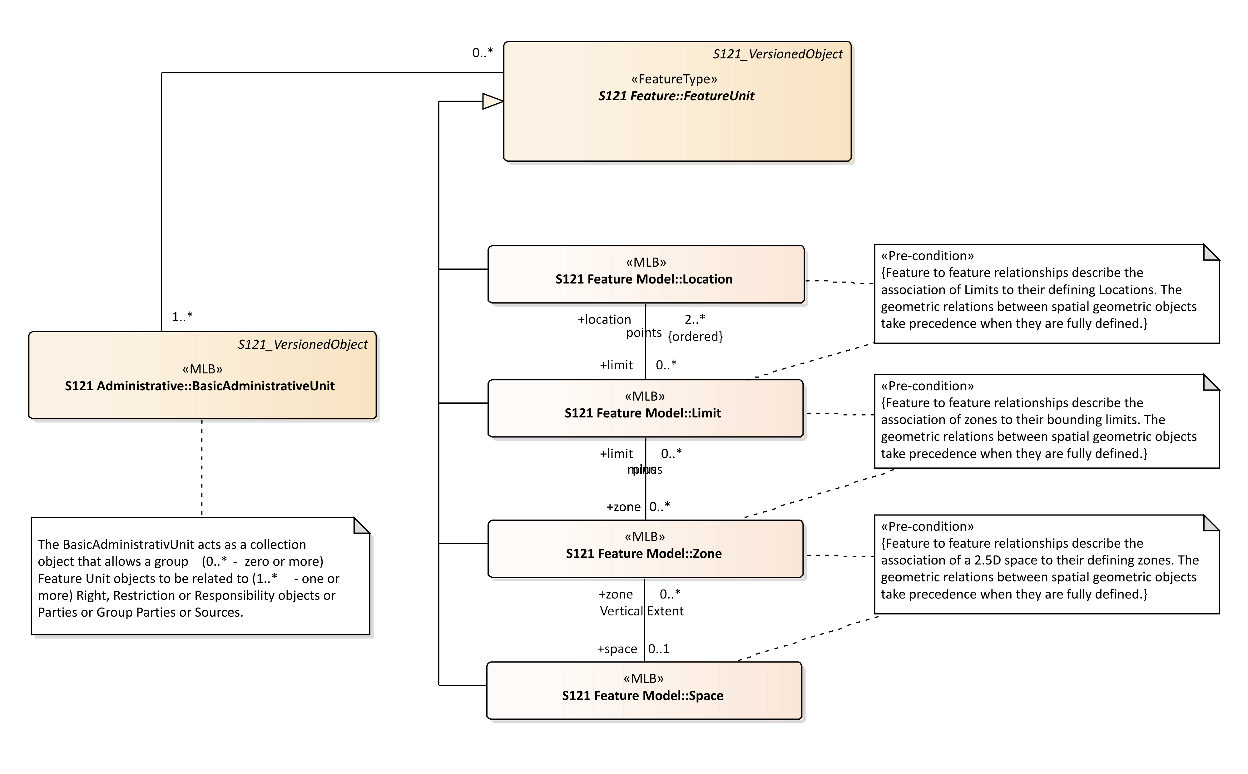
Figure C8 – Relation of Administrative Structure to Feature Unit

Source is described by reference to the Source information object. In the ISO 19152 standard there are two subtypes of Source are a SpatialSource and anAdministrativeSource. In S-121 this has been consolidated into one Source Information Object with two conditional attributes. The attributes spatialSourceType and administrativeSourceType that identify different code lists. This is shown in Figure C9.

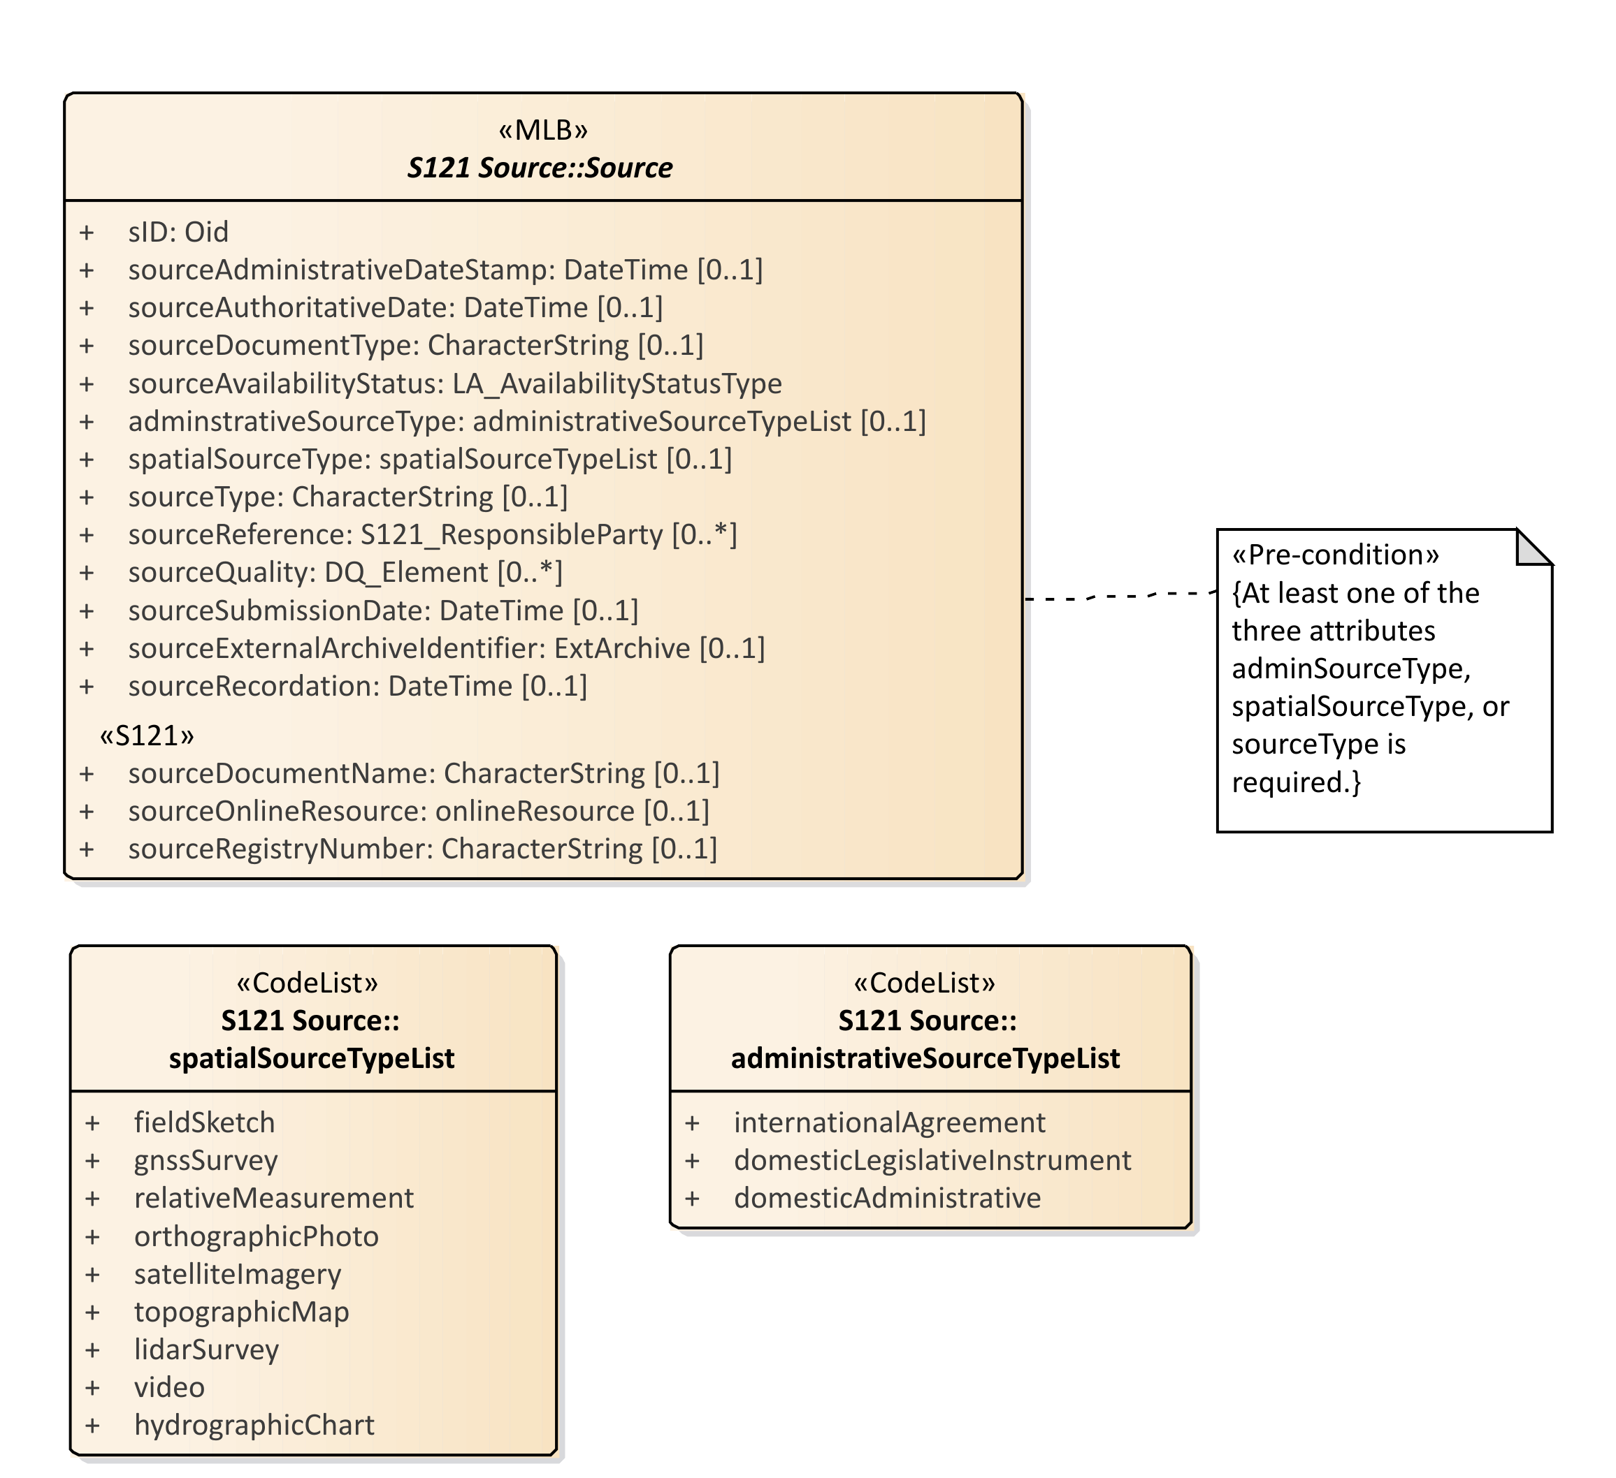
Figure C9 – Source
Figure C10 shows the Source object with all of the associated code lists and associated support classes. A set of attributes, stereotyped S121, explicitly describe the information pertinent to source documents in a legal environment. These are:
- sourceDocumentName – Document name - for example the document (legislation, treaty, title) that defines the object;
- sourceOnlineResource – official URL (or equivalent online resource) where the document is distributed;
- sourceregistryNumber – Unique official identifier of the record in a registry. For example, in states with registers of legislative instruments, versioning is controlled by the registry ID;

The other S121_Source attributes are:
- sID – the identifier of the source;
- sourceAdministrativeDateStamp – the moment that the event represented by the instance of S121_Source is further processed;
- sourceAuthoratitiveDate – the date of force of law of the source by an authority;
- sourceDocumentType – the type of document;
- sourceAvailibilityStatus – the status of document from the code list LA_AvailabilityStatusType;
- administrativeSourceType - descriptive documentation that supports, complement or describes the associated object;
- spatialSourceType - The type of spatial "Source" document;
- sourceType - The type of "Source" document Reference:
- sourceReference – reference to source through the class S121_ResponsibleParty;
- sourceQuality – Data Quality description through the metadata class DQ_Element;
- sourceSubmissionDate – The date of submission of the source by a party;
- sourceExternalArchiveIdentifier – The identifier of a source in an external registration;
- sourceRecordation - The date of registration (recordation) of the "Source" by registering authority.
The code lists and classes referenced are:
- DateTime – a data type for recording clock time;
- LA_AvabilityStatusType – a code list identifying the status of a source archive;
- SpatialSourceTypeList - Category of "spatialSourceType" (from ISO 19152:2012);
- AdministrativeSourceTypeList - Category of "administrativeSourceType" (from ISO 19152);
- responsibleParty - The responsible party of the "Source";
- CI_RoleCode - Responsible Party Role;
- EX_Archive – metadata about an external archive;
- DQ_Element – a metadata class describing data quality of the source data;
- DQ_EvaluationMethodTypeCode – a code list of the method used to evaluate data quality;
- DQ_Result – results of the data quality evaluation;
- CI_RoleCode – a code list of information about the function performed by the responsible party for the source data;
- CI_OnlineFunctionCode – a code list of the online function performed by an online resource as part of a contact for a responsible party for a source;
In addition the ISO metadata class CI_ResponsibleParty has been realized in S-121 to be ResponsibleParty. This includes the classes Contact, OnlineResource and Address that are realizations of the ISO classes CI_Contact, CI_Address and CI_OnlineResource. The attributes and inheritance of S121_Source are shown in Figure C10.
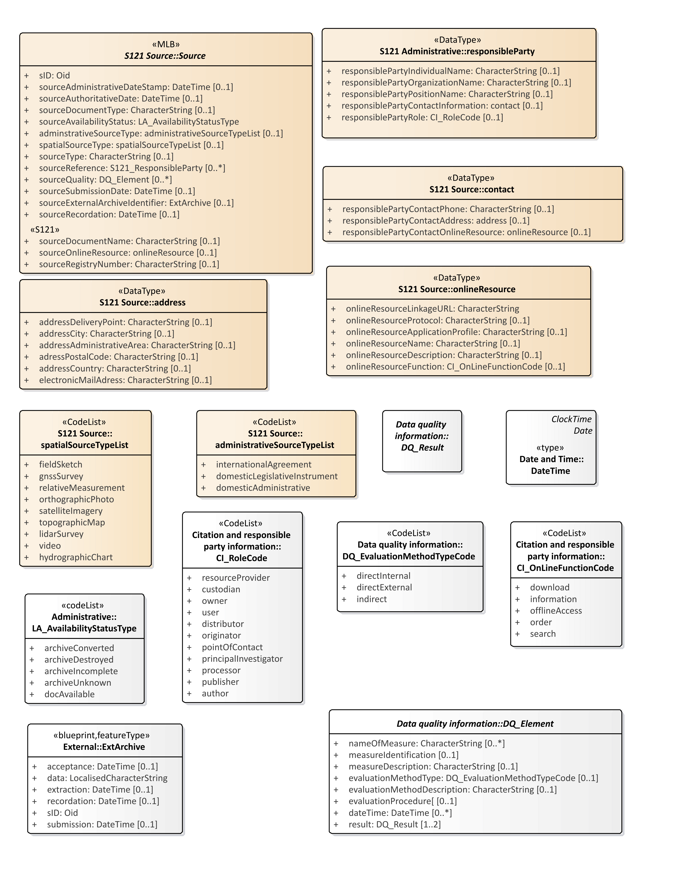
Figure C10 – S121_Source Attributes

    - Party Unit Package
A party is “a person or organization that plays a role in rights”. A Party is considered as an object which allows it to be shared. That is, a party may be part of several different rights, responsibilities and restrictions. A Group Party is also a Party that consists of several individual parties. The PartyMember class provides an attribute on the composition attribute that forms a group out of several party members. This optional attribute allows parties to have different shares within a group. The types of Parties and Group Parties are described by partyType and partyGroupType. Figure C11 shows the Party structure.

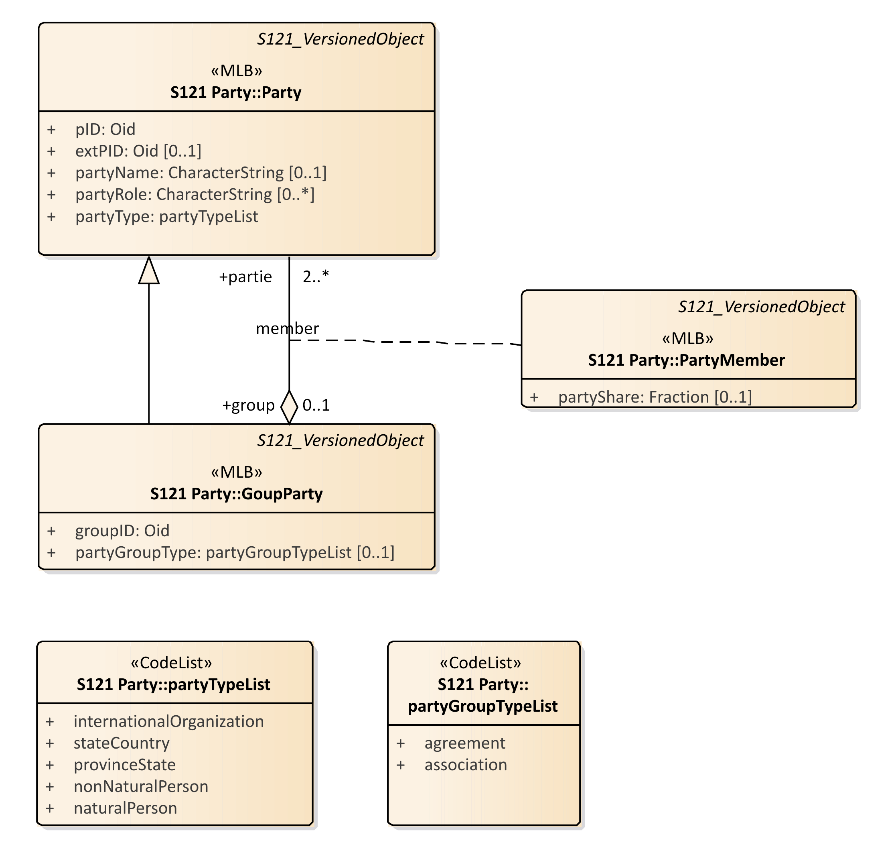
Figure C11 – S121 Party Package
The relationship between Parties, Group Parties, Rights, Restrictions and Responsibilities and feature objects (BasicAdministrativeUnit) is by reference through the Oid (Object ID). pID is the identifier of the party and optionally exPID is an identifier of the party in an external registration.
    - RRR Administrative Package
The RRR administrative package associates parties with Basic Administrative Units (BasicAdministrativeUnit). There are three subtypes.

1. Right, with rights as instances. Rights are primarily in the legal domain.
2. Responsibility, with responsibilities as instances.
3. Restriction, with restrictions as instances. Restrictions usually apply to objects independent of the rights; that is, the related party can change and the restriction remains.
Rights, Responsibilities and Restrictions appear as attributes for an BasicAdministrativeUnit.
The code lists that define the rights, responsibilities and responsibilities are rightTypeList, responsibilityTypeList, and restrictionTypeList. Code lists are used, rather than character strings in order to ensure consistency.
These objects are stand-alone entities that act as attributes by reference. They are Information Objects and do not carry spatial attributes. This structure has the advantage over direct attribution in that it collects the attribute values to make them easier to maintain. Feature objects may point to the appropriate information objects using the Oid (Object ID) attribute. For example if a particular restriction applies to a fishing zone, then all features that invoke the restriction would point to the information object that establishes that restriction. If the restriction is changed it only needs to be changed once, not through the attributes in possibly hundreds of feature objects.
Figure C12 shows the S121 Administrative Rights, Responsibilities and Restrictions.

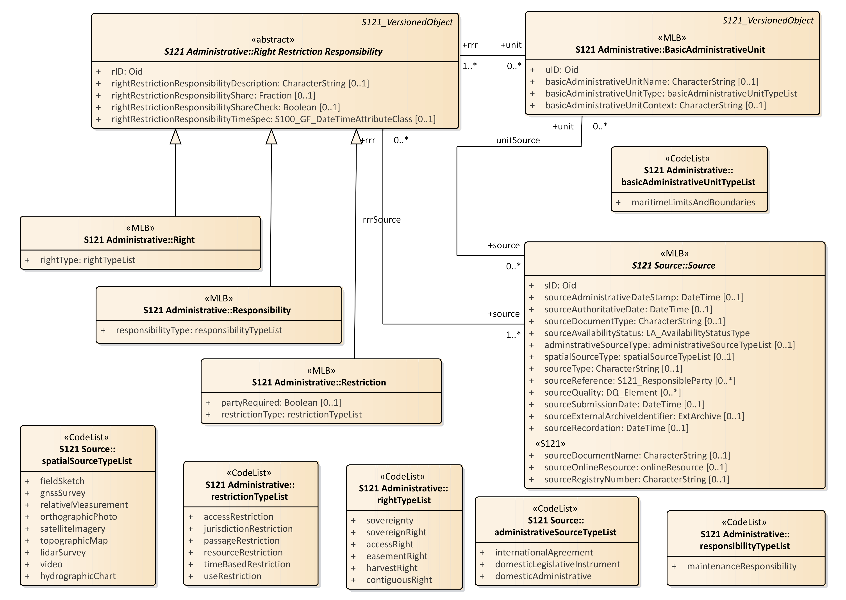
Figure C12 – S121 RRR Administrative Package

    - Governance Object
Treaties and other descriptive legal documents normally contain a textual preamble that contains information specific to the legal status of the data, or exchange data set (such as a deposit in compliance with the depositary obligations of UNCLOS). This information requires another type of Information Object. This information object is called a governance object. This information is not metadata. It is part of the dataset containing specific legal text, but it may duplicate some metadata elements such as title. The governance data object may be versioned and can reference a source or sources.
All of the attributes of the governance object are optional except for the identifier attribute: govID. There may be zero or more (0..*) governance objects associated with a BasicAdministrativeUnit. When generating a data set from data held in the S-121 data model the governance objects associated with the Basic Administrative Units selected for output would be included with the output data.
There are several optional attributes that may be used to carry specific aspects of the textual preamble such as the title (governanceTitle), or the reference number (referenceNumber) of the data. The textual preamble would be carried as a character string in the governance description (governanceDescription) attribute.
The attributes are:
govID - Reference to information objects using the "Oid" (Object ID) attribute. The "Oid" comprises a unique character string and a namespace identifier which is also a unique character string. An example might be "Governance-1" where "Governance" is the namespace and "1" is the unique id within that namespace.
referenceNumber - The reference number of the legal reference.
label – A short textual identifier of the governance object.
name – The name of the governance object.
governanceTitle – The title of the legal reference.
governanceDescription – A character string containing the governance statement.
releasibilityType – Optionally used to differentiate between releasability status for particular features
dateApproved - The date at which the legal statement or document was approved by the appropriate governing body.
dateConsidered – The date at which the legal statement or document was considered by the appropriate governing body.
dateIntroduced - The date at which the legal statement or document was introduced.
Figure C13 shows the Governance Object structure.

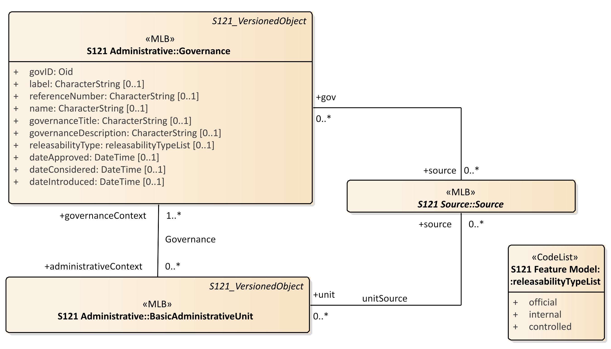
Figure C13 – Governance Object

    - Versioned Object
Versioning is a critical aspect for legal data. Each feature object and information object can be separately versioned. This is done by including two attributes in each of these objects that define the beginning and end dates of validity.
Versioned and non-versioned objects may be combined in a data set. Non-versioned objects are implicitly versioned by the metadata date stamp on the whole data set. Versioning is particularly important when data is extracted from an online database. Figure C14, which shows the S121 objects include versioning attributes.
The VersionedObject also contains the attribute collection. This attribute allows one to describe several different collections of data. For example the UN may hold data from Canada, France and other countries in the same database. There may be a unique numbering or naming system for feature and information object instances in Canada and another one in France, but there is no assurance that the two namespaces do not conflict. The collection attribute identifies which “collection” a data element is a member of. Effectively it ensures a unique namespace. This attribute is conditional. It is required in a database that contains information from different suppliers. The attribute is not required in a countries national database (if the country has a unique and unambiguous name or numbering system, and it is not required in an exchange data set because the metadata of the entire dataset uniquely identifies the dataset.

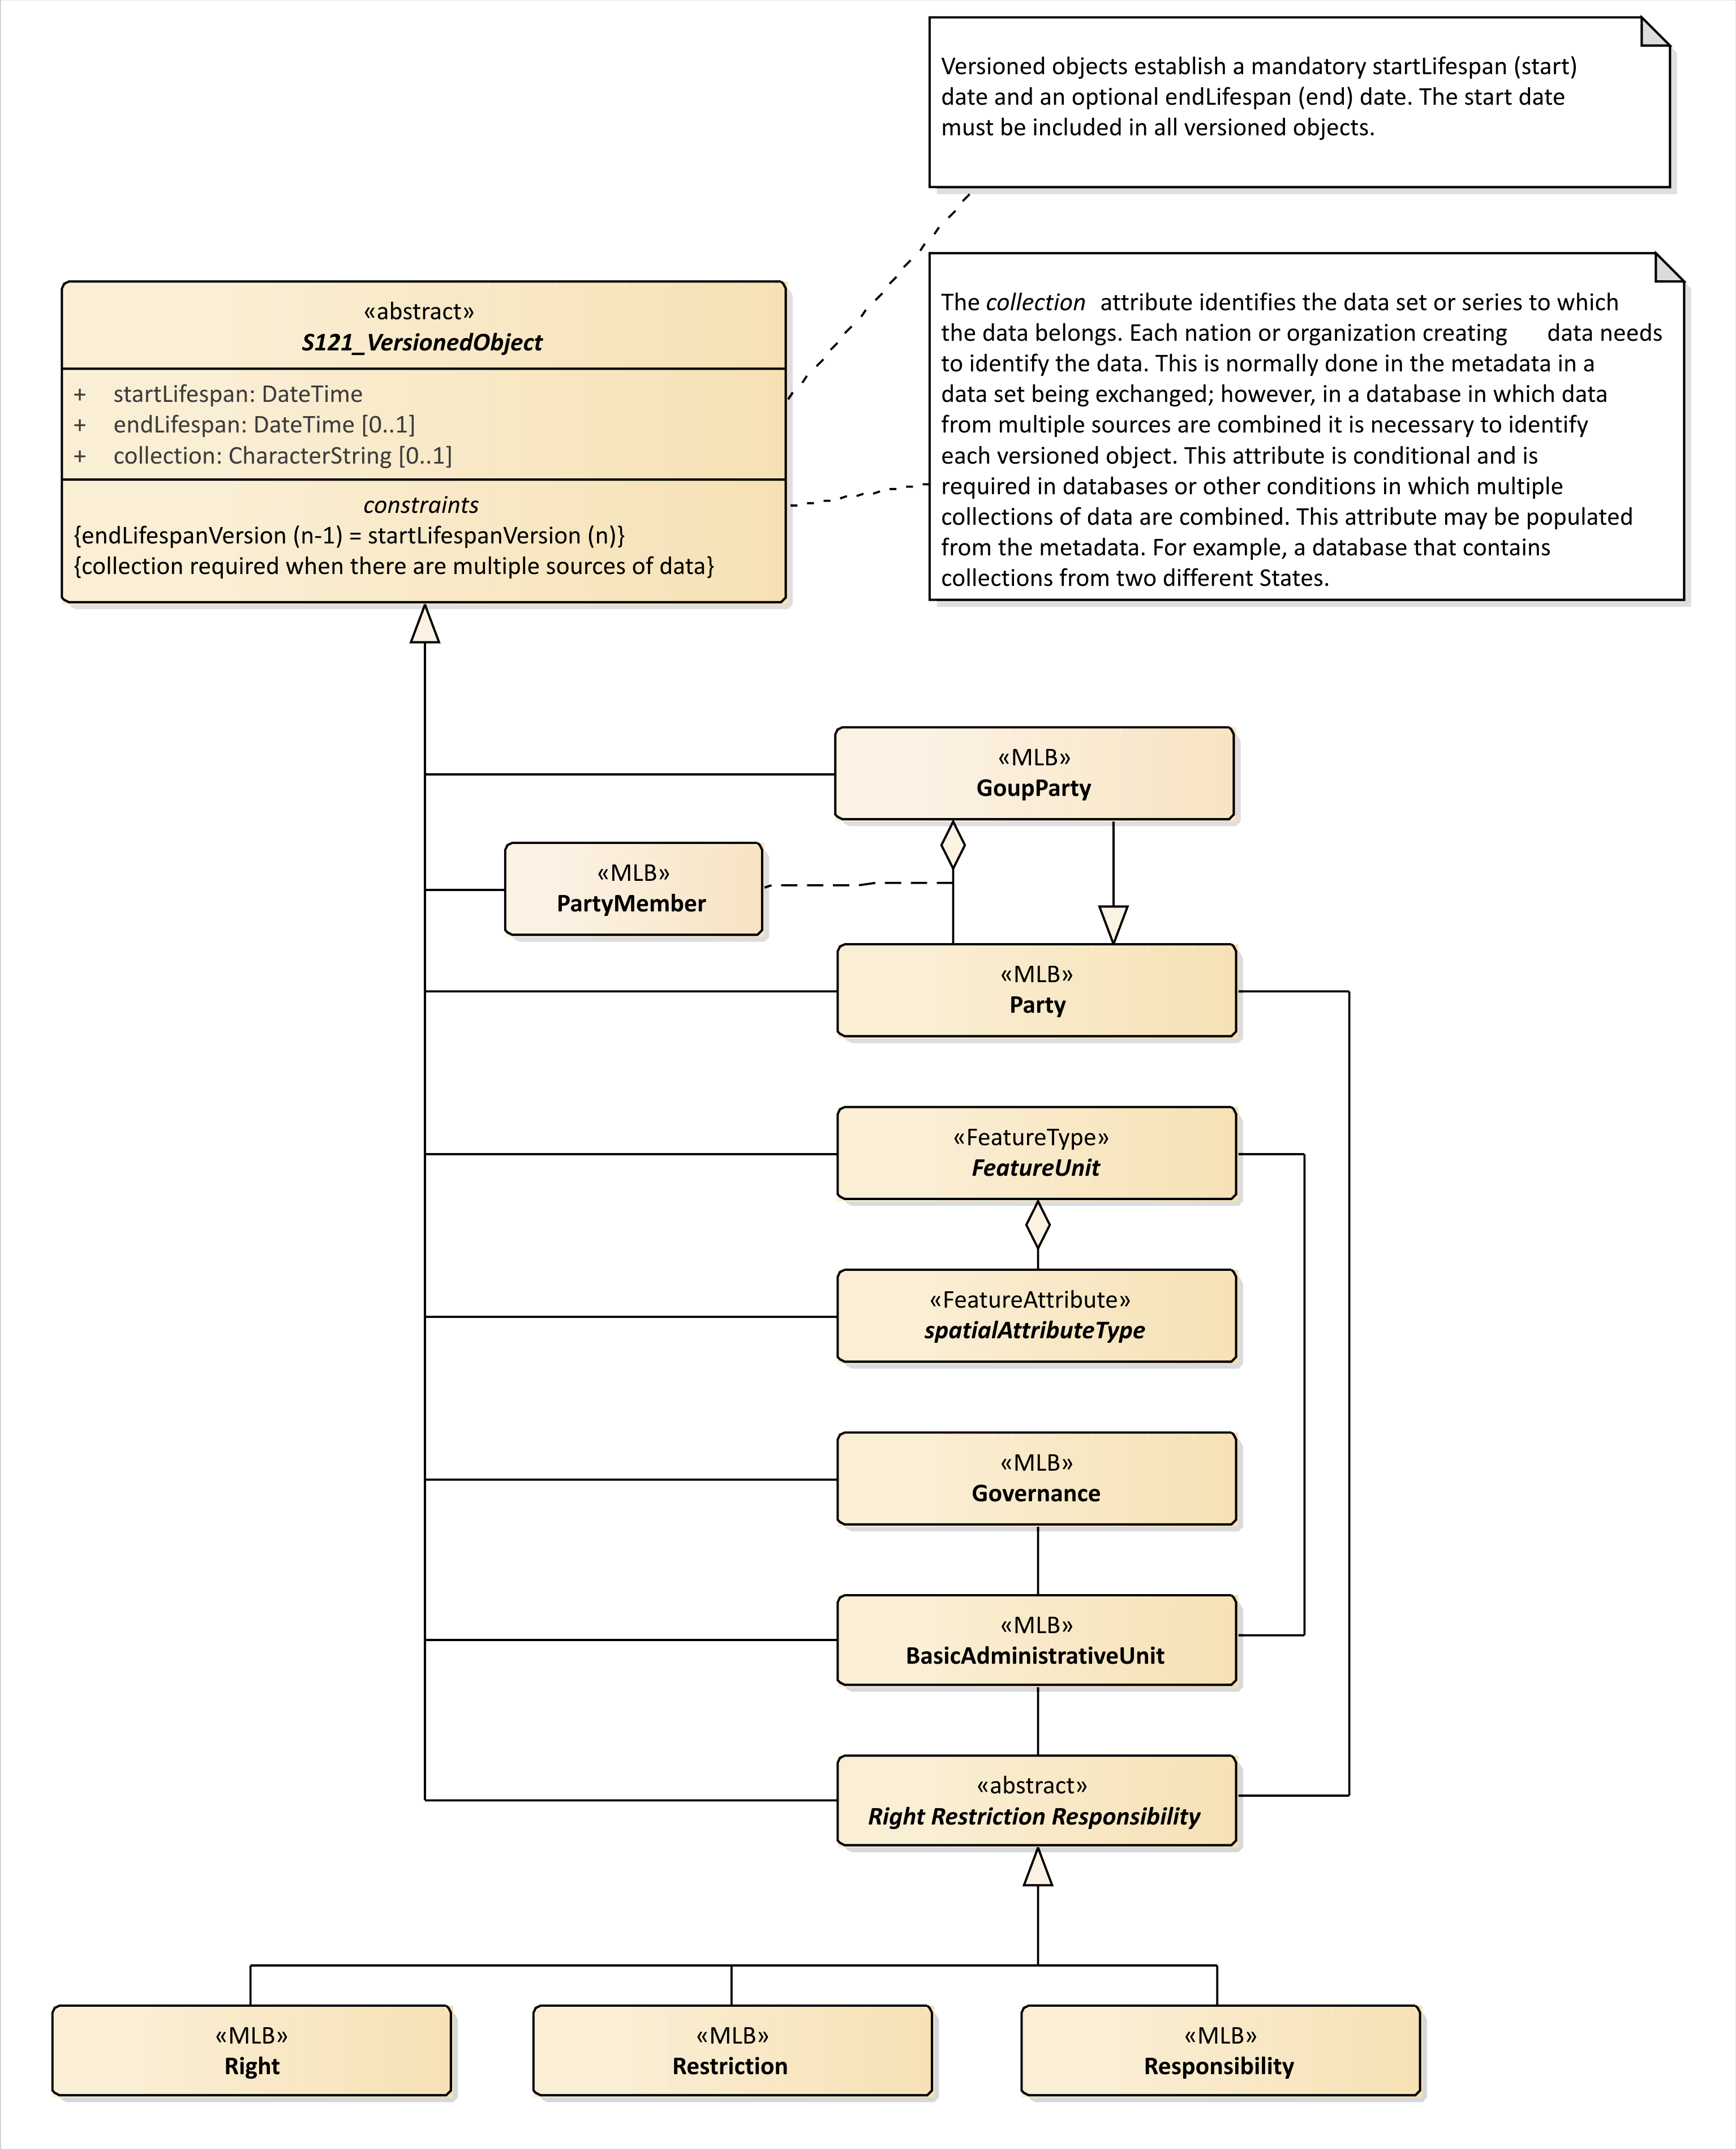
Figure C14 – Versioned Objects
  - Implementation Model
The implementation model for S-121 is shown in Figure C14. It shows four groups of objects, The Feature/Attribute Group which is derived directly from S-100 and the three additional groups added by S-121. There are only 11 instantiable classes. These additional groups are the Administrative Group that defines the Basic Administrative Unit and the Rights, Restrictions and Responsibilities. The Party group defines Parties and the Source Group defines Source references. The governance object is also part of the Administrative Group.
The structure is really very simple. There is one link from a Feature Unit to the Administrative Group BasicAdministrativeGroupUnit for Zone type features and Space type features. The whole Administrative and Party structure simply behaves as an attribute by reference describing the Rights, Responsibilities and Restrictions and the Parties involved for that Feature. It is simply a complex shared attribute.
The Administrative group and the Spatial Attribute associated with a feature may also reference the S121_Source in the Source group. This is also an attribute by reference and it allows source references to be shared.
The Feature, Administrative and Party groups are versioned objects. If a source changes a new source reference instance should be generated.
The implementation model shown in Figure C15 has resolved many of the relations to be navigable in one direction meaning that they can be implemented as pointers in an encoding structure or as simple single ended join tables in a database implementation. The pointers emanate from the FeatureUnit making the feature the central object in alignment with the philosophy of S-100.
The integration of objects from S121 into another S-100 based product such as S-101 is very simple. The versioning needs to be resolved to a single instance in time (since S-101 and many other types of data are versioned at the data set level), and those attributes from the S-121 administrative structure relevant in an S-101 environment need to be converted to thematic attributes of the feature. The Feature Type and spatial attributes should be directly usable. For example, if a producer wishes to include an EEZ boundary in an electronic chart, the feature object from the S-121 data “Outer Limit of the Exclusive Economic Zone” with its spatial attributes could be used directly or converted to whatever feature type name was appropriate in the S-101 context. The spatial attributes could also be used directly. The S-121 feature would have a pointer to an instance or instances of BasicAdministrativeUnit objects and then on to Right, Responsibility and Restriction and Party classes. Selected information from these classes, such as the sovereign right and country, could be converted into an attribute on the feature used in S-101. This gives us exactly what we have in S-101 at the present time. The S-121 structure addresses the more rigorous legal environment and the eNavigation environment takes what it needs into the S-101 environment.
The structure of the party group has been transformed in the implementation model. Since the GroupParty class inherited from ISO 19152 is a subtype of the Party class with an extra attribute, these two classes have been combined with the inclusion of a constraint that indicates that the additional attribute party group type (partyGroupType) is to only be used in a group party. The Party Member class then become a related object. This simplifies the implementation for those systems that cannot support a relationship class used for the purpose of carrying an association attribute.

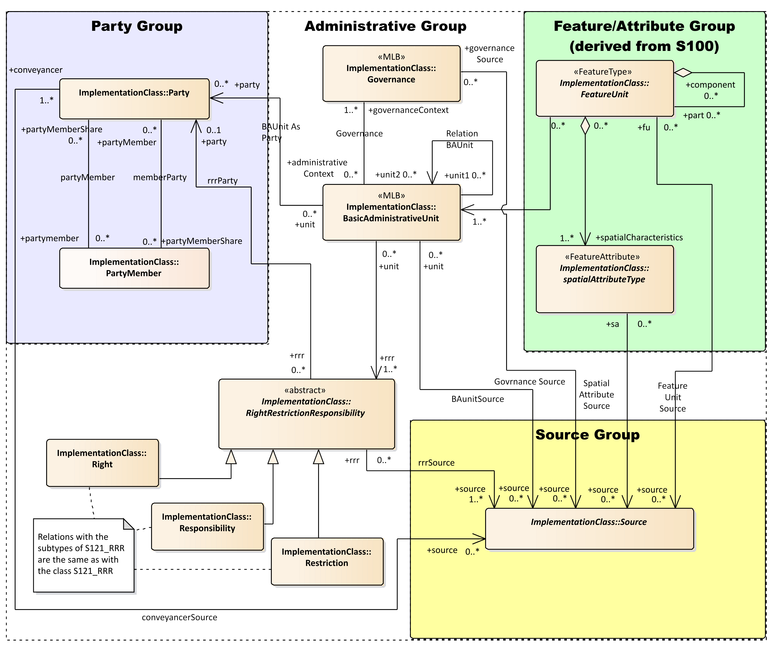
Figure C15 – S-121 Implementation Model

- Bibliography
(Informative)
- IHO S-100 IHO Universal Hydrographic Data Model (June 2015)
- ISO 3166-1:1997 - Codes for the representation of names of countries and their subdivisions,
- ISO 19101:2003 - Geographic Information – Reference model,
- ISO 19103:2003 - Geographic Information – Conceptual schema language,
- ISO 19107:2003 - Geographic Information – Spatial Schema,
- ISO 19110:2005 - Geographic information – Methodology for feature cataloguing,
- ISO 19115:2003 - Geographic information – Metadata
- ISO 19128:2005 - Geographic information – Web map server interface,
- ISO 19131:2007 - Geographic Information – Data product specifications,
- ISO 19136:2007 - Geographic Information – Geography Markup Language,
- ISO 19142:2010 - Geographic information – Web Feature Service
- NIMA Technical Report TR8350.2 Department of Defense World Geodetic System 1984, Its Definition and Relationships with Local Geodetic Systems, Third Edition, National Geospatial-Intelligence Agency.
- OGC Catalogue Service for the Web http://www.opengeospatial.org/standards/cat
- OGC (Keyhole Markup Language) KML 2.2 Document 07-147r2 http://www.opengeospatial.org/standards/kml
- EPSG Geodetic Parameter Registry Version: 8.3.3, http://www.epsg-registry.org/.
- WC3 Extensible Markup Language (XML) https://www.w3.org/XML/

The normative reference is to the base ISO 19115:2003 metadata standard because IHO S-100 references this version of the ISO standard. The revised standard ISO 19115-1:2014 is backward compatible with ISO 19115:2003 with respect to the metadata elements used in this S-121 Product Specification.
In addition to GML, the Google Keyhole Markup Language (KML) has been identified as an encoding.
ISO 19152
PT_Locale is defined in ISO 19139 and ISO 19115-3 which are the XML encodings for metadata, although the structure allows any text string to include an identifier of language and text in that language..
ISO 19152 LADM clause 4.1.13

