Part 2 - Management of Registers

Contents

2-1 Scope .............................................................................................................................. 1
2-2 Conformance ................................................................................................................... 1
2-3 Normative references ...................................................................................................... 1
2-4 General concepts ............................................................................................................ 1
2-4.1 Registry ........................................................................................................................... 1
2-4.2 Register ........................................................................................................................... 2
2-5 Roles and responsibilities in the management of registers............................................. 2
2-5.1 Register Owner ............................................................................................................... 2
2-5.2 Register Manager ............................................................................................................ 2
2-5.3 Register User .................................................................................................................. 2
2-5.4 Domain Control Body....................................................................................................... 2
2-5.5 Executive Control Body.................................................................................................... 2
2-5.6 Submitting Organizations ................................................................................................ 3
2-5.7 Processing of Proposals.................................................................................................. 3
2-6 Process of Proposals………............................................................................................ 4
2-6.1 Process of Concept Register........................................................................................... 4
2-6.2 Process of Data Dictionary Register, Portrayal Register................................................. 5
2-6.3 Process for each step...................................................................................................... 6
2-6.4 List of Submitting Organizations...................................................................................... 7
2-6.5 Publication....................................................................................................................... 7
2-6.6 Integrity............................................................................................................................ 7
2-7 Register Schema ............................................................................................................. 7
2-7.1 Introduction...................................................................................................................... 7
2-7.2 S100_RE_Register.......................................................................................................... 9
2-7.3 S100_RE_RegisterItem................................................................................................... 9
2-7.4 RE_ItemStatus ................................................................................................................ 10
2-7.5 S100_RE_ReferenceSource ........................................................................................... 11
2-7.6 RE_SimilarityToSource ................................................................................................... 11
2-7.7 S100_RE_Reference ...................................................................................................... 12
2-7.8 S100_ RE _ManagementInfo .......................................................................................... 12
2-7.9 RE _DecisionStatus ........................................................................................................ 13
2-7.10 S100_ RE _ProposalType............................................................................................... 13

Part 2 - Management of Registers

Page intentionally left blank

Part 2 - Management of Registers

2-1 Scope

This part of S-100 specifies procedures to be followed in maintaining and publishing registers of unique, unambiguous and permanent identifiers that are assigned to items of geographic, hydrographic and metadata information. In order to accomplish this purpose, this part describes the roles and responsibilities for the management of a registry and its registers. Specific administrative details of the IHO Geospatial Information Registry and registers is documented in IHO Publication S-99.

2-2 Conformance

This profile conforms to level 2 of ISO 19106:2004. The following is a brief description of the specializations and generalizations where the profile differs from ISO 19135:2005.

1) S100_RE_Register constrains the use of the attribute alternativeLangauges.

2) S100_RE_RegisterItem constrains the use of the attributes fieldOfApplication and alternativeExpression.

3) S100_RE_RegisterItem renames the attribute description to remarks.

4) S100_RE_ManagementInfo is a new class which amalgamates the classes RE_DecisionStatus, S100_RE_ProposalType, S100_RE_SubmittingOrganization, RE_ItemStatus and RE_Disposition.

5) S100_RE_ProposalType is a new class which amalgamates the 19135 classes RE_AdditionInformation, RE_ClarificationInformation, RE_AmendmentInformation and RE_AmendmentType.

2-3 Normative references

ISO 19135:2005, Geographic Information – Procedures for registration of items of geographic information.

ISO 8601:2004, Data elements and interchange formats - Information interchange – Representation of dates and times.

IHO S-99:2012, Operational Procedures for the Organization and Management of the S-100
Geospatial Information Registry.

2-4 General concepts

2-4.1 Registry

A registry is the information system on which a register is maintained.

2-4.1.1 Registry Owner

A Registry Owner has the authority to host the registers and establish the policy for access. The Registry Owner decides whether a proposed register shall be hosted on the registry.

2-4.1.2 Registry Manager

The Registry Manager is responsible for the day-to-day operation of the registry. This includes:

1) providing registry access for Register Managers, Control Bodies, and Register Users;

2) ensuring that information about items in the Registers is readily available to users in relation to those items that are valid, superseded, or retired;

3) accepting proposals and forwarding them to all Register Managers;

4) managing the resolution of persistent URI identifiers to appropriate resources, but only if resolution services are provided on a registry server.

2-4.2 Register

A register is simply a managed list. It is easier to maintain than a fixed document, because new items can be added as needed to the register, and existing items in the register can be clarified, superseded or retired. Each register item has one or more dates associated with it that indicate when changes in its status occurred. This means that a product specification, defined at a given date, may reference an item in the register at a specific point in time.

2-5 Roles and responsibilities in the management of registers

2-5.1 Register Owner

The Register Owner is an organization that:

1) Establishes one or more registers;

2) Has primary responsibility for the management, dissemination, and intellectual content of those registers;

3) May appoint another organization to serve as the register manager;

4) Shall establish a procedure to process proposals and appeals made by submitting organizations.

2-5.2 Register Manager

The Register Manager is responsible for the administration of a register. This includes:

1) Coordinating with other Register Managers, Submitting Organizations, the related
Control Body, Register Owner and the Registry Manager;

2) Maintaining items within the register;

3) Maintain and publish a List of Submitting Organizations;

4) Distributing an information package containing a description of the register and how to submit proposals;

5) Providing periodic reports to the Register Owner and/or the Control Body. Each report shall describe the proposals received and the decisions taken since the last report. The interval between those reports must not exceed 12 months.

A Register Manager may manage multiple registers.

2-5.3 Register User

A Register User is any person or organization interested in accessing or determining the content of a register.

2-5.4 Domain Control Body

A Domain Control Body is a group of technical experts appointed by a Register Owner to decide on the acceptability of proposals for changes to the content of a register. The group must comprise of experts in the related field that makes up the contents of the register.

2-5.5 Executive Control Body

A Executive Control Body (ECB) shall consist of a representative of each of the domain. Executive Control Body will monitor and advise the Register Manager(s) and act as arbiters for any decisions or disputes in the Register process. In the event that a resolution cannot be achieved, the ECB may ask for the decision of the HSSC.

2-5.6 Submitting Organizations

2-5.6.1 Eligible submitting organizations

A submitting organization is an organization that is qualified under criteria determined by the register owner to propose changes to the content of a register. The register manager shall determine whether a submitting organization is qualified in accordance with the criteria established by the register owner.

2-5.7 Processing of Proposals

2-5.7.1 Introduction

Submitting organizations may submit requests for addition, clarification, supersession, and retirement of registered items.

2-5.7.2 Addition of registered items

Addition is the insertion into a register of an item that describes a concept not adequately described by an item already in the register.

2-5.7.3 Clarification of registered items

Clarifications correct errors in spelling, punctuation, grammar or improvements to content or wording. A clarification shall not cause any substantive semantic change to a registered item. The three characteristics that can be clarified are definition, other references, and remarks.

2-5.7.4 Supersession of registered items

Supersession of an item means any proposal that would result in a substantive semantic change to an existing item. Supersession shall be accomplished by including one or more new items in the register with new identifiers and a more recent date. The original item shall remain in the register but shall include the date at which it was superseded, and a reference to the items that superseded it.

2-5.7.5 Retirement of registered items

Retirement shall be effected by leaving the item in the register, marking it retired, and including the date of retirement.

2-6 Process of Proposals
2-6.1 Process of Concept Register

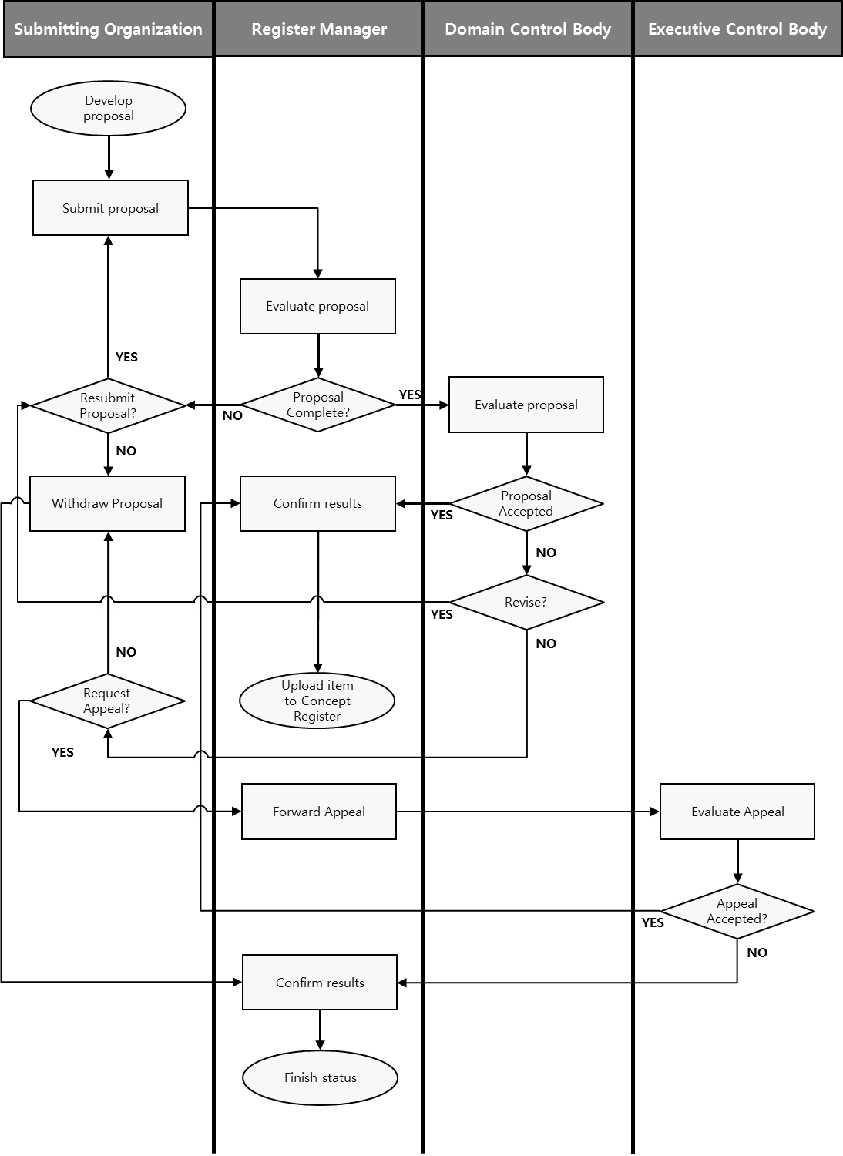
Figure 2-1 – Proposal process of Concept Register

2-6.2 Process of Data Dictionary Register, Portrayal Register

Figure 2-2 – Proposal process of Data Dictionary, Portrayal Register

2-6.3 Process for each step
2-6.3.1 Approval process

The process for determining the acceptability of proposals is illustrated in Figure 2-2. It shall be completed within a time period specified by the Register Owner.

The Register Manager shall ensure the following:
1) If the proposal is for clarification or retirement of a register item, forward the proposal to the control body; or
2) If the proposal is for registration of a new item or supersession of an existing register item:
a) Assign an itemIdentifier to the new or superseding item;
b) Set the status of the item to ‘notValid', and forward the proposal to the
Control Body.

The Control Body shall:
1) Decide to accept the proposal without change; to accept the proposal subject to changes negotiated with the submitting organization; or not to accept the proposal. Criteria for not accepting a proposal include:
a) The specification of the item is incomplete or incomprehensible;
b) An identical or very similar item already exists in the register or in another register of this registry;
c) The proposed item does not belong to an item class included in this register;
d) The proposed item does not fall within the scope of this Register; or e) The justification for the proposal is inadequate.
2) Inform the Register Manager of the decision, and the rationale for the decision, within a time limit specified by the Register Owner.

The Register Manager shall:
1) Serve as the point of contact if there is a need for negotiations between the Submitting Organization and the Control Body regarding changes to the proposal that are specified by the Control Body as a condition of acceptance; and
2) Inform the Submitting Organization of the results of processing a proposal.

If the decision of the Control Body is positive, the Register Manager shall in accordance with policies for this Register:
1) Complete the proposal management record with status set to ‘final’, disposition set to
‘accepted', and dateDisposed to the date of the Control Body’s decision;
2) Make approved changes to the content of the register item; and
3) Set the register item status to ‘valid', 'superseded', or 'retired', as appropriate.

If the decision of the Control Body is negative, the Register Manager shall:
1) Update the proposal management record by setting status to ‘tentative', disposition to
‘notAccepted', and dateDisposed to the date of the Control Body’s decision; and
2) Inform the Submitting Organization of the deadline for appealing the decision of the
Control Body.

Submitting Organizations shall:
1) Negotiate with the control body through the Register Manager, with regard to changes to their proposal that are specified by the Control Body as a condition of acceptance; and
2) Make known within their respective communities or organizations the decisions taken on proposals by the control body as transmitted to them by the register manager.

2-6.3.2 Withdrawal

Submitting Organizations may decide to withdraw a proposal at any time during the approval process.

The Register Manager shall:
1) Change the proposal management status from ‘pending’ to ‘final'; and
2) Change the proposal management disposition to ‘withdrawn’ and the value for
dateDisposed to the current date.

2-6.3.3 Appeals

A Submitting Organization may appeal to the Register Owner if it disagrees with the decision of a Control Body to reject a proposal for addition, clarification, retirement, or supersession of an item in a Register. An appeal shall contain at a minimum a description of the situation, a justification for the appeal, and a statement of the impact if the appeal is not successful. The appeal process is illustrated in Figure 2-3.

The Submitting Organization shall:
1) Determine if the decision regarding a proposal for registration is acceptable; and
2) If not, submit an appeal to the Register Manager.

The Register Manager shall:
1) Forward the appeal to the Register Owner.

If there is no appeal by the deadline for submitting an appeal, the Register Manager shall change the status of the proposal management record to ‘final' and change the dateDisposed to the current date.

The Register Owner shall:
1) Process the appeal in conformance with its established procedures;
2) Decide whether to accept or reject the appeal; and
3) Return the result to the Register Manager.

The Register Manager shall:
1) Update the proposal management record fields disposition and dateDisposed;
2) Update the register item status; and
3) Provide the results of the decision to the Control Body and to the Submitting
Organization.

The Submitting Organization shall:
1) Make the results of the appeal known within their community or organization.

2-6.2 List of Submitting Organizations

The Register Manager shall maintain and publish a register-specific list of all qualified Submitting Organizations that may submit proposals for changes to the content of each Register that it manages. Each list shall include the name and contact information for each Submitting Organization. The Registry shall contain an application to become a Submitting Organization. The Register Owner will be responsible for accepting or rejecting the application.

2-6.3 Publication

The Registry Manager shall ensure that information about valid, superseded, or retired items in the Register is readily available to users. The method for providing this information may depend upon the requirements of the members of the user community.

2-6.4 Integrity

The Register Manager shall ensure that, for each Register being managed:
1) All aspects of the registration process are handled in accordance with good business practice;
2) The content of the register is accurate; and
3) Only authorised persons can make changes to the Register content.

The Registry Manager shall ensure the security and integrity of the Registry using IT best practices.

2-7 Register Schema

2-7.1 Introduction

The schema specified in this clause describes the structure of an IHO Geospatial Information
Register.

Information about the Register and items in the Register shall be:
1) Accessible through an on-line interface to the Register;
2) Included in any copy of the Register; and
3) Included in any information package about the Register.

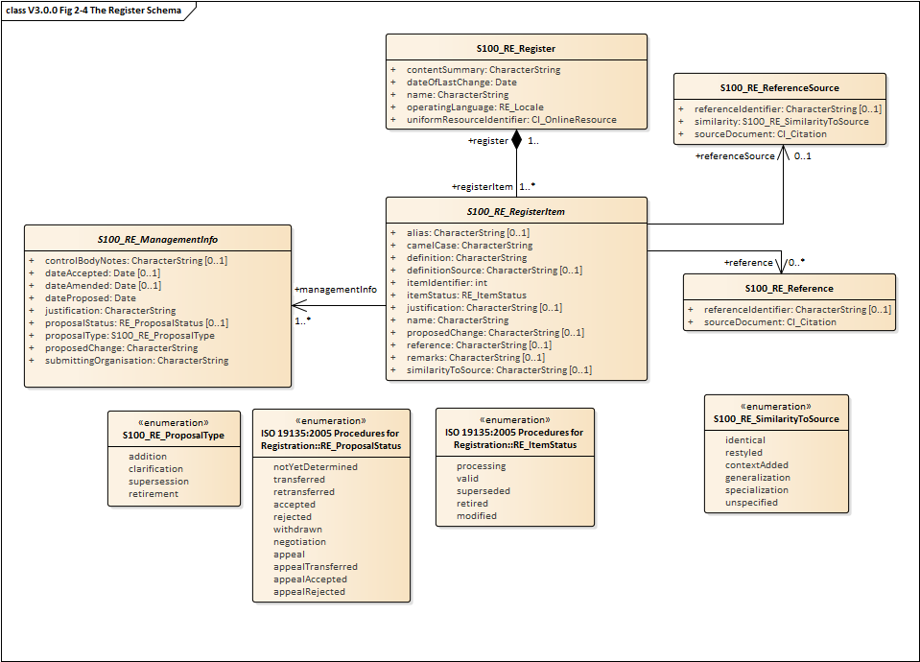
Figure 2-4 – The register schema

10 Part 2 - Management of Registers

2-7.2 S100_RE_Register

The class S100_RE_Register specifies information about the Register itself.

Role Name | Name | Description | Mult | Data Type | Remarks
Class | S100_RE_Register |  | - | -
Attribute | name | The name of the Register | 1 | CharacterString | Unique within the Registry
Attribute | operatingLanguage | The language used in this Register | 1 | RE_Locale
Attribute | contentSummary | Summary of the content | 1 | CharacterString
Attribute | uniformResourceIdentifier | The link to the interface of the Register in the Internet | 1 | CI_OnlineResource
Attribute | dateOfLastChange | The date when the last change was made to this Register | 1 | Date
Association | registerItem | The items of the Register | 1..* | S100_RE_RegisterItem

2-7.3 S100_RE_RegisterItem

The class S100_RE_RegisterItem carries the characteristics that are common to all types of registered items. Domain specific extensions may be added in the appropriate part of S-100; for example Part 2a – Feature Concept Dictionary.

Role Name | Name | Description | Mult | Data Type | Remarks
Class | S100_RE _RegisterItem |  | - | - | Class is abstract
Attribute | itemIdentifier | Each item has its own unique identifier in a Register | 1 | Integer
Attribute | name | Succinct expression of the item concept it denotes | 1 | CharacterString
Attribute | definition | Shall be a precise statement of the nature, properties, scope, or essential qualities of the concept as realized by the item. | 1 | CharacterString
Attribute | remarks | Supplementary information | 0..1 | CharacterString | Remarks

Part 2 - Management of Registers 11

Role Name | Name | Description | Mult | Data Type | Remarks
Attribute | itemStatus | The state in which a registered item exists | 1 | RE_ItemStatus
Attribute | Alias | 별칭 | 0..1 | CharacterString
Attribute | camelCase | Nam의 낙타표기법 | 1 | CharacterString
Attribute | DefinitionSource | 정의 참고문서 | 0..1 | CharacterString
Attribute | Justification | 변경이유 | 0..1 | CharacterString
Attribute | proposedChange | 변경내용 | 0..1 | CharacterString
Attribute | Reference | 참고 | 0..1 | CharacterString
Attribute | similarityToSource | 참고문서 | 0..1 | CharacterString
Association | register | The Register that contains the item | 1 | S100_RE_Register
Association | referenceSource | The source information the item definition was taken from. | 0..1 | S100_RE_ReferenceSourc e
Association | reference | Reference to other relevant standards or documents | 0..* | S100_RE_Reference | For example INT1 or M4
Association | managmentInfo | Sets of information describing the management of the item in the Register | 1..* | S100_RE_ManagmentInfo

2-7.4 RE_ItemStatus

The enumeration RE_ItemStatus identifies the registration status of a register item.

Role Name | Name | Description | Remarks
Enumeration | RE_ItemStaus
Literal | Processing | 아이템이 결재 진행중인 상태
Literal | Valid | 아이템이 결재승인된 상태
Literal | superseded | 아이템이 다른 아이템으로 대체된 상태
Literal | retired | A decision has been made that the item is no longer recommended for use. It has not been superseded by another item
Literal | Modified | 아이템이 수정되어 사용되지 않는 상태

2-7.5 S100_RE_ReferenceSource

The class S100_RE_ReferenceSource specifies information about the source of a register item taken from an external document or register.

Role Name | Name | Description | Mult | Data Type | Remarks
Class | S100_RE_ReferenceSourc e |  | - | -
Attribute | referenceIdentifier | An identifier of the place in the source document that is referenced | 0..1 | CharacterString
Attribute | sourceDocument | The source document. | 1 | CI_Citation
Attribute | similarity | Indicates how the definition is related to the source document | 1 | S100_RE_SimilarityToSou rce

2-7.6 S100_RE_SimilarityToSource

The enumeration S100_RE_SimilarityToSource identifies the type of change that has been made to an item specification relative to an item specification in an external source.

Role Name | Name | Description | Remarks
Enumeration | S100_RE_SimilarityToSou rce
Literal | identical | No change has been made to the definition
Literal | restyled | The style of the definition has been changed to match the style and structure of other definitions in the Register that has imported the definition
Literal | contextAdded | The definition includes information about its context that is not explicit in the specification in the external source
Literal | generalization | The definition of the register item has been generalized to have a broader meaning than the item specified in the external source
Literal | specialization | The definition of the register item has been specialized to have a narrower meaning than the item specified in the external source
Literal | unspecified | The nature of the differences between the register item and the similar item in the external source is unspecified

2-7.7 S100_RE_Reference

The class S100_RE_Reference specifies information about the source and/or lineage of a specific register item derived from an external document or Register.

Role Name | Name | Description | Mult | Data Type | Remarks
Class | S100_RE_Reference |  | - | -
Attribute | referenceIdentifier | An identifier of the place in the source document that is referenced | 0..1 | CharacterString
Attribute | sourceDocument | The source document | 1 | CI_Citation

2-7.8 S100_ RE _ManagementInfo

The class S100_RE_ManagementInfo specifies the management record of a register item.

Role Name | Name | Description | Mult | Data Type | Remarks
Class | S100_RE_ManagmentInfo |  | - | -
Attribute | proposalType | The type of the proposal | 1 | S100_RE_ProposalType
Attribute | submittingOrganisation | The proposal’s sponsor | 1 | CharacterString
Attribute | proposedChange | The text of the proposed change | 1 | CharacterString
Attribute | justification | Primary reason for the proposal including how it is proposed to be used | 1 | CharacterString
Attribute | dateAccepted | Date the proposal was accepted | 0..1 | Date
Attribute | dateProposed | Date the proposal was made | 1 | Date
Attribute | dateAmended | Date the proposal was adjudicated | 1 | Date
Attribute | proposalStatus | Provides values for describing the disposition of a proposal to add or modify a register item | 1 | RE_ProposalStatus
Attribute | controlBodyNotes | Supplementary management information | 0..* | CharacterString

2-7.9 S100_ RE _ProposalType

The enumeration S100_RE_ProposalType species the type of proposal for a register item.

Role Name | Name | Description | Remarks
Enumeration | S100_RE_ProposalType
Literal | Addition | The item is to be added to the Register
Literal | Clarification | A non-substantive change to an item in the Register
Literal | Supersession | The item has been superseded by another item and is no longer recommended for use.
Literal | Retirement | A decision has been made that the item is no longer recommended for use. It has not been superseded by another item

2-7.10 RE _ProposalStatus

The enumeration RE_ProposalStatus specifies the disposition of a proposal to add or change a register item.

Role Name | Name | Description | Remarks
Enumeration | RE_ProposalStatus
Literal | notYetDetermined | The Submitting Organization has submitted the proposal
Literal | transferred | The Register Manager requests Domain Control Body to review the proposal
Literal | retransferred | The Register Manager requests Submitting Organization to supplement the proposal
Literal | Accepted | The Domain Control Body decided to accept the proposal.
Literal | rejected | The Domain Control Body decided not to accept the proposal.
Literal | withdrawn | The Submitting Organization has withdrawn the proposal.
Literal | negotiation | The Domain Control Body requests Submitting Organization to supplement the proposal
Literal | appeal | The Submitting Organization appeals to Register Manager
Literal | appealTransferred | The Register Manager transfers the appealed proposal to Executive Control Body
Literal | appealAccepted | The Executive Control Body accepts appealed proposal of Submitting Organization
Literal | appealRejected | The Executive Control Body rejects appealed proposal of Submitting Organization

Page intentionally left blank

18 Part 2 - Management of Registers

S-100 – Part 2a

Concept Registers

Part 2a - Feature Concept Dictionary Registers

Page intentionally left blank

Part 2a - Feature Concept Dictionary Registers

Contents

2a-1 Scope ..................................................................................................................... 1
2a-2 Normative references............................................................................................. 1
2a-3 General concepts ................................................................................................... 1
2a-3.1 Register .................................................................................................................. 1
2a-3.2 Concept Register …............................................................................................... .1
2a-4 IHO Concept Register……………........................................................................... 1
2a-4.1 Types of registered items....................................................................................... 1
2a-4.2 Data model of a Feature Concept Dictionary......................................................... 2
2a-4.2.1 UML Model ............................................................................................................. 2
2a-4.2.2 S100_RE_Register................................................................................................ 4
2a-4.2.3 S100_CD_RegisterItem......................................................................................... 4
2a-4.2.4 RE_ItemStatus....................................................................................................... 4
2a-4.2.5 S100_Concept……………….................................................................................. 5

Part 2a - Feature Concept Dictionary Registers

Page intentionally left blank

Part 2a - Feature Concept Dictionary Registers

2a-1 Scope

The IHO Registry will contain a number of Registers, many of which will be based on Concept Register (CR). A Concept Register specifies hydrographic basic information (definitions, camelcase, etc.) that may be used to describe geographic information. The use of a Register to store hydrographic definitions will significantly improve the IHO’s ability to manage and extend multiple products based on S-100 which can be made available for use in a relatively short timescale. This Register is the primary resource where all registered concepts are stored and managed with stateless i.e. items should not be classified as feature types, information types, attributes, enumerated values or codelists. Each concept should be included into only one instance and should be the single/common source from which data dictionary concepts will be derived and used to model features, attributes etc.

2a-2 Normative references

The following referenced documents are required for the application of this document. For dated references, only the edition cited applies. For undated references, the latest edition of the referenced document (including amendments) applies.

ISO 19135:2005, Geographic Information – Procedures for registration of items of geographic information.

ISO 19126:2009, Geographic Information – Feature concept dictionaries and registers.

ISO 8601:2004, Data elements and interchange formats - Information interchange - Representation of dates and times.

RFC 3986, Uniform Resource Identifier (URI): Generic Syntax. T. Berners-Lee, R. Fielding, L. Masinter. Internet Standard 66, IETF. URL: http://www.ietf.org/rfc/rfc3986.txt or
http://www.rfc-editor.org/info/std66.

RFC 2141, URN Syntax. R. Moats. IETF RFC 2141, May 1997. URL: http://www.rfc- editor.org/info/rfc2141.

2a-3 General concepts

2a-3.1 Register

As described in Part 2, a Register is simply a managed list. It is easier to maintain than a fixed document, because new items can be added as needed to the Register, and existing items in the Register can be clarified, superseded or retired. Each register item has one or more dates associated with it that indicate when changes in its status occurred. This means that a Product Specification, defined at a given date, may reference an item in the Register at that specific point in time.

2a-3.2 Concept Register

A Concept Register specifies independent sets of primary resource for basic information that may be used to describe geographic, hydrographic, and metadata information. A Feature Concept Dictionary may use concept of Concept Register to define features. Unlike a Data Dictionary, a Concept Register does not make associations or classified as feature types, information types, attribute types.

The Concept Register defines the basic common information (name, definition, camel case, etc.) corresponding to the concept, and the registered concept can be utilized and registered as a feature referring to the Data Dictionary Register.

2a-4 IHO Concept Register

2a-4.1 Types of registered items

The following things are the required information for submitting a Concept:
1) Name

2) Alias

3) Camel Case

4) Definition

5) Reference

6) Definition Source

7) Similarity to Source

8) Remarks

9) Proposed Change

10) Justification

2a-4.2 Data model of a Concept Register

2a-4.2.1 UML Model

The following figure shows the information model of the hydrographic Concept Register:

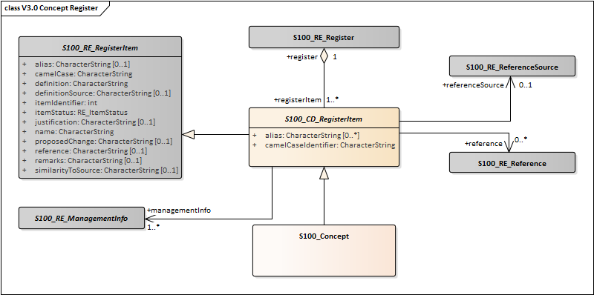
Figure 2-5 – The Concept Register UML

2a-4.2.2 S100_RE_Register

The class S100_RE_Register models a register in a feature concept dictionary. Further details can be found in S-100 Part 2.

2a-4.2.3 S100_CD_RegisterItem

The class S100_CD_RegisterItem is a specialization of the class S100_RE_RegisterItem and carries the characteristics that are common to all types of registered items listed in clause 2a-4.1.

Role Name | Name | Description | Mult | Data Type | Remarks
Attribute | camelCaseIdentifier | Identifier of the item using camelCase notation. | 1 | CharacterString | See below
Attribute | alias | Equivalent name(s) used for the item | 0..* | CharacterString

The camelCaseIdentifier must:

1) Be compound words in which the words are joined without spaces and are capitalized within the compound.

2) Be unique within the registry.

3) Conform to ISO 646 with uppercase characters A-Z, 0-9,”_”; and lowercase characters a-z.

4) Features and Information types must begin with uppercase A-Z.

5) Attributes and enumerated values must begin with lowercase a-z.

Example 1 BeaconCardinal is the Camel Case identifier for the feature Beacon Cardinal

Example 2 categoryOfLandmark is the Camel Case identifier for the attribute Category of Landmark

2a-4.2.4 RE_ItemStatus

The class RE_ItemStatus identifies the registration status of the S100_CD_RegisterItem. Further details can be found in S-100 Part 2.

2-a-4.2.5 S100_Concept
The class S100_Concept identifies the required information for Concept Register. Further details can be found in S-100 Part 2.

Page intentionally left blank

S-100 – Part 2b

Data Dictionary Register

Part 2a - Feature Concept Dictionary Registers

Page intentionally left blank

Part 2a - Feature Concept Dictionary Registers

Contents

2b-1 Scope ..................................................................................................................... 1
2b-1.1 Conformance.......................................................................................................... 1
2b-2 Normative references............................................................................................. 1
2b-3 General concepts ................................................................................................... 2
2b-3.1 Register .................................................................................................................. 2
2b-3.2 Data Dictionary ...................................................................................................... 2
2b-3.3 Feature Catalogue ................................................................................................. 2
2b-4 IHO Feature Concept Dictionary ............................................................................ 2
2b-4.1 Types of registered items....................................................................................... 2
2b-4.2 Data model of a Data Dictionary……………........................................................... 3
2b-4.2.1 UML Model ............................................................................................................. 3
2b-4.2.2 S100_RE_Register ................................................................................................ 4
2b-4.2.3 S100_CD_RegisterItem ......................................................................................... 4
2b-4.2.4 RE_ItemStatus ....................................................................................................... 4
2b-4.2.5 S100_CD_FeatureConcept.................................................................................... 5
2b-4.2.6 S100_CD_FeatureUseType................................................................................... 5
2b-4.2.7 S100_CD_AttributeConcept................................................................................... 5
2b-4.2.8 S100_CD_SimpleAttributeConcept........................................................................ 6
2b-4.2.9 S100_CD_QuantitySpecification............................................................................ 6
2b-4.2.10 S100_CD_AttributeValueType ............................................................................... 8
2b-4.2.11 S100_CD_AttributeConstraints .............................................................................. 9
2b-4.2.12 S100_CD_ComplexAttributeConcept .................................................................... 9
2b-4.2.13 S100_CD_AttributeUsage.................................................................................... 10
2b-4.2.14 S100_CD_EnumeratedValueConcept ................................................................. 10
2b-4.2.15 S100_CD_InformationConcept ............................................................................ 10
2b-4.2.16 S100_CD_AlphaCode.......................................................................................... 11
2b-4.2.17 S100_RE_ReferenceSource................................................................................ 12
2b-4.2.18 S100_RE_Reference ........................................................................................... 12
2b-4.2.19 S100_RE_ManagementInfo................................................................................. 12
Appendix 2b – A Example of a complex attribute (informative) .............................................. 13

Part 2a - Feature Concept Dictionary Registers

Page intentionally left blank

Part 2a - Feature Concept Dictionary Registers

2b-1 Scope

The IHO Registry will contain a number of Registers, many of which will be Data Dictionary (DD) Register. A Data Dictionary specifies hydrographic definitions that may be used to describe geographic information. The use of a Register to store hydrographic definitions will significantly improve the IHO’s ability to manage and extend multiple products based on S-100 which can be made available for use in a relatively short timescale. This Register will support wider use of registered items by making them publicly available and increase their visibility to potential users. This Part describes the content of the Register and specifies procedures to be followed in establishing, maintaining, and publishing registers of unique, unambiguous and permanent identifiers that are assigned to items of geographic, hydrographic and metadata information. In order to accomplish this purpose, this Part specifies elements of information that are necessary to provide identification and definitions to the registered items.

2b-1.1 Conformance

This profile conforms to conformance class 2 of ISO 19106:2004. The following is a brief description of the specializations and generalizations where the profile differs from ISO
19126:2008.

1) A new class, S100_CD_InformationConcept is introduced.

2) New classes, S100_CD_FeatureBinding, S100_CD_InformationBinding and
S100_FC_AttributeBinding are introduced.

3) A new class, S100_CD_AttributeConstraints is introduced.

4) The class FC_FeatureAttribute is specialized to be the abstract class
S100_CD_Attribute.

5) New classes, S100_CD_SimpleAttributeConcept and
S100_CD_ComplexAttributeConcept are introduced.

6) A new class, S100_CD_InformationRole is introduced.

7) The classes CD_InheritanceRelation, CD_FeatureOperation CD_Binding, CD_Constraint and CD_BoundFeatureAttribute are not used.

2b-2 Normative references

The following referenced documents are required for the application of this document. For dated references, only the edition cited applies. For undated references, the latest edition of the referenced document (including amendments) applies.

ISO 19135:2005, Geographic Information – Procedures for registration of items of geographic information.

ISO 19126:2009, Geographic Information – Feature concept dictionaries and registers.

ISO 8601:2004, Data elements and interchange formats - Information interchange - Representation of dates and times.

RFC 3986, Uniform Resource Identifier (URI): Generic Syntax. T. Berners-Lee, R. Fielding, L. Masinter. Internet Standard 66, IETF. URL: http://www.ietf.org/rfc/rfc3986.txt or
http://www.rfc-editor.org/info/std66.

RFC 2141, URN Syntax. R. Moats. IETF RFC 2141, May 1997. URL: http://www.rfc- editor.org/info/rfc2141.

Part 2a - Feature Concept Dictionary Registers 1

2b-3 General concepts

2b-3.1 Register

As described in Part 2, a Register is simply a managed list. It is easier to maintain than a fixed document, because new items can be added as needed to the Register, and existing items in the Register can be clarified, superseded or retired. Each register item has one or more dates associated with it that indicate when changes in its status occurred. This means that a Product Specification, defined at a given date, may reference an item in the Register at that specific point in time.

2b-3.2 Data Dictionary

A Data Dictionary specifies independent sets of definitions of features, attributes, enumerated values, and information types that may be used to describe geographic, hydrographic, and metadata information. A Data Dictionary may be used to develop a Feature Catalogue. Unlike a Feature Catalogue, a Data Dictionary does not make associations or bind attributes to features.

Registers of feature information may serve as sources of reference for similar registers established by other geographic information communities as part of a system of cross- referencing.

2b-3.3 Feature Catalogue

A Feature Catalogue is a document that describes the content of a data product. It uses item types, for example, features and attributes, from one or more Data Dictionaries and binds them together. In addition, constraints, units of measurement and format description of attributes can be specified. Feature Catalogues are described in detail in S-100 Part 5.

2b-4 IHO Data Dictionary

2b-4.1 Types of registered items

The following are types of items that may be registered:

1) Feature Type – abstraction of real world phenomena.

2) Information Type – an identifiable object that contains attributes, associations to other information concepts, but no spatial information.

3) Attribute Type – characteristic of a feature concept.

4) Complex Type – a combination of types, for instance a combination of measure types and units of measurement.

5) Enumerated Value Type – one of a set of mutually exclusive values constituting the domain of an attribute.

6) Codelist Value Type– an open enumeration, or the identifier of a vocabulary (mapping between codes, labels and definitions).

2 Part 2a - Feature Concept Dictionary Registers

2b-4.2 Data model of a Data Dictionary

2b-4.2.1 UML Model

The following figure shows the information model of the hydrographic Data Dictionary:

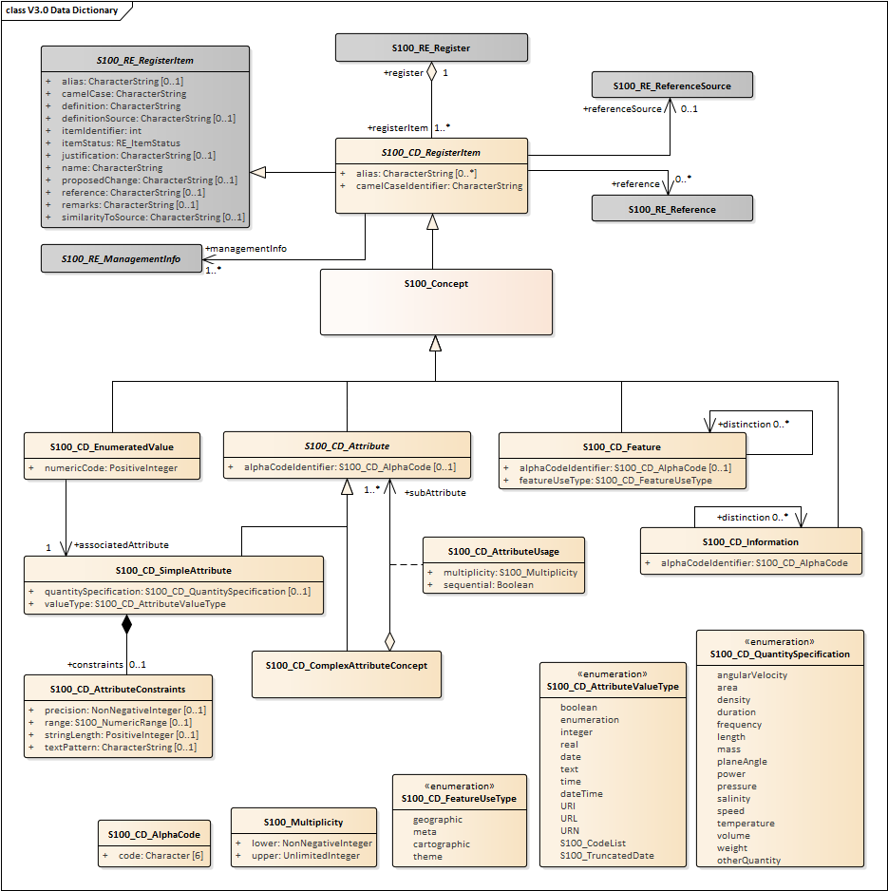

Figure 2b-1 – Feature Concept Dictionary

Part 2a - Feature Concept Dictionary Registers 3

2b-4.2.2 S100_RE_Register

The class S100_RE_Register models a register in a feature concept dictionary. Further details can be found in S-100 Part 2.

2b-4.2.3 S100_CD_RegisterItem

The class S100_CD_RegisterItem is a specialization of the class S100_RE_RegisterItem and carries the characteristics that are common to all types of registered items listed in clause 2a-4.1.

Role Name | Name | Description | Mult | Data Type | Remarks
Attribute | camelCaseIdentifier | Identifier of the item using camelCase notation. | 1 | CharacterString | See below
Attribute | alias | Equivalent name(s) used for the item | 0..* | CharacterString

The camelCaseIdentifier must:

1) Be compound words in which the words are joined without spaces and are capitalized within the compound.

2) Be unique within the registry.

3) Conform to ISO 646 with uppercase characters A-Z, 0-9,”_”; and lowercase characters a-z.

4) Features and Information types must begin with uppercase A-Z.

5) Attributes and enumerated values must begin with lowercase a-z.

Example 1 BeaconCardinal is the Camel Case identifier for the feature Beacon Cardinal

Example 2 categoryOfLandmark is the Camel Case identifier for the attribute Category of Landmark

2b-4.2.4 RE_ItemStatus

The class RE_ItemStatus identifies the registration status of the S100_CD_RegisterItem. Further details can be found in S-100 Part 2.

2b-4.2.5 S100_Concept

The class S100_Concept. Further details can be found in S-100 Part 2.

4 Part 2a - Feature Concept Dictionary Registers

2b-4.2.5 S100_CD_FeatureConcept

This class is derived from S100_CD_RegisterItem. It defines the following additional properties:

Role Name | Name | Description | Mult | Data Type | Remarks
Class | S100_CD_FeatureConcept | A feature type in a Feature Concept Dictionary | - | - | Derived from S100_Concept
Attribute | featureUseType | The intended use of a feature type | 1 | S100_CD_FeatureUseType
Attribute | alphaCodeIdentifier | Abbreviation designating the feature type | 0..1 | S100_CD_AlphaCode | See below
Association role | distinction | References to feature types that this feature type is distinct from | 0..* | S100_CD_FeatureConcept
Association | conceptReference | Refer to S100_Concept as base-class | 1 | S100_Concept

2b-4.2.6 S100_CD_FeatureUseType

Role Name | Name | Description | Remarks
Enumeration | S100_CD_FeatureUseType | Categories of feature types
Literal | geographic | carries the descriptive characteristics of a real world entity
Literal | meta | Delineates geographic location where meta information is applicable” distinct from an Information Type which carries information related to features which are related.
Literal | cartographic | carries information about the cartographic representation  (including text) of a real world entity
Literal | theme | Grouping features thematically.

2b-4.2.7 S100_CD_AttributeConcept

Attributes may either be simple or complex. A simple attribute carries a specific value such as a date. A complex attribute is an aggregation of other attributes either simple or complex. Examples of complex attributes are in Appendix 2a-A. This class is derived from S100_CD_RegisterItem and describes the common characteristics of all attribute types.

Role Name | Name | Description | Mult | Data Type | Remarks
Class | S100_CD_AttributeConcept | Base class of all attribute types in a Feature  Concept Dictionary | - | - | Derived from S100_Concept
Attribute | alphaCodeIdentifier | Abbreviation designating the attribute type | 0..1 | S100_CD_AlphaCode | See below
Association | conceptReference | Refer to S100_Concept as base-class | 1 | S100_Concept

2b-4.2.8 S100_CD_SimpleAttributeConcept

Role Name | Name | Description | Mult. | Data Type | Remarks
Class | S100_CD_SimpleAttribute  Concept | A simple attribute type in a Feature Concept  Dictionary | - | - | Derived from  S100_CD_AttributeConcept
Attribute | valueType | Describes representation, interpretation and structure of values | 1 | S100_CD_AttributeValueType | See below
Attribute | quantitySpecification | Specification of the quantity, for example length, volume, depth, weight etc. | 0..1 | S100_CD_QuantitySpecification
Association | constraints | Constraints of the attribute type | 0..1 | S100_CD_AttributeConstraints | Must be consistent with dataType

If the valueType is S100_Codelist exactly one of the following must be true:

1) There is an associated S100_RE_Reference with the namespace of a dictionary that is listed in the GI Register.

2) There is at least one S100_CD_EnumeratedValueConcept associated to the attribute concept.

Condition 1 identifies the dictionary for codelists of type “open dictionary” or “closed dictionary”. Condition 2 provides the enumerated value(s) for codelists of type “open enumeration”. The precise codelist type is determined in individual Product Specifications.

2b-4.2.9 S100_CD_QuantitySpecification

Role Name | Name | Description | Remarks
Enumeration | S100_CD_QuantitySpecification | Types of quantity measures | Adapted from ISO 19103 Measure Types
Literal | angularVelocity | The instantaneous rate of change of angular displacement with time | From ISO 19103
Literal | area | The measure of the physical extent of any two-dimensional geometric object | From ISO 19103
Literal | density | Mass per unit volume; number per unit area. Also: specific gravity (S-32). Density of soundings is the intervals between lines of sounding and soundings in the same line (S-32) | “Density” can be used in different senses, the unit of measure and attribute definition must make it clear which is intended
Literal | duration | Interval of time
Literal | frequency | Number of vibrations or cycles per unit time | IHO S-32
Literal | length | The longest dimension of an object; distance measured along a line or curve
Literal | mass | A numerical measure of the inertia of an object; the quantity of matter which a body contains, irrespective of its bulk or volume
Literal | planeAngle | The amount of rotation needed to bring one line or plane into coincidence with another, generally measured in radians or degrees | From ISO 19103 “angle”

Role Name | Name | Description | Remarks
Literal | power | Rate of doing work or transferring energy; magnification | S-32 refers “power” to “magnifying power: the ratio of the apparent length of a linear dimension as seen through an optical instrument to that seen by the unaided eye”. The unit of measure and attribute definition must make it clear which sense is intended
Literal | pressure | Force per unit area
Literal | salinity | A measure of the quantity of dissolved salts | IHO S-32 (abbrev.)
Literal | speed | Rte of change of position with time | Usually calculated using the simple formula, the change in position during a given time interval. Speed is a scalar physical quantity, having magnitude but not direction. Contrast to “velocity” which is a vector quantity having both magnitude and direction. (Adapted from ISO 19103 “velocity”)
Literal | temperature | The intensity or degree of heat | IHO S-32
Literal | volume | The measure of the physical space of any 3-D geometric object | From ISO 19103
Literal | weight | The force experienced by an object due to gravity
Literal | otherQuantity | A quantity different from the other literals of this enumeration

2b-4.2.10 S100_CD_AttributeValueType

Role Name | Name | Description | Remarks
Enumeration | S100_CD_AttributeValueType | Value types of simple attributes
Literal | boolean | True or False
Literal | enumeration | List of predetermined values that can be expanded and contracted
Literal | integer | Numeric value with defined range, units and format
Literal | real | Floating point number
Literal | text | A sequence of characters
Literal | date | Character encoding shall follow the format for date as specified by ISO 8601
Literal | time | Character encoding shall follow the format for time as specified by ISO 8601
Literal | dateTime | Character encoding shall follow the format for date and time as specified by ISO 8601
Literal | URI | Character encoding shall follow the format for URI as specified by RFC 3986
Literal | URL | Character encoding shall follow the format for URL as specified by RFC 3986
Literal | URN | Character encoding shall follow the format for URN as defined by RFC 2141
Literal | S100_CodeList | Open enumeration or identifier of entry in a vocabulary
Literal | S100_TruncatedDate | Truncated format for date

2b-4.2.11 S100_CD_AttributeConstraints

Role Name | Name | Description | Mult. | Data Type | Remarks
Class | S100_CD_AttributeConstraints | Constraints of a simple attribute | - | -
Attribute | stringLength | Shall be represented as a positive integer (that is, greater than zero) that specifies the maximum number of characters that may be assigned to the text attribute type. If not specified, then the text length shall be unconstrained | 0..1 | PositiveInteger
Attribute | textPattern | A character string that specifies a scheme of one or more constraints on the structure of the text values that may be assigned to the attribute. This shall be achieved by using a regular expression. W3C XML Standard Part 2 Appendix F (Regular Expressions) shall be used to define text patterns in this standard | 0..1 | CharacterString
Attribute | range | Specifies the range of allowed numeric values | 0..1 | S100_NumericRange
Attribute | precision | Specifies the precision of a real number | 0..1 | NonNegativeInteger

2b-4.2.12 S100_CD_ComplexAttributeConcept

Role Name | Name | Description | Mult | Data Type | Remarks
Class | S100_CD_ComplexAttributeC  oncept | A complex attribute type in a Feature Concept  Dictionary | - | - | Derived from  S100_CD_AttributeConcept
Association | subAttribute | References the sub attribute | 1..* | S100_CD_AttributeConcept | Characteristics defined by  S100_CD_AttributeUsage

2b-4.2.13 S100_CD_AttributeUsage

This class specifies the characteristics of the association between a complex attribute type and its sub attributes.

Role Name | Name | Description | Mult | Data Type | Remarks
Class | S100_CD_AttributeUsage | Characteristics of the association between a complex attribute and its sub attributes | - | -
Attribute | multiplicity | Number of occurrences of the sub attribute | 1 | S100_Multiplicity
Attribute | sequential | Boolean value that indicates if the sub attributes of a complex attribute are in a particular order | 1 | Boolean | It is only applicable if a sub attribute has multiplicity > 1

2b-4.2.14 S100_CD_EnumeratedValueConcept

This class is derived from S100_CD_RegisterItem and describes the characteristics of an enumerated value type.

Role Name | Name | Description | Mult | Data Type | Remarks
Class | S100_CD_EnumeratedValueCo ncept | Characteristics of an enumerated value type in a  Feature Concept Dictionary | - | -
Attribute | numericCode | A positive integer designating the unique value in the domain | 1 | PositiveInteger
Association | associatedAttribute | Specifies the attribute type item for which this is a domain value | 1 | Boolean
Association | conceptReference | Refer to S100_Concept as base-class | 1 | S100_Concept

2b-4.2.15 S100_CD_InformationConcept

Role Name | Name | Description | Mult | Data Type | Remarks
Class | S100_CD_InformationConcept | Characteristics of an information type in a Feature  Concept Dictionary | - | -
Attribute | alphaCodeIdentifier | Abbreviation designating the information type item | 0..1 | S100_CD_AlphaCode | See below
Association | distinction | Similar information types that this is distinct from | 0..1 | S100_CD_InformationConce pt
Association | conceptReference | Refer to S100_Concept as base-class | 1 | S100_Concept

2b-4.2.16 S100_CD_AlphaCode

Role Name | Name | Description | Mult | Data Type | Remarks
Class | S100_CD_AlphaCode | Abbreviation designating the item | - | -
Attribute | code | The code | 6 | Character | See below

The code must:

1) Be unique within the registry for all registered items that have an alpha code characteristic;

2) Be exactly six characters;

3) Conform to ISO 646 with uppercase characters A-Z, 0-9,”_”, “$”; and lowercase characters a-z;

4) Begin with uppercase A-Z, lowercase a-z, or “$.”

Example “PUBREF” is the Alpha Code designating a feature type item named “Publication Reference”.

2b-4.2.17 S100_RE_ReferenceSource

Each item in a Feature Concept Dictionary has a definition. If the definition is taken from an external source, this class describes the reference(s) to the source document. Further details can be found in S-100 Part 2.

2b-4.2.18 S100_RE_Reference

This class defines the references to other documents where additional information regarding a registered item can be found. Further details can be found in S-100 Part 2.

2b-4.2.19 S100_RE_ManagementInfo

This class contains the management information of a register item. Further details can be found in S-100 Part 2.

Appendix 2b – A Example of a complex attribute (informative)

A light may have several sectors. All of them share the same light characteristic and sequence. Other common attributes are the height and the name.

All attributes describing one sector in a complex attribute are structured “Light sector”. A complex attribute for the “Rhythm of light” is also defined.
The simple attributes used in “lightSector” are:

● sectorLimit1 (type Real)

● sectorLimit2 (type Real)

● colour (type Enumeration)
● valueOfNominalRange (type Real) Therefore the complex attribute is:

Characteristic | Value
Name | Light sector
Definition | A sector is the part of a circle between two straight lines drawn from the centre to the circumference. (Advanced Learner’s Dictionary, 2nd Edition).
Remarks | n/a
CamelCase | lightSector
AlphaCode | LITSEC
Sub Attributes | Attribute Binding
CamelCode Identifier | multiplicity | sequential
sectorLimit1 | 1 | n/a
sectorLimit2 | 1 | n/a
colour | 1 | n/a
valueOfNominalRange | 0..1 | n/a

Note: The multiplicity and sequence are carried in the attribute between the complex and sub- attribute.

The “Rhythm of light” consists of:

● lightCharacteristic

● signalPeriod

● signalGroup

Characteristic | Value
Name | Rhythm of light
Definition
Remarks | n/a
CamelCase | rhythmOfLight
AlphaCode | RHYLGT
Sub Attributes | Attribute Binding
CamelCode Identifer | multiplicity | sequential
lightCharacteristic | 1 | n/a

Part 2a - Feature Concept Dictionary Registers 13

signalPeriod | 0..1 | n/a
signalGroup | 0..1 | n/a

A second way of describing the rhythm of light is the “signal sequence” as it is currently done with the SIGSEQ attribute. A signal sequence consists of intervals where the signal is either on or off (here light or eclipse)

Characteristic | Value
Name | Signal sequence interval
Definition | tbd.
Remarks | n/a
CamelCase | signalSequenceInterval
AlphaCode | SGSQIN
Sub Attributes | Attribute Binding
CamelCode Identifer | multiplicity | sequential
signalStatus | 1 | n/a
duration | 1 | n/a

A Signal sequence is then just an ordered list of those intervals.

Characteristic | Value
Name | Signal sequence
Definition | The sequence of times occupied by intervals of light and eclipse for all “light characteristics”. (Adapted from S-57 Edition 3.1, Appendix A – Chapter 2, Page 2.191, November 2000).
Remarks | n/a
CamelCase | signalSequence
AlphaCode | SIGSEQ
Sub Attribute | Attribute Binding
CamelCode Identifier | multiplicity | sequential
signalSequenceInterval | 1..* | True

A light object would now consist of: Light:
● rhythmOfLight [1..*]

● lightSector [1..*]

● signalSequence [0..1]

● objectName[0..1]

● height[0..1]

This definition would be in the feature catalogue, although the definition of the attributes is in the data dictionary.

14 Part 2a - Feature Concept Dictionary Registers

S-100 – Part 2c

Portrayal Register

Part 2b – Portrayal Register

Page intentionally left blank

Part 2b – Portrayal Register

Contents

2b-1 Scope ..................................................................................................................... 1
2b-1.1 Conformance.......................................................................................................... 1
2b-2 Normative references............................................................................................. 1
2b-3 General concepts ................................................................................................... 2
2b-3.1 Register .................................................................................................................. 2
2b-3.2 Portrayal Register .................................................................................................. 2
2b-3.3 Portrayal catalogue ................................................................................................ 2
2b-4 IHO Portrayal Register ........................................................................................... 2
2b-4.1 Types of registered items....................................................................................... 2
2b-4.2 Data model of a Portrayal Register ........................................................................ 3
2b-4.2.1 UML Model ............................................................................................................. 3
2b-4.2.2 S100_PR_Register ................................................................................................ 4
2b-4.2.3 S100_PR_RegisterItem ......................................................................................... 4
2b-4.2.4 RE_ItemStatus ....................................................................................................... 4
2b-4.2.5 S100_PR_ColorToken ........................................................................................... 4
2b-4.2.6 S100_PR_ColorProfile ........................................................................................... 4
2b-4.2.7 S100_PR_VisualItem ............................................................................................. 5
2b-4.2.8 S100_PR_Font....................................................................................................... 5
2b-4.2.9 S100_PR_DisplayPlane......................................................................................... 6
2b-4.2.10 S100_PR_ContextParameter ................................................................................ 6

Part 2b – Portrayal Register

Page intentionally left blank

Part 2b – Portrayal Register

2b-1 Scope

The IHO Registry will contain a number of registers, one of which will be for portrayal. A Portrayal Register specifies the portrayal of data. The portrayal of data is independent of the data but closely related to the data. That is the attributes within the data set drive the portrayal process, but there may be many different portrayals for the same data. The use of a register to store aspects of portrayal will significantly improve the IHO’s ability to manage and extend multiple products based on S-100 which can be made available for use in a relatively short timescale. This Register will support wider use of registered items by making them publicly available and increase their visibility to potential users. This Part describes the content of the Portrayal Register.

2b-1.1 Conformance

This profile conforms to conformance class 2 of ISO 19106:2004.

2b-2 Normative references

The following referenced documents are required for the application of this document. For dated references, only the edition cited applies. For undated references, the latest edition of the referenced document (including amendments) applies.

ISO 19135:2005, Geographic Information – Procedures for registration of items of geographic information.
ISO 19126:2009, Geographic Information – Feature concept dictionaries and registers. ISO 19117:2012. Geographic Information – Portrayal.

Part 2b – Portrayal Register 1

2b-3 General concepts

2b-3.1 Register

As described in Part 2, a Register is simply a managed list. It is easier to maintain than a fixed document, because new items can be added as needed to the Register, and existing items in the Register can be clarified, superseded or retired. Each register item has one or more dates associated with it that indicate when changes in its status occurred. This means that a Product Specification, defined at a given date, may reference an item in the Register at that specific point in time.

2b-3.2 Portrayal Register

A portrayal register specifies independent sets of definitions of point symbols, pattern symbols, complex line styles, and colour symbols. In addition, the portrayal register may be subdivided into different domains. The portrayal register may be used to develop the portrayal catalogue. Unlike the portrayal catalogue, a portrayal register does not define the portrayal rules or bind the portrayal to a feature.

Registers of portrayal information may serve as sources of reference for similar registers established by other geographic information communities as part of a system of cross- referencing.

2b-3.3 Portrayal catalogue

The Portrayal Catalogue contains portrayal functions that map the features to symbology it also contains symbol definitions, colour definitions, portrayal parameters and portrayal management concepts such as viewing groups. Portrayal Catalogues are described in detail in S-100 Part 9.

2b-4 IHO Portrayal Register

2b-4.1 Types of registered items

The following are types of items that may be registered:

1) Pixmap

2) Color Token

3) Color Profile

4) Symbol

5) Line Style

6) Area Fill

7) Font

8) Viewing Group

9) Viewing Group Layer

10) Display Mode

11) Display Plane

12) Context Parameter

13) Symbol Schema

14) Line Style Schema

15) Area Fill Schema

2 Part 2b – Portrayal Register

16) Pixmap Schema

17) Color Profile Schema

18) Cascading Style Sheet

19) Display priority

2b-4.2 Data model of a Portrayal Register

2b-4.2.1 UML Model

The following figure shows the information model of the hydrographic Portrayal Register:

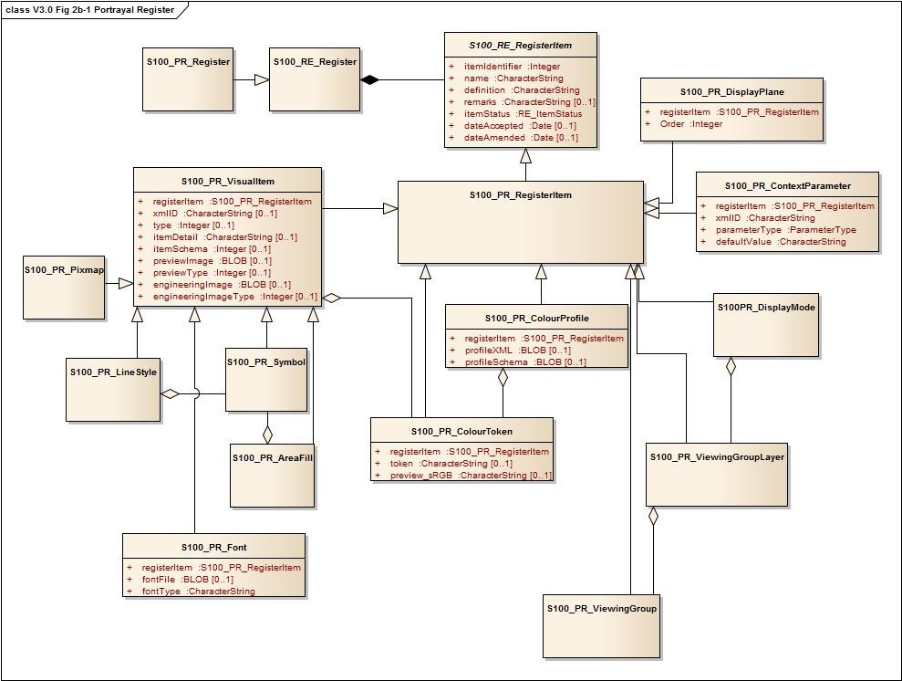

Figure 2b-1 – Portrayal Register

Part 2b – Portrayal Register 3

2b-4.2.2 S100_PR_Register

This class S100_PR_Register is derived from S100_RE_Register. It is extended with an ‘owner’ and ‘domain’. The intention is that each domain or organization may have a dedicated Register.

2b-4.2.3 S100_PR_RegisterItem

The class S100_PR_RegisterItem is a specialization of the class S100_RE_RegisterItem and carries the characteristics that are common to all types of registered items listed in clause 2a-4.1.

2b-4.2.4 RE_ItemStatus

The class RE_ItemStatus identifies the registration status of the S100_PR_RegisterItem. Further details can be found in S-100 Part 2.

2b-4.2.5 S100_PR_ColorToken

This class is derived from S100_PR_RegisterItem. The definition of a color token as a register item of type ‘colorToken’ and carries the token string and a preview RGB value in Hex encoding. Specific color CIE values etc are stored in a color profile structure.

Role Name | Name | Description | Mult | Data Type | Remarks
Class | S100_PR_ColorToken | Definition of a color token | - | -
Attribute | registerItem |  | 1 | S100_PR_RegisterItem
Attribute | token |  | 0..1 | CharacterString
Attribute | Preview_sRGB |  | 0..1 | CharacterString

2b-4.2.6 S100_PR_ColorProfile

. This class is derived from S100_PR_RegisterItem.

Role Name | Name | Description | Mult | Data Type | Remarks
Class | S100_PR_ColorProfile | The specific content for a colour profile as a register item of type ‘colorProfile’ | - | -
Attribute | registerItem |  | 1 | S100_PR_RegisterItem
Attribute | profileXML | XML file for the color profile | 0..1
Attribute | profileSchema | Schema for the XML file of the color profile | 0..1

4 Part 2b – Portrayal Register

2b-4.2.7 S100_PR_VisualItem

The specific content for a register item of type ‘symbol’, ‘lineStyle’, ‘areaFill’ or ‘pixmap’ defined in PR_VisualType. The visual items each have an XML identifier string and XML document defining the item details as well as a preview image and an engineering Image with dimensions.

Role Name | Name | Description | Mult | Data Type | Remarks
Class | S100_CD_FeatureConcept | A feature type in a Feature Concept Dictionary | - | -
Attribute | registerItem |  | 1 | S100_PR_RegisterItem
Attribute | xmlID |  | 0..1
Attribute | type |  | 0..1 | Integer | symbol, lineStyle, areaFill, or pixmap
Attribute | itemDetail |  | 0..1 | CharacterString
Attribute | itemSchema |  | 0..1 | Integer
Attribute | previewImage |  | 0..1 | Blob
Attribute | previewType |  | 0..1 | Integer
Attribute | engineeringImage |  | 0..1 | Blob
Attribute | engineeringImageType |  | 0..1 | Integer

2b-4.2.8 S100_PR_Font

This is a specialization of S100_PR_VisualItem.

Role Name | Name | Description | Mult | Data Type | Remarks
Class | S100_PR_Font | The specific content for a font file definition as a register item of type ‘font’. | - | -
Attribute | registerItem |  | 1 | S100_PR_RegisterItem
Attribute | fontFile |  | 0..1 | Blob
Association role | fontType |  | 0..1 | CharacterString

Part 2b – Portrayal Register 5

2b-4.2.9 S100_PR_DisplayPlane

S100_PR_DisplayPlane is a specialization of S100_PR_RegisterItem.

Role Name | Name | Description | Mult | Data Type | Remarks
Class | S100_PR_DisplayPlane | The specific content for a display plane definition as a register item of type ‘displayPlane’ | - | -
Attribute | registerItem |  | 1 | S100_PR_RegisterItem
Attribute | Order |  | 1 | Integer

2b-4.2.10 S100_PR_ContextParameter

S100_PR_ContextParameter is a specialization of S100_PR_RegisterItem.

Role Name | Name | Description | Mult. | Data Type | Remarks
Class | S100_PR_ContextParamet er | The specific content for a context parameter as a register item of type ‘contextParameter’. | - | -
Attribute | registerItem |  | 1 | S100_PR_RegisterItem
Attribute | xmlID |  | 1 | CharacterString
Attribute | parameterType |  | 1 | ParamterType
Attribute | defaultValue |  | 1 | CharacterString

6 Part 2b – Portrayal Register

A-18
Terms and Definitions

