INTERNATIONAL HYDROGRAPHIC ORGANIZATION

IHO GEOSPATIAL STANDARD
FOR TRAFFIC MANAGEMENT

Version 0.0
2018-02-28

Special Publication No. S-127
Traffic Management - Product Specification

Published by the
International Hydrographic Organization
MONACO

© Copyright International Hydrographic Organization February 2018
This work is copyright. Apart from any use permitted in accordance with the Berne Convention for the Protection of Literary and Artistic Works (1886), and except in the circumstances described below, no part may be translated, reproduced by any process, adapted, communicated or commercially exploited without prior written permission from the International Hydrographic Organization Secretariat (IHO Secretariat). Copyright in some of the material in this publication may be owned by another party and permission for the translation and/or reproduction of that material must be obtained from the owner.
This document or partial material from this document may be translated, reproduced or distributed for general information, on no more than a cost recovery basis. Copies may not be sold or distributed for profit or gain without prior written agreement of the IHO Secretariat acting for the IHO and any other copyright holders.
In the event that this document or partial material from this document is reproduced, translated or distributed under the terms described above, the following statements are to be included:
“Material from IHO publication [reference to extract: Title, Edition] is reproduced with the permission of the International Hydrographic Organization Secretariat (IHO Secretariat) (Permission No ……./…) acting for the International Hydrographic Organization (IHO), which does not accept responsibility for the correctness of the material as reproduced: in case of doubt, the IHO’s authentic text shall prevail. The incorporation of material sourced from IHO shall not be construed as constituting an endorsement by IHO of this product.”
“This [document/publication] is a translation of IHO [document/publication] [name]. The IHO has not checked this translation and therefore takes no responsibility for its accuracy. In case of doubt the source version of [name] in [language] should be consulted.”
The IHO Logo or other identifiers shall not be used in any derived product without prior written permission from the IHO Secretariat.

Revision History
Changes to this Product Specification are coordinated by the IHO Nautical Information Provision Working Group (NIPWG). New editions will be made available via the IHO web site. Maintenance of the Product Specification shall conform to IHO Technical Resolution 2/2007 (revised 2010).

Version Number | Date | Author | Purpose

TABLE OF CONTENTS
1 Data Content and Structure 6
1.1 Introduction 6
1.2 Application Schema 7
1.2.1 Domain model 8
1.2.1.1 Overview of domain features and information types 9
1.2.1.2 Relationships between features and information types 13
1.2.1.3 Regulations, information notes, etc. 14
1.2.1.4 Contact information 15
1.2.1.5 Supervising organizations, schedules and business hours 16
1.2.1.6 Reports to be submitted by vessels 17
1.2.1.7 Regulations applying in specific geographic features 18
1.2.1.8 Regulations applying only to vessels with specific characteristics or cargoes 19
1.2.1.9 Routeing measures 22
1.2.1.9.1 Routeing measures alternative A 22
1.2.1.9.2 Routeing measures (alternative B) 22
1.2.1.9.3 Routeing measures (alternative C) 24
1.2.1.10 Vessel traffic service areas and related features 25
1.2.1.11 Pilotage 26
1.2.1.12 Water levels and underkeel clearances 26
1.2.1.13 Other areas 27
1.2.1.14 S-127 Enumerations and codelists 28
1.2.1.15 Uncategorized additional information 31
1.2.2 Meta features 31
1.2.3 Spatial quality information type 32
1.2.4 Cartographic features 33
2 Portrayal 33

Data Content and Structure

Introduction
The S-127 product is based on the S-100 General Feature Model (GFM), and is a feature-based vector product. Figure 1 shows how the S-127 application schema is realized from the S-100 GFM. All S-127 features and information classes are derived from one of the abstract classes FeatureType and InformationType defined in the S-127 application schema, which realize the GFM meta-classes S100_GF_FeatureType and S100_GF_InformationType respectively.
Traffic Management (TRF) features are encoded as vector entities which conform to S-100 geometry configuration level 3b (S-100 section 7-5.3.5). S-127 further constrains Level 3a with the following:
- Coincident linear geometry must be avoided when there is a dependency between features.
- The interpolation of arc by center point and circle by center point curve segments must be circular arcs with center and radius, as described in S-100 §§ 7-4.2.1, 7-4.2.20, and 7-4.2.21.
- The interpolation of other GM_CurveSegment must be loxodromic.
- Linear geometry is defined by curves which are made of curve segments. Each curve segment contains the geographic coordinates as control points and defines an interpolation method between them. The distance between two consecutive control points must not exceed 0.3 mm at a display scale of 1:10000.
The following exception applies to S-127:
- The use of coordinates is restricted to two dimensions.
- Soundings features which use GM_Point or GM_Multipoint with three dimensional coordinates are not currently included in S-127.

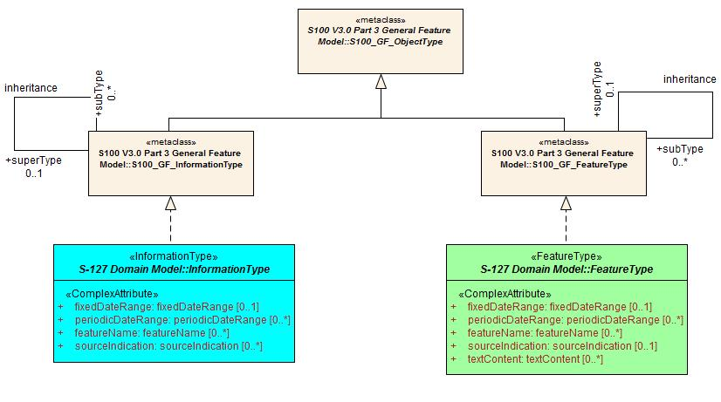
Figure 1. Realizations from the S-100 General Feature Model

This section contains the Application Schema expressed in UML and an associated Feature Catalogue. The Feature Catalogue is included in Annex C, and provides a full description of each feature type including its attributes, attribute values and relationships in the data product. Figure 2 shows an overview of the S-127 application schema.
The classes comprising the S-127 application schema are divided into three packages. The first package, the Domain model, contains the features and information types that model the TRF application domain specifically. Meta-features that provide quality and coverage information are contained within their own package as well as cartographic features, which allow dataset creators to provide cartographically necessary placements where required. Geographic features in all packages use the spatial types from S-100 Part 7, which are imported as-is into the S-127 spatial types package and therefore can be used as types for S-127 spatial attributes. The spatial types package also contains definitions of ‘union types’ (combinations of the S-100 spatial types). S-100 allows features to have different kinds of geometry, however UML does not allow an attribute of a class to have multiple types. The S-127 application schema models spatial attributes as attributes of feature classes.

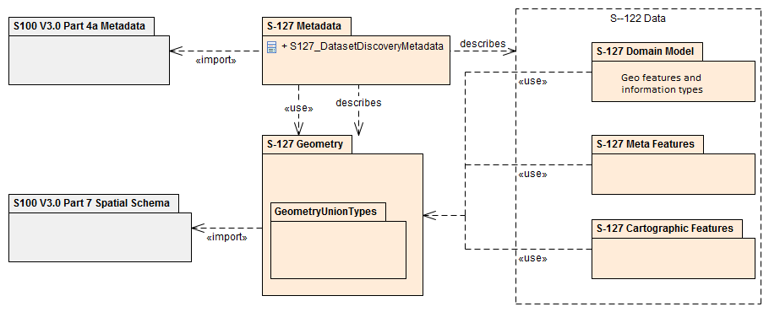
Figure 2. S-127 Data model overview

Application Schema
The UML models shown below are segments of the overall S-127 application schema, and include overviews of the feature classes, information classes, meta features, spatial types, and the relationships between them.
This section contains a general overview of the classes and relationships in the S-127 application schema. Detailed information about how to use the feature types and information types to encode Traffic management information is provided in the S-127 Data Classification and Encoding Guide (DCEG).
The following conventions are used in the UML diagrams depicting the application schema:
- Standard UML conventions for classes, associations, inheritance, roles, and multiplicities apply. These conventions are described in Part 1 of S-100.
- Italic font for a class name indicates an abstract class.
- Feature classes are depicted with green background; the dark shade for abstract feature classes and the light shade for ordinary (non-abstract) feature classes.
- Information type classes are depicted with blue background; the dark shade for abstract information type classes and the light shade for ordinary information types.
- Association classes are depicted with a white background.
- Complex attributes are depicted with a pink background.
- Enumeration lists and codelists are depicted with a tan background. The numeric code corresponding to each listed value is shown to its right following an ‘=’ sign.
- No significance attaches to the color of associations. (Complex diagrams may use different colors to distinguish associations that cross one another.)
- Where the association role or name is not explicitly shown, the default rules for roles and names apply:
  - The role name is ‘the<CLASSNAME>’ where <CLASSNAME> is the name of the class to which that association end is linked.
  - The association name is ‘<CLASSNAME1>_<CLASSNAME2>’ where <CLASSNAME1> is the source and <CLASSNAME2> the target. In case of a feature/information association the feature is the source. For feature/feature or information/information associations without explicit names the source/target are indicated by an arrowhead.
- Subclasses inherit the attributes and associations of their superclasses at all levels, unless such inheritance is explicitly overridden in the subclass.

Domain model
The S-127 domain model has two base classes (‘root classes’) from which all the domain-specific geographic features and information type classes are derived. The base classes are shown in Figure 3 below. The base class for geographic features is FeatureType and the base class for information types is InformationType. Each of the two base classes has a set of attributes which are therefore inherited by all domain-specific features. The approximate area features in S-127 are also derived from the geographic feature root class. Both base classes are abstract classes and do not have direct instances in S-127 data – instead, S-127 feature and information type data objects are instantiations of a non-abstract class derived from one of these base classes.
S-127 meta- and cartographic features are not derived from these base classes – S-127 instead incorporates meta- and cartographic feature definitions originally prepared for S-101 in the interests of harmonization and interoperability with other S-100-based data products, especially S-101 ENCs.

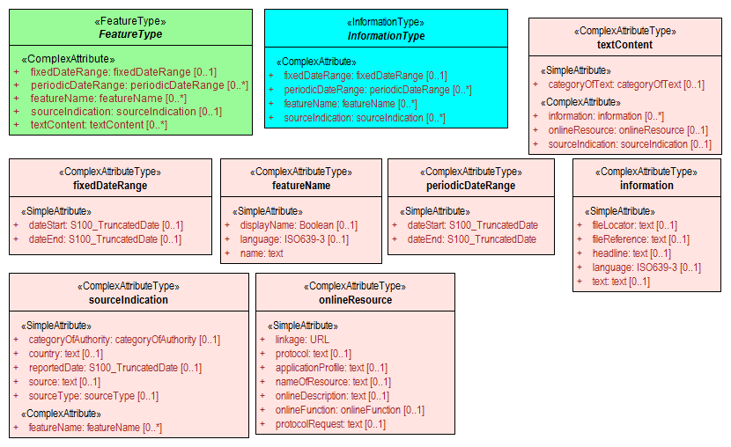
Figure 3. Base classes in S-127 and their attributes

Overview of domain features and information types
Traffic Management data products include tracks and routes, vessel traffic services, pilot services, underkeel clearance, and certain types of specially designated areas which affect ships routeing. It does not include protected areas, radio services (radio stations, NAVTEX, weather or ice forecasts, NAVAREAs, METARAs, etc.), natural conditions, or harbour services. The broad categories of geographic features included in the S-127 domain are:
- Tracks and routes, including IMO and non-IMO routeing measures and recommended tracks.
- Vessel traffic services and related features such as calling-in points, radar ranges, and signal stations.
- Pilot districts, pilot boarding places, and pilot services.
- Water level information features, including underkeel clearance information features and waterways.
- Specially designated locations which affect navigation or provide traffic services, such as military practice areas, security areas, places of refuge, and areas needing special caution for reasons other than natural hazards or environmental protection.
Figure 4 contains all the geographic features in the S-127 application schema.

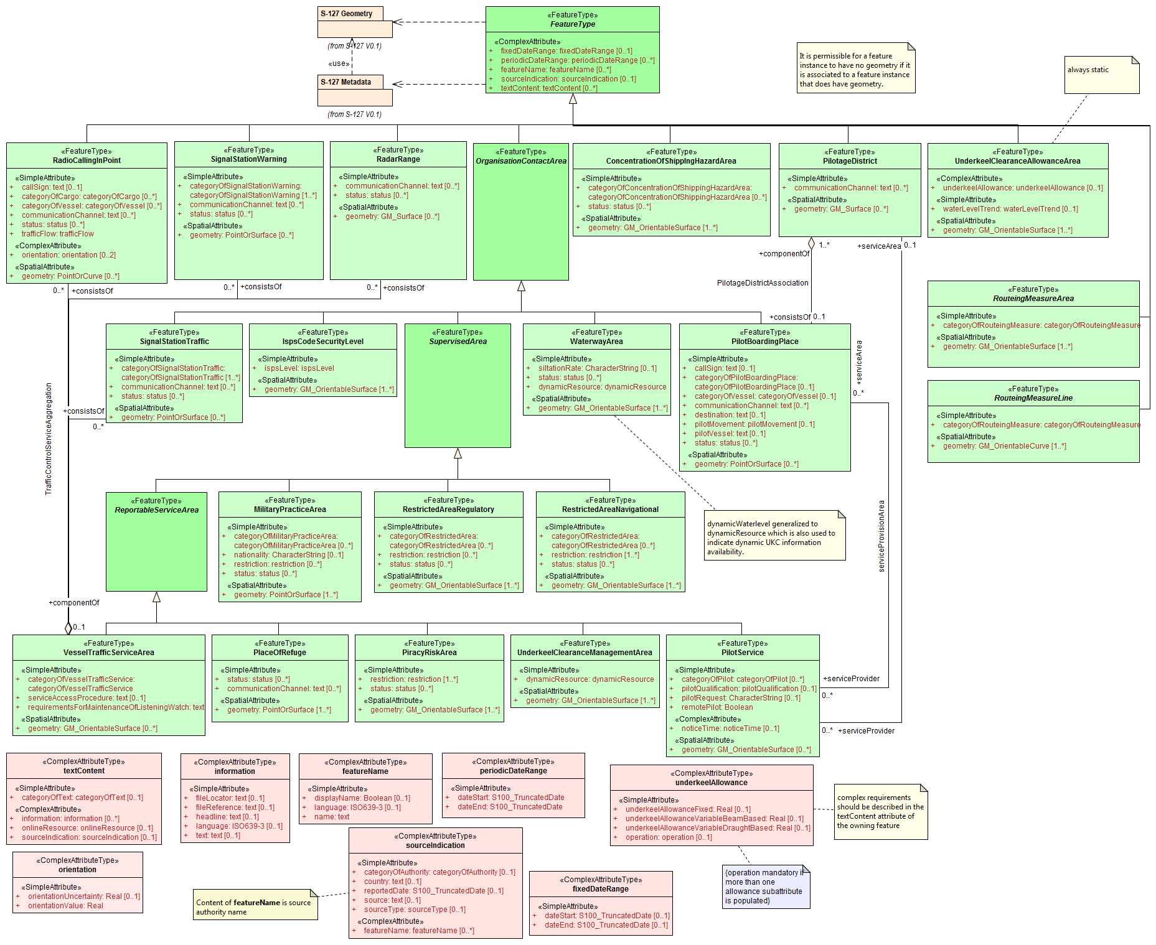
Figure 4. Overview of S-127 Feature Types

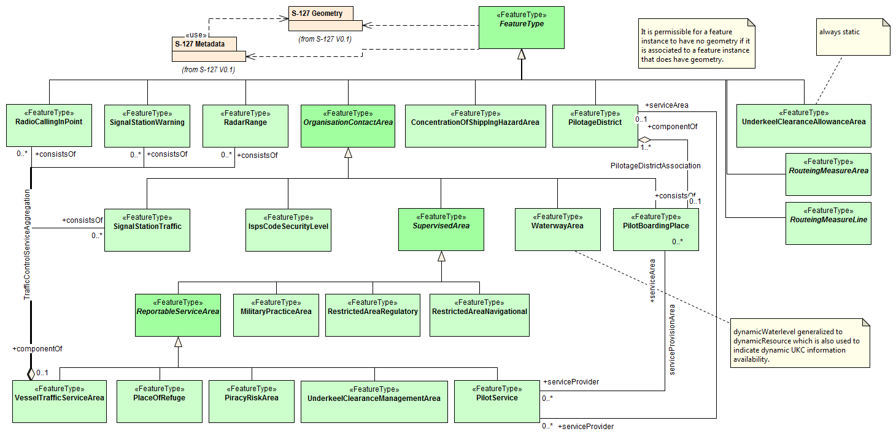
Figure 5. Overview of features (without attributes)
The abstract class FeatureType is an abstract class from which the geographic feature classes in the application schema are derived. FeatureType has attributes for fixed and periodic date ranges indicating the effective dates of the feature, name of the feature, source information, and a textContent attribute that allows text notes or references to be provided for individual feature instances where appropriate. The attributes defined in FeatureType are inherited by all S-127 geographic feature types. All the attributes in FeatureType are optional. A derived class may impose additional constraints, which will be described in the definition of the derived class or the S-127 DCEG.
Geographic features use spatial types defined in the geometry package for spatial attributes. Datasets comprised of S-127 features are described by metadata as defined in the S-127 metadata package. Metadata uses selected spatial types (specifically, it uses the polygon type to describe the coverage of a dataset).

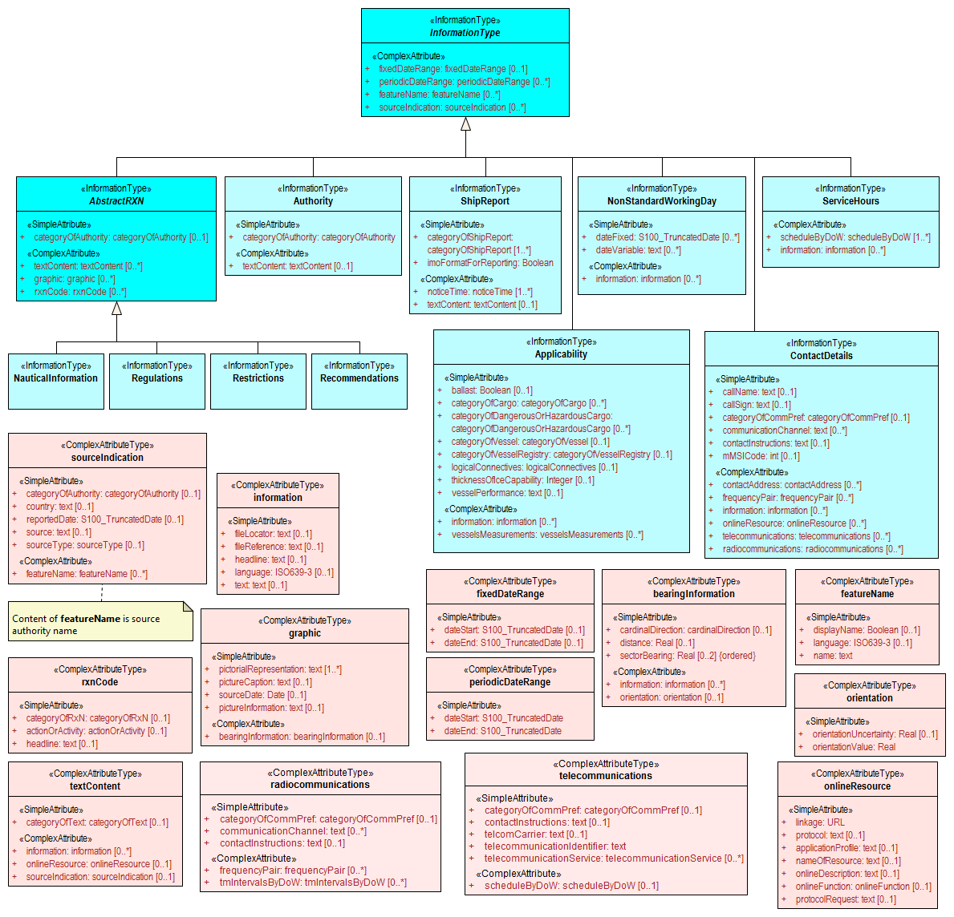
Figure 6. Overview of S-127 Information Types
The abstract class InformationType is an abstract class from which the information type classes in the S-127 domain model are derived. InformationType has attributes for fixed and periodic date ranges, name associated with the individual information object if any, source information, and a textContent attribute that allows text notes or references to be provided for individual instances where appropriate. The attributes defined in InformationType are inherited by all S-127 information type classes. All the attributes of InformationType are optional. A derived class may impose additional constraints, which will be described in the definition of the derived class or in the S-127 DCEG.

Relationships between features and information types
The hierarchy of geographic features is designed around the features’ associations to information types as well as inheritance of attributes. There is a 4-level hierarchy of abstract feature classes. Each level in the abstract feature class hierarchy is associated with one or more information type classes. Subclasses inherit the associations of their super-classes. The result is that feature classes can have the associations of their direct parent abstract super-class as well as associations inherited by the direct parent. For example, PilotBoardingPlace can be associated to a ContactDetails object (with a srvContact association) as well as with a Regulations object (with an associatedRxN association, inherited via the generalization relationship between OrganizationContactArea and FeatureType).
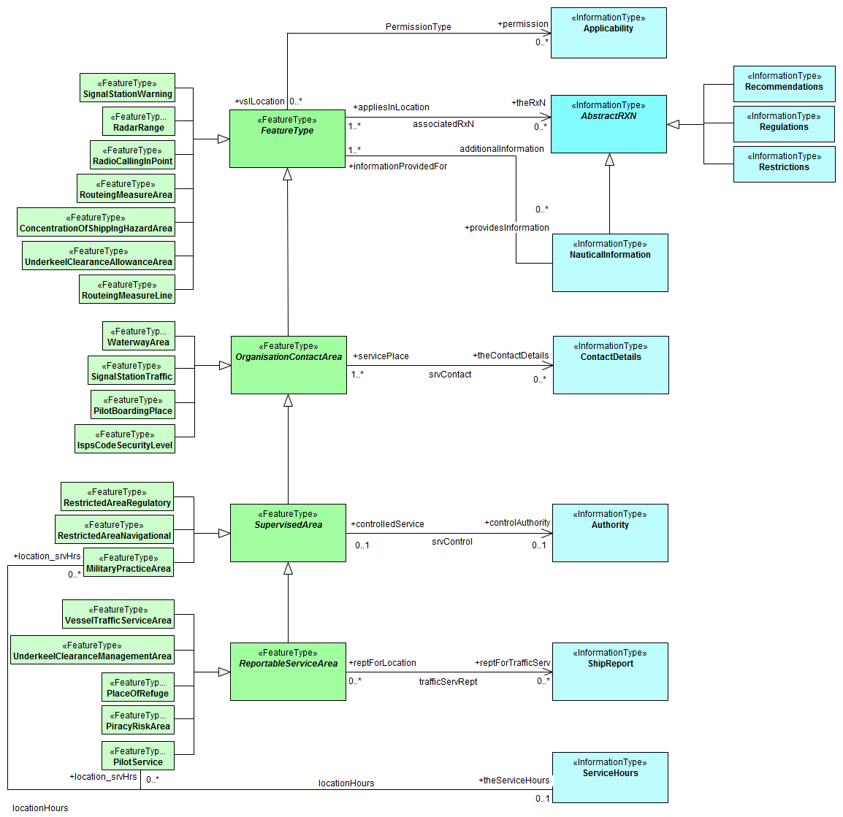
Figure 7. Allowed direct relationships between feature and information types
The four levels in the abstract hierarchy of feature classes correspond to:
- S-127 features in general. Any S-127 feature can have a note, regulation, etc., associated with it (associations to NauticalInformation, Regulations, Restrictions, and Recommendations), or be designated relevant to only a selected subset of vessels (association to class Applicability).
- Features associated with a source that may or must be contacted. The abstract feature superclass for these features is OrganizationContactArea, which adds an association to the information type ContactDetails.
- Features that may be supervised or controlled in some sense by an organization. The abstract feature superclass for these features is SupervisedArea, which adds an association to the information type Authority. It inherits the associations of OrganizationContactArea and FeatureType, so instances of these feature classes can have associations to ContactDetails, NauticalInformation, Regulations, Restrictions, and Recommendations, or be designated relevant to only a selected subset of vessels (association to class Applicability).
- Features that also involve some kind of reporting (in the broad sense). The abstract feature superclass for these features is ReportableServiceArea, which adds an association to the information type ShipReport. These features also inherit the allowed associations of FeatureType, OrganizationContactArea, and SupervisedArea.
In addition to the associations allowed through inheritance, features can have direct relationships to other information types. The S-127 application schema contains two such associations, between MilitaryPracticeArea and PilotService on the feature side and ServiceHours on the other.
Note that this figure shows only feature/information associations. Feature associations and information/information associations are allowed as defined elsewhere in the application schema – for example, the operating hours of a PilotService on holidays will be indicated by a NonStandardWorkingDay instance associated with the ServiceHours instance which is in turn associated with the relevant PilotService instance.

Regulations, information notes, etc.
There are three main information types which represent regulations, restrictions, and recommendations respectively, and a fourth information type for general or unclassifiable information.
- The Regulations class represents information derived from laws, national shipping regulations, navigation rules, etc.
- Class Restrictions is intended for restrictions that are not derived from regulatory sources.
- Class Recommendations is intended for information that is recommendatory in nature; in S-127 this may be recommendations for maintenance of listening watches, AMVER reporting, etc., that are either voluntary or have not been issued as formal regulations.
- The fourth class, NauticalInformation, is intended for general notes or other information that cannot be categorized as one of the other three classes.
These information types all inherit the attributes of their immediate abstract superclass AbstractRxN, which provides attributes textContent and graphic for textual and pictorial material respectively. The sub-attributes of its complex attribute rxnCode allow optional classification of the material encoded in textContent/graphic according to the type of material and the kind of nautical activity affected by it. They also inherit the attributes of abstract superclass InformationType, which allows encoding of the effective and expiry dates, if any, and the source of information, if it is necessary to encode that data.
These classes are intended primarily for encoding text information, such as that which derives from textual source material such as national or local laws or official publications. Where specific attributes such as the simple attribute restriction are permitted, they must be used. For example, if a geographic feature class has the restriction attribute, it should be used instead (explanations, details, paragraphs from regulations, etc., can be encoded in an associated Regulations, NauticalInformation, etc., object).
The use of these information types to associate regulatory and other information to individual features is described elsewhere in clause 6.2.1.
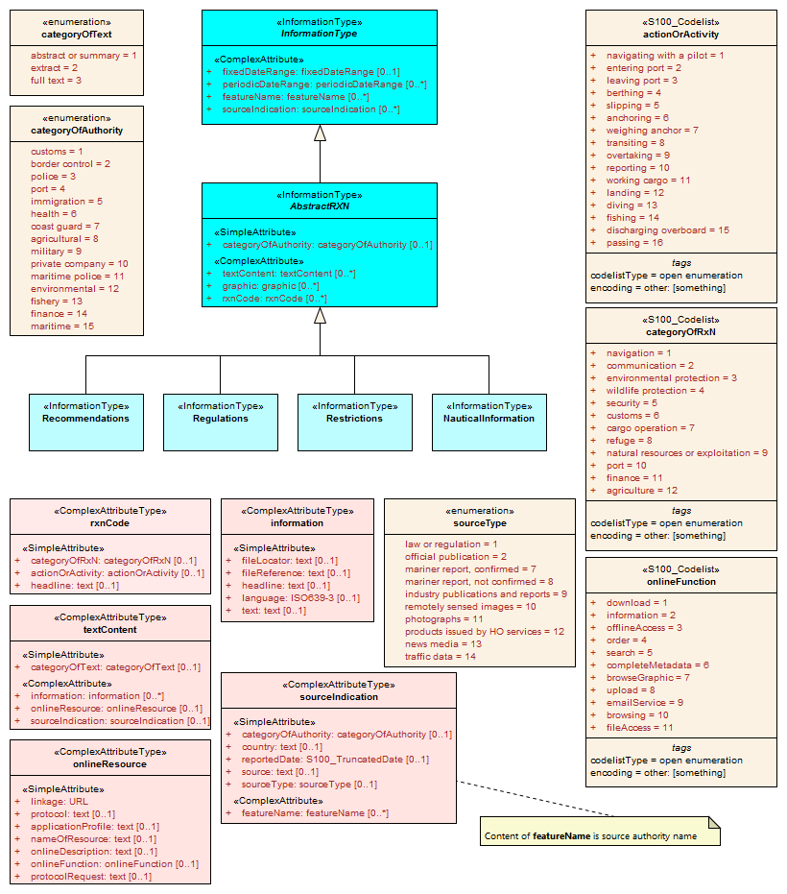
Figure 8. Structure of regulations and note information types

Contact information
The detailed model of contact information is shown in Figure 9 below.
The ContactDetails class uses a condensed form of the complex attribute radiocommunications mentioned in the previous section. When used as an attribute of ContactDetails, the sub-attributes of radiocommunications are restricted to those shown in Figure 9. The complex attribute telecommunications is analogous to radiocommunications, but describes telephone contact data.
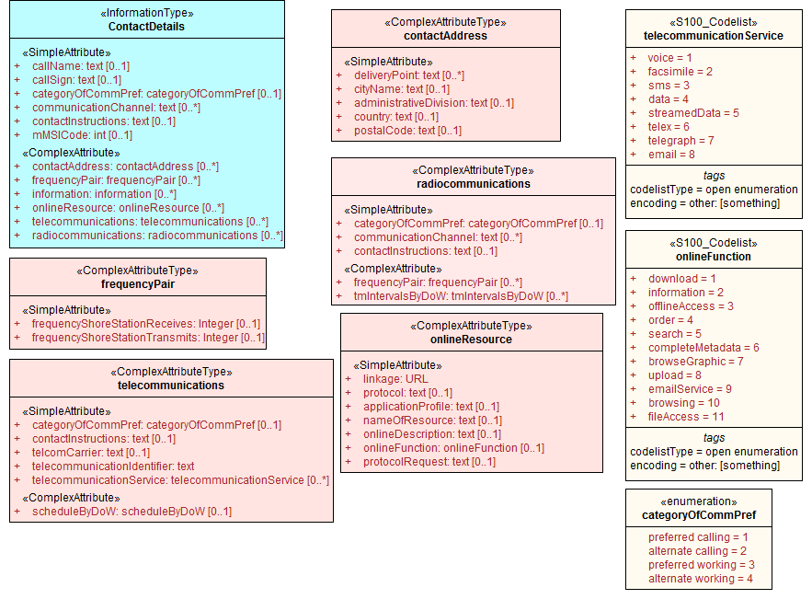
Figure 9. Contact information - detail

Supervising organizations, schedules and business hours
The SupervisedArea class models areas which may have an associated organization (government or private) that exercises some kind of control or supervision over the area.
Operating schedules and business hours of organizations are modeled by associating the ServiceHours class to an Authority. The ServiceHours class is a container for the complex attribute describing daily schedules for different weekdays (scheduleByDoW). This complex attribute contains another complex attribute for time intervals and the days to which they apply, and category sub-attribute to model whether the schedule describes opening hours, closures, etc. Exceptions to the schedule such as fixed or movable holidays are modeled by a NonStandardWorkingDay class with attributes allowing indication of the dates or days which are holidays or exceptions.
Working times and schedules for service features are modeled by an analogous association from the feature object (association locationHours). When a ServiceHours is thus linked to a service feature, the service hour information applies to the feature as a whole (e.g., all services described in a PilotService).
Working times for MilitaryPracticeArea features are to be interpreted as the hours of military activity. Absence of working hour features associated to a practice area means 24 hours/day. The dates or activity are indicated by attributes fixedDateRange or periodicDateRange as appropriate.
The model for both kinds of schedules is shown in Figure 10.

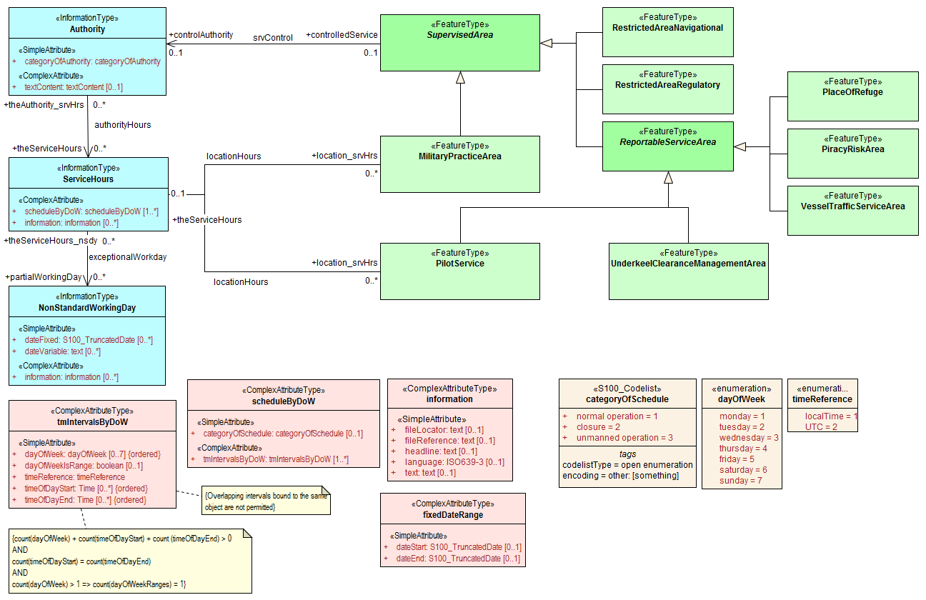
Figure 10. Working times and schedules

All the service features in S-127 can be associated to a supervising organization using the srvControl association. The authority should be encoded only if its presence in the dataset conveys information that is useful to the end user.
Since Authority also has an information association to ContactDetails (Figure 11), it is in principle possible to link a VesselTrafficServiceArea (for example) to both an Authority and ContactDetails as well as linking the VesselTrafficServiceArea to the same ContactDetails. Such linking is permissible but will generally be redundant and should, if possible, be avoided as unnecessary duplication. It may be done in situations where contact details for an operating authority are different from contact details for the service it operates.
Figure 10 also shows associations between service features and Authority. Authority-ContactDetails associations are omitted to reduce clutter.

Reports to be submitted by vessels
Some traffic management areas require reports (or communications not meeting the strict definition of “reporting”) to be filed with authorities when certain events occur such entering or leaving the area. These requirements are modeled by association of a ShipReport class to the Authority class. The area in question is modeled by a feature of the requisite type, e.g., a VesselTrafficServiceArea. Any time requirements or constraints on the filing of the report are described by the noticeTime attribute, with explanations, if any provided in text form in the textContent attribute of ShipReport. Required reporting formats, if necessary to be included, are also described in the textContent attribute. If reporting requirements depend on vessel characteristics such as type of cargo, etc., that is encoded using an associated Applicability instance. Figure 11 shows the model elements that are used to carry these conditions.
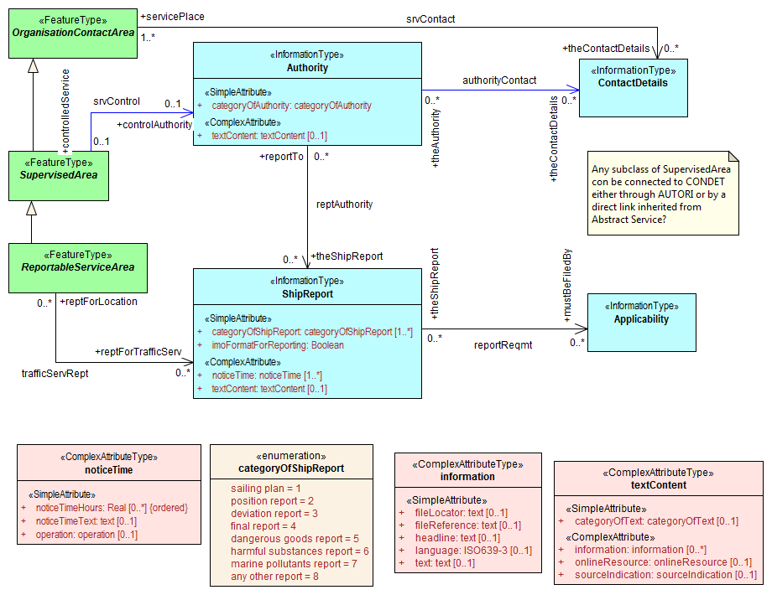
Figure 11. Reporting

Regulations applying in specific geographic features
The associatedRxN association between a feature type and a Regulations, Restrictions, Recommendations, or NauticalInformation object indicates that the Regulation, etc., is applicable within the associated feature. If it is necessary to identify an authority or organization related to a particular regulation (restriction, etc.) object, this may be done using the relatedOrganisation association between Regulations, etc., and an Authority object. This should be included only when the connection to the Authority conveys useful information to the end user – it is not intended to encode the issuing or controlling authority for every regulation. Note also that while Authority can be associated to geographic features as well as Regulations, etc., encoding both associations is not mandatory even when the same Authority is associated to a service area as well as a Regulations object (or NauticalInformation, etc.).
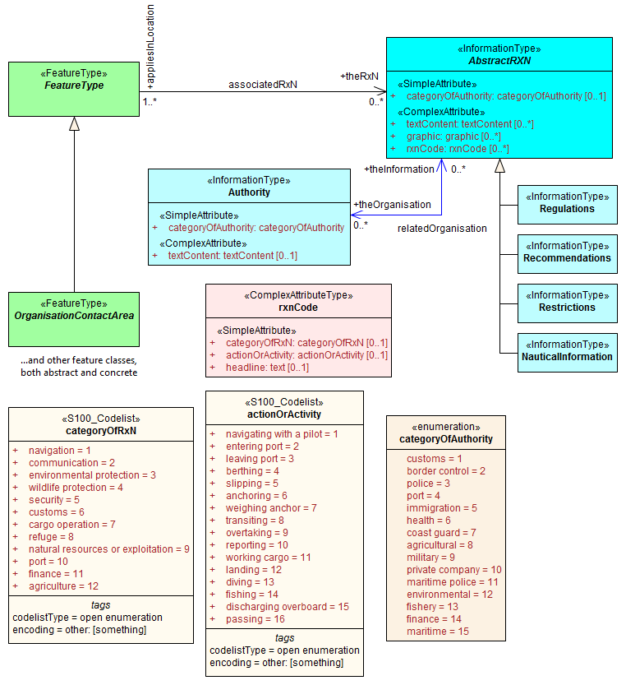
Figure 12. Regulations, etc., relevant to specific features

Regulations applying only to vessels with specific characteristics or cargoes
Certain regulations apply only to vessels of specified dimensions, types, or carrying specified cargo, etc.
This is modeled by first defining the relevant subset of vessels according to the dimension, type, cargo, etc., and then associating that subset to the appropriate feature or information type. The subset of vessels is modeled using the Applicability class, which contains attributes for the most common vessel characteristics used in nautical publications. These include measurements (length, beam, draught), type of cargo, displacement, etc. Constraints which cannot be modeled using the attributes of Applicability can be described in plain text in its information attribute.
Conditions relating to vessel dimensions are modeled by the complex attribute vesselsMeasurements, which has sub-attributes for naming the dimension and indicating the limit (whether the condition applies to a vessel which exceeds or falls below the limit). For example, the combinations below describe the condition “length overall > 50 m” (Condition 1) and “length overall < 90 m” (Condition 2):

 | Condition 1 | Condition 2 | Condition 3
vesselsCharacteristics | length overall | length overall | breadth
vesselsCharacteristicsUnit | metre | metre | metre
comparisonOperator | greater than | less than | greater than
vesselsCharacteristicsValue | 50 | 90 | 20
Table 6.1 - Conditions relating to vessel dimensions

The logicalConnectives attribute is used to indicate how to interpret the case where multiple conditions are encoded using attributes of measurements - whether the conditions described by condition attributes are cumulative (conjunctive, AND) or alternatives (disjunctive, OR). A logicalConnectives=AND combined with Conditions 1 and 2 above describes a vessel of length between 50 and 90 metres; logicalConnectives=OR combined with conditions 1 and 3 describes a vessel of length greater than 50 metres or beam greater than 20 metres.
This modeling cannot represent subsets defined by both AND and OR combinations of conditions, but it is always possible to convert such complex conditions into multiple combinations each using only AND (‘conjunctive normal form’) or OR (‘disjunctive normal form’), and model the subset using more than one Applicability object.
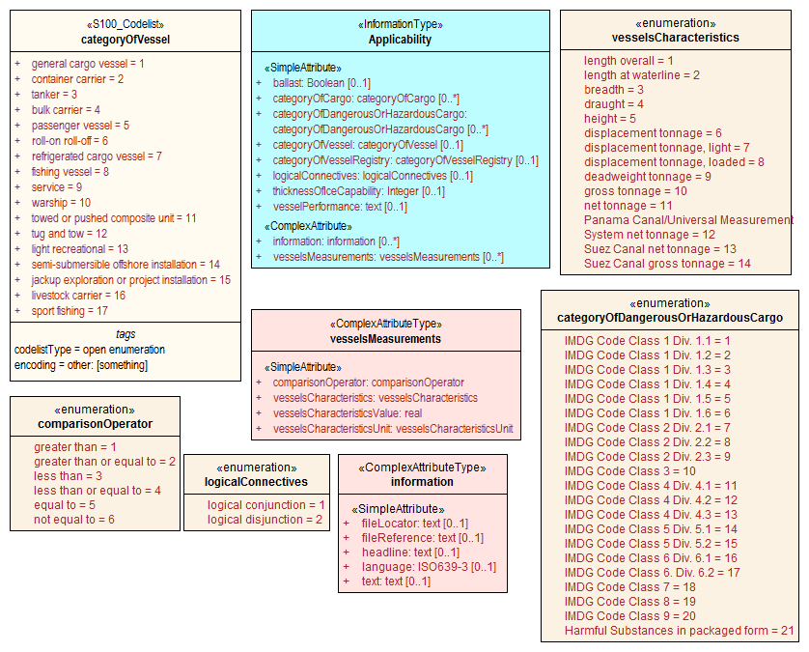
Figure 13. Vessel subsets characterized by cargo and dimensions
Given the relevant subset of vessels, it can be associated to the appropriate feature, regulation, or report by a PermissionType, or InclusionType association. These are association classes, whose single attribute models the nature of the relationship between the vessel subset and feature or information type.
The association classes PermissionType and InclusionType basically characterize the relationship. For example:
- A specified set of vessels is COVERED by a regulation and another set of vessels is EXEMPT from the regulation.
- Vessels with specified cargo & dimensions MUST use a specified pilot boarding place, vessels of smaller dimensions are RECOMMENDED to use the boarding place, and warships are EXEMPT from using the pilot boarding place.
“COVERED” and “EXEMPT” are different kinds of relationship between different subsets of vessels characterized by different dimensional limits, etc., and a given regulation.
“MUST use”, “RECOMMENDED to use”, and “EXEMPT from use” are relationships between different subsets of vessels characterized by different dimensional limits, etc., and a given feature or service.
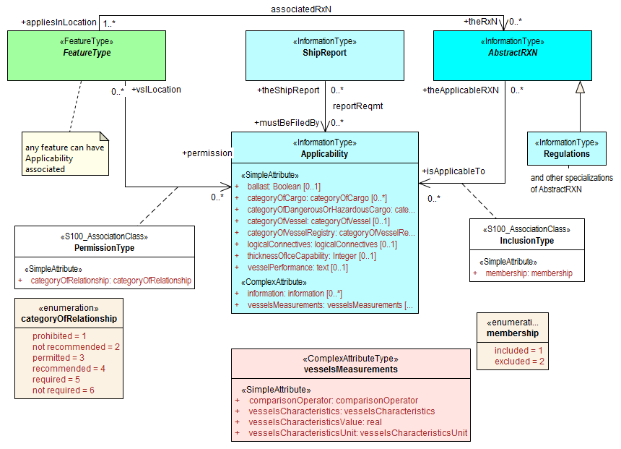
Figure 14. Applicability of reporting requirements, rules, etc. to vessel categories
PermissionType links a feature to an Applicability, and models a requirement, recommendation or prohibition on entry into a feature, by the specified subset of vessels.
Inclusion links a Regulation, Recommendation, Restriction, or NauticalInformation instance to a subset defined by an Applicability object, and indicates whether the content of the Regulation, etc., applies to the vessels (membership=included), or whether it explicitly does not apply (membership=excluded).
Informally:
- Applicability describes the set of vessels: i.e., who
- Regulations provides the text of the regulation: i.e., what
- The association class InclusionType describes the relationship between who and what. That is, who “must (or can)” / “need not” do what.
And:-
- A geographic feature defines a location or physical facility: i.e., where
- The association class PermissionType describes the relationship between who and where. That is, who can / must / should / need not use (or sail) where.

Routeing measures
Note: Only one of the 3 alternatives will be used in the final application schema.

Routeing measures alternative A
The routeing measures model defines only one generalized routeing measure feature. The type of routeing is indicated by a category attribute. The geometry may be area or line (area geometry should be encoded in preference to line geometry, if possible). The geometry is expected to be the spatial combination of relevant geometries from the ENC. The original features need not be the same class, e.g., an S-127 RouteingMeasure feature may combine Inshore Traffic Zone and TSS Lane Part geometries from S-101 data.

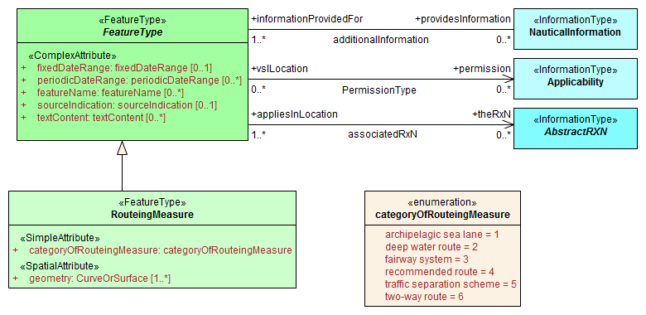
Figure 15. Routeing measures A
Regulations, etc., can be associated with the feature and requirements relating to use by specific classes of vessels indicated by an associated Applicability instance. If different parts of the routeing measure have different information associated with them, the geometry can be divided into parts as needed.

Routeing measures (alternative B)
The routeing measures model defines a set of generalized routeing measure features as depicted in the figure below. Superclasses are used to distinguish area and line features. (The category attribute of Alternative A is not used.) Each type of routeing measure has additional attributes. (The attributes depicted in the figure are selected subsets of the S-101 attributes.) The geometry may be area or line (area geometry should be encoded in preference to line geometry, if possible). The geometry is expected to be the spatial combination of relevant geometries from the ENC.

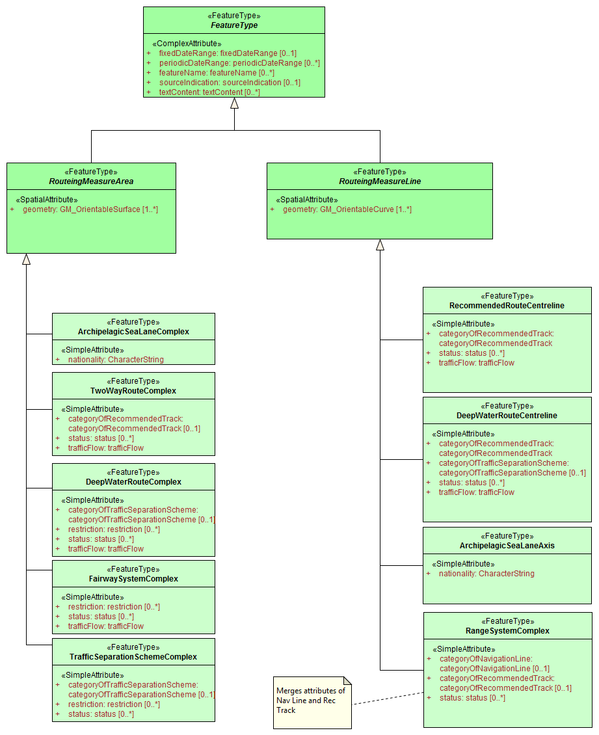
Figure 16. Routeing measures B
The ...Complex features are based on aggregation features in S-101 that aggregate component features but do not themselves bind a spatial attribute. The ...Complex features combine geometry of components of the aggregation features. The component features need not be the same class, e.g., TrafficSeparationSchemeComplex may combine Inshore Traffic Zone and TSS Lane Part geometries.
The idea is to allow a logical mapping from S-101 data to S-127 data without using all the S-101 features, while still allowing type-specific attributes which may be useful for the S-127 portrayal or other processing.

There can be more than one ...Complex feature when the information attached to one section of the TSS is different from the information attached to another section.
Regulations, etc., can be associated with the feature and requirements relating to use by specific classes of vessels indicated by an associated Applicability instance. If different parts of the routeing measure have different information associated with them, the geometry can be divided into parts as needed.

Routeing measures (alternative C)
This alternative uses most of the “Tracks and Routes” features from S-101, and will refer the reader to the S-101 Product Specification and DCEG for full details.

S-101 features used | S-101 features not used
Navigation line | Ferry route
Recommended track | Radar line
Range system | Radar station
Fairways
Fairway systems
Recommended route centreline
Two-way route part
Two-way route
Recommended traffic lane part
Deep water route centreline
Deep water route part
Deep water route
Inshore traffic zone
Precautionary area
Traffic separation scheme lane part
Traffic separation zone
Traffic separation line
Traffic separation scheme boundary
Traffic separation scheme crossing
Traffic separation scheme roundabout
Traffic separation scheme
Archipelagic sea lane area
Archipelagic sea lane axis
Archipelagic sea lane
Radio calling in point
Radar range

Vessel traffic service areas and related features
The diagram below depicts the S-127 features relevant to VTS areas and features associated to VTS. Associations to information types are also shown.
It is not necessary to associate non-VTS features in this part of the model to a VTS. They may be included independently of VTS areas if they are relevant to traffic management on their own.
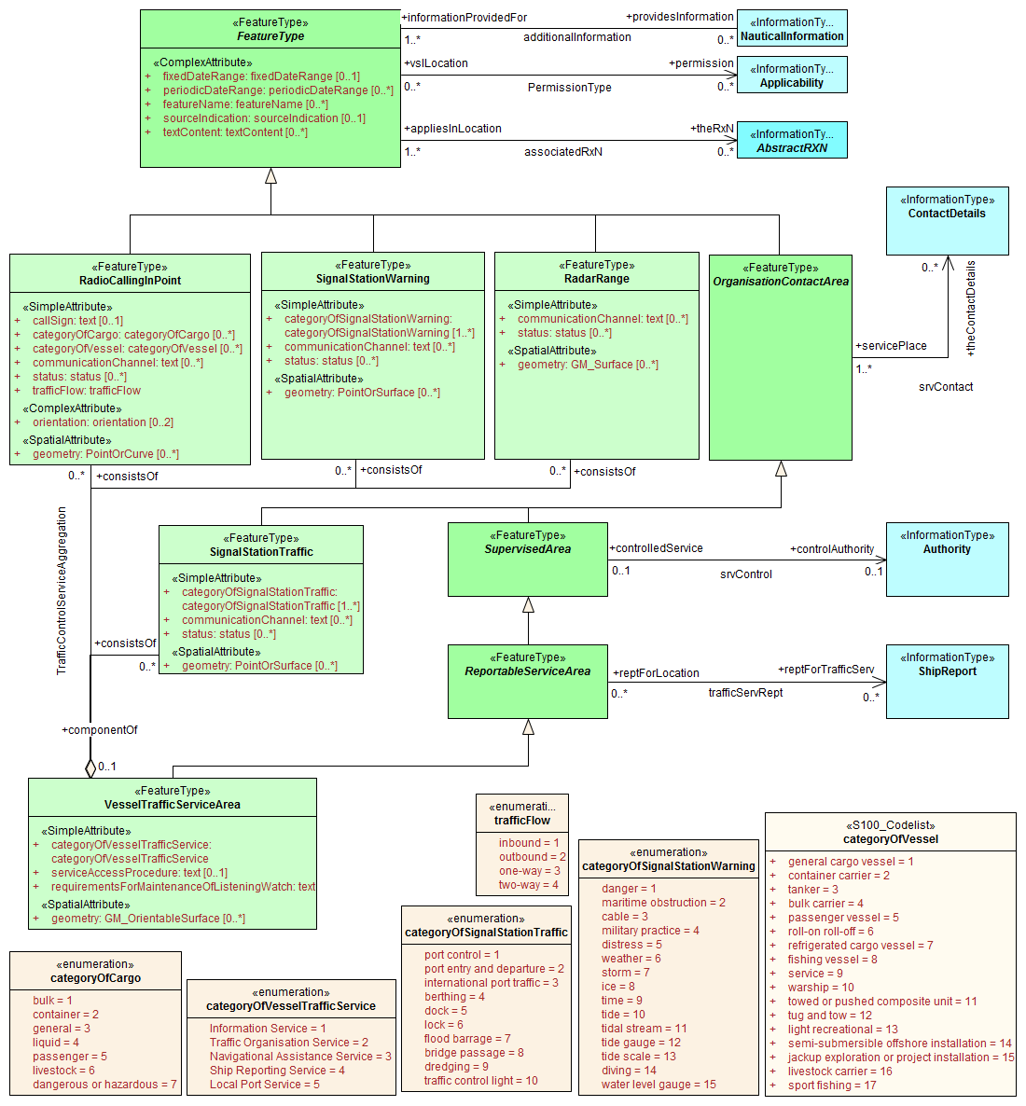
Figure 17. Vessel traffic service areas and associated classes

Pilotage
Pilot boarding places, districts, and services are depicted in Figure 18 below, along with associated information types.
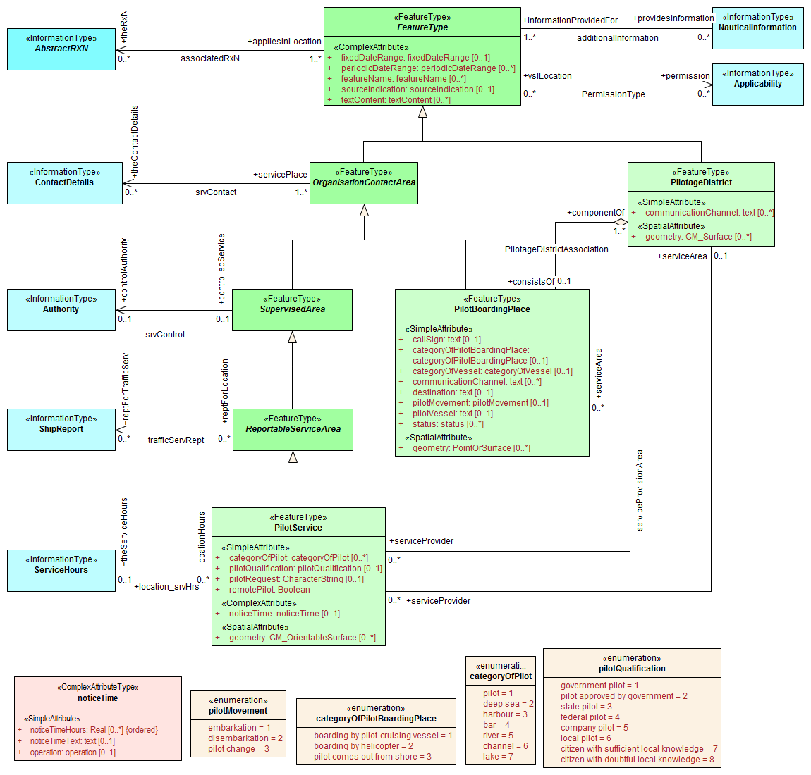
Figure 18. Pilotage features and associated classes

Water levels and underkeel clearances
Features connected to water level information are depicted in Figure 19 below. In some locations, up-to-date information may be available, or required to be obtained, from an off-vessel source, or required to be computed in near-real-time using software. This is indicated by the dynamicResource attribute. Constraints related to this attribute are:
Value | Definition | Requirement
static | The information is static, or a source of up-to-date information is unavailable or unknown. | None – vessels can use the water level or clearance information encoded in the feature.
mandatory external dynamic | An external source of up-to-date information is available and interaction with it to obtain up-to-date information is required. | The external source must be encoded in an associated ContactDetails. Vessels are required to access this external source for up-to-date information.
optional external dynamic | An external source of up-to-date information is available but interaction with it to obtain up-to-date information is not required. | The external source must be encoded in an associated ContactDetails. Vessels are not required to access this external source.
onboard dynamic | Up-to-date information may be computed using only onboard resources. | No external source is encoded. Vessels are required to compute water level or clearance information using onboard software. The controlling authority may specify the allowed software.
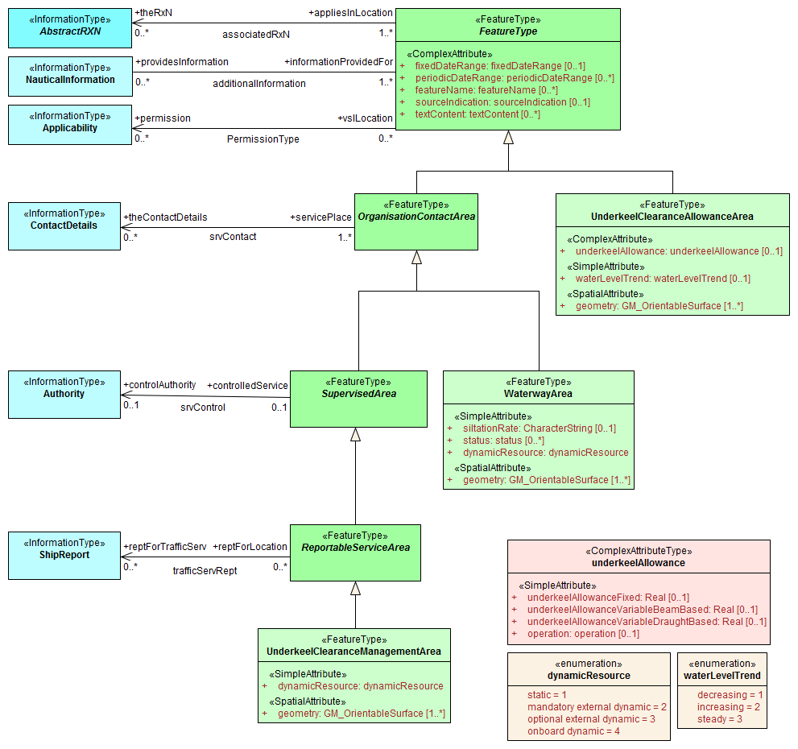
Figure 19. Underkeel clearance and water level features and associated classes

Other areas
This part of the model includes miscellaneous areas which are relevant to traffic management.
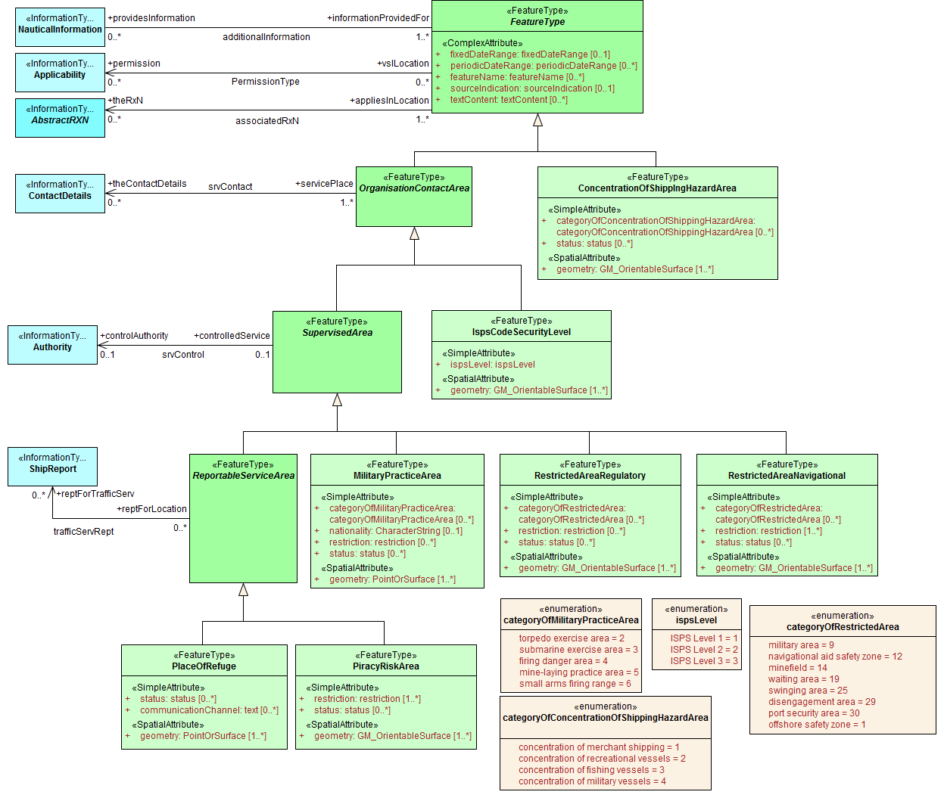
Figure 20. Cautionary and other specially designated areas

S-127 Enumerations and codelists
For completeness, the enumerations and codelists in the S-127 domain are provided in Figures 21–23. They are divided into multiple figures for convenience.

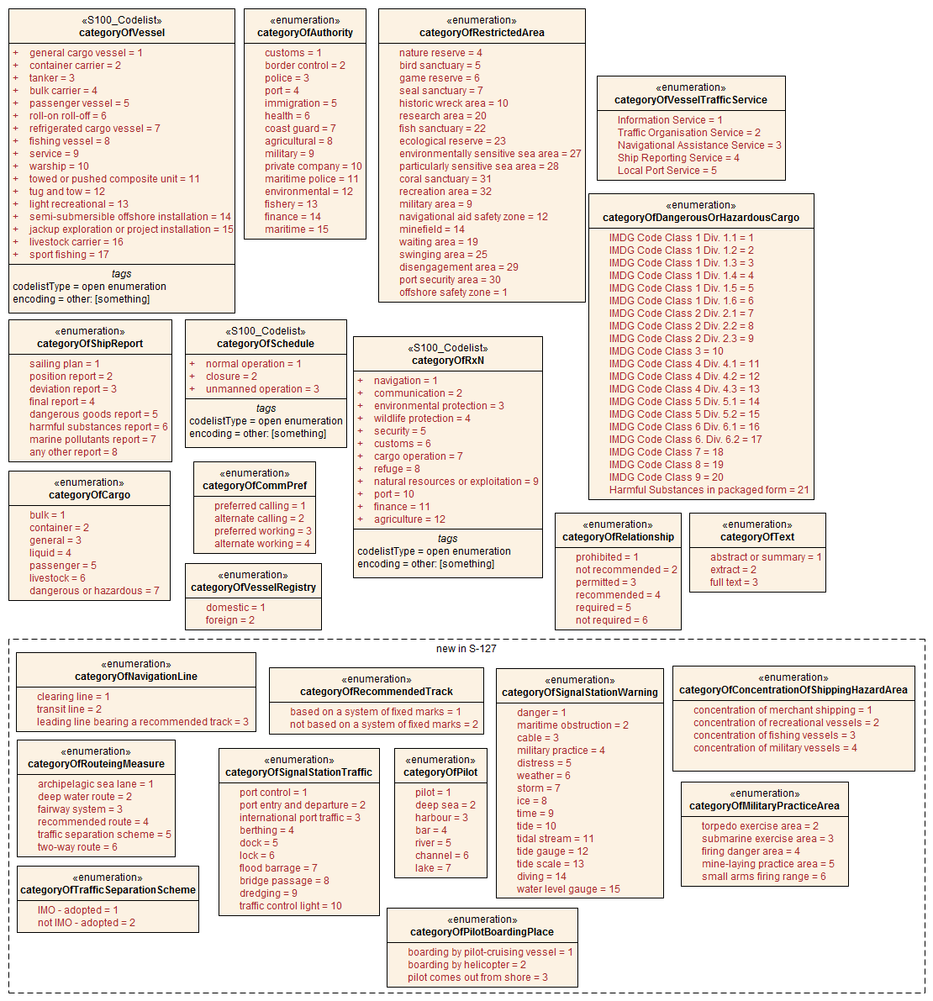
Figure 21. Category enumerations
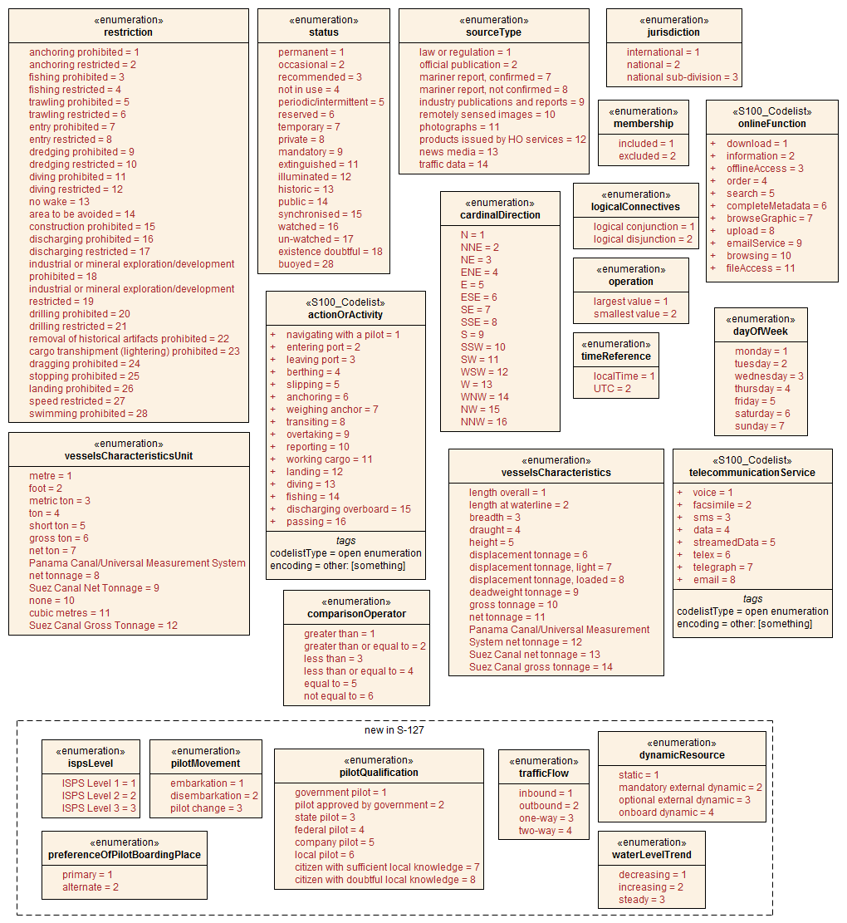
Figure 22. Other enumerations and codelists

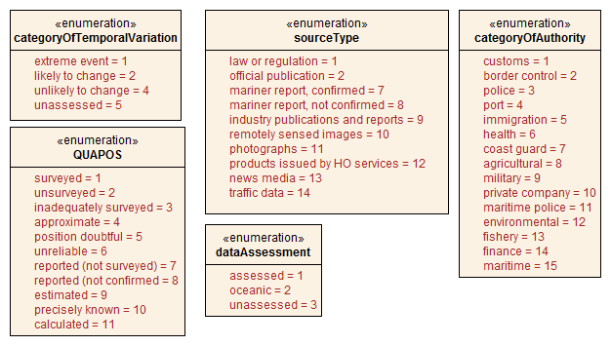
Figure 23. Enumerations for meta-features

Uncategorized additional information
The domain model also provides a method for attaching to any feature or information type data in the form of a text note, graphic, or Internet reference which cannot be categorized using an appropriate specific feature or information type. This consists of defining a NauticalInformation object and referencing it from the feature or information type using the additionalInformation association. This method is intended to be a last resort and every effort should be made to use a more specific feature or information type to encode the information to be attached, including splitting the information in question across more than one type of feature or information object as needed and/or using the associatedRxN association instead of additionalInformation, wherever the nature of the content allows it.
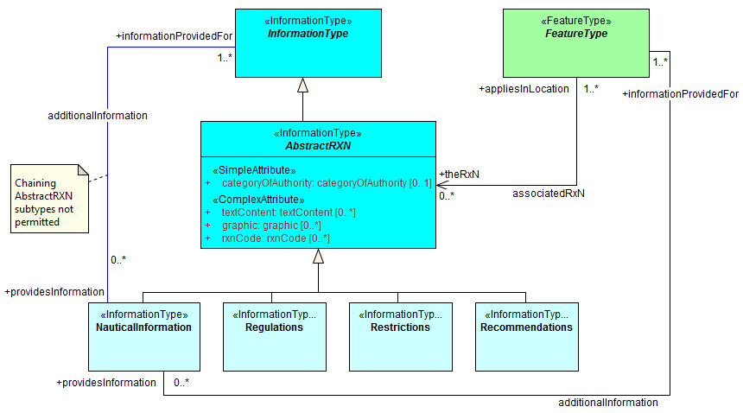
Figure 24. Attachment of uncategorizable information to any feature or information type
The additionalInformation association must not be used to chain NauticalInformation, Regulations, Restrictions, or Recommendations objects, whether they are of the same class or different classes.

Meta features
S-127 has two meta feature classes. The first one is QualityOfNonbathymetricData and is derived from QualityOfTemporalVariation, which in turn is derived from DataQuality. The second is DataCoverage.

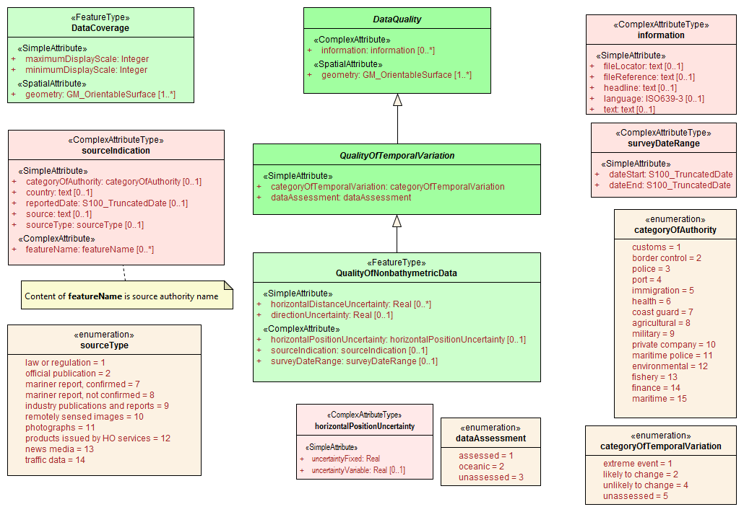
Figure 25. Overview of Meta feature classes and enumerations

Spatial quality information type
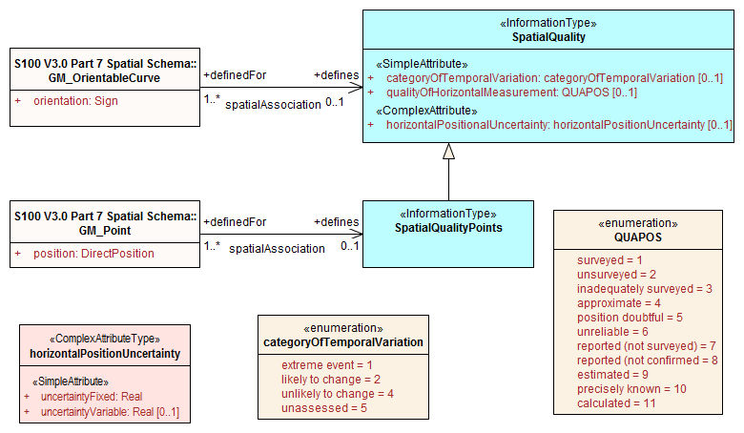
Figure 26. Spatial quality

S-127 spatial quality is composed of two information types, namely SpatialQuality and SpatialQualityPoint, which is derived of the first. As the name indicates, the latter is for spatial points, while SpatialQuality is for curves. The attributes are for temporal quality and qualitative and quantitative horizontal quality.

Cartographic features
S-127 utilizes a cartographic feature called TextPlacement that is used in association with the featureName attribute to optimise text positioning. This feature can be associated to any geographic feature and gives the location of a text string relative to the location of the feature.

Portrayal
Portrayal is not defined in this version of S-127 Traffic Management Product Specification. Users are free to choose the means and methodology of portrayal as they see best suited for their needs. It should be noted that future versions of S-127 may include a portrayal catalogue, and any implementer should therefore anticipate this, and make sufficient provisions in any system supporting S-127.

