NIPWG9-14.1

Paper for Consideration by NIPWG

Suggestions for Changes to the Encoding of Restricted Area Navigational in S-127 Maritime Traffic Management Product Specification (1.0.0)

Submitted by: | Lyu Yuxiao, China MSA
Executive Summary: | If it is required, the speed limit should be encoded in S-127.It is suggested that the complex attribute vessel speed limit, sub-attribute speed limit should be bound to the feature Restricted Area Navigational in the S-127 DCEG. It is proposed to bind two values, berthing prohibited and berthing restricted, to enumeration of the attribute restriction of the feature Restricted Area Navigational, for these types of traffic management rules structurally encoded.
Related Documents: | S-127 (1.0.0), S-101(1.0.0), S-98(1.0.0_Draft).
Related Projects: | S-127 Project.

Background
China Maritime Safety Administration have been producing S-127 test data in navigational areas under the jurisdiction of the Guangdong Maritime Safety Administration by following S-127 Maritime Traffic Management Product Specification (1.0.0). Those maritime traffic management regulations entered into the test data are sourced from "Regulations on Safe Navigation of Vessels under the Jurisdiction of Guangdong Maritime Safety Administration, Guangdong MSA File No.100/2021".
In the process of producing test data, we tried to realize some navigation regulations structurally and semantically expressed, and found that some necessary information which cannot be encoded in a structured way. Firstly, the value of speed limit cannot be encoded in S-127 Digital Classification and Encoding Guide (DCEG) in version 1.0.1. Secondly, it cannot be done using feature/attributes from the S-127 DCEG (1.0.1) to structurally encode the maritime traffic rules of berthing restricted and berthing prohibited.

Analysis/Discussion

(1) The value of speed limit cannot be encoded.
Speed is often limited and also assigned an explicit speed limit inside harbours. Such restrictions appear more than 58 times in Guangdong MSA File No. 100/2021, of which there are 44 explicit speed limits. It is possible to encode this restriction using a Restricted Area Navigational feature from the S-127 DCEG (1.0.1). But there is no bound attribute to encode the exact speed value where the speed limit is known (for example Speed limit is 10 knots).
The machine-readable speed limits are helpful for a vessel, especially an autonomous vessel to plan its passage more accurately. The specific information on the speed limit in the area are available before departure, a vessel would be aware that its planned path would pass through a speed limited zone and could plan its passage to adhere to the limit, whilst still reaching its destination on schedule. So, if it is required, the speed limit should be coded in S-127.
It is noted that it is also possible to encode speed limits in S-101 DCEG (1.0.0). If it is required to encode cases where the speed limit is known, it must be done using a Restricted Area Navigational feature, with the attribute restriction = 27(speed restricted), and with the speed limit and its unit of measurement (knots) encoded using the complex attribute vessel speed limit, sub-attribute speed limit. It doesn't mean, however, that there is no need to encode speed limit in the S-127. First of all, when making the S-100 based Products, duplicated features are allowed between products, that is, the speed limit area can be coded in both S-101 and S-127 products. The issue of duplicated features between products can be dealt with properly when considering interoperability through Data Product Interoperability in S-100 Navigation Systems (S-98 Draft Edition 1.0.0). Second, according to suggestions for how to design rules to implement interoperability from S-98, developers of Product Specifications should consider how their data model is similar and/or different from other related Product Specifications and the justification for this; While developing an interoperability catalogue, the update speed of overlapping features and the value of the data to users should be considered. It is same for speed limits information to be encoded in S-101 and S-127 products, so Product Specification developers should strive to maintain their data model as harmonised as possible. At the same time, speed limits in S-127 products are likely to be more frequently updated than those of the ENC, because the update of S-127 products follows the promulgation of regulations on safe navigation of vessels, while S-101 data products generally updated with the surveying cycles. Therefore, when developing an interoperability catalogue, priority should be given to speed limits in S-127 product that is most likely to be up to date with the latest information.

(2) It cannot be done using feature/attributes from the S-127 DCEG (1.0.1) to structurally encode the maritime traffic rules of berthing restricted and berthing prohibited.

In navigational areas under the jurisdiction of the Guangdong MSA, restrictions on berthing restricted or berthing prohibited are common. For example, at some docks, vessels exceeding a certain width are restricted from berthing.
At present, the attribute restriction of feature Restricted Area Navigational from S-127 DCEG (1.0.1) is only bound to enumerated value name such as anchoring prohibited or speed restricted (see Figure 1).
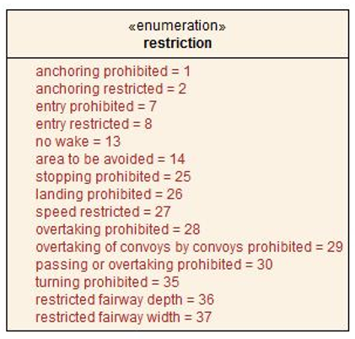
Figure 1. Enumeration of Restriction

In the IHO Geospatial Information Registry, the values for berthing prohibited with code number 31, berthing restricted with code number 32, have been registered and bound to attribute restriction within Inland ENC domain (see Figure 2). It is only necessary to bind the 2 values to attribute restriction in the data model of feature Restricted Area Navigational from the S-127 DCEG, these maritime traffic rules could be structurally encoded in S-127 products.
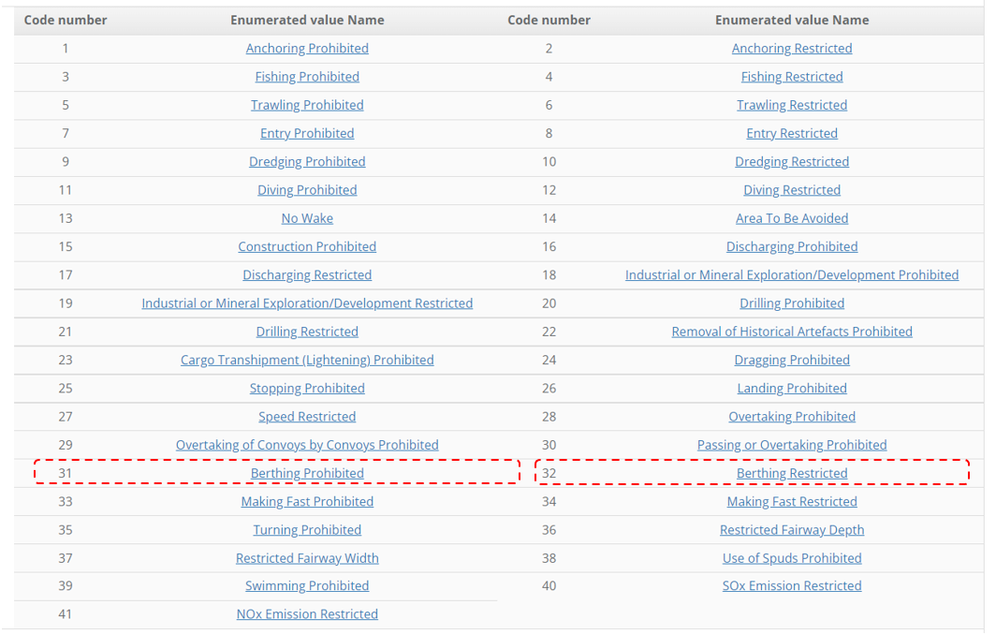
Figure 2. Enumeration of Attribute Restriction

Conclusions and Recommendations
If it is required, the speed limit should be encoded in S-127. In order to encode the limit value accurately, it is suggested that the complex attribute vessel speed limit, sub-attribute speed limit should be bound to the feature Restricted Area Navigational in the S-127 DCEG.
It is proposed to bind two values, berthing prohibited with code number 31, berthing restricted with code number 32, to enumeration of the attribute restriction of the feature Restricted Area Navigational.
The proposed changes to the model of Restricted Area Navigational is shown in figure 3. Changes are shown Inside the blue dashed frames.
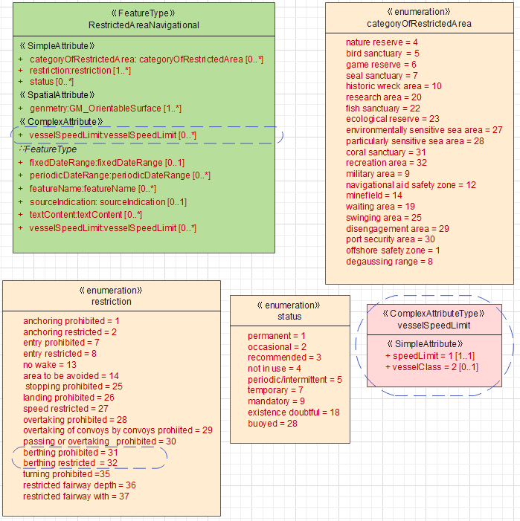
Figure 3. Model of Restricted Area Navigational

Action Required of NIPWG
The NIPWG is invited to:
a. Agree with the proposed changes to the model of Restricted Area Navigational.
b. Note the paper.

