Paper for Consideration by NIPWG
Introduction of MRN in Product Specifications

Submitted by: | Germany
Executive Summary: | The usage of MRN is essential for ensuring an operational status of S-100 based ECDIS providing a multilayer interoperable system. MRN is important to tailor-made information in S-100 based ECDIS.
Related Documents: | S-100 Ed. 5  S-98
Related Projects: | S-100 ECDIS

Introduction/Background
Keeping the necessity of enabling S-100 complaint products to be interoperable according to S-98, IALA developed the Marine Resource Name concept. This concept was integrated in S-100 Edition 5. Appendix 11-E provides Guidance on Unique Identifiers. S-100 Edition 5 advises that the specification of persistent global identifiers for feature and information objects is strongly recommended.
Taking into account that more and more S-100 compliant product specifications are maturing, it is considered necessary to cross check whether the MRN concept is implemented in each product specification seeking operational status.
Analyses/Discussion
The Member State approval of S-100 Edition 5 last year opens the opportunity to upgrade S-100 compliant product specifications.
The S-100 ECDIS concept intends interoperability between various products. To enable interoperability, the ECDIS software requires a mechanism to identify identical features from each used S-100 product. Therefore, S-100 Edition 5 implemented the MRN concept.
Employing MRN ensures further that information in ECDIS could be tailored according to the ship’s condition.
BSH crosschecked various S-100 compliant product specifications and detected that this concept is currently not reflected.

The following example underlines the importance of implementing MRN in various product specifications:
The features RestrictedAreaRegulatory and RestrictedAreaNavigational are part of both S-101 (ENC) and S-122 (Marine Protected Areas). The UML diagramns below show that both S-122 features have a reference to the information feature type Applicability.
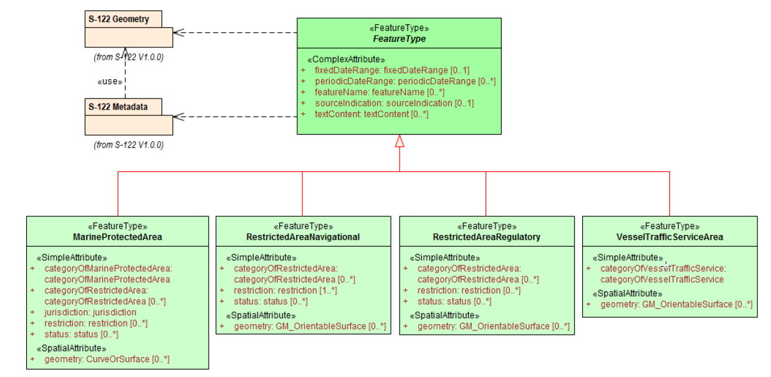
Fig 1: S-122 Feature types
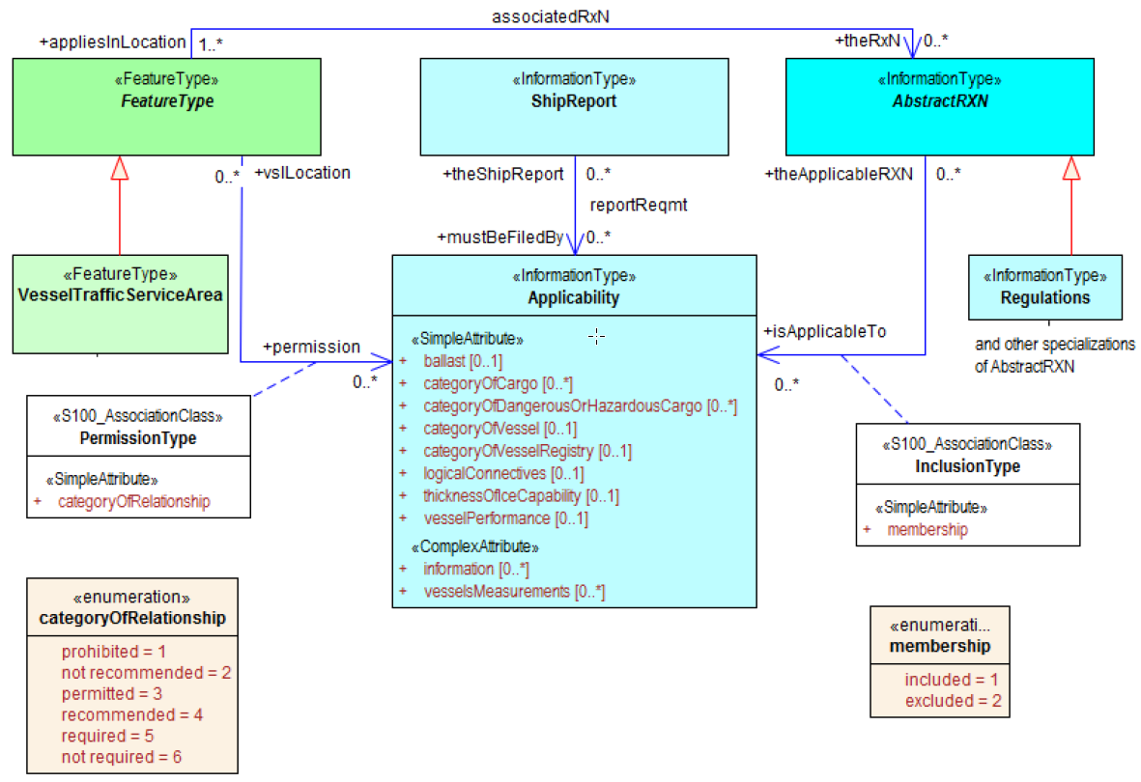
Fig 2: Relation between S-122 feature types and Applicability

The extracted data model of the S-101 features RestrictedAreaNavigational and RestrictedAreaRegulatory is provided in the table below. Information on applicability can only be provided in S-101 using the string attribute information which can provide text or a reference to an external file.
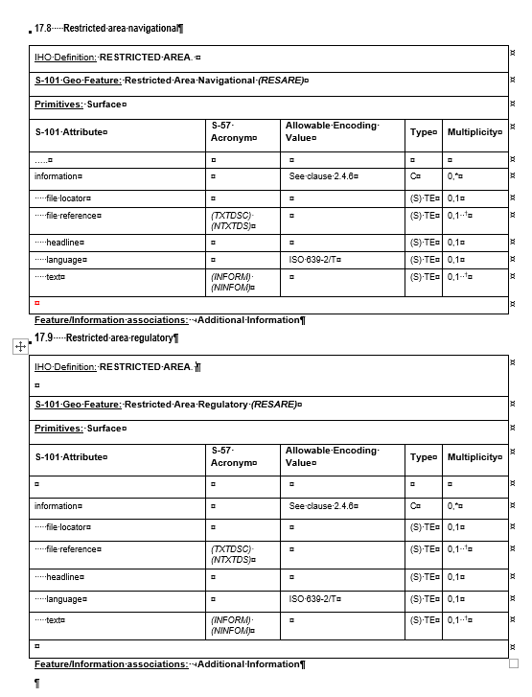
Fig 3: Extract S-101 DCEG Edition 1.1.0, p. 398 – 403

The Feature/Information is associated to AdditonalInformation, which provides an identical information structure as shown in Fig 3 for RestrictedAreaNavigational and RestrictedAreaRegulatory.

A common feature MRN for both the features in S-122 and S-101 would ensure that S-100 compliant ECDIS can link these two instances and could potentially provide tailor-made information according to the ship’s characteristics. Although feature migration would unveil the full interoperability potential of S-100 compliant ECDIS, the full S-98 compliant feature migration would be not necessary at this stage.
Although S-100 is stating that an MRN should not be assigned to each individual feature, we strongly recommend to do so. That prepares the products for future interoperability possibilities. From our point of view, it is better to have this in place as early as possible instead of trying to implement it at a later stage when products are in operational use.
Conclusion
The implementation of MRN in various S-100 complaint product specifications is essential to unveil the full interoperability function of future ECDIS. It supports the interoperable multilayer data management concept.
According to the latest HSSC statements, relevant product specifications should be upgraded to be S-100 Edition 5 compliant. The MRN concept is sufficiently described in S-100 Edition 5 and is ready for implementation in S-100 compliant product specifications.
Recommendation
The usage of MRN should be implemented in S-100 product specification seeking S-100 Edition 5 compliance.
Justifications and impacts
- Product Specifications
  - Upgrading existing product specifications is an ongoing task for all working groups. Additional resources are not needed.
- Production Software
  - Production software providers need to implement MRN in their production systems. They should provide functions ensuring that product producers know if an identical feature is located in other products. In this case the similar MRN should be used for both feature instances.
Action required of NIPWG:
The NIPWG is invited to:
- note and discuss this paper,
- consider in which NPUB product specifications the MRN implementation is useful,
- implement the MRN structure for each individual feature in the relevant NPUB product specifications to ensure the widest possible interoperability with other S-100 products.

