Attachment 2

Templates and Recommendations for DCEGs

14 December 2022

Prepared by Raphael Malyankar

[Clause numbering below is hypothetical and will depend on the structure of the actual DCEG document. Numbering is non-sequential due to the omission of clauses not relevant to associations in DCEGs.]

# Overview

## Terms, definitions and abbreviations

### Terms and definitions

Comment: Most of the terms and definitions are from S-100 Annex A, which in turn takes them from ISO standards, which means they are oriented to modellers rather than cartographers or editors. Case in point - what is a “classifier” and what is the difference between a “classifier” and a “class”, especially as pertains to “feature class” and “information class”? (Potential obscurities are highlighted below.)

The primary audiences for the PS and DCEG are different - editors and cartographers on the one hand, modelers and developers on the other.

**Recommendation: Documents intended primarily for cartographers and editors (i.e., DCEGs) should define the terms and abbreviations they use using more accessible language than S-100 and the main Product Specification, in their own “Terms and abbreviations” sections that are independent of the main Product Specification and S-100. References to S-100 and/or the PS should be included for completeness.**

**This recommendation applies to all NPUB product specifications. (It should probably apply to non-NPUB products too, but NIPWG can only recommend it to the attention of non-NIPWG Project Teams).**

**Obviously, recommendations pertaining specifically to associations apply only if the Product Specification uses associations.**

**Aggregation**

Special form of **association** that specifies a whole-part relationship between the aggregate (whole) and a component part.

**Association**

Semantic relationship between two or more classifiers that specifies connections among their instances.

[Association class is not defined in S-100 Annex A Terms and Definitions]

**Association class [Proposed]**

A class containing attributes that characterize a specified association.

NOTE: The attributes of an association class characterize the relationship between the linked instances; they are not characteristics of either participating instance.

The distinction may be explained by an analogy: The strength of a mooring cable is a characteristic of the cable itself, not of the vessel it secures or the bollard to which the vessel is secured.

(Ship and shore securements obviously have their own strength limits - those limits would be attributes of the classes representing ship and berth respectively.)

**Attribute**

(1) Named property of an entity.

NOTE: Describes a geometrical, topological, thematic, or other characteristic of an entity.

(2) Feature within a classifier that describes a range of values that instances of the classifier may hold.

NOTE: An attribute is semantically equivalent to a composition association; however, the intent and usage is normally different.

NOTE: “Feature” used in this definition is the UML meaning of the term.

**Class**

Description of a set of objects that share the same **attributes**, operations, methods, **relationships**, and semantics.

NOTE: A class represents a concept within the system being modelled. Depending on the kind of model, the concept may be real-world (for an analysis model), or it may also contain algorithmic and computer implementation concepts (for a design model). A classifier is a generalization of class that includes other class-like elements, such as data type, actor and component.

[classifier and composition are defined in S-100 Annex A]

**classifier**

mechanism that describes behavioural and structural features [ISO 19103]

NOTE Classifiers include interfaces, classes, datatypes, and components.

**composition**

form of aggregation association with strong ownership and coincident lifetime as part of the whole [ISO 19103]

NOTE Parts with non-fixed multiplicity may be created after the composite itself, but once created they live and die with it (that is, they share lifetimes). Such parts can also be explicitly removed before the death of the composite. Composition may be recursive. Synonym: composite aggregation.

**Feature**

Abstraction of real world phenomena.

NOTE: A feature may occur as a type or an instance. Feature type or feature instance should be used when only one is meant.

EXAMPLE: The phenomenon named ‘London Eye’ may be classified as a feature instance with other phenomena into a feature type ‘landmark’

[Note that the S-131 DCEG defines “feature” and “information type” separately, in clauses 2.2.1 and 2.2.2:

“A feature contains descriptive attributes that characterize real world entities.”

“An information type has no geometry and therefore is not associated to any spatial primitives to indicate its location.”

These clauses should be reconciled with the Terms and Abbreviations clause.]

**Feature Association**

**~~Relationship~~** **Association** that links instances of one **feature** type with instances of the same or a different **feature** type.

**Feature Attribute**

Characteristic of a **feature**.

NOTE: A feature **attribute** may occur as a type or an instance. Feature attribute type or feature attribute instance is used when only one is meant.

NOTE: A feature **attribute** type has a name, a **data type** and a domain associated to it. A feature **attribute** instance has an attribute value taken from the value domain of the feature **attribute** type.

NOTE: In a **feature catalogue**, a feature **attribute** may include a value domain but does not specify **attribute** values for feature instances.

EXAMPLE 1: A feature attribute named *communication channel* may have an attribute value *VHF0007* which belongs to the data type *text*

EXAMPLE 2: A feature attribute named *length* may have an attribute value *82.4* which belongs to the data type *real*

**Information association**

[The term “information association” is not defined in S-100 Annex A (Terms and Definitions).]

Proposed: Association that links instances of a feature type or information type with instances of an information type.

**Relationship**

Semantic connection among model elements.

NOTE: Kinds of relationships include association, generalization, metarelationship, flow, and several kinds grouped under dependency.

**Role [proposed]**

A name for an association-end (see S-100 clause 1-4.9.2). The name is chosen so as to describe the relationship of the feature at that end of the association to the feature at the other.

EXAMPLE: The role names in the (unnamed) association in the figure below (an extract from S-100 Figure 1-16) are *workingGroup* and *member*. The association expresses the following relationship:

A *WorkingGroup* has one or more *member*(s) who are *Person*(s);

A *Person* has a *workingGroup* relationship with zero or more *WorkingGroup*(s).



# General

**Recommendation: Include the following content in all NPUB DCEGs, except parts related to concepts that are not used in a particular Product Specification. (For example, a Product Specification that does not use association classes need not mention them.)**

## Associations

### Introduction

The “associations” concept in S-100 harmonizes the “relationship” concept in S-57 with widespread modelling concepts and terminology. The definition of relationship in S-57 is:

Relationship

A logical link between two elements from the data model which may be spatial (e.g. topological relationship) and/or non-spatial. In general a relationship is implemented in the data structure as a pointer.

S-57 implements relationships between features using the “Feature Record to Feature Object Pointer” [FFPT] field to allow one feature record to reference another, and “collection features” (C_ASSO and C_AGGR) to define collections of mutually associated (geographic) features. The “Relationship Indicator” [RIND] sub-field of [FFPT] indicates the type of relationship the referenced feature bears to the referencing feature. S-57 allows only three types of relationship: master, slave, and peer.

(S-57 also allows relationships to be indicated by means of Catalogue Cross Reference records. These records can be used to link records of any type within an exchange set. The nature of the relationship can only be indicated by use of the “Comment” [COMT] subfield.)

S-100 modernizes the modelling and implementation of relationships between features by adopting ISO 19109 terminology and conventions:

* The term “association” is introduced for relationships between classes that describe features and information types, or which imply actual links in the dataset between instances of these classes.
* The master/slave/peer relationship types of S-57 are dispensed with. In their stead, Product Specifications can identify and describe the relationship of each feature to the other using names and definitions that describe conceptual relationships meaningful for that data product.
* The generic C_ASSO and C_AGGR objects are dispensed with. In their stead, Product Specifications can designate associations as aggregation, composition, or ordinary associations (see the Terms and Definitions section).
* Feature and information type instances encode pointers to associated instances as fields in the feature (or information type) record.

### Associations in S-100 data products

An association expresses a relationship between two classes - two features, two information types, or a feature and an information type. Objects in the dataset (instances of feature/information types) are related only if the link between them is encoded in the dataset.

EXAMPLE: An **Authority** information type provides the responsible authority information to the abstract **SupervisedArea** feature. An association named Service Control (**srvControl**) is used to relate the two classes; roles are used to convey the meaning of the relationship. The association is inherited by subclasses of **SupervisedArea** and is thereby available to its subclass **MilitaryPracticeArea**.

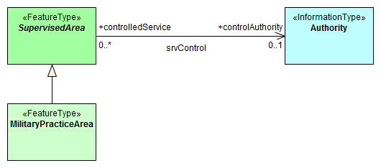

Figure 2.1 Information association relating a feature to an information type

An association end may have a multiplicity which describes how many instances the feature or information type instance at the other end is allowed to are to link to. In Figure 2.1, any single instance of **Authority** may link to any number of **MilitaryPracticeArea** instances.

### Association names

The association name is normally provided by the UML diagram at the middle of the connection line/arrow between the two involved classes and can be obtained from the feature and information type tables provided in this document).

Association names may be omitted in the UML diagrams for the following reasons:

a) the association is defined by an association class, see 2.5.5 (the name of the association class is used);

b) to avoid cluttering the diagram – however, the name is always documented in the feature/information type tables.

### Association roles

Either or both association ends can have a name (role). In Figure 2.1 the roles are **controlledService** and **controlAuthority**. This association expresses the relationship that a **SupervisedArea** (i.e., its subclasses, because **SupervisedArea** is an abstract feature and there cannot be any direct instances of **SupervisedArea**) may have zero or one controlling **Authorit(ies),** and an **Authority** may be responsible for any number of **MilitaryPracticeAreas** (or other subclasses of **SupervisedArea**).

Roles may be also omitted from the diagram to reduce clutter – again, the role name is documented in the feature/information type tables.

Note: Instead of documenting every single role, Product Specifications may describe rules for defining default roles.

### Association classes

Association classes allow relationships to be characterized by one or more attributes. The attributes of the association class belong to the association itself, not to any of the features or information types it connects. An association class is both an association and a class. Within an S-131 product the association classes **Permission Type** and **Inclusion Type** may be used for relating vessel classes to feature and information types.

#### Permission Type

This association class specifies the relationship of the vessel class to a feature, e.g., whether access to a feature (or use of a facility) is prohibited or permitted for a specified class of vessel. The class of vessel is described by the simple and complex attributes of the information type **Applicability** such as length, cargo, etc. The attributes of the association class describe the nature of the relationship, i.e., whether access to an area is permitted or prohibited, or whether use of a service is required or recommended.

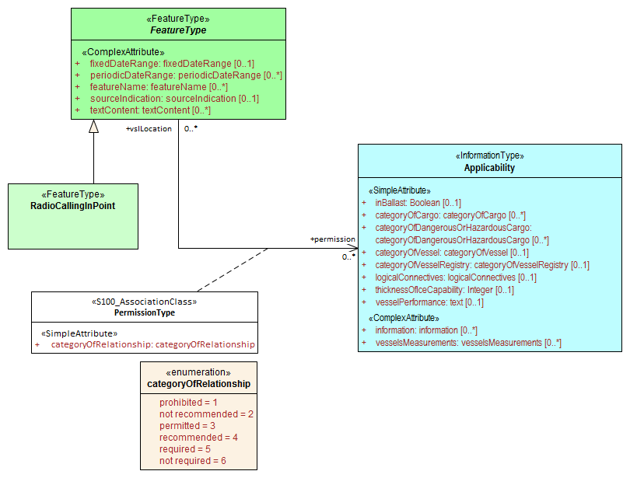

Figure 2.2 Association class for hypothetical requirement for use of a radio calling in point by a vessel type

EXAMPLE: An association between an **Applicability** instance with attribute **categoryOfDangerousOrHazardousCargo** = Class 3 and an instance of feature **RadioCallingInPoint**, with **Permission Type**’s attribute **categoryOfRelationship** = required, means that vessels carrying flammable liquids (hazardous cargo type class 3 in the IMDG Code) must use the calling-in point at the **RadioCallingInPoint** instance.

#### Inclusion Type

This association class defines whether a specified customer (class of vessels, as described by **Applicability**) is excluded or included from a particular regulation, recommendation, etc. Again, the attributes of the association class describe the nature of the relationship; in this case whether the vessel is included or excluded from the regulation, etc.

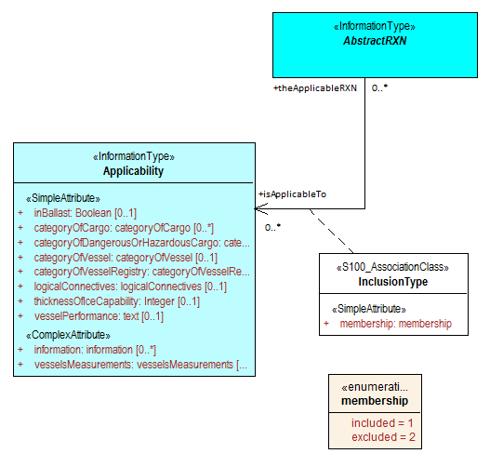

Figure 2.3 Association class for inclusion of vessel types in regulations

EXAMPLE: An association between an **Applicability** instance with attribute **categoryOfDangerousOrHazardousCargo** = IMDG Code Class 3, with **Inclusion Type**’s attribute **membership** = included, and an association of a **Regulation** instance to the same Inclusion Type, means that the information provided by the **Regulation** (a sub-type of **AbstractRXN)** applies to vessels carrying flammable liquids (hazardous cargo type class 3 in the IMDG Code).

Note (1) Since **AbstractRXN** is an abstract type, it cannot have direct instances in the dataset. Only instances of its (non-abstract) sub-types can be used.

Note (2) Specific tools may use different presentations in their user interfaces, e.g., as two associations (as described in the text of the example), or one association with an association class also shown (as shown in Figure 2.3).

### Use of various associations

#### General

In general, associations must be encoded whenever the relationship is useful for navigation, monitoring, voyage or route planning, or reporting purposes, or any other purpose for which the dataset is intended. The multiplicity lower bound of “0” at an association end means only that the absence of a link to the relevant instance does not invalidate the dataset. The encoding instructions for individual feature and information types describe what associations are allowed and whether they are required or optional.

#### Generic association for uncategorized additional information

Unless other associations are specified, information types are associated to the relevant features using the association name **AdditionalInformation** and the role names **providesInformation** and **informationProvidedFor**.

#### Associations to Restrictions, Recommendation, Regulations, and Nautical Information

The **Restrictions, Recommendation, Regulations, Nautical Information** are associated to the relevant features using the association named **AssociatedRxN (inherited from their common abstract super-type)**. The roles at the ends of this association are **appliesInLocation** and **theRxN** (the Restriction, Regulation etc.).

If the regulation applies only to a specific class, or if it mentions an exempt class, an additional association to an **Applicability** object is encoded using the **InclusionType** association class.

#### Conventional Association

Certain features and information types may be permitted or required to have associations to other feature or information types. The allowed or mandatory associations for a feature/information type are shown in the application schema (clause X of the Product Specification) and listed in the documentation for individual types in this Annex (clauses X–Y). Definitions of the associations and roles are also given in the DCEG.

#### Where to Encode Associations

The presentation and management of associations will be determined by the user interface of the encoding software tools. Since S-100 permits feature-information associations to be encoded only from the geographic feature to the information type and not vice versa, the information-to-feature link might be unavailable or treated differently from the feature-to-information link.

***[Recommendations for feature tables]***

**Recommendation: Each feature table should include a UML diagram depicting the associations of the feature or information class. To reduce diagram clutter, attributes should not be shown in this diagram.**

**The description of feature tables which is provided in each DCEG preceding the feature tables should include an example of the association diagrams and explain its meanings, including the concept of inheriting associations from super-classes. See the figure below for an example. To reduce diagram clutter, “TextPlacement” and “NauticalInformation” may be omitted (with an explanation that they can be associated to any geographic feature).**

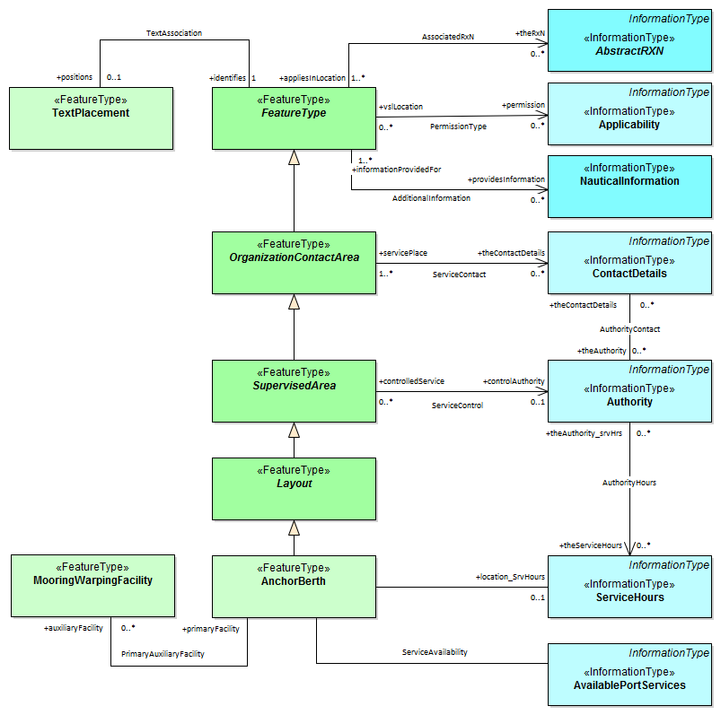

Figure 2.4 - Associations of AnchorBerth

**Explain associations in the “Feature Tables” section of DCEGs:**

The feature tables section can be conveniently divided into theme sections, each focusing on one aspect of the domain.

**Recommendation: Each “theme section” in the DCEG should have an introductory section describing the associations between features comprising that theme, and between features comprising the theme and features or information types in other themes, where appropriate. More than one diagram may be prepared to keep each diagram free of clutter.**

For example, the S-131 DCEG has a “Harbour Layout” theme; the introductory part of this theme includes separate sections on layout containment, positioning in berths, associations between layout features and physical infrastructure features, miscellaneous layout associations, and the inherited association to the TextPlacement feature. The clause on berth positioning is reproduced below as an example. Again, attributes should generally not be depicted in order to reduce diagram clutter, but Product Specification developers should determine whether exceptions are needed in particular circumstances.

# Harbour Layout

## Introduction

### Positioning in berths

Positions in a berth can be indicated by means of the **BerthPosition** feature. Mooring facilities for anchor berths or at particular positions can be linked with either **AnchorBerth** or **BerthPosition** features with the *PrimaryAuxiliaryFacility* association. These relationships are depicted in Figure 6.3.



Figure 6.3 - Positions within berths and mooring facilities

**Recommendation:** **The association of regulations (and restrictions, recommendations, and nautical notes) in relation to feature types should also be depicted by an associations diagram in a “theme” section describing regulations.**

Template text is reproduced below.

# Textual Regulations and Notes

## Introduction

### Regulations, etc., for specific locations

All geo features may have an association to any of Regulations or its sibling information types. This association is *AssociatedRxN* and it is inherited from the root feature type **FeatureType**.

If it is necessary to identify an authority or organization related to a particular regulation (restriction, etc.) object, this may be done using the *RelatedOrganisation* association between **Regulations**, etc., and an **Authority** object.

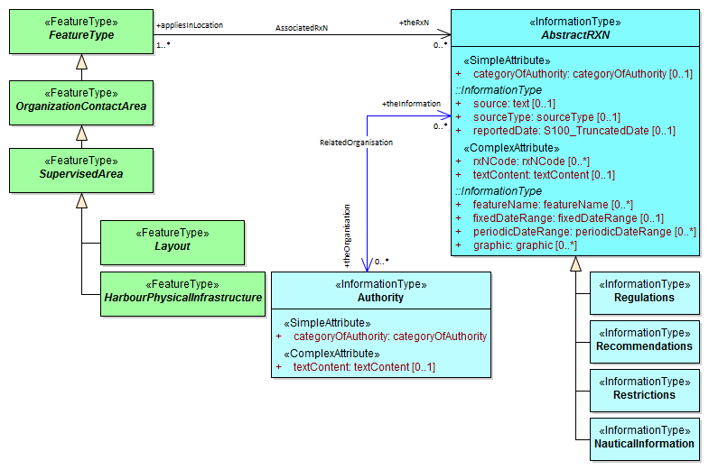

Figure 10.2 - Regulations, etc., for geo features

### Regulations applying only to vessels with specific characteristics or cargoes

Regulations applying only to vessels of specified types, exceeding specified dimensions, or carrying specified cargoes (or other limitations which apply only to subsets of vessels) are encoded by defining the subset of vessels using an **Applicability** instance and associating the **Regulations** object to that **Applicability**.

For information on the use of Applicability to define subsets of vessels, see clause X.X in this DCEG and clause X.X in the main PS.

**Recommendation: The associations involved in encoding services, organizations, and their work schedules should also be depicted by an associations diagram in a “theme” section.**

Template text is provided below.

# Services, Organizations, and Work Schedules

## Introduction

### Work schedules and holidays

Operating schedules and business hours of organizations are encoded by associating a **ServiceHours** instance to an **Authority**. Partial work schedules on holidays or other special days are encoded by associating a **NonstandardWorkingDay** instance to the **ServiceHours** instance.

Similarly, operating schedules for a facility are encoded by associating a **ServiceHours** to the geo feature representing the facility, and associating a **NonstandardWorkingDay** to the **ServiceHours** to encode partial working days.

*[An equivalent to the diagram below should be included. This diagram may do double-duty and depict the most important attributes of ServiceHours and NonStandardWorkingDay since they may be important to understanding the place of these classes in the chain, but including attributes is left to the discretion of Product Specification developers.]*

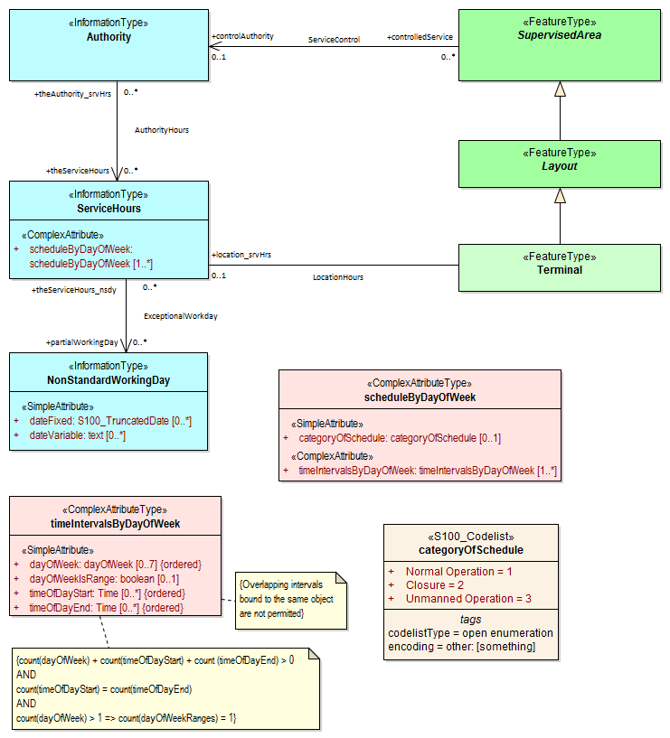

### Contact information

Contact information for service operators, controllers or facilities should be encoded in instances of the **ContactDetails** information type, which may be linked from multiple instances of geographic features or information types. Any S-131 geographic feature except meta and cartographic features can be associated to an instance of **ContactDetails**. S-131 geographic feature inherit the association to ContactDetails from the abstract feature type **OrganizationContactArea**, as shown in Figure 11.2.

Contact information must not be encoded directly in the feature or information type instance using a *textContent* or *information* complex attribute bound directly to the feature or information type. An instance of **ContactDetails** must be created instead. The exception to this rule is when contact-related attributes such as *communicationChannel* are bound to the feature or information type, in which case a **ContactDetails** instance should be created only if it is necessary to provide contact information which cannot be coded in the contact-specific attributes bound to the feature.

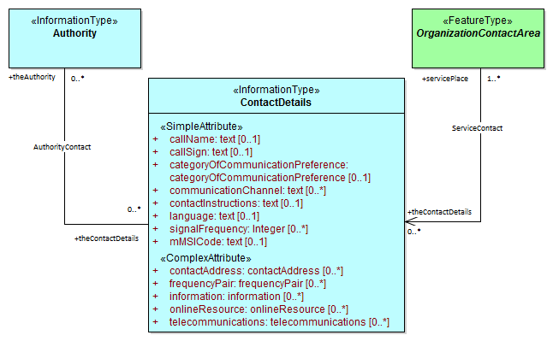

Figure 11.2 Associations to contact information

**Recommendation: There should be a separate theme describing how the Applicability information type is used in associations to describe how groups of vessels characterized by dimensions, cargo, and capabilities are linked to specific regulations or features.**

# Limitation by Vessels Characteristics and Cargo

## Introduction

Certain regulations, recommendations, etc., apply only to vessels of specified dimensions, types, or carrying specified cargo, etc. Similarly, certain features have specific significance for vessels of specified dimensions (e.g., different speed limits for vessels carrying specified cargoes or exceeding specified dimensions, or entry prohibitions for certain vessel types).

## Defining subsets of vessels by dimensions, cargo, and other characteristics

[Content omitted as being peripherally related to associations, but product specifications should consider including it. See the S-131 (Marine Harbour Infrastructure) DCEG for sample text.]

## Characterizing the relationship between the vessel set and the feature or regulation

The relationship between a set of vessels and a **geographic feature** may be one of several different mandate levels ranging from prohibition on use of entry into a geographic location to mandatory use of a feature (such as vessels exceeding certain dimensions being required to board pilots at an outer boarding place).

The relationship between a set of vessels and a **regulation information type** (or recommendation, restriction, or special note) may be one of *inclusion* or *specific exclusion* - either the regulation (recommendation, etc.) *specifically applies* to the specified set of vessels, or the specified set of vessels is *explicitly excluded* from the regulation. (If a regulation does not apply to a set of vessels but there is no explicit exemption stated in the source material, there is no relationship that needs to be encoded.)

The association classes **PermissionType** and **InclusionType** (Figures 12.3 and 12.4) characterize these relationships using values of their attributes *categoryOfRelationship* and *membership* respectively.

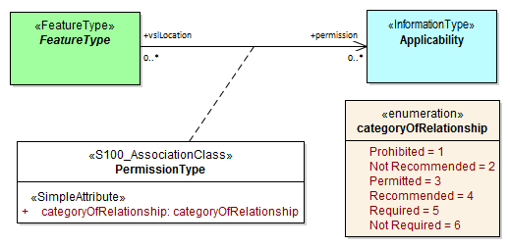

Figure 12.3 - Permission relationship

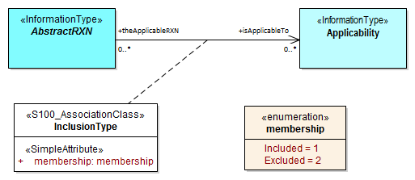

Figure 12.4 - Inclusion/exclusion relationship

EXAMPLE 1: A specified set of vessels is COVERED by a regulation and another set of vessels is EXEMPT from the regulation - described by the *membership* attribute values “included” and “excluded” respectively.

EXAMPLE 2: Vessels with specified cargo and dimensions MUST use a specified berth, vessels of smaller dimensions are RECOMMENDED to use the berth, and naval transports are EXEMPT from using the berth - described by the *categoryOfRelationship* attribute values “required”, “recommended” and “recommended” respectively.