Service Specification for S-125 Service

Contents
1 Introduction 4
1.1 Purpose of the Document 4
1.2 Intended Readership 5
2 Service Identification 6
3 Operational Context 7
3.1 Present Day Operational Context 7
3.2 Envisioned Operational Context 7
3.3 Functional and Non-functional Requirements 10
3.4 Other Constraints 12
3.4.1 Relevant Industrial Standards 12
3.4.2 Operational Nodes 12
3.4.3 Operational Activities 12
4 Service Overview 13
5 Service Data Model 14
6 Service Interface Specifications 15
7 Service Dynamic Behaviour 16
8 References 17
9 Acronyms and Terminology 18
9.1 Acronyms 18
9.2 Terminology 18

Table of figures
Figure 1: Present Day Operational Context 9
Figure 2: Envisioned Operational Context 10
Figure 3: S-124 service Interface Definition diagram 15
Figure 4: Upload interface 18
Figure 5: Acknowledgement Interface 19
Figure 6: Get Interface 21
Figure 7: Get List Interface 22
Figure 8: Subscribe Interface 24
Figure 9: Remove Subscription Interface 25
Figure 10: Get Subscription List Interface 26
Figure 11: Subscription Notification Interface 27
Figure 12: Capability Interface 28
Figure 13: Description Interface 30
Figure 14: Upload message initiated by service provider with acknowledgement. 31
Figure 15: Get Interface sequence diagram 32
Figure 16 Get List Interface Diagram 33
Figure 17 Subscription Requested by external service 34

List of tables
Table 1: Requirements Tracing 11
Table 2: Additional Requirements Definition 11
Table 2: Non-functional Requirements Definition 12
Table 3: Operational Nodes providing the S-124 NW service 13
Table 5: Operational Activities supported by the XYZ service 14
Table 6: Service Interface overview 16

Introduction

This document is a service specification for a technical service for the provision of AtoN information for endusers, following the IALA guideline G1128.
In the context of e-navigation there are a number of maritime services, and each of these make reference to a number of associated technical services. The technical services themselves are described on three levels;
Service specification (this document)
Service design (one or more)
Service instance (one or more)
all the above documents are part of G1128, and are explained in that guideline.
The service specification (this document) includes the data model for the technical service, which in that case is taken from the S-125 product specification.
This specific technical service will probably be referenced in several maritime services including MS12 - nautical publications, and possibly also in the newly proposed MS17 on AtoN.
This service specification may be used with the Maritime Connectivity Platform (MCP), where the MCP would provide means of authentication of service providers and service consumers as well as means of service discoverability.

Purpose of the Document

The purpose of this service specification document is to provide a holistic overview of the service and its building blocks in a technology-independent way, according to the G1128 guideline. It describes a well-defined baseline of the service by clearly identifying the service version.
The aim is to document the key aspects of the service at the logical level:
- the operational and business context of the service
  - requirements for the service (e.g., information exchange requirements)
  - involved nodes: which operational components provide/consume the service
  - operational activities supported by the service
  - relation of the service to other services
- the service description
  - service interface definitions
  - service interface operations
  - service payload definition
  - service dynamic behaviour description
- service provision and validation aspects

Intended Readership
This service specification is intended to be read by service architects, system engineers and developers in charge of designing and developing an instance of the service.
Furthermore, this service specification is intended to be read by enterprise architects, service architects, information architects, system engineers and developers in pursuing architecting, design and development activities of other related services.

Service Identification
The purpose of this chapter is to provide a unique identification of the service and describe where the service is in terms of the engineering lifecycle.

Name
ID | MRN assigned by IALA
Version | x.x
Description
Keywords | AtoN information, S-125
Architect(s)
Status | Provisional

Operational Context
This section describes the context of the service from an operational perspective.

Present Day Operational Context
In accordance with IHO S-12, The List of Lights and Fog Signals describe maritime signal installations on land or afloat producing light or sound signals (fog signals). In addition, these volumes contain information relating to certain other navigational aids: buoyage (day and night); signals (port signals, rescue signals, tide signals, etc.), radio-based aids (radio beacons, radar, radio navigation systems), etc. From a practical perspective, the List of Lights is intended for use by mariners as a compendium to the navigational chart for AtoN information. The present day operational context of promulgation at the component level, is depicted below:
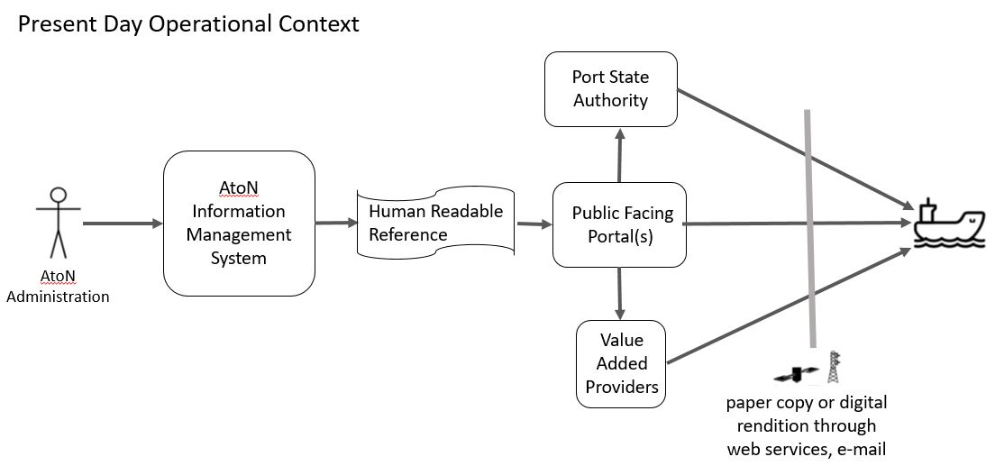
Figure 1: Present Day Operational Context
System interfaces between AtoN Administrations, Hydrographic Officers, Nautical Publication Publishers, and dissemination methods are not standardized, and may rely on manual processes involving carriage of paper print copies or human readable digital renditions obtained via web services or email. Provision of the AtoN information included within the List of Lights via web services is not standardized.

Envisioned Operational Context

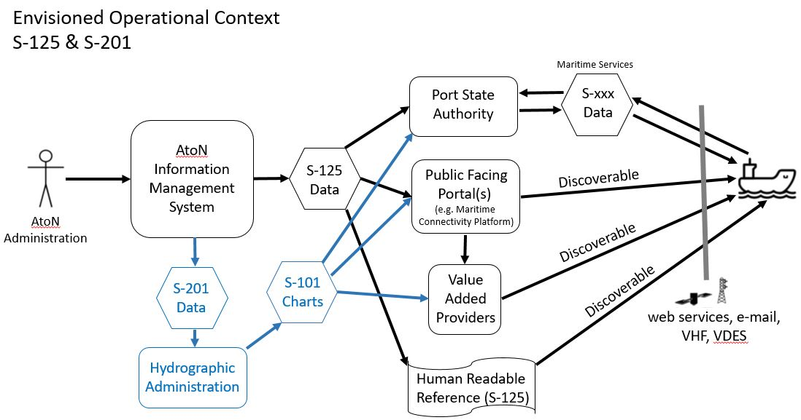
Figure 2: Envisioned Operational Context
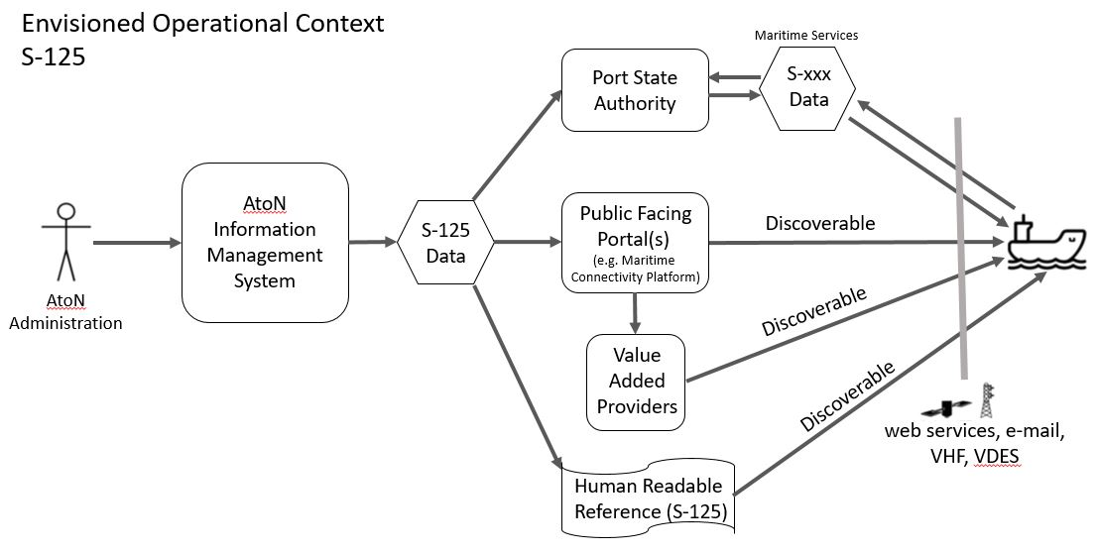
Alternate Diagram for Figure 2

This scenario depicts an envisaged future of S-125 data promulgation. Based on a standardized structured AtoN information (List of Lights) format, compatible systems will be able to exchange AtoN Data seamlessly. As depicted, each AtoN Administration may have a unique AtoN Information Management System. This system should automatically promulgate S-125 Data from the authoritative source for use by national and local authorities (e.g. Port State Authorities, Harbor and port authorities), the mariner public, as well as being available for use by commercial value added services providers.
AtoN Administrations will administer and publish local S-125 Data for their area of responsibility. Where appropriate should coordinate with adjacent or overlapping AtoN administrations who share responsibility within the same waterway. (e.g. Both the U.S. Coast Guard and Canadian Coast Guard maintain aids to navigation within the waterways comprising the Great Lakes.)

Relationship of S-125 to S-201

S-201 is a standard for exchanging all information related to any AtoN including metadata like maintenance schedules, equipment types (such as battery and bulb types). S-201 is intended to be the means of communicating such information within an AtoN organization or between AtoN organization and in certain circumstances with its main partners such as hydrographic offices. S-201 is not intended to be for navigation systems like ECDIS, and therefore is not constrained by ECDIS requirements. This means the S-201 can include additional cartographic information to inform about AtoN services that would not be appropriate in a navigation system, such as positioning source confidence. Historically, positioning requirements for AtoN were divided into “High” and “Low” accuracy categories. Additionally, requirements for accuracy were influenced by “Cartographer’s Tolerance” which determined if the AtoN’s positioning accuracy was sufficient to justify advertising the aid with a closed circle navigation symbol on paper charts based upon the scale of the chart.
S-125 meanwhile, would be a derivative of S-201 service as the public facing information for use in ECDIS/ECS. In other words, S-125 would be the digital equivalent of the extended list of lights in order to meet IMO SOLAS Chapter V requirements of having list of lights on board and serve as a continually updated list of AtoN, including virtual AtoNs. Not all Hydrographic Offices have consistent AtoN Authorities, which have the capabilities or responsibilities of providing the S-125 data as a separate dataset to the ENC provided by the Hydrographic Office.

Discoverability and Dissemination

The S-125 data should be made available to public facing portals and be discoverable to mariners, Port State Authorities, and commercial value added providers. S-125 data should boost S-124 NW and ENC S-101 productions, especially by reducing the effort in the transformation of data, with the harmonization of data models. This could be accomplished by introducing efficient data exchange mechanism between authorities. It is envisioned that upon complying with applicable ship reporting requirements to Port State Authorities, a vessel would then receive available S-xxx data supporting Maritime Services (e.g. latest ENC S-101 updates, S-127 Marnie Traffic Management, S-129 Under Keel Clearance, etc.) appropriate for their respective route. In terms of S-125 is means the exchange of data on recognition and navigational aspects of AtoN.

The S-125 Data received by ships will thus depend on the promulgation method of choice. If, say, a ship targets the website of a specific port authority; it may see only that data provided by the corresponding AtoN Administration. If, however, the ship queries for S-125 data via other non-governmental public portals, such as the Maritime Connectivity Platform, it will receive S-125 data from various national and local authorities relevant to its current position and planned routes. The S-125 Service detailed in this specification only caters for a small part of this promulgation regime. It exposes multiple service operations for machine to machine consumptions of all currently Aton Information from the targeted authority. It may be used by any client, such as a ship, a website or an app.

ECDIS Compatibility

Since S-125 is intended for ECDIS, it is required that S-125 comply with requirements of S-98, the Interoperability Catalogue Specification for ECDIS. This standard will govern how the various product layers will interact within an ECDIS. Within the IHO, S-98 is developed and maintained by S-100WG.

Functional and Non-functional Requirements
The table below lists applicable functional requirements for the S-125 service.
Table 1: Requirements Tracing
Requirement Id | Requirement Name | Requirement Text | References
S-125R001 | Transmission of New datasets | Dataset with all current and valid AtoN Information.
S-125R002 | Cancellation of dataset | Dataset which cancels, removes permanent AtoN information (e.g. an AtoN is disestablished)
S-125R003 | Transmission of New dataset - Temporary Changes | Dataset with a new AtoN Information regarding temporary changes (e.g. 6 months of less) which will ultimately return to previous configuration.
S-125R004 | Transmission of  New dataset – Cancellation of Temporary Changes | Dataset used to cancel previous AtoN Information regarding temporary change, restoring AtoN to permanently assigned configuration.
S-125R005 | Transmission of New dataset – Proposed Changes to AtoN | Dataset with a new AtoN Information regarding Proposed Changes to AtoN which the AtoN Administration is considering.
S-125R006 | Transmission of New dataset – Withdraw of Proposed Changes to AtoN | Dataset used to withdrawl previous AtoN Information regarding Proposed Changes to AtoN.
S-125R007 | Subscription of datasets | Service consumers must be able to subscribe to new datasets and updates.

The table below defines non-functional requirements for the S-125 service.
Table 2: Non-functional Requirements Definition
Requirement Id | S-125NF001
Requirement Name | Authenticity
Requirement Text | The recipient of AtoN Information data must be able to verify the authenticity of the received datasets.
Rationale
Author

Requirement Id | S-125NF002
Requirement Name | Integrity
Requirement Text | It must be clear to both service provider and consumer whether changes have been made to the AtoN Information data after the dataset was created.
Rationale
Author

Requirement Id | S-125NF003
Requirement Name | Availability
Requirement Text | The service must always be available with the ability to deliver AtoN Information to its consumers.
Rationale
Author

Requirement Id | S-125NF004
Requirement Name | Performance – Time behaviour
Requirement Text | The service must provide a Response to a service consumer’s request instantly. New AtoN Information must be broadcasted to the service consumers as soon as the service provider has knowledge of these.
Rationale
Author

Requirement Id | S-125NF005
Requirement Name | Modularity
Requirement Text | The services architecture must be constructed in such a way that individual functionality can be extended, modified or deleted, without changing the basic service architecture.
Rationale
Author

Other Constraints

Relevant Industrial Standards
- To be Developed

Operational Nodes
The following tables describe the operational nodes of the service.
Table 3: Operational Nodes providing the S-124 NW service
Operational Node | Remarks
AtoN Administration – AtoN Information Management System | The AtoN Information Management System collects all AtoN Information available from its Authoritative Source (AtoN Administration).
Port State Authority | Governmental Agency responsible for overseeing vessel arrival within a respective area. Should facilitate dissemination of S-125 and other relevant S-xxx data sets
Public Facing Portal (Governmental or NGO such as Maritime Connectivity Platform) | S-125 and other S-xxx data sets should be made available to public facing portal by which mariners and value added service providers have access. Such portals must be discoverable.
Ships | Ships sailing in a service coverage area.

Operational Activities
Optional. If an operational model exists and provides sufficient details about operational activities, then this section shall include a mapping of the service to the relevant operational activities.
Table 4: Operational Activities supported by the XYZ service
Operational Activity | Remarks
TBD

Service Overview

Service Data Model

Service Interface Specifications

Service Dynamic Behaviour

References
Nr. | Version | Reference

Acronyms and Terminology

Acronyms
Term | Definition
API | Application Programming Interface
MC | Maritime Cloud
MEP | Message Exchange Pattern
MRN | Maritime Resource Name
NAF | NATO Architectural Framework
REST | Representational State Transfer
SOA | Service Oriented Architecture
SOAP | Simple Object Access Protocol
SSD | Service Specification Document
UML | Unified Modelling Language
URL | Uniform Resource Locator
VTS | Vessel Traffic Service
WSDL | Web Service Definition Language
XML | Extendible Mark-up Language
XSD | XML Schema Definition

Terminology
Term | Definition
External Data Model | Describes the semantics of the “maritime world” (or a significant part thereof) by defining data structures and their relations. This could be at logical level (e.g., in UML) or at physical level (e.g., in XSD schema definitions), as for example standard data models, or S-100 based data produce specifications.
Message Exchange Pattern | Describes the principles how two different parts of a message passing system (in our case: the service provider and the service consumer) interact and communicate with each other. Examples:  In the Request/Response MEP, the service consumer sends a request to the service provider in order to obtain certain information; the service provider provides the requested information in a dedicated response.  In the Publish/Subscribe MEP, the service consumer establishes a subscription with the service provider in order to obtain certain information; the service provider publishes information (either in regular intervals or upon change) to all subscribed service consumers.
Operational Activity | An activity performed by an operational node. Examples of operational activities in the maritime context are: Route Planning, Route Optimization, Logistics, Safety, Weather Forecast Provision, …
Operational Model | A structure of operational nodes and associated operational activities and their inter-relations in a process model.
Operational Node | A logical entity that performs activities. Note: nodes are specified independently of any physical realisation.  Examples of operational nodes in the maritime context are: Maritime Control Center, Maritime Authority, Ship, Port, Weather Information Provider, …
Service | The provision of something (a non-physical object), by one, for the use of one or more others, regulated by formal definitions and mutual agreements. Services involve interactions between providers and consumers, which may be performed in a digital form (data exchanges) or through voice communication or written processes and procedures.
Service Consumer | A service consumer uses service instances provided by service providers. All users within the maritime domain can be service customers, e.g., ships and their crew, authorities, VTS stations, organizations (e.g., meteorological), commercial service providers, etc.
Service Data Model | Formal description of one dedicated service at logical level. The service data model is part of the service specification. Is typically defined in UML and/or XSD. If an external data model exists (e.g., a standard data model), then the service data model shall refer to it: each data item of the service data model shall be mapped to a data item defined in the external data model.
Service Design Description | Documents the details of a service technical design (most likely documented by the service implementer). The service design description includes (but is not limited to) a service physical data model and describes the used technology, transport mechanism, quality of service, etc.
Service Implementation | The provider side implementation of a dedicated service technical design (i.e., implementation of a dedicated service in a dedicated technology).
Service Implementer | Implementers of services from the service provider side and/or the service consumer side. Anybody can be a service implementer but mainly this will be commercial companies implementing solutions for shore and ship.
Service Instance | One service implementation may be deployed at several places by same or different service providers; each such deployment represents a different service instance, being accessible via different URLs.
Service Instance Description | Documents the details of a service implementation (most likely documented by the service implementer) and deployment (most likely documented by the service provider). The service instance description includes (but is not limited to) service technical design reference, service provider reference, service access information, service coverage information, etc.
Service Interface | The communication mechanism of the service, i.e., interaction mechanism between service provider and service consumer. A service interface is characterised by a message exchange pattern and consists of service operations that are either allocated to the provider or the consumer of the service.
Service Operation | Functions or procedure which enables programmatic communication with a service via a service interface.
Service Physical Data Model | Describes the realisation of a dedicated service data model in a dedicated technology. This includes a detailed description of the data S-124 to be exchanged using the chosen technology. The actual format of the service physical data model depends on the chosen technology. Examples may be WSDL and XSD files (e.g., for SOAP services) or swagger (Open API) specifications (e.g., for REST services). If an external data model exists (e.g., a standard data model), then the service physical data model shall refer to it: each data item of the service physical data model shall be mapped to a data item defined in the external data model.  In order to prove correct implementation of the service specification, there shall exist a mapping between the service physical data model and the service data model. This means, each data item used in the service physical data model shall be mapped to a corresponding data item of the service data model. (In case of existing mappings to a common external (standard) data model from both the service data model and the service physical data model, such a mapping is implicitly given.)
Service Provider | A service provider provides instances of services according to a service specification and service instance description. All users within the maritime domain can be service providers, e.g., authorities, VTS stations, organizations (e.g., meteorological), commercial service providers, etc.
Service Specification | Describes one dedicated service at logical level. The Service Specification is technology-agnostic. The Service Specification includes (but is not limited to) a description of the Service Interfaces and Service Operations with their data S-124. The data S-124 description may be formally defined by a Service Data Model.
Service Specification Producer | Producers of service specifications in accordance with the service documentation guidelines.
Service Technical Design | The technical design of a dedicated service in a dedicated technology. One service specification may result in several technical service designs, realising the service with different or same technologies.
Service Technology Catalogue | List and specifications of allowed technologies for service implementations. Currently, SOAP and REST are envisaged to be allowed service technologies. The service technology catalogue shall describe in detail the allowed service profiles, e.g., by listing communication standards, security standards, stacks, bindings, etc.
Spatial Exclusiveness | A service specification is characterised as “spatially exclusive”, if in any geographical region just one service instance of that specification is allowed to be registered per technology.  The decision, which service instance (out of a number of available spatially exclusive services) shall be registered for a certain geographical region, is a governance issue.

- Service Specification XML
This appendix contains the formal definition of the service specification.
To be done.

