Draft IHO C-17 3.0

Spatial Data Infrastructures

“The Marine Dimension”
Guidance for Hydrographic Offices

Chapter 1: Introduction and Background - The Current Landscape

1.1 C-17 Overview
The purpose of this publication is to explain why and how Hydrographic Offices (HO) should develop, support, and promote Marine Spatial Data Infrastructures (MSDI), the marine domain of a Spatial Data Infrastructure (SDI). The content is not exhaustive, rather it provides guidance on how to engage in MSDI through practical advice, systematic processes, useful links to reference materials, and examples of good practices.

The C-17 is primarily intended to serve as guidance to HOs at any stage of MSDI development and management. In recognition of the increasing value, demand and uses of geospatial data, this publication could also be relevant to a wider target audience linked to the marine spatial data ecosystem beyond custodians of MSDIs, for example, other marine data providers and users +including governments, industries, citizens, and other stakeholders.

HOs are encouraged to consult this publication to make informed decisions regarding whether they wish to take a leading role in MSDI development, seek to support an existing MSDI initiative, or work with others to develop a MSDI. Further information regarding MSDI can also be accessed through the IHO MSDI Working Group (MSDIWG) Body of Knowledge (BoK). With expertise in hydrographic data management, HOs are likely best positioned to develop robust and reasonable MSDI capabilities to support the increasing demand for marine spatial data and be viewed as the competent authorities concerning the provision of authoritative hydrographic and other marine-related data under any national and/or regional MSDI.

This publication is structured into five chapters. The first chapter covers introductory concepts regarding geospatial data, SDI/MSDI, and data management. The second chapter describes the role of HOs and the importance of MSDI. The third chapter presents a systematic approach towards MSDI development. The fourth chapter details the Integrated Geospatial Information Framework (IGIF) from the HO and MSDI perspective. The fifth and final chapter sets out the emerging trends in MSDI.

1.2 What is a SDI?
Geospatial information is information that describes objects, events, or other features at a location on the surface of the Earth. Geospatial data typically combines location information (coordinates on the Earth, e.g. latitude, longitude, depth/height) and attribute information (the characteristics of the object, event, or phenomena concerned) with temporal information (the time or life span at which the location and attributes exist). The location provided may be static in the short term (e.g. coastline, bathymetry) or dynamic (e.g. a moving vessel). Geospatial data typically involves large datasets gathered from different sources. Its usefulness is enhanced when it can be discovered, shared, analysed, and used in combination with other data to generate insights.

The importance of geospatial information in decision-making and addressing growing national, regional, and global issues was highlighted at the 1992 Rio Summit and by a special session of the United Nations (UN) General Assembly in 1997 to assess Agenda 21 implementation. It was identified as a clear need, at all scales, to be able to access, integrate, and use geospatial information from different data sources in guiding decision-making. The ability to make sound decisions collectively at the local, regional, and global levels is dependent on the implementation of SDIs because they provide for compatibility across jurisdictions and promote information access and use.
Only through common conventions and technical agreements is it possible for local communities, nations, and regional decision-makers to discover, acquire, exploit, and share geospatial information vital to the decision process. The use of common conventions and technical agreements also makes sound economic sense by limiting the cost involved in the integration of information from various data sources as well as eliminating the need for parallel and costly development of tools for discovering, exchanging, and exploiting spatial data. The greater the limitation on available resources for SDI development, the greater the incentive for achieving alignment between initiatives to build SDI.

SDI is usually defined as “the relevant base collection of technologies, policies, and institutional arrangements that facilitate the availability of and access to spatial data”. SDIs provide a basis for spatial data discovery, evaluation, and application for users and providers within all levels of government, industry, commerce, non-profit sectors, academia, and by citizens in general. The term “infrastructure” is used to promote the concept of a reliable and supportive environment that facilitates access to geographically-related information using a minimum set of standard practices, protocols, and specifications.

A SDI must be more than a single dataset or database. It hosts geospatial data and attributes, sufficient documentation (metadata), means to discover, visualise, and evaluate the data (catalogues and web mapping), and methods to provide access to the geospatial data. Beyond this, there are additional services or software to support data applications. In order to become functional, a SDI must also include the organisational agreements needed to coordinate and administer it on a local, regional, national, or transnational scale. A SDI also provides the ideal environment to connect applications to data. It influences both data collection and application construction through minimal appropriate standards and policies.

1.2.1 Types of SDI
A SDI’s hierarchy is usually structured from Global SDI (GSDI), Regional SDI (RSDI), National (NSDI), State SDI (SSDI), Local SDI (LSDI), and Corporate SDI (CSDI) .

Depending on the scale or scope of implementation, another designation may be used. For example, Thematic SDI, Marine SDI (MSDI), Federated (Marine) SDI, Organisational (Marine) SDI, Internal MSDI, and External MSDI.

1.3 MSDI and Open Marine Geospatial Data Value
A MSDI is the element of a SDI that focuses on the marine input in terms of data content, governance, standards, and technologies.

Typically, marine geospatial information has been used primarily for navigation. However, it has gained wider applications in other areas, including: maritime trade, environmental protection, sustainable fishing, resource development, infrastructure construction, defence, search and rescue, and scientific research. The combination of marine spatial data for efficient analysis can also support some of the major challenges: blue economy, e-navigation, emergency planning and response, climate change and sea level rise, and marine spatial planning (MSP). The value of MSDI and open marine geospatial data and information can be assessed through the UN Committee of Experts on Global Geospatial Information Management (UN-GGIM) Integrated Marine Geospatial Information Management-Hydro (IGIF-H) Part One and Part Two documents.

The broader use of marine geospatial data requires that it be held in a holistic approach rather than for a particular product, for a limited user group, or for a specific purpose. A MSDI is not a collection of hydrographic products, but an infrastructure that promotes interoperability of data at all levels.

HOs are a major source for marine geospatial information. However, in tailoring data for specific products, the extended use and user base is drastically constricted. Therefore, a shift must occur from a product-based approach to a data-centric approach, where data is placed at the centre of the organisation and specifically designed for re-use by a broader community of stakeholders. This increases data value and gives a more prominent role to HOs. These concepts are further developed in chapter 2.

1.4 MSDI architecture
A MSDI typical architecture is flexible, and its emerging technologies are further detailed in chapter five and in the IHO MSDIWG BoK.

A MSDI is frequently associated with web access and uses a client-server architecture, where several clients access a server. Data is stored on the server and requested by the client. These requests are satisfied using standardised and interoperable web services, for instance, Open Geospatial Consortium (OGC) Web Map Service (WMS) (ISO 19128:2005), Web Feature Service (WFS) (ISO 19142:2010), Web Map Tile Service (WMTS), or Web Coverage Service (WCS).

A MSDI usually comprises the following physical components: a spatial database to store marine geospatial data, a map server for publishing that geospatial data on the web, a data catalogue to manage marine geospatial metadata and assure its findability, and a web portal for users to access data. To safeguard the MSDI, cybersecurity should also be considered in its architectural design.

1.5 Quality management principles
Quality management principles should be considered in the strategy by which a HO develops a MSDI. Therefore, HOs need to think about basic concepts and schemes, like the Data-Information-Knowledge-Wisdom (DIKW) hierarchy, Findable-Accessible- Interoperable-Reusable-Traceable-Licensable-Connected (FAIR-TLC) and the 7 quality management principles (QMPs).

1.5.1 DIKW (Data, Information, Knowledge, Wisdom) Hierarchy
The DIKW pyramid (Figure 1) demonstrates the relationship between data, information, knowledge and wisdom. Data are facts, signals or symbols that have no meaning outside of the human mind. Information (or meaning) emerges through cognitive processing of data, arranged and ordered in a consistent way, the products. Knowledge constitutes a collection of information with its associated context, giving a specific human understanding, which is reached through services. Wisdom is shared understanding, and it is reached through judgement. Wisdom has more value than data, but is also more difficult to transmit.
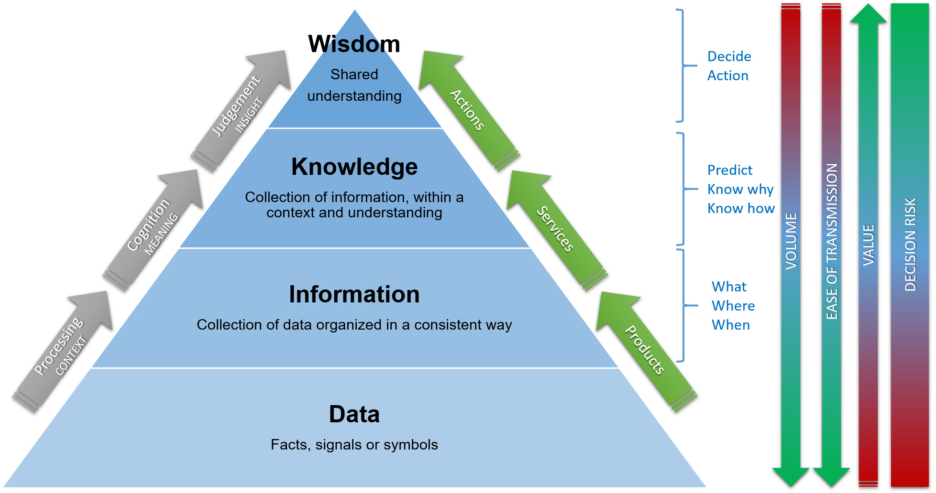
Figure 1: Data-Information-Knowledge-Wisdom Pyramid
The principle of data being the foundation of knowledge and wisdom for data-driven decisions is well known in the hydrographic community. In essence, a broad base of data is required to extract a smaller volume of information, knowledge and wisdom. The conversion of detailed bathymetric surveys into digital maps, maritime services and decisions though a full spectrum of hydrospatial data is a good example of this. Thus, knowledge transfer is only a small part of the potential of the original data, while wisdom is a very dense concentration of value and purpose. Many hydrographic datasets have the potential to convey a range of very different knowledge and wisdom applications, from safety of navigation to blue growth and sustainable development. This becomes especially true when their analysis within a knowledge theme is integrated with the necessary and complementary scientific, administrative, and legal marine geospatial information.

Data quality is usually associated with the difference between the measurement or the model and the reality, weighted by its purpose. Geospatial data quality principles are described in ISO 19157 and structured into six categories: completeness, logical consistency, positional, temporal and thematic accuracy, and usability.
Information, knowledge and wisdom quality can be associated with requirements fulfilment and fit for purpose.

1.5.2 FAIR principles

Marine geospatial data has great value if it can outreach to all of its potential users. To increase data benefits and make the data accessible and transparent, it should be managed in accordance with the FAIR (Findable, Accessible, Interoperable, Re-usable) data principles.

FAIR principles describe features, attributes and practices that will move a digital resource closer to a state of “FAIRness”, maximising the data lifespan. It fundamentally enables machine-readability which supports knowledge discovery, distribution, integration, and reuse of data by enabling data harvesting and analysis of multiple datasets and for artificial intelligence (AI) ingestion. It is noteworthy that FAIR principles should be applied not only to (meta)data, a community-endorsed word that identifies both data and metadata, but also to many other non-data assets such as software, algorithms, tools, workflows, and protocols. This “fractal FAIRness” encompasses all the MSDI components, which means that high-technology-based services and infrastructures, including registry cataloguing, are needed.

In order to make resources and key components findable, accessible, interoperable and reusable, it is required to comply with the following guiding principles. HOs may refer to the FAIR data checklist for guidance towards achieving FAIR principles (Annex A).

- Findable: The first step towards the FAIRification process concerns the need to describe (meta)data fully and unambiguously in order to make them discoverable for both humans and machines.
- Accessible: Once the (meta)data have been found, it is needed to know how they can be accessed, possibly including authentication and authorization.
- Interoperable: Once the (meta)data are accessed, suitable tools are required to move from non-cooperating resources to integrate or work together with minimal effort.
- Reusable: To achieve the reuse of (meta)data, it should be well-described so that they can be replicated and/or combined in different settings.

Three additional principles, also relevant in the marine domain, may be added to the FAIR principles. These are: traceability, licensure, and connectedness (FAIR-TLC).
- Traceability: Provenance and much richer information, well documented and clearly declared, is required to understand how, why, when and by whom the digital assets were created. This enables potential (re)users to assess the accuracy, reliability and quality of the data, and to determine whether these data meet their needs.
- Licensure: Data should be accompanied by a clear and accessible usage license that dictates how digital resources can be accessed, re-used, and redistributed by licensees (the end users). The conditions under which data are licensed should be transparent to both humans and machines. Even when data resources are publicly funded and seemingly publicly available, not all of them are free to use. For the purpose of referring to any legally binding instrument that grants permission to access, re-use, and redistribute resources with few or no restrictions, the term “Open License” is frequently used.
- Connectedness: The development of a “data centric” concept entails a radical shift in how information is handled and research performed. Combining extensive data collections from different repositories and new methods of data analytics, open great opportunities for making digital assets inherently more usable, integrated, connected, and linked.

It should be noted that many relevant values, correlated with the FAIR principles, are likely to have ethical, legal and social implications including, but not limited to the following:
- Interdependency by encouraging scientific communities and private and public organisations to collaborate and reinforce one another;
- Transparency about provenance, data processing, management, stewardship and costing;
- Sustainability by avoiding unnecessary duplication and reducing costs of data acquisition/ production;
- Efficiency by investing strategically and making technologies/ innovations more affordable;
- Legitimacy of (meta)data and digital assets as a whole;
- Reciprocity through recognition received by the scientific communities and/ or the general public for the multiple allowed uses of data;
- Reproducibility by facilitating the use of technical verifiable solutions that add a plus and avoid time and monetary waste;
- Accountability by organising a fair and clear distribution of responsibilities along the data re-use chain;
- Public debate facilitation by raising public awareness and involvement in FAIR strategy implementation;
- Non-discrimination principle must be guaranteed. Accessibility, interoperability, and licensing must not discriminate against any person, group, or field of scientific research, in this way enhancing distribution of benefits and opportunities.

1.5.3 The 7 Quality Management Principles
HOs, along with academic research centres and authoritative national and international organisations, promote a marine spatial data culture that results in the behaviour, attitudes, activities and processes that deliver value through fulfilling the needs and expectations of customers and other relevant interested parties.
The term “quality” identifies the degree to which a set of inherent characteristics of an object fulfils requirements. The object can be material (e.g., an engine, a sheet of paper), non-material (e.g., conversion ratio, a project plan) or imagined (e.g., the future state of the organisation); the adjective “inherent” means existing in the object, therefore it is opposed to “assigned”; requirements are needs or expectations that are stated, generally implied or obligatory.

The 7 Quality Management Principles are defined in the International Organization for Standardization (ISO) publications and standards (ISO 9000:2015). They can be used to certify and guide the quality of HOs processes, for instance, MSDI development and implementation.
The seven QMPs and a possible use of them by a MSDI perspective (Fig. ##) are as follows:
- QMP 1 – Customer focus: The primary focus of quality management is to meet customer requirements and to strive to exceed customer expectations.
MSDI perspective: All possible users are MSDI customers.
Benefits: Increasing use of data, wider community of users, enhanced reputation.
Actions: Plot direct and indirect users; understand users’ current and future needs, satisfaction and expectations; manage relations with users.
- QMP 2 – Leadership: Leaders at all levels establish unity of purpose and direction and create conditions in which people are engaged in achieving the organisation’s quality objectives.
MSDI perspective: MSDI needs a strategic vision, aligning policies, processes and data.
Benefits: Better communication of MSDI levels; data-centric and not only data-driven HO; fit for purpose.
Actions: Encourage an organisation-wide commitment to quality and trust founded on MSDI; provide people with the required resources, training, and authority to act with accountability to release authoritative MSDI services; guide the future of the HO through an MSDI perspective.
- QMP 3 – Engagement of people: Competent, empowered and engaged people at all levels throughout the organisation are essential to enhance its capability to create and deliver value.
MSDI perspective: focusing people enables a people centric and not only data centric MSDI.
Benefits: motivation; initiatives and creativity to change; shared MSDI vision.
Actions: empower people to develop MSDI skills; open discussion and sharing of knowledge and experience around MSDI topics; focus on the importance of individual contribution.
- QMP 4 – Process approach: Consistent and predictable results are achieved more effectively and efficiently when activities are understood and managed as interrelated processes that function as a coherent system.
MSDI perspective: MSDI data management is a blockchain of individual trusted processes.
Benefits: focusing key processes; predictable outcome; optimised performance.
Actions: manage risks of data quality management in the full MSDI spectrum; define necessary data and metadata for each data package; analyse interrelations among different processes.
- QMP 5 – Improvement: Successful organisations have an ongoing focus on improvement.
MSDI perspective: MSDI is a long term change of view and not an objective to achieve or a web portal.
Benefits: focus on route causes investigation; being more reactive and proactive; drive for innovation.
Actions: establish measurable MSDI key performance indicators (KPI); structured education; use improvement to update data services.
- QMP 6 – Evidence-based decision making: Decisions based on the analysis and evaluation of data and information are more likely to produce desired results.
MSDI perspective: MSDI links data and information to policy and governance.
Benefits: improved decision making; data driven decisions; easier change of past decisions;
Actions: establish measurable MSDI KPI; curate a lessons learned repository, make data available for all decision-makers; make data and information more reliable and quality flagged.
- QMP 7 – Relationship management: For sustained success, an organisation manages its relationships with interested parties, such as suppliers.
MSDI perspective: networking enables MSDI shared knowledge.
Benefits: common understanding of goals; focus more valuable data; long term stability.
Actions: determine relevant MSDI players; prioritise relationships; create relationships sharing data.
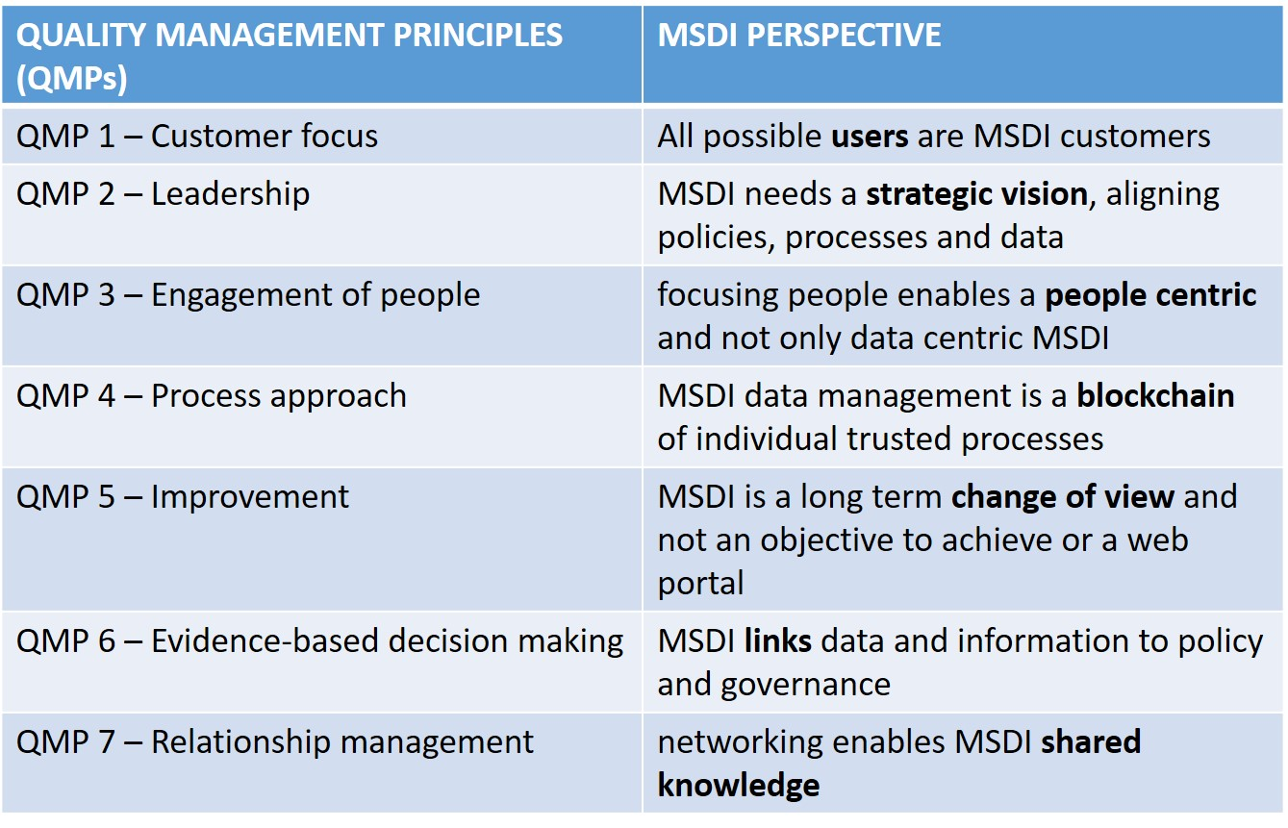

1.6 IHO Implementation Status
MSDI is critical to increasing the use of marine data for the benefit of society, and to raise marine data value and give a more important role to HOs. Therefore, the IHO encourages all member states to develop, support and promote MSDI. The following web map shows the implementation status across the coastal states:
https://iho.maps.arcgis.com/apps/webappviewer/index.html?id=6225e69a6d424b38b46dd2b59e7ca722.

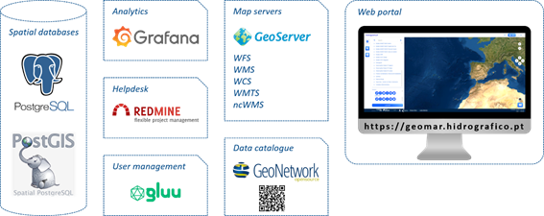
Portugal’s Open Source MSDI Case Study
The Portuguese Hydrographic Institute (IH) has long recognized the importance of SDIs and, specifically MSDIs, since the early 2000s, a CSDI (IDAMAR). However, the adaptation to the new geospatial tendencies and the upgrade of processes, technologies and services, was beyond the internal pool of resources. Therefore, IH developed a project called “Hidrografico Plus”, integrated into the program to support digital transformation in public administration (SAMA2020). The project started in 2018 and ended in 2020. It comprised several phases: mapping of processes and workflows, compilation of case studies and best practices, definition of requirements, outsourcing and contracting services, quality control and acceptance. One of the main goals of the MSDI development was that it should use open source technologies and its architecture should be interoperable, modular and scalable. Since the project ended, the Hidrografico Plus MSDI has been constantly improved under other projects or funding sources.

Hidrografico Plus architecture is composed by:
- Spatial databases to store marine data;
- Map servers to publish geospatial data on the
web;
- Data catalogue to manage marine metadata;
- Additional modules for analytics, helpdesk and
user management;
- Web portal for visualising data.

Components:
PostgreSQL
PostgreSQL is an open source object-relational database system that uses and extends structured query language (SQL) combined with many features that can store and scale complex data workloads. It comes with many features aimed to help developers build applications, administrators to protect data integrity and build fault-tolerant environments, and help you manage your data no matter how big or small the dataset.

PostGIS
PostGIS is a spatial database extender for PostgreSQL object-relational database. It adds support for geospatial objects, for instance, allowing location queries to be run in SQL.

GeoServer
GeoServer is an open source server for sharing geospatial data. It is designed for interoperability, allowing publishing data from any spatial source using open standards. GeoServer implements OGC (Open Geospatial Consortium) protocols such as Web Feature Service (WFS), Web Map Service (WMS), and Web Coverage Service (WCS). Additional formats and publication options are available as extensions including Web Processing Service (WPS), and Web Map Tile Service (WMTS).

ncWMS
ncWMS is a WMS for geospatial data stored in CF-compliant NetCDF files. The intention is to create a WMS that requires minimal configuration: the source data files should already contain most of the necessary metadata. ncWMS is developed and maintained by the Reading e-Science Centre at the University of Reading, UK.

GeoNetwork
GeoNetwork is a catalogue application to manage geospatial data. It provides powerful metadata editing and search functions as well as an interactive web map viewer. It is currently used in several SDI initiatives across the world and it is compliant with multiple metadata formats, e.g., European INSPIRE Directive[6].

Chapter 2: Role of the Hydrographic Office and MSDI

2.1 Traditional Role of the Hydrographic Office

Traditionally, most HOs operate in terms of product and require data provided by multiple sources both internally and externally from third parties. The creation of nautical products for example requires an assessment of source information for product relevance. Having determined source information is relevant, the information, or data, is decomposed into an appropriate data model, perhaps into different features with associated attributes or metadata. Oftentimes, HOs will even use a common centralized hydrographic database to store the source information. However, the output is still a generalized product, albeit provided as data sets. The delivery of these data sets is on a cell-by-cell basis, characterized by scale or spatial extent, therefore restricted in use by their design.

Most HOs focus on supplying products to a narrow sector of navigational users. The driving force is navigational safety, often via governmental mandate, with any additional use, being an opportunistic spin-off. The opportunity to service a wider user community (outside of navigation) has been overlooked in the past but now needs to be seriously considered. The imperative to engage with this much wider community of users has grown with the demand for access to marine and maritime geospatial data from commerce, government, academia and the citizen.

2.2 Why is MSDI important to Hydrographic Offices?

2.2.1 Why is a MSDI needed?
HOs are key curators and custodians of marine spatial data. These data can be collected by them or deposited by others through partnerships and agreements. Traditionally, the data are used for creating nautical or navigational products, but in doing so, HOs are not exploiting their full potential. Widening the user base is a way of increasing marine data value, as data are acquired once but used many times.

Figure 2 illustrates this paradigm in the traditional HO workflow, from hydrographic data acquisition to product generation. A product like an Electronic Navigational Chart (ENC) which is built for a particular purpose has limited use and a narrow user base. Going backwards in the processing workflow, a bathymetric surface has a broader use than the ENC (while the ENC is used almost exclusively for navigation, the bathymetric surface can be used, for instance, for marine spatial planning (MSP) or tsunami and flood modeling). Going further backwards in the processing workflow, the original sounding data points have wider applications than the bathymetric surface, as they preserve the original data resolution without applying any gridding method.
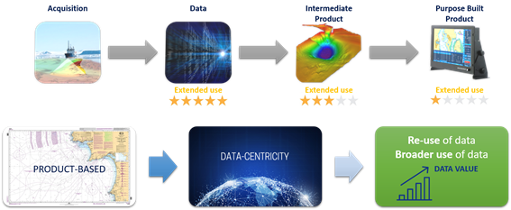

Figure 2: Traditional Hydrographic Office Workflow - Data acquisition to Product

Figure 3: Data centric approach to maximise data value

To implement this paradigm, HOs must migrate from a traditional product-based approach to a data-centric approach (Figure 3). This potentiates marine data use, as it can be applied in broader domains and by a larger number of stakeholders. The intensification of marine data use is beneficial for HOs, as it increases marine data value and reinforces the role of HOs in ocean knowledge.

MSDIs are used by HOs to successfully provide marine spatial data to a wider user base. Currently, spatial data are critical for decision-making processes and to achieve effective solutions.
Data relevant for marine spatial planning purposes are often stored in different formats and in different online locations. The combination of data, their possible interoperability and the derivation of geospatial solutions require an infrastructure which connects different storages and harmonized data formats at the minimum. Geographic information systems (GIS) and geospatial technologies are frequently being used to integrate and analyze data from multiple sources, and to obtain insights.

MSDIs are solutions for both HOs to manage the data and stakeholders to find, access and use the data in adequate and interoperable formats. The key aspects collected in Section 2.3 demonstrate the need for better utilization of marine data, such that more informed decision making can lead to effective solutions.

2.2.2 Hydrographic Offices and Authoritative and Non-Authoritative Data
HOs are usually associated as producers of authoritative data with expertise and experience in authoritative data management. There is no one definition of authoritative data, but elements of it were discussed within the UN-GGIM Authoritative Data Paper. An obvious element of authoritative data are those that are legislated or regulated and have legal value because they are defined by a competent authority such as depth values in nautical charts produced by HOs. However, non-authoritative data that have gone through validation and certification can also be classified as trusted data and still be useful for integration, analysis and, ultimately, societal benefit. In such a way, an MSDI can be employed by HOs to provide third-party marine data that have undergone quality assurance processes and that can be used with some degree of confidence. This reinforces the role of HOs as the primary marine data providers and/or custodians. The policy and legal components of MSDI are further discussed in Section 4.1.2.

2.3 Several aspects seeking MSDI
There is an increasing demand for marine spatial and hydrographic data from diverse users seeking MSDIs. Some examples of environmental and socio-economic, operative, and administrative aspects are elaborated in this section.
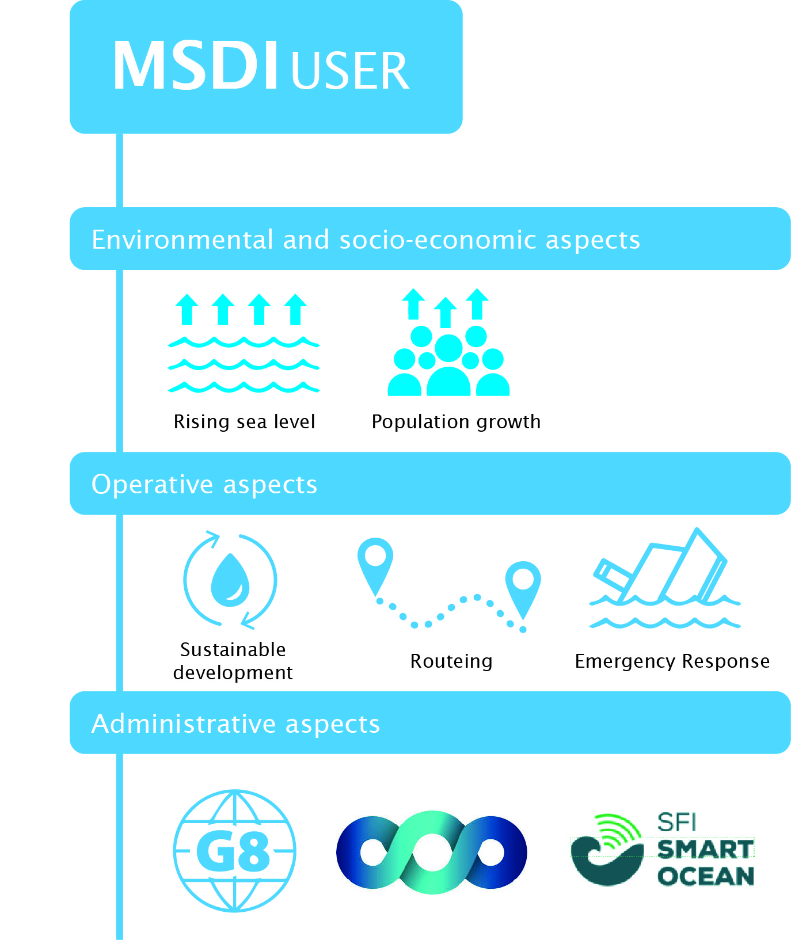

2.3.1 Environmental and socio-economic aspects
Rising Sea Levels
Evidence of climate change is leading to raised concerns for the coastal zone both in terms of rising sea levels and the increasing occurrence of extreme weather patterns leading to greater coastal flooding. Sufficient spatial planning in coastal areas should consider coast erosion and effects inter alia on all infrastructure elements, human settlements, agriculture.

Population growth
With over 50% of the world’s population now living within 50km of the sea, the drive for additional infrastructure development in the coastal zone is growing year on year. Overall population growth is putting great pressure on energy generation, food production and other resources as well as on both the marine environment and seaborne trade. This in turn puts pressure on HOs to provide suitable support to marine spatial planning.

2.3.2 Operative aspects
Integrated Coastal Zone Management (ICZM)
Each coastal State should develop an ICZM structure reflecting its unique characteristics, including institutional arrangements, traditions, environmental and economic conditions taking into account that all components are dynamic and will evolve over the time. It should become an integral part of economic development plans both at the national and local level requiring sufficient support of politics, legal administration, planning and other official agencies.

The ICZM spatial covers usually the area between a zone extending inland to the upper reaches of the coastal watersheds and seaward to the limit of national juris- diction. generally, the limit of the territorial sea (12 nautical miles) or to the 200-mile Exclusive Economic Zone (EEZ).
The ICZM should, if possible, use a holistic ecosystem approach which will take all components into account, especially those which are democratically agreed. The complexity of the tasks requires an iterative approach.

The ICZM should consider the following principles:
- Precautionary;
- Polluter pays;
- Proper resource accounting;
- Transboundary responsibility; and
- Intergenerational equity.

Sustainable development
Each coastal State should bear in mind that resources are limited. Some resources can only be used once in a life. Therefore, the responsibility of HOs to support decision making processes in providing detailed hydrographic information is essential.
The decision to develop a nation sustainably is not only a political question. It is everyone’s daily life or business decision. Detailed hydrographic information may support this decision-making process.

Every Information helpful for route planning purposes is crucial. Either hydrographic information on tidal streams or information based on regulatory framework may have effects on route planning. An improved route planning could reduce fuel consumption, greenhouse gas emissions and carbon footprint. It can also save flora and fauna by reducing underwater noise or other man-made disturbances in certain sea areas. This is only one example but it may build the foundation of sustainability.

Map Once, Use Several Times
Official nautical charts (paper or digital) content is a compilation of data provided by many sources; inside and outside the marine domain. The portrayal of the content is standardised by IHO and fit to support safe navigation.
However, the content is not easily compatible with the tools and systems used by non-marine agencies. Therefore, it is of great importance to store the information in standardised IHO formats. This allows a greater interoperability between data and involved stakeholders and supports multiple use of the data.

Routeing
A growth in the use of cross-polar routes as the Arctic ice sheet melts may put environmental pressure on developing new sea routes in that region as well as increasing the challenges of disaster response. These new initiatives will require interoperable spatial data.

Emergency response
Independent of being natural or man-made, devastating events and emergencies around the globe require the development and provision of improved plans and a far more proactive way of responses. The response requires a multi-disciplinary approach including immediate emergency response, environmental protection and longer-term regional planning.

2.3.3 Administrative aspects
Administrative aspects seeking MSDIs could be from national, regional and international levels.

UN-GGIM
The United Nations Global Geospatial Information Management (UN-GGIM) is now playing a leading role in setting the agenda for the development of global geospatial information and to promote its use to address key global challenges. It provides a forum to liaise and coordinate among Member States, and between Member States and international organizations.
The IHO currently has observer status at UN-GGIM and has stated that in the marine space, the future role of the IHO and its MS will be crucial to enabling the wider reach and use of HO data as part of the framework of work activities such as:
- Development of the global geodetic reference frame;
- Development of a global map for sustainable development;
- Geospatial information supporting sustainable development;
- Adoption and implementation of standards by the global geospatial information community;
- Development of a knowledge base for geospatial information;
- Identification of trends in national institutional arrangements in geospatial information management;
- Integrating geospatial statistics and other information;
- Supporting the development of legal and policy frameworks, including support in resolving critical issues related to authoritative data;
- Development of shared statement of principles on the management of geospatial Information;
- and determining fundamental data sets.

G8 Open Data Charter
In June 2013, the G8 Group of major economic nations signed the Open Data Charter. The world is witnessing the growth of a global movement facilitated by technology and social media and fueled by information; one that contains enormous potential to create more accountable, efficient, responsive and effective governments and businesses, and to spur economic growth.
Access to data allows individuals and organizations to develop new insights and innovations that can improve the lives of others and help to improve the flow of information within and between countries. While governments and businesses collect a wide range of data, they do not always share these data in ways that are easily discoverable, usable, or understandable by the public.
People expect to be able to access information and services electronically when and how they want. Increasingly, this is true of government data as well. People are keen to use open data to generate insights, ideas, and services.
Open data can increase transparency in government and businesses. Open data also increase awareness on how countries’ natural resources are used, how extractive revenues are spent, and how land is transacted and managed. All of which promotes accountability and good governance, enhances public debate, and helps to combat corruption. Transparent data on G8 development assistance are also essential for accountability.
Providing access to government data can empower individuals, the media, civil society, and business to fuel better outcomes in public services such as health, education, public safety, environmental protection, and governance.
A set of principles will be the foundation for access to, and the release and re-use of data made available by G8 governments. They are:
- Open data by default;
- Quality and quantity;
- Useable by all;
- Releasing data for improved governance; and
- Releasing data for innovation.

While working within national political and legal framework, implementation of these principles in accordance with the technical best practice and timeframes will need to be set out in our national action plans.

Blue Economy
The concept of a “blue economy” came out of the 2012 Rio+20 Conference and emphasises conservation and sustainable management, based on the premise that healthy ocean ecosystems are more productive and a must for sustainable ocean-based economies.
To support a shift to this new approach,
- the UN Food and Agriculture Organization (FAO) launched the Blue Growth Initiative (Figure 4), through which it will assist countries in developing and implementing blue economy and growth agendas; and
- the European Union developed its long-term strategy to support sustainable growth in the marine and maritime sectors as a whole. Seas and oceans are drivers for the European economy and have great potential for innovation and growth. It is the maritime contribution to achieving the goals of the Europe 2020 strategy for smart, sustainable and inclusive growth.
The blue economy represents roughly 5.4 million jobs and generates a gross added value of almost €500 billion a year. However, further growth is possible in a number of areas which are highlighted within the strategy.
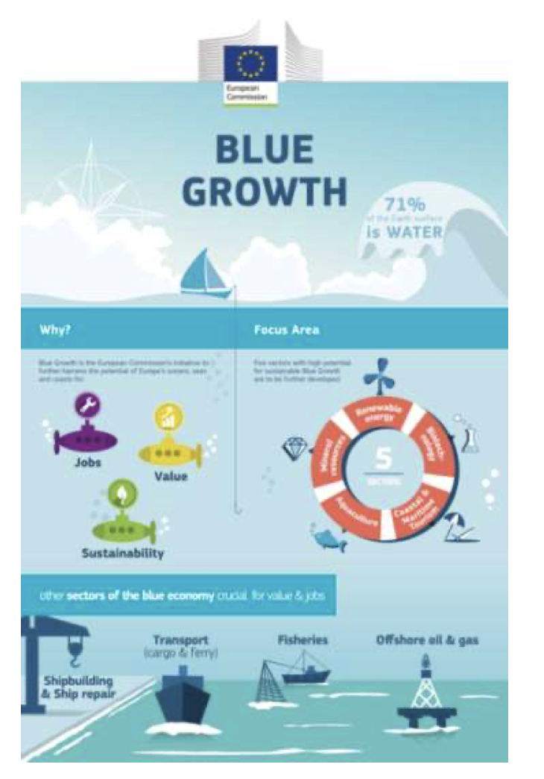
Figure 4: Blue Growth Schematic

The strategy consists of three components:
a) Develop the sectors with potential for sustainable jobs and growth:
- aquaculture and fisheries;
- coastal tourism;
- marine biotechnology;
- ocean energy generation; and
- seabed mining.
b) Providing knowledge, legal certainty and security in the blue economy:
- marine knowledge to improve access to information about the sea;
- maritime spatial planning to ensure an efficient and sustainable management of activities at sea;
- integrated maritime surveillance to give authorities a better picture of what is happening at sea.
c) Sea basin strategies to ensure tailor-made measures and to foster cooperation between countries in the following sea basins:
- Adriatic and Ionian Seas;
- Arctic Ocean;
- Atlantic Ocean;
- Baltic Sea;
- Black Sea;
- Mediterranean Sea; and
- North Sea.

e-navigation
The IMO e-navigation initiative also has a vision beyond current navigational products. The Strategy Implementation Plan (SIP) states that ‘as shipping moves into the digital world, e- navigation is expected to provide digital information and infrastructure for the benefit of maritime safety, security and protection of the environment, reducing administrative burden and increasing the efficiency of maritime trade and transport.’ E-navigation relies on IHO standard S-100 as an enabler, but also on data not currently held by HOs. Thus, in sympathy with MSDI, e- navigation requires interoperability of data.

The description of Maritime Services in the context of e-navigation is the foundation of a digital information network connecting ship to ship, ship to shore, shore to ship and shore to shore by a maritime digital infrastructure.

Digital Twins (of the ocean and of coastal zone areas)
Certain high-level initiatives aiming to develop digital twins of the ocean to support sustainable developments of nature human interactions. Digital twins are considered as crucial tools as they are capable of reflecting all aspects related to the oceans. However, digital twins are not limited to the water area. They are also digital replications of the coastal zones and consequently, of land areas.

These two aspects are relevant for HOs. They have a core competence in providing all hydrographic data comprehensively, covering deep and shallow waters as well as coastal areas.
Therefore, it is important for HOs to support all digital twin initiatives with their core expertise and to provide the data needed in a sophisticated MSDI.

Infrastructure for Spatial Information in Europe (INSPIRE)

A regional example of administrative aspect is INSPIRE (http://inspire.ec.europa.eu/). The Directive 2007/2/EC of the European Parliament established an infrastructure for spatial information in Europe to support Community environmental policies, and policies or activities which may have an impact on the environment. It is operated by the 28 Member States of the European Union.

The Directive addresses 34 spatial data themes needed for environmental applications, with key components specified through technical implementing rules, of which several are marine and maritime themes. INSPIRE is a unique example of a legislative “regional” approach to SDI.

To ensure that the spatial data infrastructures of the Member States are compatible and usable in a Community and transboundary context, the Directive requires that common Implementing Rules (IR) are adopted in a number of specific areas (Metadata, Data Specifications, Network Services, Data and Service Sharing and Monitoring and Reporting). These IRs are adopted as Commission Decisions or Regulations, and are binding in their entirety.

2.4 Third Party Data Incorporation Methods
Much of the data that are used by HOs to create and maintain nautical products and services are provided by third parties e.g. Lighthouse Authorities or Port Authorities. The method by which these data are transferred from the third party to the HO varies depending on the type of dataset, the status and capability of the third party and how the third party chooses to make the data available. Often one or several copies of the data are maintained by the HO e.g. within different products, charts or cells, with the information being updated manually each time the third party notifies the HO of a change, by the HO scanning public documents or the HO being informed of a change by the mariner.

Where there is an agreement between the HO and the third-party, change notifications can be provided in the form of a written or sometimes a verbal statement, a paper or electronic e.g. PDF report, or by the transfer of a data file e.g. text file containing the changes, the format having been agreed beforehand. Traditionally, these disparate methods are underpinned by some form of source data receipt and assessment (SDRA) workflow which ultimately validates and accepts the changes prior to their inclusion in the next update or edition of the nautical chart or other publication. Where the change is considered important or urgent enough then a temporary or provisional ‘Notice to Mariner’ may be issued.

The above approach is at best slow, inefficient, and increasingly archaic when compared to being able to utilize the new technologies that are readily available, such as the Internet and World Wide Web. In other words, these technologies allow us to create an information or data infrastructure which, for information with a geographical component, is commonly known as a spatial data infrastructure (SDI) that facilitates the exchange of information between different parties, including from third party sources of data to HOs and ultimately from HOs to the mariner.

Figure 5 illustrates the steps from exchanging text-based information verbally, in reports or in non-editable electronic e.g. PDF format (1 Star Data) to exchanging datasets in editable but proprietary formats (2 Star Data), then editable open formats (3 Star Data), via Data or Web Services (4 Star Data), and ultimately as Linked Data (5 Star Data), the latter utilizing Internet based technologies such as RDF (Resource Description Framework).

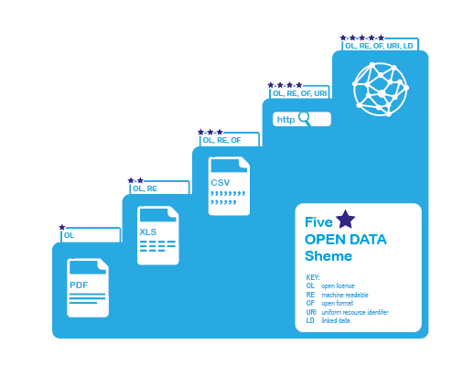
Figure 5: Five Star Scheme for Data Exchange. Adapted and adopted from: https://5stardata.info/en
While 4- and 5-stars data are the ultimate goal, much can be achieved by first agreeing on how to exchange datasets at the 3 Star level, such as utilizing S-100 based datasets to transfer aids to navigation or maritime boundary datasets over FTP between different authorities. Editable proprietary formats, such as Excel or ESRI Shapefile, should be avoided if possible due to their limitations, and of course some form of policy or governance framework is required to ensure licensing, warranties and other commercial and legal requirements are covered appropriately.

Chapter 3: MSDI Maturity

This chapter provides a step by step approach towards the development of MSDI and a means by which HOs can assess its MSDI and/or IGIF-MSDI maturity to plan its development roadmap and enhancements to remain relevant. The approach considers how geospatial data is managed to support these products and services but also whether and how HOs are involved in the wider geospatial data ecosystem.

The chapter addresses MSDI ‘maturity’ in terms of the policies and procedures the HO has in place to:
- Manage the geospatial data for which it is solely responsible (internal datasets)
- Ingest data from third parties that is used in (navigational) products and services
- License its data or data products to value added providers or directly to end users
- Engage with national and wider SDI and regional / international MSDI initiatives

An HO that has a high level of maturity with regard to MSDI will almost certainly have a data governance framework that contains the policies and procedures for each of the above areas. Although not strictly necessary, this framework should ideally run parallel with other governance frameworks such as for Quality, HSE, Human Resources and Finance. The latest ISO business management standards (e.g. ISO 9001, 14001, 27001 and 45001) encourage this integrated business management system approach.

3.1 Maturity Criteria and Assessment
- Manage the geospatial data for which it is solely responsible (internal datasets):
i) Data is held in product e.g. Anchorage Areas within an ENC cell; the data is optimized for a specific product and can only be ‘repurposed’ with difficulty
ii) As i) but data is held outside product in non-editable format e.g. paper or reports
iii) As ii) with the data being held in a editable form, such as in a file store or relational database; the dataset is still product focused e.g. shoalest soundings only
iv) The data is held in a file store or relational database and the data is maintained agnostically; e.g. application specific e.g. navigational aspects are added at the product level e.g. a navigational bathymetry surface is created or an abandoned pile becomes an obstruction (i.e. the form of the feature is maintained not its function)
v) As iv) but the data is available internally - and potentially licensed externally - as a web service to be utilized in products or value added services.

- Ingest data from third parties that is used in navigational products and services:
i) HO gathers third party data from published reports etc. or ‘closed’ applications e.g. GeoCable and maintains a copy of the data as an internal dataset or directly in product e.g. ENC cell
ii) HO has an agreement with third party data holder but receives this data in a non-editable format and transcribes data to an internal dataset or directly in product e.g. ENC cell
iii) As ii) but data is transferred in non-open digital format e.g. Excel or Shapefile
iv) As iii) but data is transferred in open digital format e.g. GML
v) Data is made available as a web service and ingested (or better accessed) as when and required. No permanent copy of the dataset is held by the HO

- License its data or data products to value added providers or directly to end users
i) Data is used by the HO in navigational products alone, usually in encrypted form and is otherwise inaccessible to third-parties, who historically have scanned or digitized navigational products to gain access to the data
ii) Navigational datasets e.g. Raster Charts in GeoTIFF format or ENCs in unencrypted S-57 format are made available to third-parties under license
iii) Source datasets are made available in non-editable formats under license
iv) Source datasets are made available in proprietary editable formats
v) Source datasets are made available in open formats or as web services

- Engage with national and wider SDI and regional / international MSDI initiatives:
i) The HO has no interest in MSDI and retains traditional workflows for publishing navigational products and services
ii) As i) but the HO understands the benefits of MSDI (and the parallel improvements in data governance) and is seeking assistance
iii) The HO is engaged in national SDI and/or regional or international MSDI initiatives and is working on a plan to implement data governance and MSDI
iv) The HO has a plan and is implementing MSDI. It is working with other HOs within the IHO and RHCs to address boundary and other data quality issues
v) The HO has an established role in its country’s national SDI for identified hydrographic datasets and makes these available to end users either directly or via licensed third party VARs, ideally but not necessarily as web services.

A IHO MSDI Maturity Assessment questionnaire was previously completed.

The above could be presented as a graph such as the one below for each of the maturity areas (based on the DAMA functional/environment matrix):
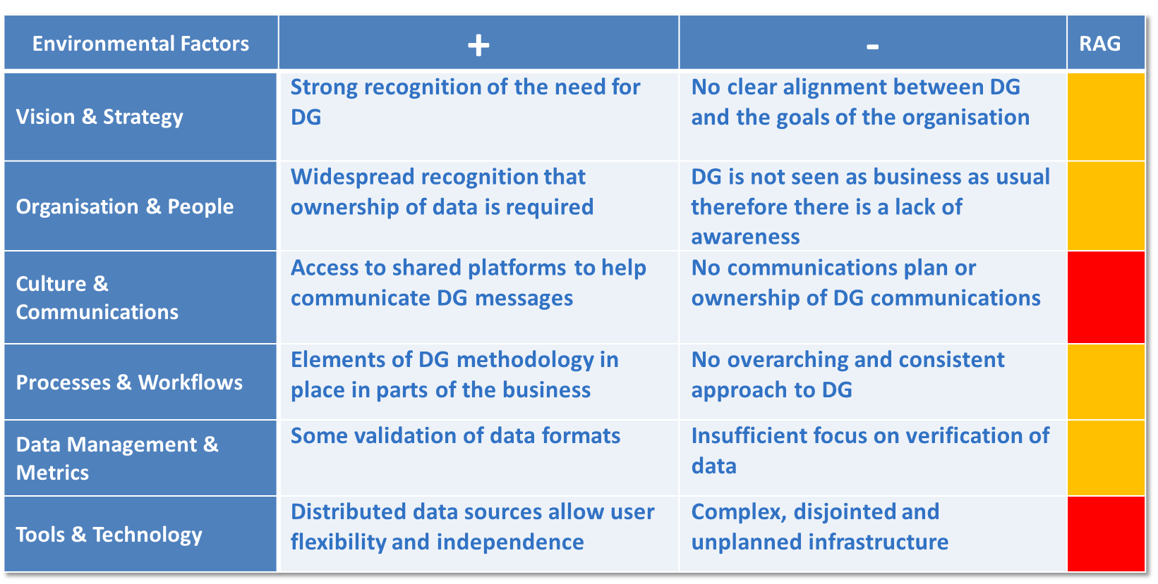

3.2 Step-by-step approach
Arctic SDI/ARMSDIWG Case Study
to be inserted
MSDIs can operate at the organization level (as an enterprise SDI) or at the country/state level or at the regional level across borders (e.g. Arctic SDI).

In all cases, it is recommended to follow the steps below for the MSDI successful development and sustained relevance:
            - Prepare and define the HO policy and role for MSDI (if not done already).
            - Identify an MSDI "champion" to influence, lead and gain support for MSDI at the highest levels of leadership (this may need to be at Ministerial and/or Senior Management level).
            - Identify key HO stakeholders and their requirements.
            - Build support for engagement at Senior Management level.
            - Identify national or regional initiatives/legislation which might support MSDI and establish a governance structure.
            - Participate in the appropriate IHO Regional Hydrographic Commission(s).
            - Join and actively participate in the IHO MSDI Working Group.
            - Identify other data providers to the MSDI:
              - Who are they and what is their data?
              - How does that data compliment that of the HO?
              - Who are the key people in that organization to engage with?
              - What do they expect from the HO by way of data content, skills and knowledge?
              - How do they interact with other organizations in the MSDI?
              - What are their data sharing and exchange protocols?
            - Invite other relevant marine and terrestrial data providers to engage with you.
            - Plan engagement with stakeholders and all other data providers and work to get stakeholder support (e.g. users, influencers, enablers).
            - If the MSDI is new and the HO is the lead organization, consider developing a "White Paper" for discussion and comment by senior management, decision makers and politicians across all stakeholders. The IHO MSDIWG produced White Paper could be referred to.
            - Promote the benefits and opportunities to be derived from MSDI to all non-HO stakeholders.
            - Gain necessary HO approvals for involvement.
            - Set up and/or participate in MSDI stakeholder groups (e.g. Steering Group).
            - Scope out a work plan or "road map" (including timescales).
            - Identify internal HO benefits and promote them to all colleagues and decision makers.
            - Engage, respond, and communicate with all stakeholders.
            - Develop HO involvement in the MSDI.
            - Evaluate emerging trends and consider enhancements to MSDI features, functions and/or architecture.

3.3 Evolution from MSDI 4 Pillars to 9 Pathways – Tips on how to do it right and better

The MSDI Four Pillars (Figure 6) and IGIF Nine Pathways (Figure 7) can synergise with or complement each other and are not mutually exclusive approaches and frameworks. Generally, the MSDI Four Pillars: People, Standards, ICT and Data can mapped to the IGIF Nine Pathways matrix. Besides Standards, Data and Innovation (for ICT) pieces of the framework, the remaining 6 IGIF pathways could be viewed as detailed approach to the People (policy and governance) MSDI pillar. This is naturally a simplification that may miss other connections between MSDI and IGIF but is useful as a guiding concept where the Four Pillars can be taken as a hydrographic office’s specific “lens” on the Nine Pathways, which encompasses a nation’s All-Domain NSDI across Land, Sea, Air, Space, and Cyberspace (where applicable).

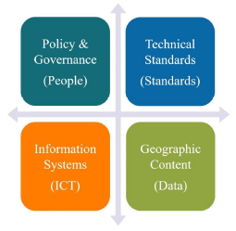
Figure 6: The MSDI Four PIllars
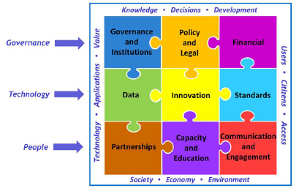
Figure 7: The UN-GGIM Integrated Geospatial Information Framework Nine Strategic Pathways

The evolution from MSDI 4 Pillars to the IGIF 9 Pathways would be beneficial in aligning HOs efforts with the global geospatial community and enabling integration of MSDIs to the broader marine and geospatial ecosystem and/or national, regional and global geospatial programs in order to effectively respond to the various aspects seeking MSDIs.

A good principle or vision for a HO’s digital transformation efforts is to ensure an “IGIF-aligned MSDI implementation”; first and foremost an MSDI that serves marine and maritime geospatial requirements, but additionally contributing to a nation’s NSDI development or implementation. For nations beginning their IGIF and MSDI transformation journeys, introducing the MSDI Four Pillars (hydrographic office specific) for a period before the full IGIF Nine Pathways (all of nation) may ease institutional acceptance and engagement longer-term.

Although there are undoubtedly many ways to encapsulate the IGIF Nine Pathways, two useful statements of intent are helpful for considering before and during an MSDI development programme. These are that an IGIF-aligned MSDI implementation should seek to “Drive Technology, not be Driven by Technology” and also it should “Make the Data Count, not just Count the Data”. There are likely many other such statements that may be crafted and tailored to a nation’s hydrographic vision, but these are useful starting points if not directly applicable already. The ‘IGIF-MSDI Maturity Roadmap’ produced under the OGC’s FMSDI project includes a Diagnostic Assessment Tool for an IGIF-aligned MSDI implementation that offers robust organisational baselining.

Chapter 4: IGIF 9 Pathways from the HO Perspective

4.1 Governance
“Governance is the framework of authority and accountability that defines and controls the outputs, outcomes and benefits from projects, programmes and portfolios. Governance is the mechanism whereby organisations exert control over the deployment of work (effort) and the realisation of value.” (APM Body of Knowledge 7th edition)

A useful guiding vision for Governance is balancing focus on hard Technology with that on softer aspects such as People, Partnerships, and Policies (effectively the top and bottom layers of the IGIF matrix that sandwiches Technology) (Figure 7). Although there are many other ways of encapsulating effective Governance, this concept is agnostic of Technology and more inclusive of constraints around IGIF-aligned MSDI development, either due to financial or other limitations. Driving the use of Technology to meet genuine sovereign requirements, however modest or expansive, whilst ensuring appropriate Governance, allows national HOs to participate in the global drive for digitalisation whatever their level of resourcing.

HOs are key players of the marine spatial data governance. Given this governance’s complexity and desired adaptability to local, national, regional and international priorities, a general definition below borrows from the work of researchers in the field (Sutherland and Nichols, 2006, Edwards and Evans, 2017). It is proposed for practical purposes:

Marine Spatial Data Governance consists in an effective framework of leadership, policies, laws, directives, regulations, agreements, partnerships, processes and procedures focussing on marine data to oversee and ensure the continuity of good decision-making prioritized based on scientific evidence and authoritative data in order to oversee sustainable social, economic, environmental protection and scientific human activities in marine space.

This simplified definition must take global priorities and trends in consideration. It requires more development in this section to expand on the different aspects of data governance over marine spaces. Note that elements of governance and proposed steps to achieve it for an HO have been presented earlier in the perspective of Quality Management Principles (Section 1.5.3) and attaining a national or regional MSDI maturity at a level that is sustainable (Chapter 3). The steps necessary to establish an MSDI presented in Chapter 3 can be mapped as actions to achieve Marine Spatial Data Governance following the UN-GGIM IGIF model for governance and institutions. These actions also articulate the strategies towards marine spatial data governance that the HO will adopt.

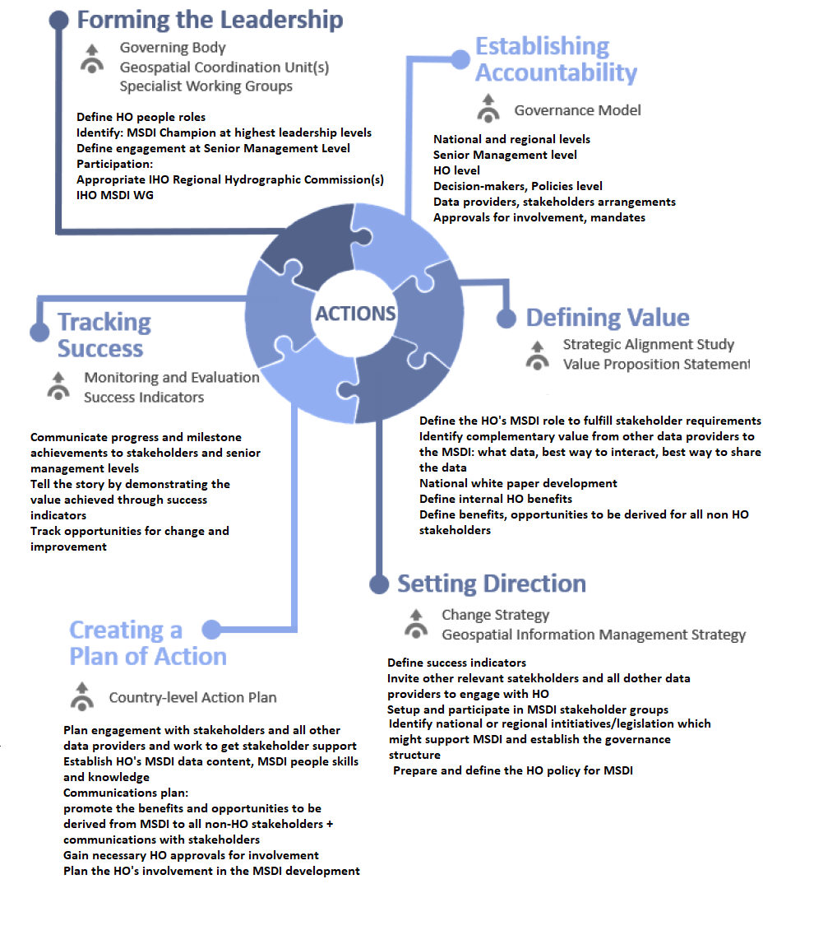
Figure 8: Diagram modified from UNGGIM IGIF SP1 Governance and Institutions remapping the steps from the MSDI maturity section under the 6 IGIF Strategic path 1 actions.

Challenges
For coastal States, establishing Marine Spatial Data Governance is an ongoing endeavour that faces many challenges. HOs are one of the many participants in this national or regional effort. They have to integrate with the wider governance structure existing in their country, regionally, and globally. Sutherland and Nichols (2006) have divided known marine spaces governance issues into categories of:
1) Stakeholder Issues
- Not meeting users and stakeholders’ requirements
- Decisions unsupported by scientific or commercial evidence
- Lack of consultation and inclusion
- Vision and Strategy is lacking where Data Governance is not clearly aligned with the goals of the organisation (Chapter 3, Table 3.1)
- Lack in Culture and Communications where there is no communication plan or where data governance communications have no owner (Chapter 3, Table 3.1)
- Lack in Organisation and People: Data Governance is not seen as business as usual, thus generating a lack of awareness (Chapter 3, Table 3.1)
2) Legal Issues
Fragmented marine legal framework
Conflicting overlapping legislations
Gaps in legislation
Lack of jurisdictional clarity
Non-compliance
3) Technical Issues
Uncoordinated use of or lack of interoperable Standards
Isolated unsustainable solutions and applications: Complex disjointed, and unplanned infrastructures (Chapter 3, Table 3.1)
Major technological evolution away from traditional methods
Lack of consistency in processes and workflows: No overarching and consistent approach to Data Governance. (Chapter 3, Table 3.1)
These marine domain issues represent challenges to overcome which can be mapped with some overlaps to the UN-GGIM IGIF Strategic Pathways (SP) as interpreted in IGIF-Hydro:
- Stakeholder: Governance and Institutions (SP1), Financial (SP3), Partnerships (SP7), Capacity and Education (SP8) and Communication and Engagement (SP9)
- Legal: Governance and Institutions (SP1), Legal and Policy (SP2)
- Technical: Data (SP4), Innovation (SP5), Standards (SP6), Capacity and Education (SP8)

The guiding principles behind Marine Spatial Data Governance are shared with the IGIF Strategic Pathway 1. These principles are also what a HO would strive to integrate in its MSDI solution: Facilitation, Strategic Outlook, Credibility, Participatory, Open and Transparent, Accountability, Guidance, Clarity, Project Management, Oversight, Communication and Evaluation, Legal Interoperability.

Principles of Marine Spatial Governance have been presented in the literature as part of various infrastructure research projects in marine space. These cover a range of topics such as Marine Spatial Data Infrastructures, Integrated Coastal Zone Management, Marine Cadastre and Marine Spatial Planning. All of these share common elements of governance articulating the coordination between land, coastal and marine interests where the MSDI must be accepted as a fundamental part of the solution.

What is the role of governance in a MSDI?
Marine Spatial Data Governance enables the provision of authoritative reliable data enabling an harmonised and sustainable human use of marine space through collaborative and integrating approaches. It aims at clarifying the situation in the marine space, integrating the fragmented information and legal framework and providing certainty for the users while remaining adaptable to the evolution of technology and global practices. The UN-GGIM IGIF-Hydro, for example, is such a guideline to establish global practices in the field of Integrated Geospatial Information Framework for the marine domain. The present document aims at providing similar guidance focussed on the MSDI and HOs.

Considering the governance’s role as one of the four pillars of an MSDI, the governance pillar is seen as the main organising force behind all the other pillars (Guay, 2016) because it deals with the actors, the people. There is governance over the data, metadata and applications pillar, the Standards pillar, and the Hardware, software and services infrastructure pillar. Its own Governance pillar is inclusive of directives, agreements, establishing processes, ensuring that enabling laws, directives and regulations are in place and requires a national will to construct and integrate the MSDI into an adaptive and integrated digital ecosystem reaching beyond the HOs traditional marine user-base.

Need to define a governance model in marine space:
The six IGIF actions along the Governance and Institutions Arrangements Pathway consist in: 1) Forming the Leadership, 2) establishing Accountability, 3) Defining Value, 4) Setting Direction, 5) Creating an Action Plan and 6) Tracking Success. As far as Leadership is concerned an integration in existing national geospatial governance structure is mandatory.

The authority over data mapping human activities in marine space is divided between multiple players. A multi-disciplinary approach involving key participants is required to properly coordinate this data. As shown in chapter 2, HOs structures and products were originally developed and specialised for safety of navigation. When the MSDI is considered, the user-base expands to the non-navigational users for which the HO will not usually own all the necessary authoritative data. Therefore, HOs cannot do this alone and must become an integral part of the national or regional strategic approach that aims to establish sustainable marine spatial data governance. This implies coordinating their efforts with MSP and Marine Cadastre Services. Among the significant participants and governing factors to interact with we count:
- Data owners with a marine mandate to fulfil as described in regulations, directives and laws
- IT resources ensuring infrastructure support, maintenance and data management
- Data and digital policies environment
- Expert advisors and agencies providing oversight and guidance
- User needs and stakeholder requirements
- Financial support

In order to refine and adapt the governance to the requirements of the targeted MSDI maturity and national situation, inclusive consultations with different stakeholders should be conducted. Inclusion in the governance structure ensures that the best scalable fit-to-purpose solution can be obtained.

4.1.1 Governance and Institutions

4.1.1.1 Systems supporting marine spatial data governance
Often the roles of the different pieces of infrastructure or systems that enable marine spatial data governance are not well differentiated. This can lead to a misinterpretation of their function and uncertainty on which of their data aspects fit inside the HO’s MSDI mandate.

The following definitions of roles aim at demonstrating an example of deconflicting three different system components of marine spatial data governance which have to work together: Marine Spatial Planning (MSP), Marine Cadastre and Marine Spatial Data Infrastructure (MSDI). The following seeks to emphasize an interdependency and complementarity of the marine information and services hosted, used and generated by these systems.

- Marine Spatial Planning (MSP): Planning of concurrent marine activities
- Disaster response planning, economic activities, environmental protection
- Situational awareness, Scientific evidence data and models integration
- Community of practice, input from Marine Cadastre, support from MSDI.
- Marine Cadastre: Geospatial depiction of Marine Regulatory Framework/Georegulations
- “Management tool which spatially describes, visualizes and realizes formally and informally defined boundaries and associated rights, restrictions and responsibilities in the marine environment as a data layer in a marine SDI, allowing them to be more effectively identified, administered and accessed (PCGIAP-WG3 2004)”.
- Marine Spatial Data Infrastructure (MSDI): Infrastructure
- Host, enable discovery, work on & distribution of authoritative marine spatial data
- Grouping by theme allowing targeted applications to add value to the data
- Data governance

4.1.1.2 Telling the story to secure the value
The MSDI being an infrastructure, there is a danger that it becomes hidden or invisible to the financing agencies. A clear description of its role and goals must be expressed. Once established with operational processes in place, the MSDI becomes an enabler and facilitator of marine information use. It can then feed other systems such as Marine Spatial Planning and a Marine Cadastre (see Section 4.1.2 Policy and Legal). Its successes must be communicated and its services maintained. Its governance must include an outreach effort to express the realised value of the MSDI to its stakeholders and users.
General Bathymetric Chart of the Oceans (GEBCO) Case Study – Marine Spatial Data Governance
The General Bathymetric Chart of the Oceans (GEBCO) is a well-established international institution with a mission to map the world’s oceans. GEBCO’s marine spatial data governance illustrates an example of collaborative international governance with participation from government, commercial, not for profit and academic sectors. In order to address the areas of governance that it needs to map the worlds’ oceans, it has established several sub-committees of experts whose work can be related to the UNGGIM IGIF Pathways: Governance, Data, Technology and Innovation, Communications, Education and Training and Partnerships.

Ensuring that the marine spatial data governance requirements and stumble blocks are known and communicated helps promote the policies and legislation necessary to support and enable the MSDI as part of a national or regional enterprise solution supporting decision-making for the management of marine space.

4.1.2 Policy and Legal

Whereas marine spatial data governance makes the coordination, engagement and implementation of an MSDI possible, compliance with the national marine and data policy, administrative and legal framework must also be maintained at all times. This framework establishes the legal and regulatory environment where the MSDI will integrate. It gives teeth to the Marine Spatial Governance by forcing mandatory contribution, data management obligations, and defining geospatial areas of enforcement. Legislative and administrative gaps as well as marine domain mandates must be examined carefully with other government stakeholders to assess whether the domestic marine laws are sufficient to enable, maintain and sustain the MSDI capacity building.
- IGIF-H, IGIF components for policy and legal
- Policies necessary to support a MSDI
- Open Data policies
- Examples of legislation
- Advantages
- Policies and requirements for a Marine Cadastre integrating with MSDI and Marine Spatial Planning
- Requirements for Marine Spatial Planning policies and enforcement
- Marine Spatial Planning definition
- Role of the MSDI to support Marine Spatial Planning
- Examples of legislations in support of MSP
- Advantages
- Marine Legal Framework and benefits of a Marine Cadastre to complete a MSDI
- Administrative layers and requirements
- Legislative layers and requirements
- Integration of activities linked to a Marine Cadastre
- Infrastructures, legal surveys, registered plans, licensing of activities
- Jurisdictions
- Extents of policies and identifying gaps or overlaps in jurisdiction
- The coastal zone and nearshore
- The Territorial Sea
- The Exclusive Economic Zone
- Evolution of requirements for infrastructure in the EEZ
- The continental shelf and extended continental shelf

4.1.3 Financial
The IGIF-H provides comprehensive guidance on:
- Business model
- Opportunities
- Investments, and
- Benefit realization

The implementation guidance provided within IGIF-H are intended to highlight and address considerations specifically focused on marine geospatial information. There is substantial flexibility within the IGIF-H guidance which considers that each individual country’s governance, plans, policies, and value outlooks can and likely will lead to different implementations.
General Bathymetric Chart of the Oceans (GEBCO) Case Study - Financial
Because it has a voluntary participation basis where each participant’s organisation funds individually their attendance, GEBCO’s ocean mapping progress would be limited without a major financial enabler: the Nippon Foundation – GEBCO Seabed 2030 project. This project, with oversight by GEBCO and direct contribution to its mission, is presently the effective driving force behind GEBCO ocean mapping. It brings forth financial support and resources distributed worldwide stimulating the development of Partnerships, Innovation, Governance, Success indicators (number of partners, percentage of world oceans mapped to modern standards), Outreach, Communications and sustains a global community of practice.

Operational Sustainability of a MSDI
The development cost of setting up and establishing a MSDI can be significant and the benefits and return on investment of a MSDI would be expected. It is recommended that cost-benefit and/or cost-effectiveness analyses be conducted to monitor the benefits generated and to inform its strategic directions.
[Proposed] New Zealand Case Study on a systematic review on the cost-benefits
To be invited/inserted

Benefits from a MSDI can be direct and/or indirect, quantitative and/or qualitative and it is advised that the value produced should not be confused with revenue generated. There is potential for MSDIs to generate revenue and MSDIs could consider the various cost structure models (e.g. Open-access, Extract and Deliver, Subsidised, Cost recovery, Freemium or Full commercial) outlined under the IGIF Strategic Pathway 3 Financial, Appendix 3.4 Business Model Canvas in determining the possibility of a revenue stream.
[Proposed] UKHO Paid Admiralty Data Service Case Study
To be invited/inserted

4.2 Technology

4.2.1 Data
Data is said to be the “new oil” of the hydrospace and with the advancements in technology, data acquisition has promoted the increase in Big Data which MSDIs and HOs as data custodians must consider elements which promote consistent and reliable access to authoritative marine spatial data. Data is at the core of MSDI and there are various sections in this publication which touches on it: Section 1.5.1 suggests a definition for data, Sections 1.5.2 and 1.5.3 outlines the data principles to account for, Section 2.4 recommends third party data incorporation methods, Section 4.1 sets the institutional context of marine data governance and Sections 2.2.2 and 4.1.2 underscores what it means to provide “authoritative” data. This section elaborates on the data governance policies and expounds on common data challenges and solutions in data curation, privacy, security, integrity and themes HOs could consider.

4.2.1.1 Data Governance Policies
Establishing the policies or “rules of the game” for data contribution and sharing is important to avoid duplication of efforts and to make clear what should be shared through the MSDI and who is going to be the audience. When designing these policies, it is important to consider who are the “enablers” of the MSDI, in other words who conforms to the Community of Practice. This Community of Practice is formed of three groups: Data Providers, Data Consumers and a Coordinating Body.
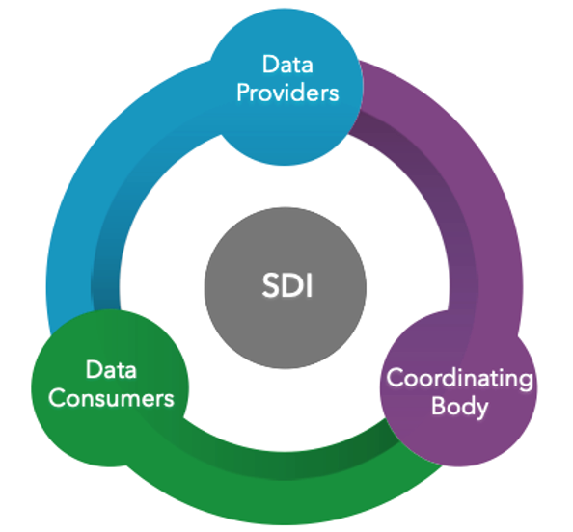

4.2.1.2 Data Curation
One of the fundamental functions of any spatial data infrastructure is the curation of authoritative data assets meant for broader community use. The organization doing the curating could be a designated administrative group – such as the GIS team - or a committee of distributed domain experts. The key goals are to help accelerate use of spatial data and information products by providing a trusted brand to a catalogue of content that signals quality. Authoritative data must be supported by a minimum standard of quality that comes with a trusted methodology for content review and approval. It’s often the expert curation of ‘pre-certified’ datasets that solve 80% of the data use discovery cases within certain communities of practice. A selected group of Data curators must be appointed for this task, their function is to ensure the best maps and layers are made available through the system. Curation rules enforce minimum requirements for an item to be accepted. But it is the curator who leads the user through discussions on how to get the most out of each item. The overall curation process ensures that a qualitative review can occur, so all parties know what is expected, what the benefits are to users, etc.
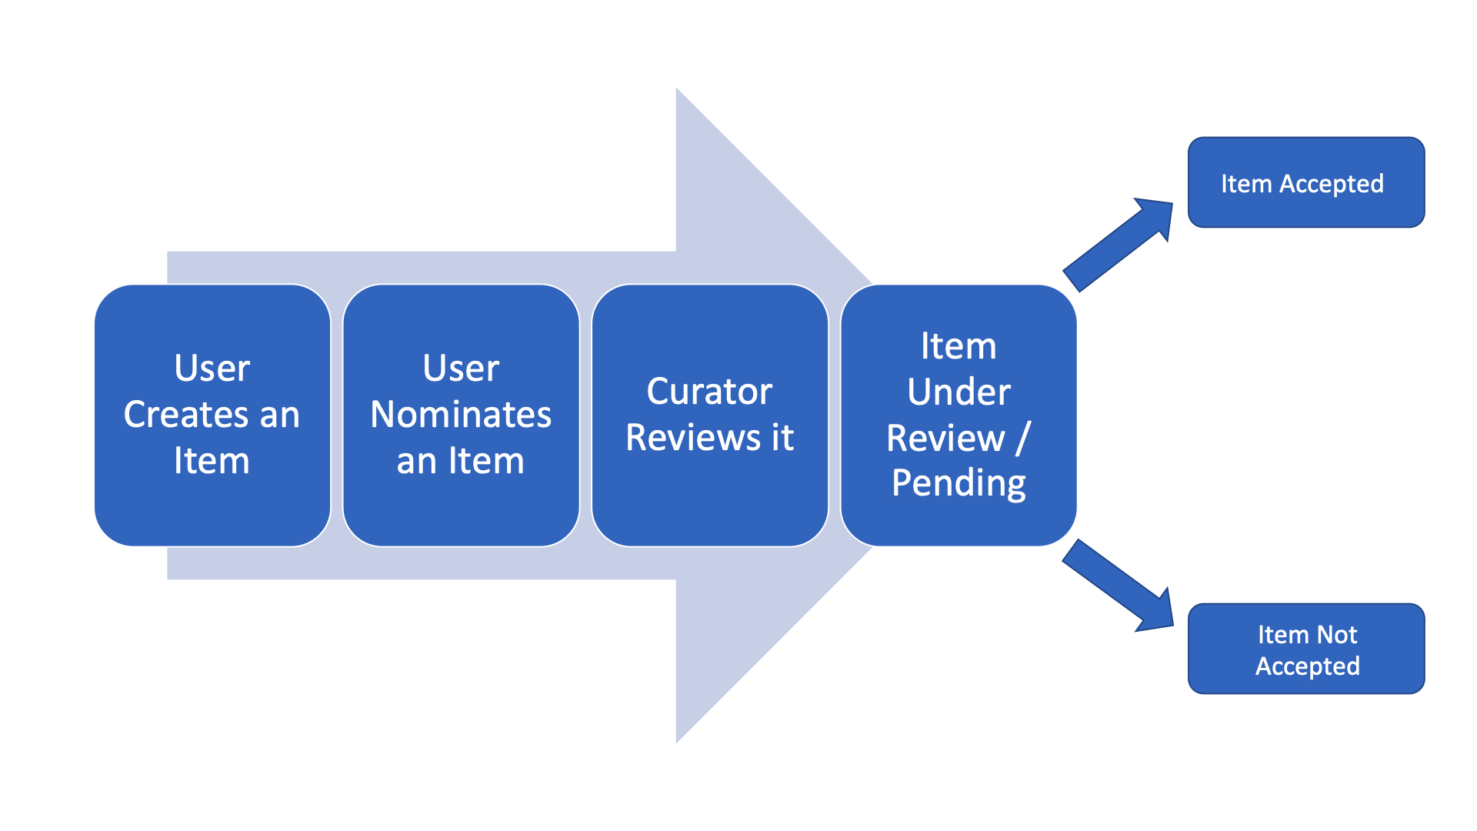
Curation Workflow

4.2.1.3 Data Privacy
Sometimes referred as information privacy, it is an area of data protection that concerns the proper handling of sensitive data (personal data, confidential data, intellectual property or financial data among others). For MSDI geospatial data, an organization should consider the development of regulatory requirements to define how data should be kept protected. There are typically three broad categories: traditional data protection (backup and restore copies), data security (encryption, access control, authentication, threat monitoring), and data privacy (legislation, policies, best practice for data governance). The latter can be considered an outcome of best practice in data protection. The term “data privacy” contains what the European Union (EU) refers to as “data protection”. An important aspect to consider, mainly when collaborating beyond national borders, is the “data sovereignty”, which refers to digital data that is subject to laws of the country in which it’s located. The increased adoption of cloud data services and a perceived lack of security has led many countries to introduce new legislation that requires data to be kept within the country in which the customer resides. Some countries are trying to prevent data from being stored outside their national boundaries. In most countries, privacy is a legal term and not a technology one, and so it’s the term “data protection” that deals with the technical framework of keeping the data secure and available.

4.2.1.4 Data Security
Data privacy is not data security. Data security protects data from compromise by external attackers and malicious insiders, whereas data privacy governs how data is collected, shared and used. Due to the sensitive nature of that data, HOs often work closely with the Navies of their respective nations and their information technology experts.

4.2.1.5 Data Integrity
To reference MSDIWG10 discussion on Data Integrity

4.2.1.6 Data Themes
To reference IHO-OGC Concept Development Study recommended themes and any others

4.2.2 Innovation
Innovation from MSDI perspective are two folds. As new trends and technologies emerge, MSDIs must be enabled to support new innovations and innovation programs to fulfil the quantitative and qualitative benefits of providing open marine spatial data. Likewise, platforms and opportunities for innovation are important in advancing MSDIs.

4.2.2.1 Supporting Innovation Programs
Fundamentally, MSDIs are a single window and authoritative source for marine spatial data, web services and APIs required for innovation projects and/or programs.

OGC FMSDI Case Study – How existing MSDIs have supported Innovation
To be inserted

4.2.2.2 Innovating and Enhancing MSDIs
The One Map concept approach
Many organizations are building their geospatial infrastructures around the “one map” concept. This can be understood as a strategic resource providing a collection of authoritative products and web services in one place (a single window or one-stop-shop) for all geospatial information needs, organizing partners, involving different levels of government, private sector and academia among others. The idea is to enable access to any information required by the user (who doesn’t have to be a technical expert) in the least number of clicks possible. Providing applications, analysis tools, and APIs to build apps, data can be browsed by themes, used online or downloaded for local consumption.

MSDI patterns in practice
In practice there are different patterns to develop an MSDI, which in general is part of a National SDI. These patterns are understood as ways in which organizations approach the coordination and relationships with stakeholders. Some of the most common patterns of practice are:
- Regional planning initiatives
- Foundational data initiatives
- Thematic initiatives
- “Whole-of-government (WoG) collaboration
- Emerging Hub networks
- Sustainable development thematic initiatives

OGC APIs – Building Blocks for Location
To be drafted - information about new OGC standards being worked on (including OGC API standards not released yet) as well as information about technology that could become OGC standards.

Data at the “Speed of Trust”
Collaboration is foundational to the success of any MSDI. Trust is the bonding among those that form the Community of Practice. It is commonly said that when the trust goes up, speed goes up with it and associated costs (economical, time or resources) go down. Many books and articles have been written about this, they refer usually to enterprises, relationships, business, leadership. All important, but how to translate this concept to data? Trust can be understood as credibility and with that, there are four key elements: integrity, intent, capabilities and results. Data in a MSDI must be authoritative, quality controlled and its metadata clearly established to understand its capabilities and possible results in use it.

4.2.3 Standards
o Details on how HOs can use certain standards to set up and enhance their MSDI (OGC, ISO and IHO)
o OGC APIs, FMSDI Projects, Guidance on S-100 from MSDI perspective (Products, use, UN shared guiding principles/IGIF principles/National regulation with reference to the WEND S-1xx Implementation Guidelines)
- S-100 from MSDI Perspective

4.3 People
Roles and expertise
Certification of hydrographers and land surveyors for surveys in the marine environment
New skills:
- Data science
- MSDI literacy
Bridging the training gap:
- Traditional Hydrography: Safety of navigation, surveying, nautical charts and products
- MSDI: whole of government approach for data centric marine data management
- How to bridge HOs expertise and Non-navigational Marine Science sector expertise to make data FAIR: Findable Accessible, Interoperable, Reusable
- People to assemble and implement knowledge transfer from other marine sectors
- Data owners and managers
- Infrastructure providers and managers and maintenance service providers
- Technology and standards integrators
- Testers and implementers
- Applications developers
- Facilitators bridging IT and MSDI
- Distribution of roles and expertise for a Federated MSDI

An MSDI that forms a contribution to an NSDI (or similar) may likely require two or more agencies to collaborate in its operational delivery, beyond transactional data exchange or arms-length cooperation. This requires not only data interoperability, but interoperability of institutions and their decision-making processes for an integrated MSDI that supports onward applications like Digital Twins. This institutional interoperability requires a common understanding of Data Governance roles and of terms used in Data Management.

Different institutions can have markedly different responsibilities for the same role titles, such as “Head of Data” that may be managerial in large organisations with reduced expectations of technical expertise, which is held by lower-level subject matter experts (SMEs). At the other end of the spectrum in smaller organisations, such a role may conversely be highly technical, yet requiring higher-level approvals for making decisions and committing to action.

This can inhibit agile decision-making and responsiveness for urgent issues within a multi-agency MSDI implementation, as managerial-dominant roles must take time to confer with their SMEs, whilst technical-dominant roles must delay until leadership approval is given. These layers of delay and communication increase the risks of decisions being made too late, which even for routine tasks will eventually accumulate into far longer delays overall. It is also a similar situation for definitions used across different institutions and incorrectly assumed to be understood by each organisation in the same way, but now with the risk of wrong decisions being made. For example, Data Quality may mean statistical conformance to one organisation, whilst meaning cleansed data subject to a strict Standard by another.

One recommended solution is to use common Data Governance role titles alongside regular job titles from a host agency’s hierarchy, such as Senior Risk Owner, Information Asset Owner, Data Custodian, Data Steward, and/or Data Practitioner. These are only recommended examples and can be changed according to institutional culture, it is far more important that these roles are commonly and clearly understood by all stakeholders, regardless of the actual terms used. A similar solution of mutually agreed upon common Data Management terms will also empower communications amongst MSDI agencies.

As an example of an issue relating to pipeline instability due to seabed movement, it may be far quicker for the Information Asset Owner (Pipelines) in Agency X to directly request a crucial meeting with the Information Asset Owner (Bathymetry) in Agency Y, than a more traditional method of trying to navigate a 3rd party hierarchy, where conventional job titles may have markedly different practical responsibilities to similar ones within their own institution.

4.3.1 Partnerships
Where appropriately chosen, the use of common Data Governance role titles can also facilitate partnerships between different national sectors, such as Government, Academia, and Industry; whilst also serving a role across national boundaries for federated initiatives (such as the OGC’s FMSDI initiative). The possibility of “diagonal partnerships” across national borders may also offer unique benefits where the need and opportunity arise, outside of traditional G2G (Government to Government) or G2B (Government to Business) within the same country.

Whether national or international, partnerships are crucial for maximising strengths and capabilities, as an effective MSDI will need the participation of Government, Academia, and Industry, perhaps alongside international bodies in some instances. The governance of such multiparty partnerships will likely require robust implementation via a number of consensus groups that empower fair and inclusive decision-making. A three-level example may begin with a top-level MSDI Governance Board for strategy and vision, a mid-level MSDI Steering Group for operational planning, followed by an MSDI Working Group for implementation.

A key trait of effective governance enabling real-world progress is that each group adopts collaborative goal-setting, not just passive cooperation, but a “One Fail, All Fail” approach to prevent minimalist and/or individualist contributions and encourage true joint working. This may require a political and cross-domain level of understanding that lies outside the scope of this document, but is worth the time and effort in realising.

To ensure inclusive participation and decision-making, independent Chairs are an ideal solution where possible for each group, supplemented by common MSDI (or Data) Governance titles to break down perceived hierarchies, which can cause relatively smaller participants to feel side-lined or dominated by larger peers, leading to disengagement or withdrawal. The use of common MSDI Governance titles should also be supplemented by a robust diplomatic-style approach by the Chair(s), where each participant is taken as an “sovereign ambassador” representing their organisation, regardless of perceived status due to regular job titles, or the heritage, size, budget, or influence of their home institution. An effective MSDI requires close operational interoperability of institutions, to deliver unique outcomes that no one, two, or sometimes even three parties could deliver alone. This goes far beyond contractual and transactional data exchanges, where even one “broken link” could have outsized deleterious impacts on the collective outcome.

4.3.2 Capacity and Education
Building the Team to deliver MSDI
Identify the appropriate skills and knowledge in your workforce to enable the development of SDI within the HO to progress. These skills should include:
- Understanding what constitutes an MSDI and how it might be developed and delivered;
- Understanding the data (e.g. its constituents, capture, aggregation);
- Understanding the variety of potential users of the MSDI and their specific needs can better inform decision making regarding content, accessibility and metadata;
- A knowledge of data management (standards, metadata, architecture, modelling, best practice);
- A knowledge of Information and Communications Technology (ICT) such as web services and delivery, interoperability, data sharing and exchange, geo-portal development;
- The ability to communicate (e.g. with users to determine requirements and describe data; with management to gain support, acceptance and funding to provide the best service);
- A knowledge of software solutions across the geospatial information industry (e.g. platforms for delivery, database design and operation); and
- Experience in team working to ensure delivery of common MSDI goals.

4.3.3 Communication and Engagements
In an area of increasing societal concern around misinformation, disinformation, and malinformation, it is important to not only make authoritative and assured data openly available, but to ensure that decision-makers are cognizant of the need for trusted data and metadata. Succinct messaging and infographics to capture the attention of end-user communities are needed amidst increasing amounts of parallel, alternative, and competing communications.

Depending on the national environment at hand, such communication may require a focus on the value of trusted (or insurable) information for critical and time-pressured decision making. In other circumstances, an outreach and education programme or strategy may be needed where new MSDI capabilities are unfamiliar or new to the end-user community, which may require two-way active engagement compared to one-way passive communication.

Whatever the chosen channel, medium, and approaches taken, coordination with national peer-agencies or higher-level Executive bodies (where applicable) could help avoid unnecessary duplication (unless deliberately desired) and even conflicting messaging. Having a unified whole-of-Government approach can leverage each participating party’s strengths and resources, enabling a wider synergy greater than the sum of its parts. This assumes unified understanding across a national Government, where a prior or concurrent campaign of intra-Government communication and engagement may be needed. The intensity and breadth of such a campaign will depend on many factors such as the diversity of marine or maritime agencies, and the presence of competing or alternative narratives.

Chapter 5: Emerging Trends in MSDI
HOs are advised to consider emerging trends related to MSDIs it is at its implementation phase when these trends could be factored into technical specifications or its mature phase when enhancements to system or governance could be considered. This chapter summarises emerging trends in MSDI and in doing so envision a “Future MSDI”.

5.1 Transformation of the Hydrographic Office

As detailed in Chapter 2 and 3, the role of the HOs have transformed and with the advent of new technologies, this role will extend to provide not just a single dataset or product, but combinations of data for a wide variety of products, such as weather simulations and predictions, real-time data that changes with respect to time. This is an interdisciplinary effort involving multiple agencies across the data life cycle:
- Data collection
- Raw data processing
- Providing easy access to data
- Applications and Commercialisation of the data
HOs can and should play a central role in all of these activities.

5.1.2 Future role of HO and relations with ports, ship owners
To be drafted

5.1.3 Climate change and its impact on shorelines
To be drafted

5.1.4 HO, technology and not re-inventing the wheel
To be drafted

5.1.5 Collaboration with other sectors (Energy, aviation, port cities, infrastructure)
Seaports, airports operators and maintain large capital assets valued in billions of dollars. These assets can generate large amounts of IoT data in real time, have lots of moving and static parts. This has certain similarities with the assets involved in oil and gas such as refinery complexes, oil terminals, gas terminals. We see some overlap in terms of use cases across these domains (aviation, maritime, oil and gas) such as hazard communication, handling of hazardous materials, emergency response, operation and training, maintenance.

5.1.6 HO and innovation hubs, technology accelerators
To be drafted

5.2 Emerging Trends

5.2.1 Digital Twins
A digital twin is a representation of a physical asset, created by using data collected by various means. Such data can be surface data (bathymetry, lidar, photogrammetry) pressure, temperature, wind velocity, direction or any other parameters. Metaverse is a term often used to describe a set of technologies and its end product which allows you to see visualization of a physical asset or any real-world object in such detail that the visualization begins to look exactly like the real world.

Digital twins in the past were a numerical representation of a physical asset. For example, if your asset was a wind turbine, the digital twin of the wind turbine would be all the data generated from it. Each wind turbine over a period of time would generate data that will show its wear and tear and ageing. The representation of such data in charts, tables was the only way to see that data as data visualization techniques were limited by the compute capabilities available.

Today, compute capabilities have improved, therefore we can now visualize 3D Digital Twins which models an asset (a wind turbine for example), along with its data. We can apply the data to the 3D model. For example, if your data is RPM, you can show the 3D model of the wind turbine blades and gears rotate accordingly.
Features of a 3D digital twin that are common across multiple domains are:
- Raw 3D data collection and its processing mechanism.
- IoT data collection and its processing (in real time.)
- Storage of data on cloud.
- Wireless connectivity.
- Applications such as hazard communication, emergency response, maintenance, operations.
- Knowing the state and location of expensive mobile assets (such as aircrafts, helicopters, ships), stationary assets (such as oil terminals, gas terminals, airports, oil refineries, oil wells, oil platforms).

Technology stack involved in a 3D digital twin
For most 3D digital twins, you need the following technologies
- LIDAR, photogrammetry, satellite imagery, bathymetry.
- AI (artificial intelligence), ML (machine learning)
- Cloud computing, edge computing
- 4G, 5G telecommunication technologies
- VSAT, BGAN
- High performance computing
- VR (virtual reality), AR (augmented reality)
- Wearable devices, headsets, mobile devices
- Game engines
- High performance computing
- Methods for collecting and storing IoT data in real-time
- Simulations

Relevance of a 3D digital twin to the maritime sector
In the maritime domain, common assets are the infrastructure associated with ports, natural features such as shorelines. A large port can have several manmade structures such as locks, bridges, pipelines. For example, Berendrecht lock is the world's second largest lock located in the port of Antwerp. A 3D digital twin in this case would be the 3D model of the lock plus the lock’s positional data which can change with respect to time.

MSDI and Digital Twin of the Ocean
One of the ten challenges of the UN Decade of Ocean Science for Sustainable Development is the Digital Twins of the Ocean (DITTO). Lead by the GEOMAR Helmholtz Center for Ocean Research Kiel and Kiel University, DITTO will support the development of digital twins of the ocean as “a realistic digital representation of assets, processes or systems in the built or natural environment”. Their goal is to establish a digital framework on which all marine data, satellite data, modelling and simulation and specialised tools, including best practices will form a new globally shared capacity to access, manipulate, analyze, visualize and use marine information. DITTO tries to empower ocean professionals including scientific users to create their local or topical digital twins of “their ocean issue” by using standard workflows. This initiative started on the 1st of July 2021 and is scheduled to end on 30th of June 2026. It’s important to mention that another important initiative under the UN Decade of Ocean Science is the development of the IGIF-Hydro, with the goal to provide guidelines to produce an operational framework for integrated marine geospatial information, for the efficient use this type of data to facilitate decision-making in support of sustainable oceans and seas, coastal zones, deltas and tributaries, and inland bodies of water and waterways.

5.2.5 Spatial data and maritime domain, ECDIS, ENC
ECDIS stands for Electronic Chart Display System. ENC stands for Electronic Navigation Chart. This is the current or legacy system being used to store and transfer positional, geospatial information needed by the maritime industry.
As of 2022, ECDIS and ENC performs the functions of data visualization, providing situational awareness to mariners on a ship’s bridge. An ECDIS system is not just a display system, it involves:
- Edge computing system,
- Data storage system, (ENC)
- 4S (Ship to Ship, Ship to Shore communication system)
- IMUs, Gyroscopes,
- GPS,
- Autopilots,
- Fusion of data coming from all the sensors,
- Presentation layer or screen that is used by the mariners.
Before the advent of ECDIS and ENCs, printed paper charts were being used. The information displayed on paper was similar to what you see on today’s ECDIS and ENCs. (navigational chart) Except on a single paper, you can see a single layer of information whereas on ECDIS you can overlay multiple layers on top of each other and turn on and off layers according to the needs. Both ENCs and paper charts show 3D data on a 2D surface.
ECDIS and ENCs did not happen overnight. They were slowly introduced from the late 1980s until in the mid-2010s they started becoming mandatory.
- 1980s, 1990s Initial introductions of new technology
- 2012 Mandatory on newly built passenger ships and tankers.
- 2013 Mandatory on newly built cargo ships.
- 2014 Mandatory on existing cargo ships.
Both IHO and IMO are involved in setting standards for the hardware and software involved in ECDIS and ENC. The AR, VR, MR, wearable devices, head mounted displays are a logical step forward in the same direction where new methods and technology will be used to display data. However, these new devices are capable of showing 3D data in 3D form, instead of projecting it into a 2D manner. AR, VR, MR, and the new devices that come with it should be seen as an extension of the existing ECDIS system.
Some of the standards created by IHO and IMO relevant to ECDIS, ENCs are
- S-57
- S-52
- S-63
We expect the new S-1XX standards to cover new technologies, new developments that came after the S-57. Work groups that develop and monitor these standards are
- MSDIWG (Marine spatial Data Infrastructure Work Group)
- WENDWG (Worldwide ENC Database Working Group)
- S1XXWG (S1XX Work Group)
- ENCWG (ENC Work Group)

5.2.6 Visualization of spatial data, AR, VR, MR
Examples of visualization spatial data are many ranging from animated movies to CAD, surface model of seafloor, visualization of weather simulation, CFD simulation. Earlier, all this 3D data was seen on flat screens. Today in addition to screens, we can use wearable headsets.
VR or virtual reality is a visualization technique where the display is mounted on the user's head allowing the user to see a virtual screen that is similar to a 360-sphere surrounding the user’s head. In this case, the visual input from the real world is completely blocked or replaced by the 360 virtual screen.
AR or Augmented reality When the user sees the real world with small amounts of 3D data and non 3D data is overlaid on top of the real world visual inputs.
MR or Mixed reality When the user sees highly realistic and detailed 3D visualizations mixed with the real world. The goal here is to make the virtual 3D data indistinguishable from the real world.

5.2.7 Current and future use cases from HO, ports, ship owner perspective
Information regarding navigation, AIS data, situational awareness (with nearby ships, land) can be inserted, overlayed on top of the live imagery. The display of this information could happen on a head mounted display. Ideally the base layer of the live imagery should have 360 coverage coming from cameras with views unobstructed from the ship's own surfaces. One such implementation exists on an experimental basis on ships as of 2022. However, it probably does not have 360 degrees coverage and may not be a truly head mounted display.
The information displayed on the head mounted display could use 4 modes of display.
a) UI pinned to the head of the user for certain critical information for information that is not 3 dimensional in nature. (This is similar to head mounted displays used on fighter jets.)
b) UI pinned to a wall on a bridge or anchored to a point in 3D space within the bridge.
c) A holographic display which multiple people can see simultaneously. (It may look impressive but will have a long way to go before it gets adopted for practical use.)
d) See through mode where you could see the surface below behind ship surfaces. (Such as ocean floor below the keel for UKC)

5.2.8 Basic building blocks of AR, VR, MR wearable headsets
What are the basic building blocks of AR, VR, MR headsets or devices?
- Headset or display device
- Gyroscopes
- Sourcing of 3D data
- Optimization of 3D data
- Positioning data, GPS, GNSS, IMU
- SLAM
- Anchors in 3D space
Headset or display device for industrial use.
You can expect these wearable devices to be,
- Intrinsically safe,
- Ruggedized to withstand fall from 2m height on a hard surface,
- Low in weight, power consumption,
- Expected to withstand, dust, heat, sun water,
- Able to withstand humid, salty environments for maritime use,
- Minimum moving parts, no fan, passive cooling.

To fit above criteria, these devices will likely have processors that are used on mobile phones and hence are expected to have around 4-16 GB RAM. In other words, these are thin clients with limited memory and processing power.
Gyroscopes.
These are used to sense the head orientation and movement of the user. Around 7 of these are present in new generation mobile phones.

Sourcing of 3D data
3D data has to be collected, processed. As of now, this happens through various sources such as satellite-based sensors, UAVs, LIDAR, photogrammetry, bathymetry, sounding, radar.

Optimization of 3D data
Because the headsets are thin clients and have limited memory, storage and processing power, the 3D data in its raw format will not fit on them. Hence in most cases you will see either abstraction, optimization, or conversion of 3D data before it goes onto the headsets to get displayed. This should be taken into consideration when looking at safety and dependability of these systems in the whole.

Positioning data, GPS, GNSS, IMU
These are inputs coming from larger systems that can be fed into the wearable devices. For example, the gyroscopes and IMUs of the wearable device will sense the head movement and orientation of the user but the location of the user or the ship on the face of earth would come from other systems such as GPS, GNSS in the form of positioning data.
SLAM
SLAM stands for Simultaneous Location and Mapping. Such a system can process imagery data and extract positioning information out of it. SLAM is currently being used on autonomous cars. Anchors in 3D space This is a software-based system which puts markers in 3D space.

5.2.9 Current AR, VR, MR and maritime, industrial applications

To be expanded
Virtual and Augmented Reality
There are several types of “realities” that sometimes can be confusing. The term “Virtual Reality” (VR) refers to a simulated world, where people can visit (or experience) different artificial scenarios using hardware (headsets) and software. Is a virtual representation of the real world, it isolates the user from the real world. “Augmented Reality” (AR) in the other hand, is where parts of the user’s physical world is enhanced with computer-generated feeds, this can be done in the form of sound, images, video, GPS and more types of overlays that respond in real time to changes (motion) of the user in the real world. Some digital elements appear over real-world views. The combination of VR and AR elements is called “Mixed Reality” (MR) and basically the designed elements are anchored to a real environment, where the digital and real elements can interact. There is an umbrella term used for technology that combines VR, AR and MR (and any new technology) to alter really by adding virtual elements to the real world, the “Extended Reality” (ER).

Adding AR, VR to current ECDIS
It should be possible to project existing ECDIS information through a web browser which then gets projected onto the head mounted display. One of the devices used in these tests was an intrinsically safe head mounted display, called realwear HMT-1. Another was HoloLens 2. As of now there are multiple headsets available that are designed for industrial uses. No standards are set for such displays from a maritime perspective yet (This is where IHO could come in) As of now, (and for the near future) I see head mounted displays being used in "display only" mode. I do not see inputs being fed back into the navigation systems from these devices (such as changing the course of the ship) Supporting positioning and other information. As mentioned earlier, all the headsets and most higher end mobile phones come with accelerometers and gyroscopes that can keep up with human head movements at 90-120 frames per second. In addition to accelerometers and gyroscopes many devices also use SLAM to extract positioning data from capturing images of the surrounding area. These provide the head position and orientation information within the local space of the bridge. However, as all gyroscopes and accelerometers accumulate errors over a period of time, some sort of correction will have to be applied at regular intervals. (Similar to an IMU) You might need a station for applying these corrections to the headset but otherwise, these headsets should be self-sufficient to position themselves within the local space of the bridge. It should be possible to connect the headset to the main ECDIS station through the 4G private wireless network that are currently available. So, the headset should function anywhere on the ship as long as there is 4G available. The ship's own position and orientation in world space is necessary. This could come from existing GPS, GNSS, IMU, etc. 10 All this data is currently mashed inside the existing ECDIS which can be used on the head mounted display in AR, VR format.

5.2.11 Limitations of current technology and future
Current technology and most of the developments are driven largely by commercial, consumer market demands. Hence, they don't necessarily cater for situations such as semi dark and dark conditions where SLAM becomes unreliable. Most of the headsets are designed to work within closed indoor environments so there is testing, R & D involved to see how it might work within maritime environments specially on a ship. The current displays don't have a wide field of view that comes close to natural human vision. however, some high-end devices have shown high fidelity, high resolution. Current combination of ECDIS data and displays were designed for flat 2D displays. In other words, they are a natural progression of a flat paper-based. chart. Hence the base layers are flat 2D images. To get the most out of 3D, AR, VR, we will need to add the third dimension to the data. We are already collecting the bathymetric and hydrological data with the understanding of 3D. We end up flattening it so that it can be displayed on a flat screen. Now that we have AR, VR displays that understand 3D space, such abstraction of 3D data in 2D space is not always necessary. Significantly, S-57 was designed in the days when electronic charts did not exist, and this is reflected by how the data is formatted. But S-100 should be able to adapt to new type of displays and accordingly have the data formatted or modeled. As for the processing and storing of data, you could say the on board ECDIS is an edge computing device. For smaller crafts that do not have ECDIS, the functions performed by ECDIS, especially the storage of base layer data could happen at a shore-based cloud computing facility, connected to the thin client on board the ship via satellite broadband. In other words, the wearable device will be connected to an ECDIS like system that sits on the shore, via a satellite broadband connection. Some 11 computing will always have to happen on board the ship as the positioning data is being generated from ship-based sensors. Such a combination and split of ship-based, land-based computing would prevent data duplication, unnecessary data transmission, provide for the ability to push more frequent updates. There will be certain latency issues involved here which are inherent with a satellite broadband connection, however, there are ways around it. Extending the idea of thin client and fat server, such a system would be connected to the thin client on board the ship via a satellite connection and can act as a backup for the on board ECDIS computing infrastructure or can provide ECDIS like capabilities for smaller crafts which are too small or too inexpensive to have full-fledged ECDIS systems.

5.2.12 Handling of large amounts of 3D data, S1XX
HDF5 has been in use for scientific visualization of 3D data. It is part of the S-100 data model. With 3D data you are looking at an increase in the footprint of data by several magnitudes compared to 2D data which can cause problems for the limited processing and memory of the wearable devices. So possibly you could store original 3D data in HDF5 format and create an abstraction of it for display. (There have been efforts to tackle this problem over the last 2 years. (Display of very large 3D data on thin clients.) Regarding the size of 3D data, you can expect it to get very large. Hence you will need the appropriate data infrastructure that can handle big 3D data. In this regard, our work was focused on visualization of very large 3D datasets, (up to petabyte size) on thin clients (wearable devices, AR, VR, MR) with the help of high performance computing, 3G, 4G, satellite broadband connections (BGAN, VSAT).

5.2.13 Wireless capabilities available (current and near future)
TO DO: Add more description
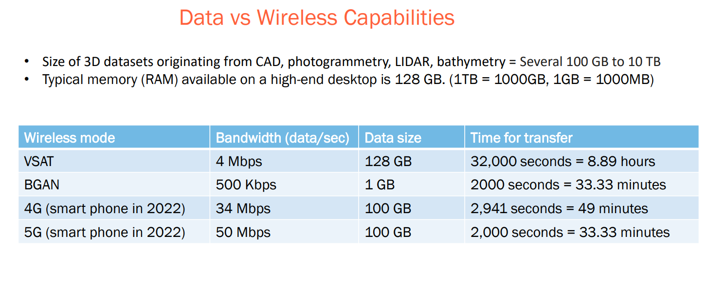

5.2.14 Edge computing, high performance computing, ML, AI
TO DO: Add more description on how HPC and ML, AI can be used.
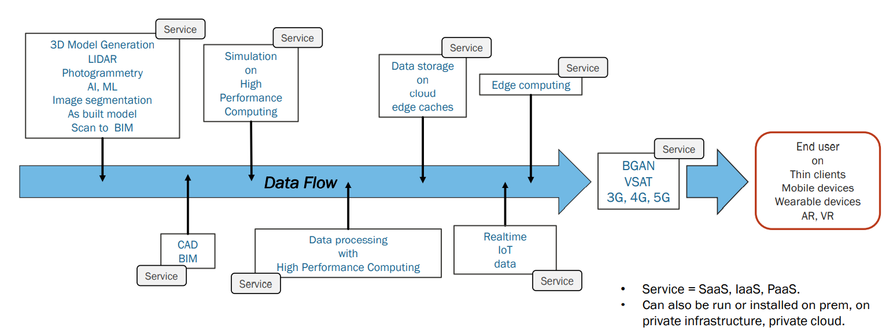

5.2.15 Micro Services
To be drafted

5.2.16 Artificiel Intelligence
To be drafted

5.2.17 Multi-dimensional data
To be drafted

Conclusion
To be drafted

Glossary (including abbreviations and acronyms)
AI Artificial Intelligence
BoK Body of Knowledge
CSDI Corporate Spatial Data Infrastructure
DIKW Data Information Knowledge Wisdom
FAIR-TLC Findable Accessible Interoperable Reusable Traceable Licensable Connected
GSDI Global Spatial Data Infrastructure
HO Hydrographic Office
IGIF Integrated Geospatial Information Framework
IGIF-H Integrated Marine Geospatial Information Management
ISO International Organization for Standardization
KPI Key Performance Indicator
LSDI Local Spatial Data Infrastructure
MSDI Marine Spatial Data Infrastructure
MSP Marine Spatial Planning
NNSDI National Spatial Data Infrastructure
OGC Open Geospatial Consortium
QMP Quality Management Principle
RSDI Regional Spatial Data Infrastructure
SDI Spatial Data Infrastructure
SSDI State Spatial Data Infrastructure
UN United Nations
UN-GGIM United Nations Committee of Experts on Global Geospatial Information Management
UNCED United Nations Conference on Environment and Development
WCS Web Coverage Service
WFS Web Feature Service
WMS Web Map Service
WMTS Web Map Tile Service

This glossary provides definitions of terms used in IHO C-17 3.0.

Annex A: FAIR Principles Checklist
To be inserted

Bibliography

(i) References from Journals: Anders, F.J. and Byrnes, M.R. (1991). “Accuracy of shoreline change rates as determined from maps and aerial photographs”, Shore and Beach, 59, pp. 1726.
(ii) References from Books: Foley, J.D., van Dam, A., Feiner, S. K. and Hughes, J.F. (1990), Computer Graphics – Principles and Practice, 2nd ed., Addison-Wesley, Reading, MA.
(iii) References from the technical material or research literature: Smith, A. (1988). Colour photomapping. Report NRC-01-512. National Research Centre. Ottawa, Canada.
(iv) References from a web site: desJardins, M. (2005). How to succeed in postgraduate study, Applied Ecology Research Group, University of Canberra, viewed 26 April 2009, http://aerg.canberra.edu.au/jardins.t.htm.

Drafting Team
Name | Country/Organisation
Pearlyn Pang | Singapore
Caitlin Johnson | USA
Nicola Pizzeghello | Italy
Jens Peter Hartmann | Denmark
Jens Schroeder-Fuerstenberg | Germany
Chris Hemmingway | Canada
Jean-Francois Beaupre | Canada
Serge Levesque | Canada
Manuela Milli | Italy
Mario Jahuey | Mexico
Christopher | Brazil
Cesar Borba | Brazil
Telmo Geraldes Dias | Portugal
Pablo Sánchez Gámez | Spain
Helen Philips | UKHO
Gerald Wong | UKHO
Marilyn Eghan | Ghana
Abdellah Hadou | Morocco
Julien Barbeau | Teledyne CARIS
Rafael Ponce | ESRI
Mike Osborne | Oceanwise
Neehar Karnik | Bujibui
Jonathan Pritchard | IIC Technologies

https://iho.int/en/body-of-knowledge [accessed 14 October 2022].
United Nations Conference on Environment and Development (UNCED): https://www.un.org/en/conferences/envir onment/rio1992 [accessed 14 October 2022].
https://sustainabledevelopment.un.org/outcomedocuments/agenda21 [accessed 14 October 2022].
http://gsdiassociation.org/images/publications/cookbooks/SDI_Cookbook_GSDI_2004_ver2.pdf [accessed 14 October 2022].
http://gsdiassociation.org/images/publications/cookbooks/SDI_Cookbook_GSDI_2004_ver2.pdf [accessed 14 October 2022].
https://www.researchgate.net/publication/242276273_Diffusion_of_Regional_Spatial_Data_Infrastructures_with_ particular_reference_to_Asia_and_the_Pacific [accessed 14 October 2022].
Link.
https://www.ogc.org/standards/wms [accessed 14 October 2022].
https://www.iso.org/standard/32546.html [accessed 14 October 2022].
https://www.ogc.org/standards/wfs [accessed 14 October 2022].
https://www.iso.org/standard/42136.html [accessed 14 October 2022].
https://www.ogc.org/standards/wmts [accessed 14 October 2022].
https://www.ogc.org/standards/wcs [accessed 14 October 2022].
https://www.researchgate.net/publication/279942958_Data_Information_Knowledge_Wisdom_DIKW_A_Semioti c_Theoretical_and_Empirical_Exploration_of_the_Hierarchy_and_its_Quality_Dimension [accessed 28 November 2022].
ISO 19157:2013 - Geographic information - Data quality: https://www.iso.org/standard/32575.html.
https://data.europa.eu/sites/default/files/analytical_report_15_high_value_datasets.pdf [accessed 28 November 2022].
https://www.nature.com/articles/sdata201618; https://www.go-fair.org/fair-principles; https://ec.europa.eu/info/site s/default/files/turning_fair_into_reality_1.pdf [accessed 28 November 2022].
https://www.nature.com/articles/s41586-022-04501-x [accessed 28 November 2022].
https://zenodo.org/record/203295#.Y1_ku2mZPIU [accessed 28 November 2022].
https://resources.data.gov/open-licenses/#:~:text=U.S.%20Government%20Works [accessed 28 November 2022].
https://faircookbook.elixir-europe.org/content/recipes/introduction/FAIRplus-values.html [accessed 28 November 2022].
ISO 9000:2015(en) Quality management systems — Fundamentals and vocabulary
https://www.iso.org/publication/PUB100080.html; https://www.iso.org/standard/45481.html; https://www.iso.org/st andard/62085.html (accessed 28 October 2022).
https://www.iode.org/index.php?option=com_oe&task=viewDocumentRecord&docID=12661 (accessed 28 November 2022).
UNGGIM Authoritative Data Paper: [Link to be inserted when ready]
https://documents1.worldbank.org/curated/pt/754341468767367444/pdf/multi-page.pdf
http://ggim.un.org
http://ggim.un.org/docs/statement%20of%20shared%20guiding%20principles%20flyer.pdf
https://www.gov.uk/government/publications/open-data-charter/g8-open-data-charter-and-technical-annex
http://www.fao.org/zhc/detail-events/en/c/233765/
IHO MSDIWG MSDI Maturity Assessment Questionnaire: https://iho.int/uploads/user/Inter-Regional%20Coordination/MSDIWG/Body%20of%20Knowledge/DRAFT_23MAR2021MSDIMaturityAssessment_GoogleForms.pdf
International Hydrographic Organization Marine Spatial Data Infrastructures Working Group: https://iho.int/en/msdiwg
IHO MSDIWG White Paper – Realising the benefits of Spatial Data Infrastructures in the Hydrographic Community (https://iho.int/uploads/user/Inter-Regional%20Coordination/MSDIWG/Body%20of%20Knowledge/MSDI_white_paper-2017.pdf)
International Hydrographic Review (24) 2020, article on Singapore’s National Marine Spatial Data Infrastructure “GeoSpace-Sea”: Enabling Hydrospatial Context, provides example of how the MSDI four pillars and IGIF 9 strategic pathways can be complementary (https://ihr.iho.int/wp-content/uploads/2021/06/IHR_November2020.pdf)
IGIF-MSDI Maturity Roadmap Diagnostic Assessment Tool: [Link to be inserted here when ready]
Sutherlands, Michael and Sue Nichols.- Issues in the Governance of Marine Spaces; International Federation of Surveyors (FIG), Article of the month, September 2006
Edwards, Rosemary and Alan Evans.- The challenges of marine spatial planning in the Arctic: Results from the ACCESS programme; Ambio volume 46 (Supplement 3), December 2017; pp 486-496
Sutherlands, Michael and Sue Nichols.- Issues in the Governance of Marine Spaces; International Federation of Surveyors (FIG), Article of the month, September 2006
UNGGIM, ISO, IHO, OGC.- IGIF -H, Operational framework for Integrated Marine Geospatial Information Management, Part-2 The Strategic Pathways; draft version accessed on 23 June 2022.
UNGGIM.- IGIF Strategic Pathway 1, January 2022.
Guay, Claude.-Marine Spatial Data Infrastructure for Marine Spatial Planning, in: UNGGIM 9th session, side event of the Working Group on Marine Geospatial Information,05 August 2019. https://ggim.un.org/meetings/GGIM-committee/9th-Session/side_events/Monday/Marine/4-Claude-Guay.pdf
UNGGIM.- IGIF Strategic Pathway 1: Governance and Institutional Arrangements, January 2022
Permanent Committee on GIS Infrastructure for Asia and the Pacific-WG3.- Report of PCGIAP -WG3, in: International Workshop On Administering the Marine Environment – The Spatial Dimensions, 4-6 May 2004, Kuala Lumpur, Malaysia^{th} October 2004.
UN-GGIM IGIF-H Part Two; [Insert Link when ready]
UN-GGIM IGIF Strategic Pathway 3 Financial, Appendix 3.4: https://ggim.un.org/IGIF/documents/SP3-Appendices-19Jun2020-GLOBAL-CONSULTATION.pdf

