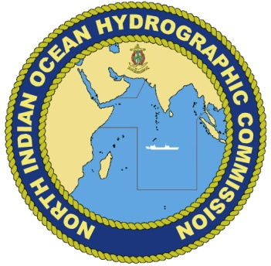
Annex B
NIOHC CL 06-2017
12th June 2017

17th NORTH INDIAN OCEAN
HYDROGRAPHIC COMMISSION MEETING
Cairo, Egypt
17th to 20th July 2017

Delegate Registration Form

Please send the completed Registration Form to the NIOHC Secretariat, Egyptian Navy Hydrographic Department, Raseltin, Alexandria via e-mail to hydro@enhd.gov.egcc: ahmed.naguib@eagles.usm.edu or fax (+ 20 3 480 2233) before 19th June 2017.

Member State
Organization
- Contact Details
Head or Member of delegation
Rank or Title
Family Name
Given or Personal Name
Position / Job title / Role
Nationality
Telephone
Fax
E-mail
Special Dietary Requirements (Please State Type)

- Travel Details (For administrative purpose only). Participants are expected to make their own travel arrangements.
Your arrival in Cairo | Date
 | Flight Number
 | Airline
 | Arrival Time

Your departure from Cairo | Date
 | Flight Number
 | Airline
 | Departure Time

- Hotel Information (For administrative purpose only). Participants are expected to make their own accommodation arrangements.

Hotel at which booking has been made | AlMasah | Yes/No
 | Other | (Name)

Signature |  | Date

