ANNEX B
The 15th Eastern Hydrographic Commission Conference and Seminar
REGISTRATION FORM
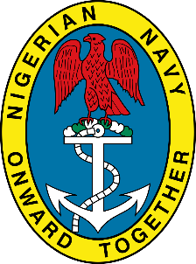
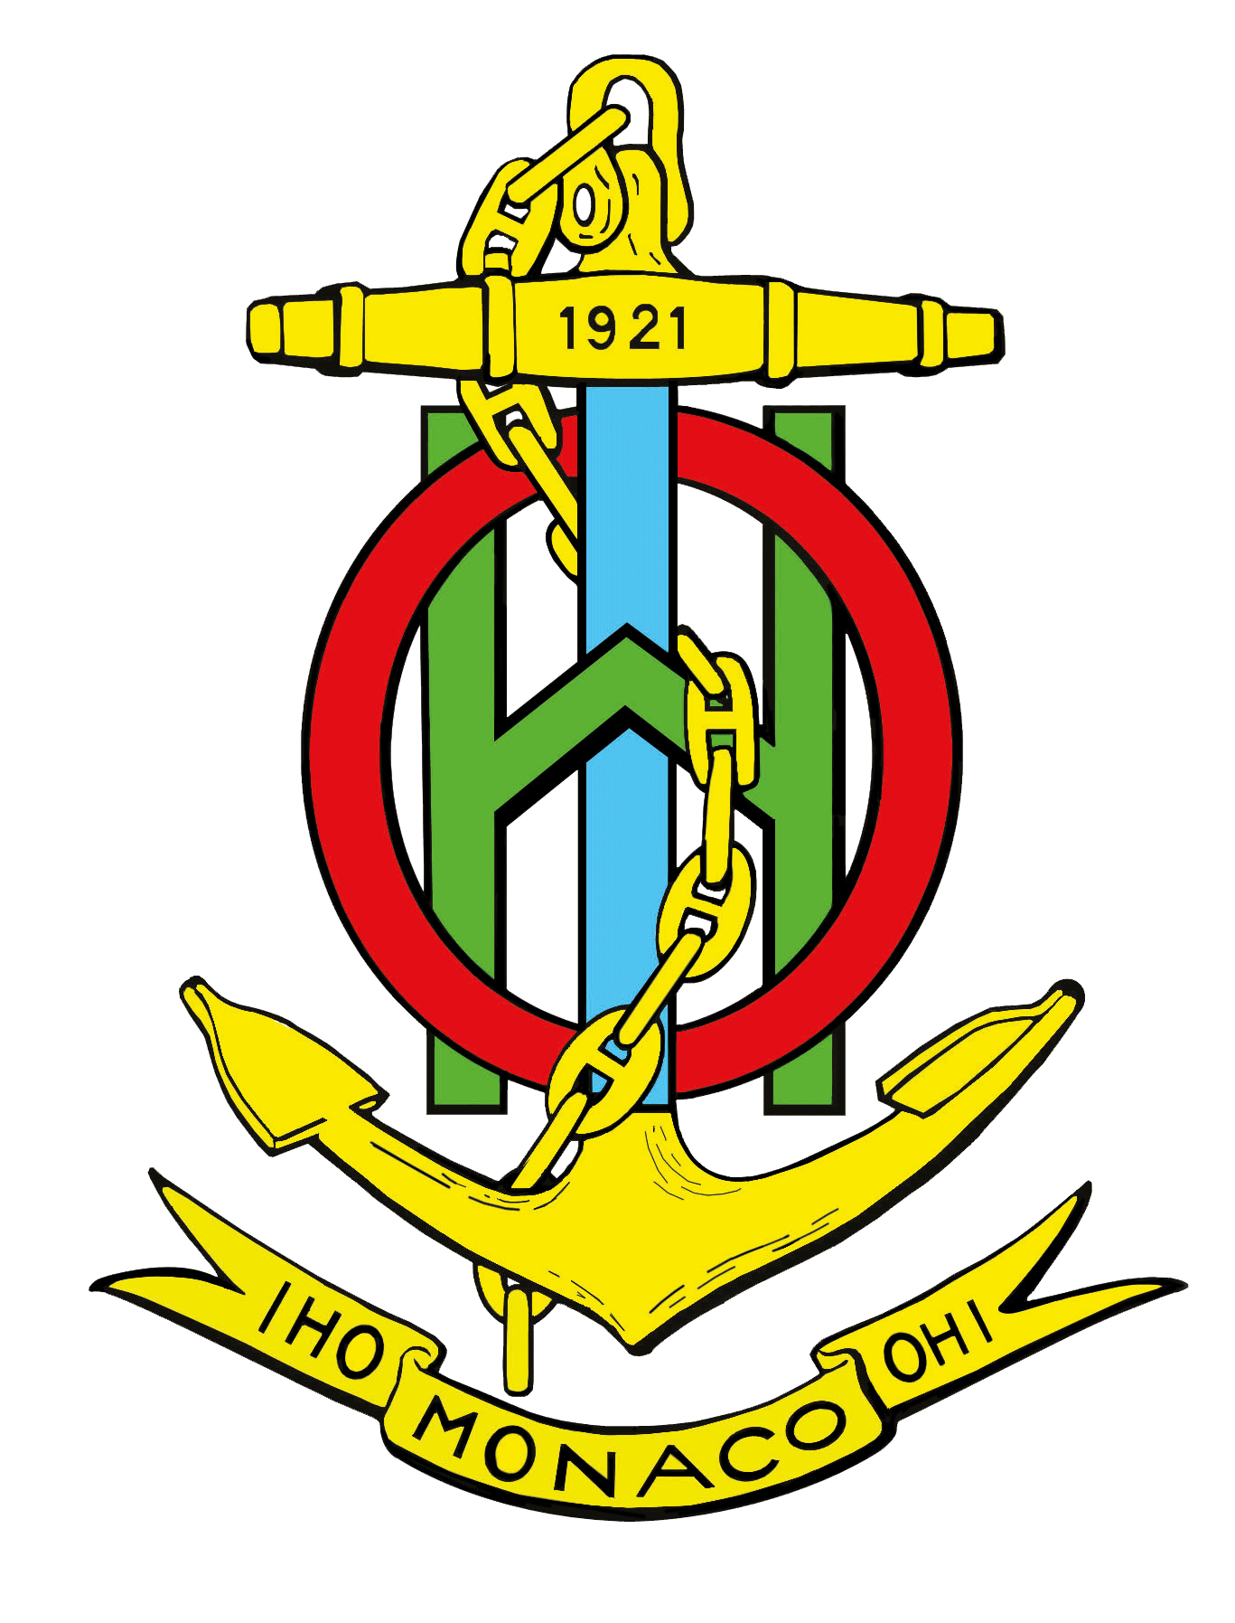

IMPORTANT Note: All participants to the conference and/or the seminar must please complete the information requested in this form, and forward it to the Nigerian Navy Hydrographic Office (info@nnho.ng) (copy: jbuscal@fn.mde.es, ihmesp@fn.mde.es and yves.guillam@iho.int ) not later than 20 June 2018.
Form available in “word” format on IHO website.

Personal Details
First name: …………………………………………..
Surname:…………………………………………………………………………..
Name of partner (if applicable): …………………………………………..
Organization: ………………………………………….
Nationality ………………………………………………………………………….
Passport Num (If visa support letter is required)……………………………….

Accommodation Details
Booked Hotel or Preference:…………………………………………………………
Arrival Date: ……………………………………………………………………………..
Departure Date:………………………………………………………………………….
Room type (Standard or Superior)……………………………………………………
Smoking or non smoking……………………………………………………………..

Flight Details
Arrival at MM1 International Airport Departure at MM1 International Airport

Arrival Date……………………………… Depature Date……………………………..
Flight No: ……………………………….. Flight No: ………………………………..
Airline: ………………………………….. Airline…………………………………………..
Arrival time: …………………………………. Departure time………………………………..

ATTENDANCE
Please indicate if you are attending both the Seminar and the Conference or only one.
(those attending the seminar are supposed to stay at the conference)
Geospatial Awareness Seminar Yes or No…………………………………..
15th EAtHC Conference Yes or No…………………………………………………..

If you need letter of invitation for visa application, kindly provide the following information:
a. Nigerian Embassy Address in country of application.
b. Scan copy of the international passport bio-data Page.

Comments or additional information:

…………………………………………………………………………………………………………

……………………………………………………………………………………………………………

………………………………………………………………………………………………………………

Date: ……………………

