ARHC7-

Seventh Meeting of the Arctic Regional Hydrographic Commission (ARHC)
Ilulissat, Greenland, Denmark – 22-24 August 2017
Arctic Shipping Best Practices Forum Update
Submitted by: United States
Executive Summary: This paper provides an update on the efforts of the PAME Working Group to develop an Arctic Shipping Best Practices Information Forum in 2017 and invites the ARHC to deliberate if it wishes to support the relevant efforts of this Forum.
This may support discussions at the ARHC Special session in April 2017 related to the action ARHC Special-4 “c/OTWG to ask ARHC MS for information to the WEB portal”
Related Projects: The Arctic Shipping Best Practices Information Forum https://pame.is/index.php/projects/arctic-marine-shipping/the-arctic-shipping-best-practices-information-forum

BACKGROUND
PAME is one of six Arctic Council working groups. PAME was first established under the 1991 Arctic Environmental Protection Strategy and was continued by the 1996 Ottawa Charter that established the Arctic Council. PAME is the focal point of the Arctic Council’s activities related to the protection and sustainable use of the Arctic marine environment and provides a unique forum for collaboration on a wide range of activities in this regard. PAME's mandate: "To address marine policy measures and other measures related to the conservation and sustainable use of the Arctic marine and coastal environment in response to environmental change and from both land and sea-based activities, including non-emergency pollution prevention control measures such as coordinated strategic plans as well as developing programs, assessments and guidelines, all of which aim to complement or supplement efforts and existing arrangements for the for the protection and sustainable development of the Arctic marine environment."
The establishment of the Arctic Shipping Best Practices Information Forum is in response to the newly adopted International Code for Ships Operating in Polar Waters (Polar Code) by the International Maritime Organization (IMO). The aim of the Forum is to raise awareness of its provisions amongst all those involved in or potentially affected by Arctic marine operations and to facilitate the exchange of information and best practices between the Forum members on specific shipping topics, including but not limited to; hydrography, search and rescue logistics, industry guidelines and ship equipment, systems and structure. A publicly accessible web-portal will be created with information specific to each topic. The Forum membership is open to Arctic States, Permanent Participants and Arctic Council Observers as well as any widely-recognized professional organization dedicated to improving safe and environmentally sound marine operations in the Arctic as demonstrated by expertise and experience in Arctic shipping and/or related issues. The Protection of the Arctic Marine Environment (PAME) Working Group of the Arctic Council approved the Forum's Terms of Reference at their last meeting (February 2017).
The ARHC has supported efforts of PAME in prior years through the provision of hydrographic assessments and information for the Arctic.
The ARMSDIWG efforts related to the Marine Spatial Data Infrastructure effort and the Arctic Voyage Planning Guide may also offer relatively seamless support to the PAME Arctic Shipping Best Practices Information Forum.
The PAME-II 2017 meeting will take place September 18-20 in Helsinki, Finland. The next steps in PAME’s buildout of the Forum will be discussed there.
DISCUSSION
The Arctic Shipping Best Practices Information Forum identifies ten themes of priority interest. These include hydrography, ice data, traditional and local knowledge, and others. Several of these may represent valuable themes to which the ARHC, as an authoritative body of hydrographic offices of Arctic nations, may readily be able to demonstrate value to the efforts of the Arctic Council at large by simply providing links and content references to the summary information for a wide range of stakeholders concerned with promoting arctic shipping best practices. A preliminary review by the U.S. representative to PAME (NOAA) for the PAME-I 2017 identified several existing types of information for the U.S. that may be of relevance to the PAME effort. See Appendix A.
It appears the ARHC can further demonstrate its value as “the hydrographic authority” for information concerning the state of hydrography in the Arctic as pertains to navigation risk and the protection of the marine environment.
For reference, the National Points of Contact for PAME are provided in Appendix B.
RECOMMENDATION
The ARHC is invited to
- Note this information update;
- Discuss interest and opportunities for ARHC as individual national offices as well as collectively may wish to offer as feedback to the PAME and in support of PAMEs effort to build out its Arctic Shipping Best Practices;
- If decided and as warranted, the ARHC designate a hydrographic office to communicate back to PAME on behalf of the ARHC before September 05, 2017 so any information may be considered at the PAME-II 2017 meeting September 18-20 in Helsinki, Finland.

Appendix A
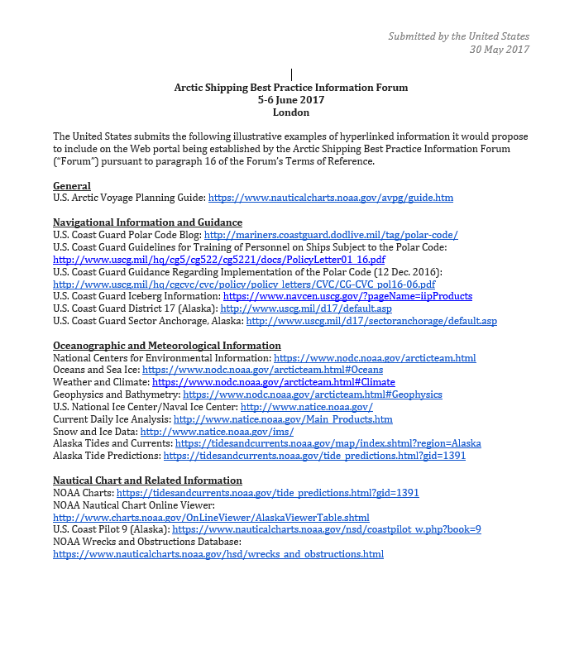

Appendix B

PAME NATIONAL REPRESENTATIVES (Heads of delegations)
Canada | Kingdom of Denmark | Finland | Iceland
Steve Newton  Fisheries and Oceans Canada  E-mail: steve.newton@dfo-mpo.gc.ca | Thomas Klinggaard  National Institute of Aquatic Resources  E-mail: thobk@nst.dk | Kristiina Isokallio  Ministry of the Environment  E-mail: kristiina.isokallio@ymparisto.fi | Helga Jónsdóttir  Ministry for the Environment  Email: helga.jonsdottir@uar.is
Norway | Russian Federation | Sweden | United States of America
Anja Elisenberg  Ministry of Environment  E-mail:anja.elisenberg@md.dep.no | Alexey Bakhtov  Ministry of Natural Resources and Environment  E-mail: alex.bakhtov@mnr.gov.ru | Jessica Nilsson  Swedish Agency for Marine and Water Management  E-mail: jessica.nilsson@havochvatten.se | Elizabeth S. McLanahan  NOAA Office of International Affairs  E-mail:Elizabeth.McLanahan@noaa.gov

https://pame.is/index.php/shortcode/about-us
https://pame.is/index.php/projects/arctic-marine-shipping/the-arctic-shipping-best-practices-information-forum
https://pame.is/index.php/shortcode/list-of-members

