INTERNATIONAL HYDROGRAPHIC  ORGANIZATION | INTERGOVERNMENTAL OCEANOGRAPHIC  COMMISSION (of UNESCO)

UNDERSEA FEATURE NAME PROPOSAL
(See IHO-IOC Publication B-6 and NOTE overleaf)

Note: The boxes will expand as you fill the form.
Name Proposed: | Umiushi Spur | Ocean or Sea: | N/A

Geometry that best defines the feature (Yes/No) :
Point | Line | Polygon | Multiple points | Multiple lines* | Multiple polygons* | Combination of geometries*
 |  | Yes
* Geometry should be clearly distinguished when providing the coordinates below.
 | Lat. (e.g. 63°32.6’N) | Long. (e.g. 046°21.3’W)
Coordinates: | 21°25.76’N  21°25.32’N  21°16.92’N  21°24.06’N  21°23.09’N  21°10.97’N  20°56.13’N  20°44.95’N  20°35.93’N  20°38.17’N  20°48.94’N  21°10.43’N  21°20.45’N  21°25.76’N | 150°07.32’E  150°13.80’E  150°18.13’E  150°23.73’E  150°28.19’E  150°27.85’E  150°22.47’E  150°23.95’E  150°17.28’E  150°07.67’E  150°01.92’E  150°05.51’E  150°04.80’E  150°07.32’E

Feature Description: | Maximum Depth: | 6,060 m | Steepness : | N/A
Feature Description: | Minimum Depth : | 2,406 m | Shape : | Elongated
Feature Description: | Total Relief : | 3,654 m | Dimension/Size : | 45 km × 90 km

Associated Features: | Weiluo Guyot, and Weiqi Guyot

Chart/Map References: | Shown Named on Map/Chart: | 6724
Chart/Map References: | Shown Unnamed on Map/Chart:
Chart/Map References: | Within Area of Map/Chart:

Reason for Choice of Name (if a person, state how associated with the feature to be named): | Following the rule II-A-7 of B-6 (page 2-3), JCUFN gave a descriptive name to this feature. “Umiushi” is the Japanese for a sea slug. The shape of this feature resembles a pair of horns of a sea slug.  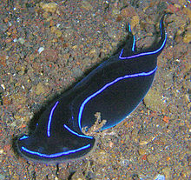  Image from wikipedia

Discovery Facts: | Discovery Date: | Nov. 1999
Discovery Facts: | Discoverer (Individual, Ship): | Japanese survey vessel "Takuyo"

Supporting Survey Data, including Track Controls: | Date of Survey: | Nov. - Dec. 1999  Nov. - Dec. 2001  Feb. - Mar. 2002
Supporting Survey Data, including Track Controls: | Survey Ship: | Japanese survey vessel "Shoyo" and "Takuyo"
Supporting Survey Data, including Track Controls: | Sounding Equipement: | Multibeam echo sounder  Seabeam 2112
Supporting Survey Data, including Track Controls: | Type of Navigation: | GPS without Selective Availability (2001 and 2002)  GPS with Selective Availability (1999)
Supporting Survey Data, including Track Controls: | Estimated Horizontal Accuracy, in nautical miles (M): | 0.014 nm (26 m) (2001 and 2002)  0.054 nm (100 m) (1999)
Supporting Survey Data, including Track Controls: | Survey Track Spacing: | 5 nm
Supporting Survey Data, including Track Controls: | Supporting material can be submitted as Annex in analog or digital form.

Proposer(s): | Name(s): | JCUFN
Proposer(s): | Date: | August 20, 2018
Proposer(s): | E-mail: | ico@jodc.go.jp
Proposer(s): | Organization and Address: | Hydrographic and Oceanographic Department, Japan Coast Guard Kasumigaseki 3-1-1, Chiyoda-ku, Tokyo 100-8932, Japan
Proposer(s): | Concurrer (name, e-mail, organization and address):

Remarks: | The position of the summit is located in (20°38.08’N, 150°09.42’E).

NOTE: This form should be forwarded, when completed:

a) If the undersea feature is located inside the external limit of the territorial sea:
- to your "National Authority for Approval of Undersea Feature Names" (see Publication B-6) or, if this does not exist or is not known, either to the IHO or to the IOC (see addresses below);

b) If at least 50 % of the undersea feature is located outside the external limits of the territorial sea:
- to the IHO or to the IOC, at the following addresses :

International Hydrographic Organization (IHO)  4b, Quai Antoine 1er  B.P. 445  MC 98011 MONACO CEDEX  Principality of MONACO  Fax: +377 93 10 81 40  E-mail: info@iho.int  Web: www.iho.int | Intergovernmental Oceanographic Commission (IOC)  UNESCO  Place de Fontenoy  75700 PARIS  France  Fax: +33 1 45 68 58 12  E-mail: info@unesco.org  Web: http://ioc-unesco.org/

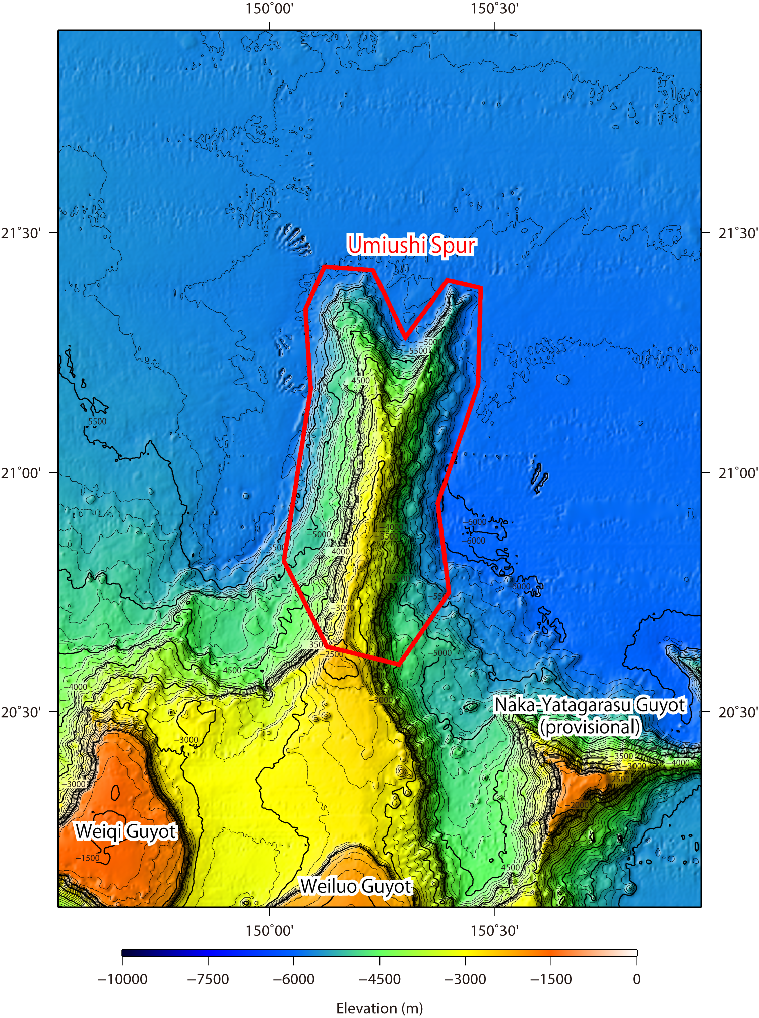

Fig. 1. Bathymetric map of the Umiushi Spur. Contours are in 100 m.

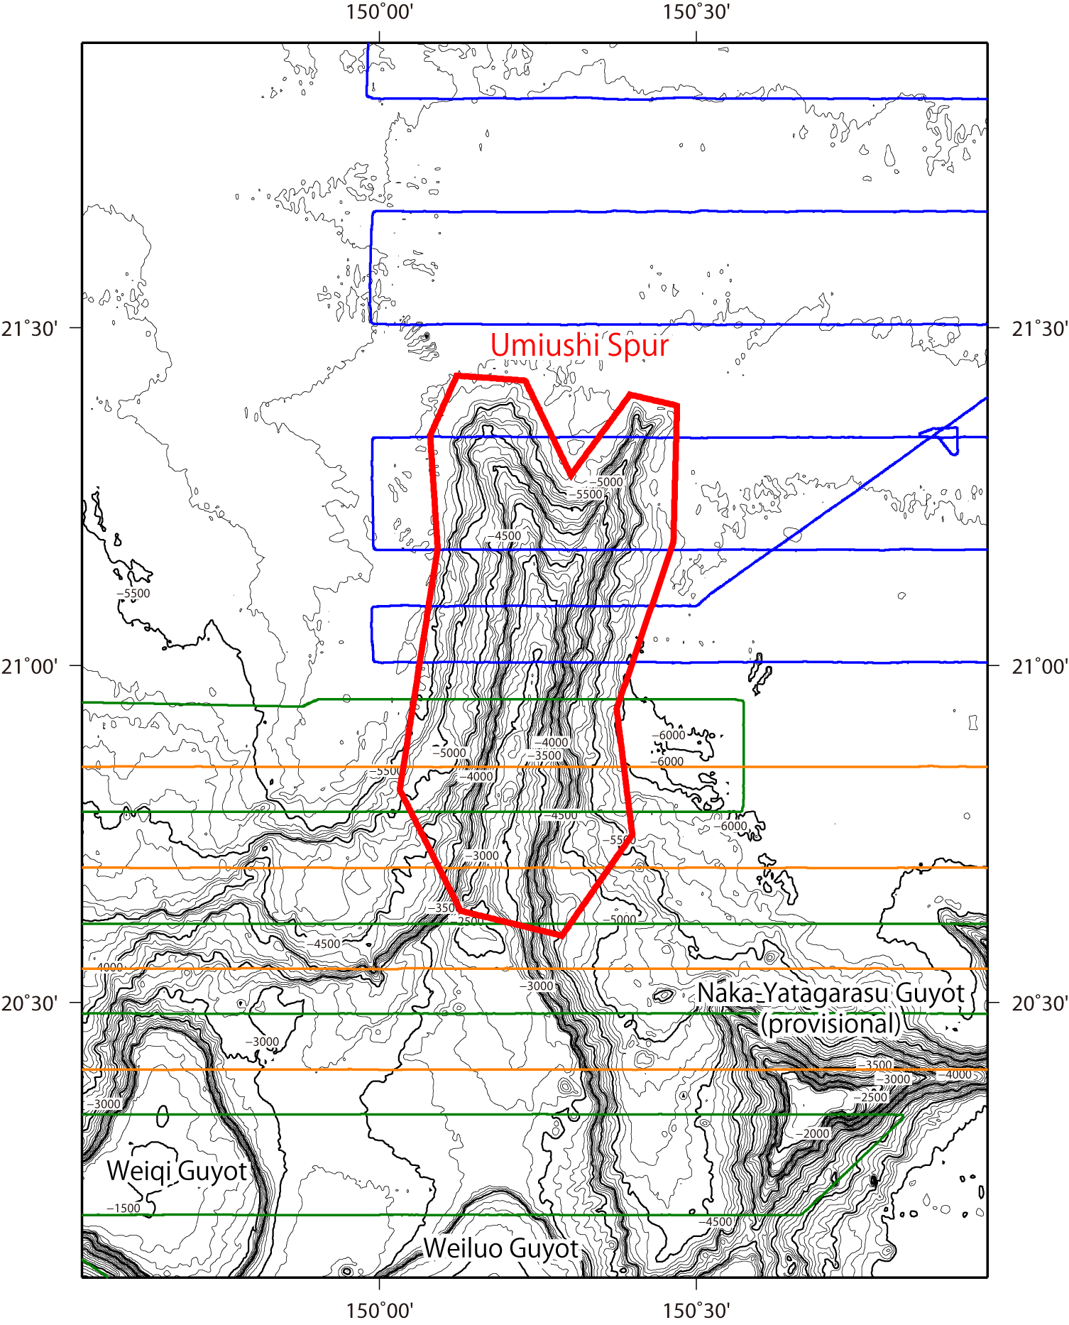

Fig. 2. Bathymetric map of the Umiushi Spur, shown with track lines. Contours are in 100 m.

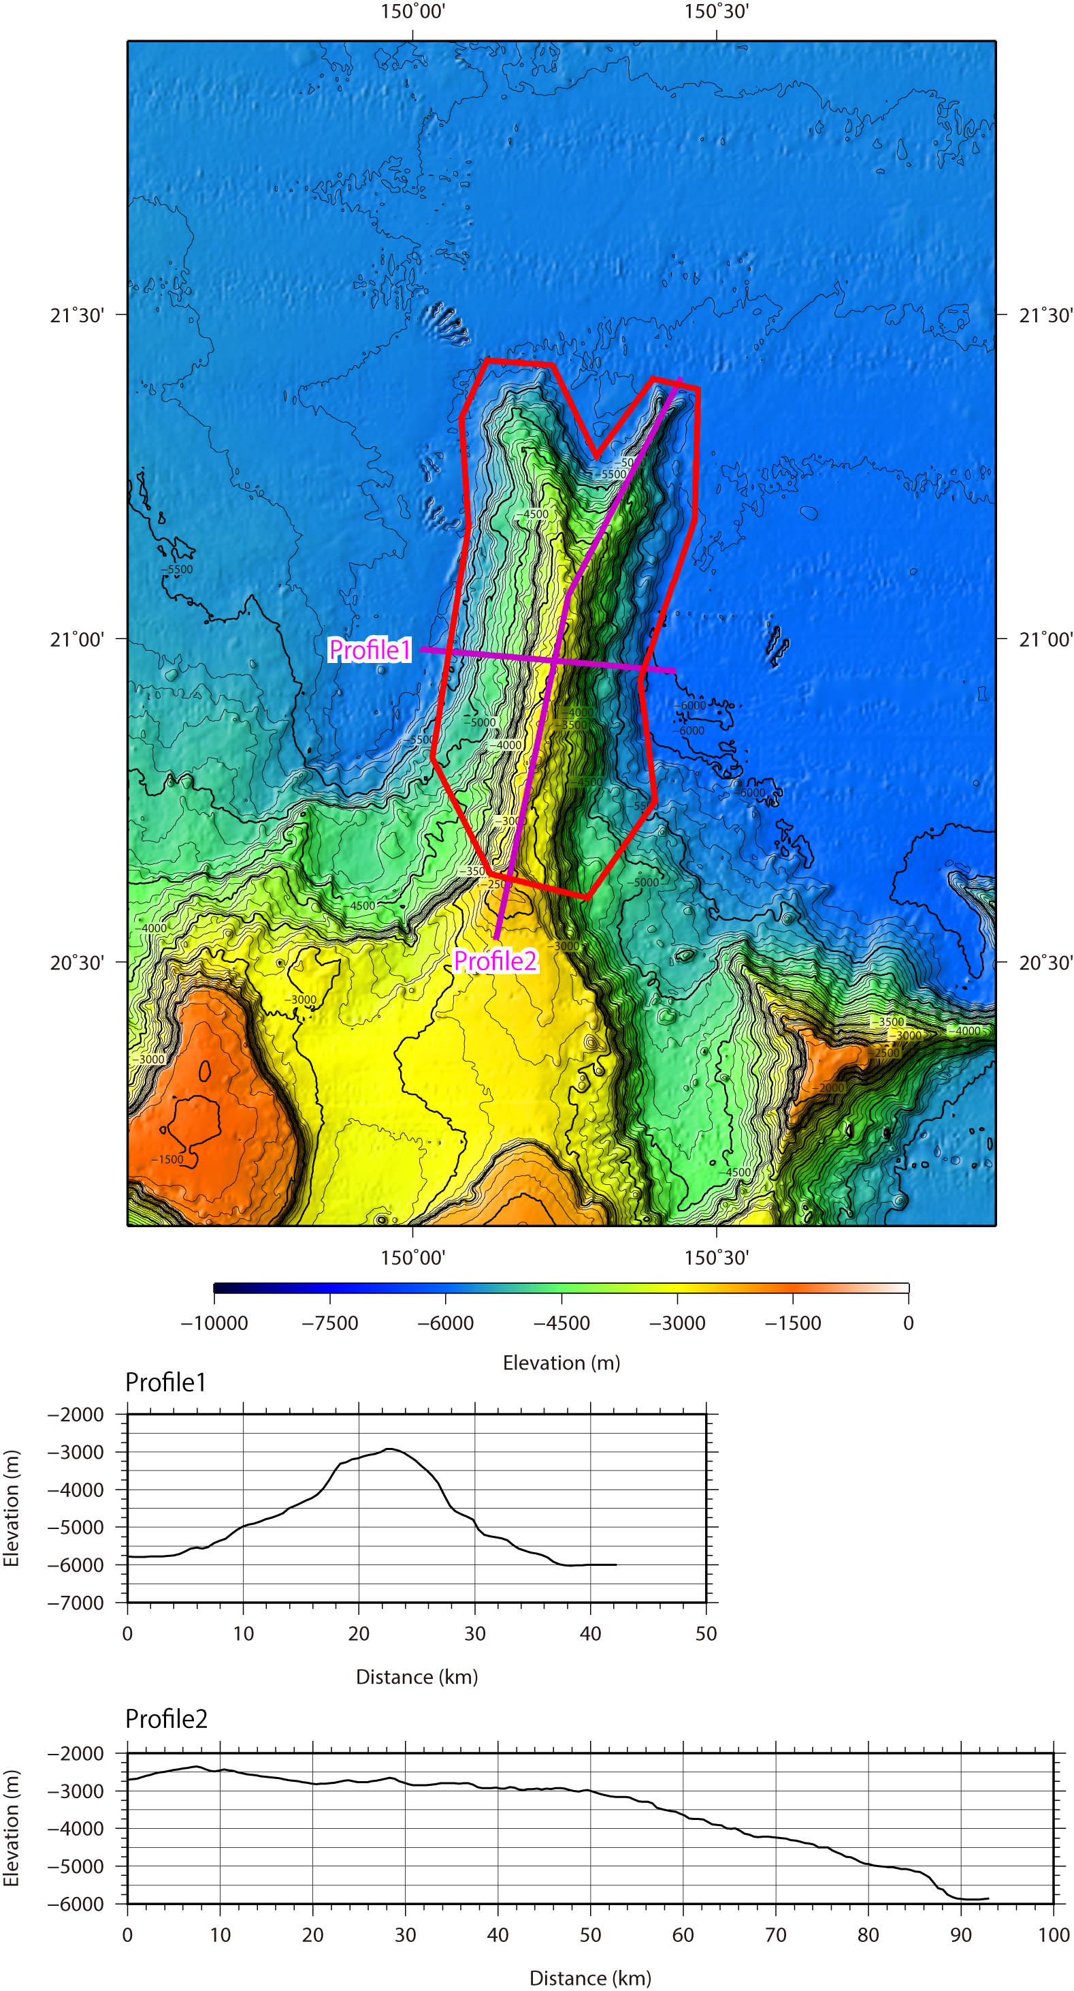

Fig. 3. Bathymetric profile across the Umiushi Spur.

