INTERNATIONAL HYDROGRAPHIC ORGANIZATION  4b, quai Antoine Ier  B.P. 445  MC 98011 MONACO CEDEX  PRINCIPAUTE DE MONACO | 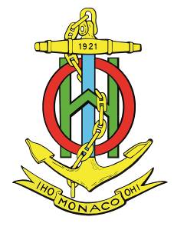 | ORGANISATION HYDROGRAPHIQUE INTERNATIONALE  Tel. : +377 93 10 81 00  Fax : +377 93 10 81 40  Email : info@iho.int  Web : www.iho.int

NAUTICAL CARTOGRAPHY Working Group

Chair: Mikko HOVI  Finnish Transport Agency  Opastinsilta 12 A  00520 Helsinki  Finland | Secretary: Andrew HEATH-COLEMAN  United Kingdom Hydrographic Office  Admiralty Way, Taunton, Somerset  United Kingdom
Tel: +358 29 5343463 | Tel: +44 1823 483218
Email: mikko.hovi@liikennevirasto.fi | Email: andrew.coleman@ukho.gov.uk

NCWG Letter: 05/2017
UKHO ref: HA317/010/031-14
Finnish ref: LIVI/326/00.03.01/2017
Date 17 October 2017

Subject: NCWG3 – Action 35 Membership List
Dear Colleagues

As secretary of NCWG, I have responsibility to maintain the NCWG ‘Membership List’. This is not an easy task, especially as I am not always informed when named members change their contact details, leave their organizations or are replaced. I prepared a discussion paper for NCWG3 (in consultation with Yves Guillam). This paper (NCWG3-14.1A) is attached for reference at Annex A.

Following discussion at NCWG3, the members present decided not to divide members into two ‘levels’ of participation, as circumstances beyond their control may limit their degree of participation, particularly in attending meetings. However, I was given permission to ask NCWG members to confirm their on-going membership of the WG. This is intended to allow me to delete any members who never acknowledge or respond to correspondence, so that I am unaware if the correspondence is even being received. I will therefore be deleting any members listed in Annex B who do not respond to this letter. Of course, if your organization subsequently decides to provide an active member, NCWG remains open to every Member State whenever they want to engage or re-engage.

I have decided the simplest way to identify members of subWGs or project teams is by marking them with superscript numbers, with a key at the foot, as shown on the attached list at Annex B. I have inserted these numbers in accordance with my understanding of current membership of these subWGs, but I do need members’ confirmation that these are correct, please. It would also be an opportunity to state if you would like to be contribute to one of these groups where you are not marked as being a member.

Please reply, using the Response form at Annex C, by 12 December 2017

Yours sincerely,
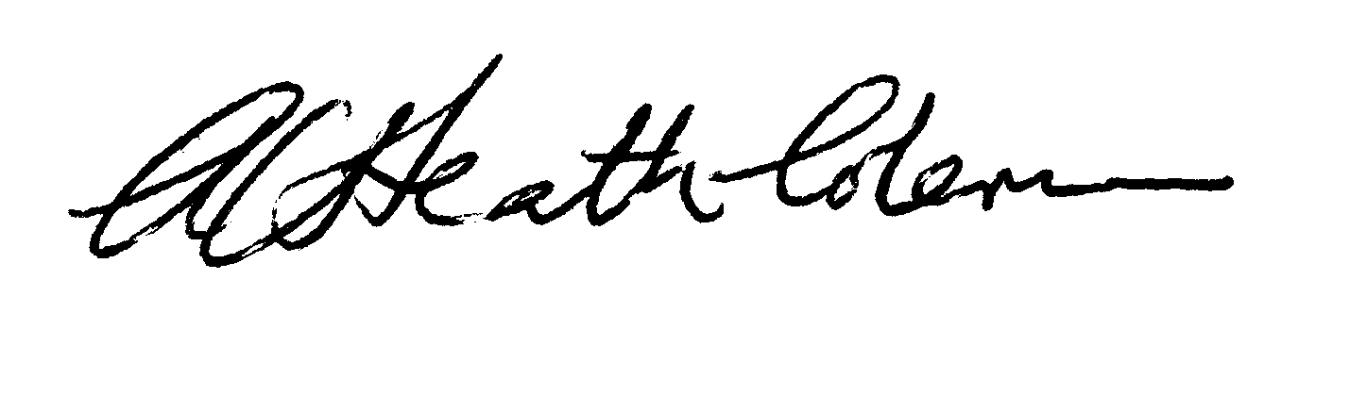
Andrew Heath-Coleman
Secretary NCWG
Annex A to NCWG Letter 05/2017

NCWG3-14.1A

3rd NCWG MEETING
ESRI HQ, Redlands, California, USA 16-19 May 2017

Paper for Consideration by NCWG
NCWG Membership List

Submitted by: | Secretary
Executive Summary: | Should the NCWG membership list be divided into two main categories, with possible ‘sub-categories’?
Related Documents: | NCWG3-01C
Related Projects: | None

Introduction / Background
Introduction / Background:
- The NCWG membership list is maintained in the NCWG part of the IHO website. It has three columns: Member State (or Expert Contributor)/Name/Email. The column ‘Name’ does not differentiate the level of participation. When the HSSC considered the restructuring of the HSSC WGs in 2014 and 2015, Member States were invited to indicate what their level of participation would be (IHO CL 39/2014 & 76/2014 refer). Two categories were suggested at this time: A (as Active member, present at meetings), or C (Corresponding member – point of contact). This was made in order to evaluate the effective resources available to carry out/lead/participate in various work items assigned to the working groups and subsequently improve the preparation of realistic planning for high priority tasks.
Analysis / Discussion:
- While many HOs inform the NCWG secretary when there is a change of representative, some do not. Sometimes, the Secretary receives an email response from a different person and then asks if the representative has changed – sometimes we receive a reply. Other members never engage in correspondence or attend meetings; presumably they are reading the correspondence, but it is not possible to know for sure. In some cases, individuals have left the service but NCWG has not been informed whether a replacement has been appointed.
- The DQWG splits its ‘Names’ column into two: ‘Active Member’ and ‘Correspondence Member’ (in line with the HSSC suggestion above). While such a distinction does not resolve all the problems of maintaining the list, it is useful to know whether an individual intends to be active and possibly take the lead for some actions, or just wishes to be kept informed of the activities of the WG.
- ‘Active Member’ and ‘Correspondence Member’ may not be the best split. A representative who regularly engages in correspondence (but is unable to attend meetings) is still an active member and may possibly lead on relevant actions. So perhaps ‘Active’ should be paired with ‘Inactive’ – or is there a better word or phrase, such as ‘Observer’ or ‘Information only’? It could also be useful to add other columns giving some visibility on the membership of sub-groups (INT1, Future of the Paper Chart, etc.)
- In the first place, the Secretary cannot determine who should be categorized as ‘Active’ or ‘Inactive’. It would be possible to write to all current listed members and ask them to advise which category they should be listed under. In the event of no reply at all (after a chase up email), we could remove that individual and organization from the list, keeping in mind that the NCWG remains open to every Member State whenever they want to engage or re-engage.
- The list could be more appropriately referred to as a ‘Representative List’.
Conclusion:
- The NCWG Members list could be more informative by introducing a second category, and possibly sub-groups membership categories as well.
Recommendation:
- Split NCWG Membership List into two main categories, and other sub-group categories. Correspond with existing members to ascertain appropriate category. Get a rough estimate from Active members of the number of working days they can spend on supporting or leading work items and actions.
Justification and Impacts:
- A more informative list results and the process provides an opportunity to remove names that no longer represent a Member State (or other body). It is also a great opportunity to build realistic work plans taking into account the possible resources and commitments.
Action required of NCWG:
- The NCWG is invited to:
endorse the above recommendation;
advise what categories are appropriate;
advise whether ‘Representative List’ is a more appropriate title.

Annex B to NCWG Letter 05/2017

MEMBERSHIP OF NCWG
(Updated 14 September 2017)

Member State | Name | Email
Australia | Mr Alvaro Sanchez ³ | Alvaro.Sanchez@defence.gov.au
Brazil | Lt Alice MARINHO Etienne  Lt Rafael VIEIRA  Lt Estela DIERKA | alice@chm.mar.mil.br  rafael.vieira@chm.mar.mil.br  estela.dierka@marinha.mil.br.
Canada | Mr Daniel BROUSSEAU ³ | Daniel.Brousseau@dfo-mpo.gc.ca
Denmark | Mr Lasse ANDRESEN  Mr Thomas CHRISTENSEN | landr@gst.dk  thchr@gst.dk
Finland | Mr Mikko HOVI ^{2,3} (Chair) | Mikko.Hovi@liikennevirasto.fi
France | Mr Stéphane GUILLOU ¹ | stephane.guillou@shom.fr
Germany | Ms Sylvia SPOHN ¹ | sylvia.spohn@bsh.de
Greece | Ms Julia PAPAGIANNOPOULOU | dcd_hnhs@navy.mil.gr
India | Dr BK RAMPRASAD | ia-inho-navy@nic.in  ia-inho@navy.gov.in
Indonesia | Captain DYAN Primana Sobaruddin | dyanmaxp@gmail.com
Iran (Islamic Rep. of) | Mr Akbar ROSTAMI | akrostami@pmo.ir
Italy | Cdr Carlo MARCHI ^{2,3}  Ms Manuela MILLI ³  Mr Valentino PALMA | carlo.marchi@marina.difesa.it  manuela_milli@marina.difesa  valentino.palma@persociv.difesa.it
Japan | Dr Masayuki FUJITA | chart@jodc.go.jp
Korea (Rep of) | Mr Sung-Joo PARK | martin.park@korea.kr
Latvia | Ms Ilona MARKUSA | ilona.markusa@lhd.lv
Netherlands | Mr Ben TIMMERMAN | B.Timmerman@mindef.nl
New Zealand | Mr Adam GREENLAND  Mr Gareth HODKINSON | agreenland@linz.govt.nz  ghodkinson@linz.govt.nz
Norway | Ms Inger TELLEFSEN | inger.tellefsen@kartverket.no
Pakistan | LtCdr Fayyaz ul Hassan BHATTI | hydropk@paknavy.gov.pk
Russian Fed. | Mr Igor BONAKOV | unio_main@mil.ru
South Africa | Mr Alfons VAN CRAEYNEST | hydrosan@iafrica.com
Spain | Cdr Federico YANGUAS GUERRERO ¹ | fyangue@fn.mde.es
Sweden | Mr Magnus HOVBERG | magnus.hovberg@sjofartsverket.se
Turkey | Mr Emre AKILLI ² | eakilli@shodb.gov.tr
Ukraine | Mr Oleg MARCHENKO | chart_dpt@charts.gov.ua
United Kingdom | Mr Nick RODWELL ³ | nick.rodwell@ukho.gov.uk
United Kingdom | Mr Andrew HEATH-COLEMAN ¹ (Secretary) | andrew.coleman@ukho.gov.uk
USA (NOAA) | Mr Colby HARMON ^{2,3} | colby.harmon@noaa.gov
USA (NGA) | Ms Jacqueline BARONE ³ (Vice Chair) | jacqueline.barone@nga.mil
Expert contributors
IHO Secretariat | Mr Yves GUILLAM ^{2,3} | adcs@iho.int
IHO Secretariat | Mr Jeff WOOTTON | tsso@iho.int
IBSC/ICA | Mr Ron FURNESS | rfurness@ozemail.com.au
C-MAP | Mr Justin HORNBY | justin.hornby@c-map.com
ESRI | Ms Patricia (Trish) SHEATSLEY ³ | PSheatsley@esri.com
HSSC Contacts: HSSC Contacts list
1 INT1subWG
2 Portrayal subWG
3 Future of the Paper Chart subWG (FOPCsubWG)

Annex C to NCWG Letter 05/2017
NCWG3 – Action 35 Membership List

Response Form
(please return to NCWG Secretary by 12 December 2017)
andrew.coleman@ukho.gov.uk

If you vote ‘No’ to any of the following questions, please explain in the ‘Comments’ section.
No. | Question | Yes | No
1 | Are you still a member of the NCWG?
2 | If the answer to 1 is ‘No’, is there anybody else in your organization who should be listed instead? (Please provide name and contact details below)
3 | Do you agree that the membership of subWGs and Project teams, etc, is best shown by reference numbers, as shown in Annex B?
4 | Is your personal participation in subWGs correctly shown? (If not, please provide details below)

Further comments:

Name:
Organization:

